





AIATSIS

ANNUAL REPORT

2017–18

AUSTRALIAN INSTITUTE OF
ABORIGINAL AND TORRES STRAIT ISLANDER STUDIES
ANNUAL REPORT 2017–18

Produced by: Australian Institute of Aboriginal and Torres Strait Islander Studies
Location: 51 Lawson Crescent, ACTON ACT 2600 Postal address: GPO Box 553, CANBERRA ACT 2601 Telephone: +61 2 6246 1111
Facsimile: +61 2 6261 4285
Email: executive@aiatsis.gov.au
Home page: www.aiatsis.gov.au
Annual report: www.aiatsis.gov.au/about-us/corporate-documents-and-policies
/annual-report
Content management, writing and contact: Courtney Barker
Editing: Kirsten McNeill, Apricot Zebra Pty Ltd
Design and typesetting: Peta Stamell & Nick Williams
Printed by: New Millennium Print Pty Ltd

Cover image: Japingka Country, 1989 ATS 1036_366 Jimmy Pike
(c1940–2002, Waljarri people)

ISSN (print) 2204-0196x
ISSN (digital) 2204-020X
© Australian Institute of Aboriginal and Torres Strait Islander Studies 2018

This work is copyright. Apart from any use permitted under the Copyright Act 1968 (Cth), no part may be reproduced by any process without prior written permission from the Australian Institute of Aboriginal and Torres Strait Islander Studies.

Feedback on this report, requests for additional information, and enquiries regarding permission to reproduce material from this work, should be addressed to the Australian Institute of Aboriginal and Torres Strait Islander Studies Executive through the above channels.

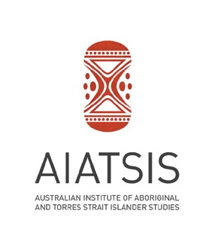

ANNUAL REPORT

2017–18



LETTER OF
TRANSMITTAL

To:
Senator the Hon Nigel Scullion Minister for Indigenous Affairs Parliament House
CANBERRA ACT 2600

Dear Minister

It is with great pleasure that I present the Australian Institute of Aboriginal and Torres Strait Islander Studies (AIATSIS) Annual Report for 2017–18.
The report details our ongoing efforts to:
- tell the story of Aboriginal and Torres Strait Islander Australia;
- create opportunities for people to encounter, engage with and be transformed by that story;
- support and facilitate Aboriginal and Torres Strait Islander cultural resurgence; and
- shape the national narrative.
This report has been prepared in accordance with section 46 of the (PGPA) Public Governance, Performance and Accountability Act 2013.
As the Accountable Authority of AIATSIS, I certify that:
- fraud risk assessments and fraud control plans have been prepared;
- appropriate mechanisms to prevent, detect, record, report and investigate fraud are in place; and
- all reasonable measures have been taken to deal appropriately with fraud relating to AIATSIS.

Yours sincerely


Professor Michael McDaniel
Chairperson AIATSIS Council
21 September 2018

Australian Institute of Aboriginal and Torres Strait Islander Studies ii

TABLE OF
CONTENTS
Letter of Transmittal ii
About this report 1
INTRODUCTION AND SUMMARIES 3
AIATSIS at a glance 4
Legislation and Purpose 4
AIATSIS Timeline 7
EXECUTIVE OVERVIEW 9
Chairperson’s statement 11
Chief Executive Officer’s Report 12
OUR PERFORMANCE 15
Introductory Statement 17
AIATSIS Performance Framework 18
Summary analysis of 2017-18 performance 19
Analysis of performance against agency purpose 19
Strategic priorities 22
- Ensuring our collections are safe, accessible, valued and growing 23

- Provide leadership in Indigenous research, and ethical engagement in research, collections and publishing
- Strengthening understanding of Aboriginal and Torres Strait Islander culture and heritage
- Promote and share Aboriginal and Torres Strait Islander heritage by connecting with community and the nation
- Provide advice to the Commonwealth on the situation and status of Aboriginal and Torres Strait Islander culture and heritage
- Create strong governance and to ensure a resilient organization through leadership, innovation and partnership

37

49

64

90

104

Performance results 116
- AIATSIS collections 116
- AIATSIS research and ethics 117
- AIATSIS public programs, publishing, communications and engagement 118

OUR ORGANISATION 121
Governance 122
AIATSIS Council 123
Organisation structure 128
Corporate Governance 129

FINANCIAL STATEMENTS 135

APPENDICES 159
Appendix A – Research project summaries 160
Appendix B – Governance committees 164
Appendix C – Strategic partnerships 169
Appendix D – Research outputs – publications and presentations 172
Appendix E – Researcher memberships and offices 174

AIDS TO ACCESS 191
- Abbreviations and acronyms 192
- Compliance Information Index 194
- Alphabetical index 198



ABOUT THIS
REPORT

INTRODUCTION AND SUMMARIES
  - Provide a brief guide to AIATSIS, including its purpose and outcomes
  - Summarise our performance in 2017–18.

Executive Overview
  - Includes both the AIATSIS Council Chairperson and Chief Executive Officer’s (CEO’s) reports for 2017–18
  - Provides overview of financial results for 2017–18
  - Looks forward to 2018–19 and beyond.

Our Performance
  - Summarises AIATSIS’ performance in the Annual Performance Statement 2017–18;
  - Discusses performance against the six strategic priorities in the AIATSIS Corporate Plan 2017–18 to 2020–21; and shares how AIATSIS:
» tells the story of Aboriginal and Torres Strait Islander Australia;
» createsopportunitiesforpeopletoencounter, engagewithandbetransformedby that story;
» support and facilitate Aboriginal and Torres Strait Islander cultural resurgence; and
» shapes the national narrative.

Our Organisation
  - Outlines management and accountability matters as required under the annual report guidelines, including:
» governance structures;
» external accountability mechanisms;
» people management activities;
» financial management activities; and
» other mandatory information.

Financial Statements
  - Presents AIATSIS audited financial statements for 2017–18.

Appendices
  - Provides additional information to support the performance story provided in ‘Our Performance’ and ‘Our Organisation’.

Aids To Access
  - Delivers materials that can help the reader to access and interpret the report.

Australian Institute of Aboriginal and Torres Strait Islander Studies 1

INTRODUCTION
AND SUMMARIES

Introduction and Summaries

AIATSIS
AT A GLANCE

Legislation and Purpose
AIATSISisestablishedbythe Australian Instituteof Aboriginaland Torres Strait Islander Act 1989 (Cth). AIATSIS’ purpose, as set out in this Act, is to:
- develop, preserve and provide access to a national collection of Aboriginal and Torres Strait Islander culture and heritage;
- use that collection to strengthen and promote knowledge and understanding of Aboriginal and Torres Strait Islander culture and heritage;
- provide leadership in the fields of:
  - Aboriginal and Torres Strait Islander research;
  - Ethics and protocols for research and other activities relating to collections related to Aboriginal and Torres Strait Islander culture and heritage; and
  - Use (including use for research) of the national collection and other collections containing Aboriginal and Torres Strait Islander culture and heritage;
  - lead and promote collaborations and partnerships among the academic, research, non - government, business and government sectors and Aboriginal and Torres Strait Islander peoples in support of other functions; and
  - provide advice to the Commonwealth on the situation and status of Aboriginal and Torres Strait Islander culture and heritage.

Our Vision
A world in which Aboriginal and Torres Strait Islander knowledge and cultures are recognised, respected, celebrated and valued.

Our Mission
- Tell the story of Aboriginal and Torres Strait Islander Australia
- Create opportunities for people to encounter, engage with and be transformed by that story
- Support and facilitate Aboriginal and Torres Strat Islander cultural resurgence
- Shape our national narrative

Authority
AIATSIS is an executive agency under the Public Service Act 1999 (Cth), and a non-corporate entity under the Public Governance, Performance and Accountability Act 2013 (Cth).


4

Our focus
The AIATSIS Corporate Plan 2017–18 to 2020–21 explains our strategic directions for the next four years. It sets out the context in which we undertake legislative responsibilities under the Australian Institute of Aboriginal and Torres Strait Islander Studies Act 1989 (AIATSIS Act). Our new legislative functions, introduced in 2016, reflect on AIATSIS’ cultural leadership and expertise, particularly as they apply to improving outcomes for Aboriginal and Torres Strait Islander peoples. The forward work plan and performance indicators for 2017 to 2021 focus AIATSIS on its continued delivery of its core functions.

Our journey
Over the next few years, our challenges include:
- preserving, managing and growing the AIATSIS collection—independently assessed as the world’s most significant collection of Aboriginal and Torres Strait Islander materials
- building a sustainable resource base—diversifying our revenue base through more effective harnessing of philanthropic and corporate sector resources
- understanding and articulating our leadership role in Aboriginal and Torres Strait Islander research—redefining our role in response to the changing research environment and articulating a strategy to provide leadership and support across the Indigenous research sector
- increased public engagement—connecting strategically with a larger and more diverse audience while managing demand and expectations
- building and maintaining strategic partnerships—collaborating more effectively with research, government and cultural agencies, both in Australia and overseas
- effective change leadership—transforming the agency with effective leadership and a clear strategy and processes that support reforms.

Portfolio and responsible Ministers
During 2017–18 the Ministers responsible for AIATSIS were:
- Senator the Hon. Simon Birmingham, Minister for Education and Training (July 2017–April 2018) within the Department of Education and Training
- Senator the Hon. Nigel Scullion, Minister for Indigenous Affairs (April 2018 – current) within the Department of the Prime Minister and Cabinet.

Funding basis
The agency receives most of its funding from Australian Government appropriation ($19 493 million in 2017–18).
Additional revenue is derived from the sale of goods and services, grants and other sources ($4 597 million in 2017–18).
More information is provided in the ‘Financial resource management’ introduction to the Financial Statements (page 121).


Introduction & Summaries 5

Introduction and Summaries

Our outcome
AIATSIS is responsible to the Australian Government for furthering understanding of Australian Indigenous cultures, past and present through undertaking and publishing research, and providing access to print and audiovisual collections.

Our program
To achieve its outcome AIATSIS is responsible for three programs:
  - Collections
  - Research and ethics
  - Public programs, publishing, communications and engagement.

Our staff
As at 30 June 2017, AIATSIS had 116 ongoing staff. More information can be found on page 115.

Our values
The Australian Public Service (APS) values apply to staff in AIATSIS. We are:
  - impartial
  - committed to service
  - accountable
  - respectful
  - ethical.

Where we work
AIATSIS has administrative and operational headquarters in Canberra at 51 Lawson Crescent, Acton, ACT, 2601; and at 14 Childers Street, Canberra, ACT, 2601.

Our performance
AIATSIS’ success in achieving its outcome is measured against specific deliverables and key performance indicators outlined in the AIATSIS Corporate Plan 2017–18 to 2020–21. Its performance against these targets is described in the Annual Performance Statement on page 17 of this report.

Our history
AIATSIS was originally established in 1964 to preserve as many components of traditional Aboriginal and Torres Strait Islander cultures as possible before they were lost forever.
After more than 50 years, and in the context of Aboriginal and Torres Strait Islander cultural and social resurgence, AIATSIS stands as a testament to the living and vibrant story of Aboriginal and Torres Strait Islander peoples and the important place this has in our nation’s story.

6

AIATSIS TIMELINE
The timeline below celebrates some of the milestone events in AIATSIS’ history.














2016 Reflecting its credibility in growing, building and promoting understanding of Indigenous culture and heritage, AIATSIS is given an explicit role in providing advice to the Commonwealth
The Governor General, the Honourable Sir Peter Cosgrove and | 2015
Lady Cosgrove launch the AIATSIS
Foundation to develop partnerships
and raise funds to support and
extend the institutes work.
AIATSIS produces the award winning - The Encyclopaedia of | 1994
Aboriginal Australia, with 2000
entries from 200 researchers on
all known aspects of Indigenous
history, society and culture.
The AIAS becomes the Australian Institute of Aboriginal and Torres Strait | 1989
Islander Studies (AIATSIS).
Ephraim Bani becomes the first Torres Strait Islander appointed to the AIAS | 1976
Council.
Alawa man Philip Roberts becomes the first Aboriginal member of the | 1970
AIAS Council.
Act of Parliament passed to establish the Australian Institute | 1964

on the situation and staus of Aboriginal and Torres Strait Islander culture and heritage.
2008 The Australian Parliament apologises to the Aboriginal and Torres Strait Islander peoples for profound grief, suffering and loss inflicted by national law and policy.

1992 Terra Nullius is overturned when the High Court upholds Eddie Mabo and Meriam plaintiffs’ claim on Mer Island.
Bidjara woman Marcia Langton becomes the first Female Chair of the AIATSIS Council.

1984 The AIAS provides a small grant to Edward Koiki Mabo to record traditional boundaries on Mer Island in the Torres Strait.

1974 The Council approves funding for the training of Aboriginal people involved in AIAS research projects.

of Aboriginal Studies (AIAS) to preserve as many components of traditional Aboriginal and Torres Strait Islander cultures as possible, before they were lost forever.
1967 Over 90% of Australians vote ‘Yes’ to give Aboriginal people legislative and constitutional recognition.

1961 More than fifty scholars establish an institute and interim Council in Canberra, aiming to record endangered Aboriginal cultures


Introduction & Summaries 7

EXECUTIVE
OVERVIEW

Executive Overview




10


CHAIRPERSON’S
STATEMENT
In 2017–18 the AIATSIS Council focused on resetting the strategic direction of the organisation after changes to the composition of the Council in 2016–17. I took on the appointment as Chairperson in September 2017. I look forward to working with the organisation and our stakeholders to achieve our vision over the next four years.
The year came with an administrative change within the organisation: AIATSIS was moved from the Education portfolio into the Department of the Prime Minister and Cabinet under the Indigenous Affairs portfolio. This change was announced in the 2018 Closing the Gap statement. In February 2018 we had the privilege of welcoming to AIATSIS the Prime Minister, the Hon. Malcolm Turnbull MP, Mrs Lucy Turnbull AO; the Minister for Indigenous Affairs, Senator the Hon. Nigel Scullion and Minister for Indigenous Health, the Hon. Ken Wyatt AM MP. This was a wonderful chance for the AIATSIS Council, the AIATSIS Executive and the dedicated staff to highlight the complex and important work the organisation does.
In my role as the Chairperson of AIATSIS, I was honoured to be able to attend both the Australian and the Vatican launches of the joint publication between AIATSIS and the Vatican Museums of Australia: The Vatican Indigenous catalogue. The launch, held in May 2017, enabled us to continue to tell the story of Aboriginal and Torres Strait Islander Australia in an international setting. You can read more about AIATSIS engagement and new partnerships throughout this report.
AIATSIS’ leadership in the areas of revitalisation of language and providing advice on Indigenous culture and heritage were highlighted this year with the Chief Executive Officer, Craig Ritchie, being nominated (by the Australian Government) as the Asia and the Pacific representative on the UNESCO Steering Committee for the 2019 Year of Indigenous Languages. Craig also was chosen as the head of the Australian delegation for the Tenth Session of the Expert Mechanism on the Rights of Indigenous Peoples, which was held in July 2017 in Geneva, Switzerland. This closely reflects our vision not only to tell the story of Aboriginal and Torres Strait Islander cultures and heritage domestically but also for it to translate on an international platform.
The Council held two planning workshops that resulted in the 2018–2023 Strategic Plan, which will be launched early in the next financial year. I look forward to being able to report on the plan in 2018–19.
In September 2017, Council member Emeritus Professor Cindy Shannon stepped down from the Council. I take this opportunity to thank her for her contribution to the AIATSIS Council. I also thank my Council colleagues, the AIATSIS Executive and the staff for their work and contribution over the year.

Professor Michael McDaniel

Chairperson AIATSIS Council
Executive Overview 11

Executive Overview


CEO’S
REPORT
Our mission is a profound but simple one to tell the story of, support and facilitate cultural resurgence of Aboriginal and Torres Strait Islander peoples and shape the national narrative while creating opportunities for people to engage with and be transformed by that story.
After a year of change and transformation in 2016–17, 2017–18 has been a year of internal consolidation, strategic direction setting, and building for long term sustainability. The Council and I spent the year reflecting on where AIATSIS had been and where AIATSIS would go into the future. This is reflected in our Strategic Plan for 2018–2023 which outlines some exciting initiatives as we continue our transformation to an outwardly focussed, publicly engaged national institution.
We continued to progress the critical digitisation and preservation of our ever-growing collection. While challenges to this progress arose due to major platform upgrades, significant collections have been completed, including the Olive Pink and Jimmy Pike collections. Our Collection Development Strategy was endorsed by the Council in 2018 and provides the framework for us to continue building our collection and leading across collection and ethical practice. Requests to access our collection continued, with an increase in online collection access. Discoverability of the collection remains a priority focus, with our Art and Object collection platform going live.
Through the year, I had the extraordinary privilege of seeing the work of AIATSIS come alive across a number of arenas. Our work on revitalisation of Indigenous Australian languages was highlighted through linguist Doug Marmion who has been teaching (with Ngunnawal elders) the near-extinct Ngunnawal language throughout Canberra, including to the Prime Minister, The Hon Malcolm Turnbull MP and the Gondwana children’s choir, who performed the national anthem in Ngunawal at Parliament House in September 2017. The opening of the Barunga Statement exhibition at Parliament House in May 2018 also highlighted our collection and the work of our curatorial team in partnership with the Department of Parliamentary Services and the staff at Parliament House to mark the 30th Anniversary of the signing of the statement. The advisory and research work of our Native Title Research Unit and our Public Engagement team shone through at the National Native Title Conference, which presented many challenges being held in Yawuru country (Broome, WA). It was staged without a hitch and I received positive feedback from all of those who were in attendance. I would like to take this opportunity to thank our co-partners, Kimberley Land Council. I look forward to seeing those involved in the sector at the next conference, to be held in 2020.

12

The story of Aboriginal and Torres Strait Islander Australia was told across a range of domestic and international platforms with AIATSIS speaking authoritatively across our five functions in a total of 70 presentations throughout the year. We concluded Memoranda of Understanding (MoU) with three international cultural institutions, the National Museum of the American Indian, the Menzies Australian Studies Centre at King’s College London, and the Pitt Rivers Museum at Oxford University. There are a number of other opportunities for collaborations and partnerships in the pipeline and I look forward to reporting on these in the coming year.
AIATSIS continued to lead across the collection practice, publishing and research fields. We had a higher than ever demand for other ethical practice publications and resources. The quality and impact of our research was highlighted with funding being renewed for both our Native Title Research and Family History units. While our other research areas continued to focus on measuring the impact of key projects including Preserve, Strengthen and Renew which links Indigenous communities with best practice for preservation, recording of knowledge and documentation.
It is an honour to be able to highlight the work of Jimmy Pike (c1940–2002) throughout this report and to be the custodians of some major works from his collection.
Of course, none of this would have been possible if not for our people. I thank in particular our Council Chairperson, Professor Michael McDaniel and the other Council members for their leadership and guidance throughout the year. I also take this opportunity to thank the outstanding AIATSIS team for their commitment and resilience they have shown in achieving a positive outcome for 2017–18 and I look forward to pursuing our strategic directions in 2018–19.


Craig Ritchie
Chief Executive Officer AIATSIS

Executive Overview 13

OUR
PERFORMANCE

Our Performance

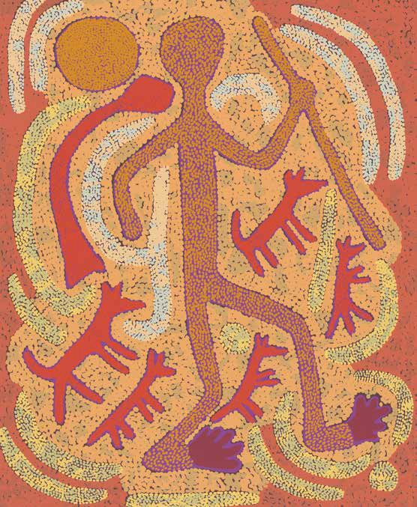


16

2017–18
ANNUAL PERFORMANCE STATEMENT

Introductory Statement

I, Professor Michael McDaniel, on behalf of the AIATSIS Council, the accountable authority of AIATSIS, present the Institute’s 2017–18 Annual Performance Statement.

This statement is presented as required under paragraph 39(1)(a) of the Public Governance, Performance and Accountability Act 2013 (PGPA Act).

The Annual Performance Statement:
- accurately reflects AIATSIS’ performance in the reporting period; and
- complies with subsection 39(2) of the PGPA Act.

Professor Michael McDaniel
Chairperson AIATSIS Council

21 September 2018


Our Performance 17

Our Performance

AIATSIS
PERFORMANCE FRAMEWORK
AIATSIS Portfolio Budget Statements 2017–18
The AIATSIS Portfolio Budget Statement (the PBS) sets out how we intend to expend our annual appropriation.
Approximately $19 million is appropriated by AIATSIS to support its functions as it pursues the strategic goals set out in the AIATSIS Corporate Plan, and deliver the outcome expressed in the PBS.
The PBS sets this single outcome for AIATSIS:
Further understanding of Australian Indigenous cultures, past and present, through undertaking and publishing research, and providing access to print and audiovisual collections.
AIATSIS is organised into three programs to deliver this outcome. The programs are:
Collections;
Research and ethics;
Public programs, publishing, communications and engagement.

AIATSIS Corporate Plan 2017–2021
The AIATSIS Corporate Plan 2017–18 to 2020–21 sets out how AIATSIS intends to achieve its vision and fulfil its mission as outlined on page 4.
The plan outlines the operating environment and key challenges and identifies six strategic priorities, with key outcomes, planned actions (strategies), and performance criteria, measures and targets. These strategies are:
- Ensuring our collections are safe, accessible, valued and growing
- Providing leadership in Indigenous research, and ethical engagement in research, collections and publishing
- Strengthening understanding of Aboriginal and Torres Strait Islander culture and heritage
- Promoting and sharing Aboriginal and Torres Strait Islander heritage by connecting with community and the nation
- Providing advice to the Commonwealth on the situation and status of Aboriginal and Torres Strait Islander culture and heritage.
- Creating strong governance and ensuring a resilient organisation through leadership, innovation and partnership.
Key aspects of AIATSIS’ 2017–18 performance against the PBS performance criteria are summarised and discussed in Our Performance.

18

Summary analysis of 2017–18 performance
To achieve its outcome and purpose, AIATSIS is responsible for three programs:
  - Collections
  - Research and ethics
  - Public programs, publishing, communications and engagement.
Program performance is measured by a number of deliverables and key performance indicators (KPIs) as outlined in the PBS and our Corporate Plan.
AIATSIS’ performance against these targets provides an indication of its success in fulfilling its purpose for the benefit of the Australian community.

Analysis of performance against agency purpose
For 2017–18, AIATSIS performed well against the KPIs identified in the PBS (as detailed in the following performance results). This gives a good indication that AIATSIS has been largely successful in delivering its priorities and planned achievements for the year and, in line with its purpose, has made a significant contribution to furthering understanding of Aboriginal and Torres Strait Islander peoples, both past and present.
AIATSIS’ performance results were achieved in the context of an intensely dynamic operating environment. Important factors affecting AIATSIS’ performance include:

Renewed focus and new opportunities
Recent changes to the Australian Institute of Aboriginal and Torres Strait Islander Studies Act 1989 (Cth) (AIATSIS Act) functions and governance were accompanied by significant additional ongoing resourcing. These factors position AIATSIS to capitalise on its authoritative advisory capability and to grow its expertise and influence.

Increased pressure for preservation and access
There is growing pressure to achieve preservation of the most fragile and vulnerable materials within the collection as well as an increased expectation of digital delivery, discoverability and access to the AIATSIS Collection.

Innovation and a changing research environment
We are exploring initiatives for funding research through research grants, ARC Linkage Projects and the National Collaborative Research Infrastructure strategy.

Technological change
We are responding to opportunities and threats presented by evolving technologies and technical capabilities.

Our Performance 19

Our Performance

  - A growing and active Indigenous academy
We are encouraging, supporting and partnering with growing numbers of Indigenous scholars and researchers.

Active Aboriginal and Torres Strait Islander research enterprise
Indigenous communities, industry and government engage actively with research. AIATSIS collaborates to identify and shape these research priorities and deliver research outcomes to benefit society.

Appetite for information on Aboriginal and Torres Strait Islander peoples, traditions, history and cultural heritage
There is an ever-growing demand in Australia, and internationally, for authoritative content–including calls for a national cultural centre.

Increased resurgence of Aboriginal and Torres Strait Islander culture
There is a growing demand from Aboriginal and Torres Strait Islander communities for control and management of their own materials held within cultural collections.

Indigenous affairs arrangements
Leadership in Indigenous affairs has largely been consolidated in the Prime Minister’s portfolio to ensure that the issues facing Indigenous Australia are shared and acted on centrally and with a focus on educational outcomes for children, economic participation and community safety.

Demand for efficiency
Resource constraints across government are aimed at focusing agencies on providing outcomes at costs that meet community expectations.

A number of significant change initiatives that impacted AIATSIS’ activities or organisational capability in 2017–18, including:
  - strengthening internal communications;
  - enhancing stakeholder confidence;
  - establishing a Business Development and Marketing Unit;
  - rework of the AIATSIS operational model;
  - centralising project management;
  - optimising the workforce; and
  - changes to AIATSIS Shared Services arrangements.

20



Our Performance 21

Our Performance

2017–18

STRATEGIC PRIORITIES
The AIATSIS Corporate Plan 2017–18 to 2020–21 identifies AIATSIS’ six strategic priorities and the associated work program for the four financial years ending 2020–21.
The six strategic priorities are:
    - Ensuring our collections are safe, accessible, valued and growing
    - Providing leadership in Indigenous research, and ethical engagement in research, collections and publishing
    - Strengthening understanding of Aboriginal and Torres Strait Islander culture and heritage
    - Promoting and sharing Aboriginal and Torres Strait Islander heritage by connecting with community and the nation
    - Providing advice to the Commonwealth on the situation and status of Aboriginal and Torres Strait Islander culture and heritage
    - Creating strong governance and ensuring a resilient organisation through leadership, innovation and partnership.
Each of these strategic priorities, their outcomes and activities are illustrated in more detail below. Beyond that follows deeper discussion, stories and analysis.

22

STRATEGIC PRIORITY 1

ENSURING OUR COLLECTION IS SAFE, ACCESSIBLE, VALUED AND GROWING
The AIATSIS Collection contains over one million items, including film and video, photos, audio, art, material culture objects, manuscripts and published materials.
The majority of the collection consists of unique materials—stories, oral histories, language, songs, ceremony and traditions.
Collectively, these materials are invaluable not only to Aboriginal and Torres Strait Islander peoples and communities but also to the national and international community.
AIATSIS will continue to work with Aboriginal and Torres Strait Islander peoples and communities to grow this collection and ensure it is preserved, discoverable, understood, accessible and valued by all.

KEY OUTCOMES OVER FOUR YEARS
- A refocused collection strategy and program aligned with policies and objectives that support improved outcomes for Aboriginal and Torres Strait Islander peoples, including a regional focus.
- Improved online discoverability, access and understanding of our collection.
- Increased scope and representation of Aboriginal and Torres Strait Islander peoples in the collection and increasing the national and international significance and value of the collection.
- Improved physical infrastructure for the storage, management and exhibition of the collection.

Our Performance 23

Our Performance

2017–18 STRATEGIES
Develop and implement a strategy to grow the collection and conduct research to promote the value, significance and understanding of the collection.
The refocused Collection Development Strategy 2017—2021 aligns collection development with AIATSIS’ amended legislative functions. The AIATSIS Council endorsed the new strategy in March 2018.
The strategy’s core principles aim to enable building a collection that:
  - is ethically developed and managed, and where the ethical collecting practices underpin our collection development strategies;
  - is appropriately accessible;
  - recognises Aboriginal and Torres Strait Islander peoples as creators and owners of their own knowledge;
  - encompasses cultural, heritage and historical materials that are created by, as well as with and about, Aboriginal and Torres Strait Islander peoples;
  - is representative of the geographic and linguistic diversity of Aboriginal and Torres Strait Islander peoples; and
  - is focused on the 20th and 21st century experiences and expressions of Aboriginal and Torres Strait Islander peoples.
Staff have carried out a range of activities to promote the Collection. As well as delivering exhibitions, preparing presentations and publications, writing blog posts and preparing for media interviews, staff have done provenance research and prepared significance statements to assist in the assessment of material offered as donations.
Collections staff prepared a content package showcasing twelve highly significant items from the AIATSIS Collection. The selection provides a representative overview of the Collection that communicates its strengths and can be used in a wide variety of ways.
The package was used to produce a collection of twelve postcards, which has been used in Australia and around the world to promote AIATSIS and its Collection.
The Day of Mourning—26th January 1938 online exhibition was refreshed by the curators ahead of the 80th anniversary of the event. The exhibition provides enhanced access to digitised items from the AIATSIS Collection for one of our most frequently visited online resources.
Upgrade and maintain capable digital infrastructure
In 2017–18 AIATSIS initiated a transition from a locally housed and managed data repository to a managed storage offering from AARNet (a National Research and Education Network). Upon completion this will provide highly scalable storage capabilities together with more robust data protection and safety for the digitised collection items.

24

During the course of the year, Collections and ICT staff initiated and migrated the entirety of the open access pictorial collection to a browser-based discovery and display platform. Significant updating of the access and rights conditions was undertaken as a component of the migration, resulting in more uniform and more easily understood rights information.

Develop, implement and maintain a single platform for the discovery of and research into Australian Indigenous languages
Work progressed significantly this year on AIATSIS’ Australian Indigenous languages datasets, Austlang and the Languages & Peoples Thesaurus.
Austlang is the authoritative international resource on Australian Indigenous languages. It contains 1200 detailed records for every reported language variety, including dialects, patrilects and clan-based varieties as well as referenced information such as location, historical and linguistic documentation, surveys of speaker numbers, and documentation scores. Austlang accepts a wide variety of language names and spellings and uses the AIATSIS language codes first developed in 1963 to provide an integrated search experience for users. Austlang is the most comprehensive dataset on the health of Australian languages and is a vital resource for strengthening and reinvigorating language and the design of policy and programs for languages.
This year, the languages team completed phase 1 of the project to develop one platform for language discovery and research. It was achieved through the migration of Austlang to a new purpose-built platform, providing opportunity for linked data both within and outside of AIATSIS and potential for future connection with the AIATSIS Collection.
Ozbib—a curated bibliography about Indigenous Australian languages—was also updated and will be migrated to the platform.

Develop, implement and maintain a digital technology program for the preservation of Indigenous community and organisation archives and knowledge
AIATSIS has continued to support Indigenous community organisations, archives and knowledge throughout 2017–18, including through collaborations with the Wadeye community and the Kimberley Aboriginal Law and Culture Centre (KALACC).
After extended consultation, KALACC and AIATSIS signed a Memorandum of Understanding (MoU) to formalise their commitment to ongoing collaboration between the two organisations. AIATSIS partnered with the University of Melbourne’s Grimwade Centre to support KALACC directly with the digitisation of a considerable amount of the audiovisual material held in KALACC’s collection.
These materials contained highly diverse and unique songs, images and stories donated by communities, Elders and families across the Kimberley region from 1984 to now; and recordings of the KALACC cultural festivals since 1984.

Our Performance 25

Our Performance

Plan, implement and maintain an appropriate physical storage for the expanding collection
Aging vaults and an expanding collection have necessitated the lease of offsite collections storage. Therefore, in 2017–18 AIATSIS completed a collections offsite storage strategy, costed plan and risk assessment and management plan.
A secured, climate-controlled storage facility with custom-built infrastructure was procured. The facility, managed by Grace Records Group / Grace Fine Art, is based in Hume, Australian Capital Territory (ACT).
Approximately 200 items from the Art and Object collection, including oversize paintings previously installed in the Stanner Reading Room, were condition assessed, digitised, catalogued, packed and moved offsite along with seventy linear metres of manuscript materials and audio collection documentation.

26

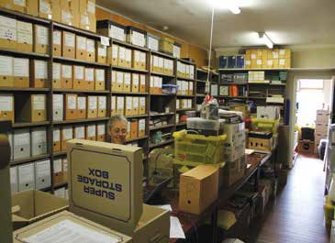
The Pallottines material
In July 2017, AIATSIS received a donation of from the Pallottine Fathers and Brothers. The collection, which has a wide array of materials including photos, film and archival documents, is especially rich in language resources of the peoples of the Kimberley regions of Western Australia. Since 2015 AIATSIS has been working with the Pallottine archive in Rossmoyne, Perth, on preserving and documenting the Aboriginal activities of the mission.
The Pallottine Fathers and Brothers, also known as the Society of the Catholic Apostolate, came to Australia from Europe in 1901 to take over the Trappist missions to the Aboriginal people of Beagle Bay in the Kimberley region of Western Australia. After World War II the Pallottines established a number of schools and hostels for Aboriginal children, mainly from the Kimberley.
A number of the Pallottine priests were scholarly linguists and ethnographers who made great efforts to learn local Kimberley languages. For example, Father McKelson’s papers, which form a large part of this donation, contain versions of the Mass, the so-called ‘Missa Kimberley’, in eight of the local languages—Nyamal, Nyangumarda, Karajarri, Mangala, Yawuru, Walmatjarii, Yulparitja and Mardu. The linguistic material in the donation complements other AIATSIS holdings from priests who were both scholars and educators.

The final stages of packing the Pallottines’ donation, Rossmoyne, Perth July 2017.

Our Performance 27

Our Performance
2017–18 RESULTS:

ACCEPTANCE OF MATERIAL INTO THE AIATSIS COLLECTION (ACCESSIONED)
MEASURE AND TARGET | 2016-17 | 2017-18 | OUTCOME
Printed and published media  –items | 5 960 | 2 706 | –55%
Manuscripts–pages | 18 514 | 222 706 | +1 103%
Audio–hours | 790 | 187 | –76%
Pictorial–items | 21 277 | 18 725 | –12%
Film–feet | 32 100 | 169 707 | +429%
Video–hours  Art objects and artefacts–items  Average % Target for this measure | 437  570 | 643  118 | +47%  –79%  +194% TARGET MET
 | +2% | +1.5%

DIGITAL PRESERVATION OF MATERIAL IN AIATSIS COLLECTIONS
MEASURE AND TARGET | 2016-17 | 2017-18 | OUTCOME
Print–items | * 72 909 | 62 519 | -14%
Audio–hours | 3 251 | 2 340 | -28%
Pictorial–items | 59 826 | 53 892 | -10%
Film–feet | 992 812 | 617 866 | -38%
Video–hours | ** 583 | 1 135 | +95%
Film sound–hours  Art objects and artefacts–items  Average % Target for this measure | ** 240  647 | 299  272 | +24%  -58%  -5% TARGET NOT MET
 | +5% | +5%

* In 2016–17 the 72 909 items included 64 426 manuscript pages (in 2017–18: 61 968 manuscript pages).

28

COLLECTION MADE DISCOVERABLE
MEASURE AND TARGET | 2016-17 | 2017-18 | OUTCOME
Manuscript finding aids–no. | 13 | 14 | +8%
Audio audition sheets–no. | 664 | 179 | –73%
Audio finding aids–no. | 46 | 28 | –39%
Pictorial caption lists–no. | 208 | N/A* | N/A
Moving image audition sheets  –no. | 36 | 34 | –6%
Moving image finding aids–no.  Catalogue records (new and updated)–no.  Average % Target for this measure | 10 | 11 | +10%
 | 7 255 | 4 626 | –36%
 |  |  | –23%
 | +2% | +1.5% | TARGET NOT MET

- Due to the development of a new platform, caption lists are no longer created. Instead, individual captions are assigned to images.

Our Performance 29

Our Performance

COLLECTION ACCESSIBILITY*
MEASURE AND TARGET | 2016-17 | 2017-18 | OUTCOME
Total number of enquiries/ requests received** | 6 214 | 4 061 | -35%
Total number of complex and ROMTIC *** requests completed | 1 660 | 1 263 | -24%
Total items supplied | 8 327 | 9 764 | +17%
Total number of visitors/ clients onsite | 1 097 | 1 113 | +1%
Use item statistics (used in Reading Room) | 5 190 | 3 913 | -25%
Mura® sessions | 59 635 | 62 180 | +4%
Mura® page views | 448 000 | 432 841 | -3%
Unique Mura® users  TOTAL:  Target for this measure | 35 499 | 39 102 | 10%
 |  |  | -7%
 | +10% | +10% | TARGET NOT MET

* Results vary from those published in 2016–17 due to a change in accessibility measurements.
** Includes email, telephone and in person requests—directional, simple and complex.
*** Return of materials to Indigenous Communities

30

ANALYSIS
There was an overall increase in material being accepted into the collection this year, from 79 648 items in 2016–17 to 414,792. When averaged across all formats this represents a real increase of 194 per cent. This increase was driven by the accessioning of several large collections, notably of film and manuscript materials. In most other formats, quantities of material accepted were reduced compared to the previous year. Fluctuations in result across the various media year on year reflects the diversity of materials that are offered to AIATSIS and the responsiveness of AIATSIS staff to opportunities that arise to grow the collection in line with the Collection Development Strategy.
Over the last four years the AIATSIS collection has grown across all formats, with an average growth of between 2 per cent and 5 per cent across the 18 major collection categories. Large acquisitions such as the ATSIC video collection added significantly to some categories. In spite of this continued growth there has been a satisfying increase in the total percentage of the collection material digitised over the four years. For example, our pictorial collection grew 6.5 per cent in size, but we have still managed to digitise 52.8 per cent of the total format. In that time, a new stream of activity was established, digitising artworks and material culture objects. After only three years 17 per cent of a 6,093 item collection had been digitised as at June 2018.
The digitisation of our unique audio collection, has now reached 83 per cent of the total holdings. Our audio collection contains the only remaining recordings of many Indigenous languages. Our motion picture collection also achieved significant milestones by completing the digitisation of 23.8 per cent of our 6.7 million feet of irreplaceable footage, at the same time as growing the collection by 9.5 per cent. Disruptions in our digital preservation effort this year meant that, overall, our target for preservation of the collection was not met. This was caused by a combination of factors, including the project to replace our aging digital storage, and a reduction in outsourced digitisation. The result this year is also impacted by a focus on the digitisation of ageing, fragile audio and video material, which requires more time consuming treatments. As a result, there has been a 95 per cent increase in the hours of video digitised. There has also been an increase in the number of specialised digitisation requests to support exhibition and publication projects. This resulted in a decline (-5 per cent) in the average of digitisation volume across formats.

Our Performance 31

The years’ results show an overall reduction in the production of the catalogue records, finding aids, audition sheets and caption lists which make the collection discoverable, though there were slight increases (8 and 10 per cent respectively) for the production of manuscript and moving image finding aids. Reduced staffing across the program, along with attendant decisions to redirect activity, was the major reason for the downturn. One area that did see an increase was the Art and Object collection, for which 779 item level records, and 137 collection level records were created in preparation for release of the catalogue records onto a publicly available platform later in 2018. For the first time there will an ability to search the records of the Art and Object collection, a major achievement. There will also be over 440 licensed images of items of these works available online. A redirection of effort was needed to complete the implementation of this new platform for both this collection and the photograph database. This new platform will have a long–term positive impact on discoverability of the collection (see story on page 60). The ability to add searchable captions to each photograph in the collection, instead of making standalone caption lists, is one example of this impact. The platform also makes it easy for community members and other knowledge holders to add or correct the captions.
There was a reduction in the overall rate at which the collection is accessed this year. However, key indicators, including number of items supplied, visitor numbers, and access to the online catalogue, Mura©, all show an increase. Refurbishments were completed in the Stanner Reading Room and audio-visual access rooms to enhance both safety of the collection and the visitor experience. Despite limited on-site access to the collection and Reading Room during construction, overall visitor numbers show a 10 per cent increase from the previous year, although in house use of items was adversely impacted. Online use of the catalogue continues to be strong, with an increase in the number of unique users up to just over 39 000 from almost 35 500 the year before.

32

Significant Additions to the Collection 2017–18

Art and Object
Munggurrawuy Yunupingu bark painting
In 2017–18 AIATSIS purchased an important eastern Arnhem Land bark painting by Munggurrawuy Yunupingu dating from the early 1960s. The bark was owned by the donor’s grandfather, the then Lord Mayor of Sydney, Henry (Harry) Frederick Jensen, and has never been on public display.
The Art and Object collection has particular strengths in late 20th century works and works in contemporary materials. Recent acquisitions of artworks by contemporary Aboriginal and Torres Strait Islander artists continue to build upon the strength of the collection.
This year AIATSIS acquired artworks by leading and emerging artists working across the country. Highlights include new works by Maree Clarke (born 1961, Mutti Mutti / Yorta Yorta and Boon Murrung peoples) and Vicki West (born 1960, Trawlwoolway people). For over three decades, Clarke and West have engaged in the continuation and transformation of traditional practices in Victoria and Tasmania, respectively.
In April, AIATSIS acquired one of Clarke’s kangaroo tooth and claw necklaces. This major work was also exhibited in the 2017 National Indigenous Art Triennial Defying Empire—a showcase of contemporary Indigenous practices at the National Gallery of Australia.
West was also featured in Defying Empire with her contemporary sculptures made using kelp. In Tasmania, kelp is best known as a material for water carriers. In West’s contemporary application, kelp is transformed into sculptures such as Armour (2018), which is now an important part of the AIATSIS Art and Object collection.

Maree Clarke (born 1961, Mutti Mutti/Yorta Yorta and Boon Murrung peoples), Kangaroo Tooth Necklace with Kangaroo Toe, 2017, AIATSIS Collection
[AO AIAS285_003]

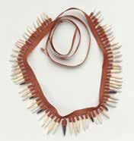

Our Performance 33

Our Performance

Works by emerging and mid-career artists Daniel O’Shane (born 1990, Kuku Yalanji, Miriam Mer and Kulkagal peoples) and Jason Wing (born 1978, Biripi people) were also acquired. O’Shane and Wing both exhibited at the 2017 Sydney Contemporary Art Fair— one of Australia’s leading contemporary art events.
O’Shane is a young artist based in Cairns. He uses vinyl cut printing to create works such as Ii ra mer ene Gawei (The Sound of Tears and Awei) (2016). This large-scale print showcases O’Shane’s incredible carving skills in depicting how the pelican mouth shape drum design came to be in the Torres Strait.
Wing’s Battle Ground (2017) is a shield made from corten steel oxidised in the waters of Sydney Harbour. The shield’s materials are drawn from the earth, referencing the country where Wing lives and works. However, the horizontal gold lines sprayed onto the shield’s surface recall European methods of demarcating boundaries and present-day surveyor’s marks.
Wing’s transformation of an ancient practice creates a powerful statement about country today.
These artworks continue to enhance the AIATSIS Art and Object collection as a reflection of the diversity of Aboriginal and Torres Strait Islander cultural expression and its continuity and transformation.

Vicki West (born 1960, Trawlwoolway people), Armour, 2018, kelp and waxed thread, 32 x 30 x 27 cm (irregular, largest dimensions), AIATSIS Collection [AO AIAS285_001]

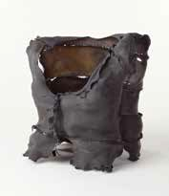

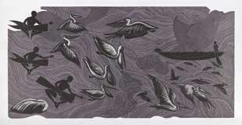
Jason Wing (born 1978, Biripi people) Battle Ground (gold edition), 2017, oxidized steel with metallic paint, 120 x 40 x 8 cm (irregular, largest dimensions), AIATSIS Collection [AIAS092_001]

Daniel O’Shane (born 1990, Kuku Yalanji, Miriam Mer and Kulkagal peoples), Ii ra mer ene Gawaii, 2016, vinylcut print on paper, 115.5 x 215.5 cm, AIATSIS Collection [AIAS093_001]

34

Print and Manuscripts
Papers of Beulah Lowe
In 2017–18 Stephen Wearing donated the papers of Beulah Lowe—a missionary linguist who worked in Arnhem Land from the 1950s. The materials included diaries, papers and books used in the creation of bilingual texts and teaching resources of Yolngu dialects.
Language materials
Highlights among the language materials accepted into the collection include a comprehensive grammar of Wanyjirra—a Ngumpin-Yapa language from Northern Territory—and a collection of songs performed by singers in Arrarnte, Anmatyerr, Alyawarr and Kaytetye.
Barrie Pittock—personal papers
Barrie Pittock, who has had a long involvement in Indigenous activism, donated a part of his personal papers to AIATSIS. The donation is significant, as it provides a unique perspective of Indigenous activism and chronicles aspects of the life of a prominent activist.

Audio recordings
The Lowitja Institute’s Cooperative Research Centre for Aboriginal and Torres Strait Islander Health Research—History Project
Raw audio and moving image materials were received from the History Project of the Lowitja Institute’s Cooperative Research Centre for Aboriginal and Torres Strait Islander Health Research. These materials are interviews conducted by AIATSIS Research Fellows documenting the history of the Lowitja Institute and its predecessors and their contribution to Aboriginal and Torres Strait Islander health research. This material was made available following Lowitja Institutes’ release of the accompanying publication.

Photographic images
National Aboriginal Council
Some 2000 photographs from the National Aboriginal Council (NAC) were added to the collection. The photographs document activities that the NAC has undertaken, including visits to remote outstations documenting Indigenous living conditions and attendance at various protests in capital cities around Australia. Of particular note are the series of images depicting protest scenes from the 1982 Brisbane Commonwealth Games.

Film and video
Jeff Doring collection
Video items from the Jeff Doring collection were accessioned into the Print and Manuscripts collection. In total, the Jeff Doring collection comprises two film items and 388 video items relating to the Pathways Project, which portrays information on the complex art, law and society of the Ngarinyin/Ungarinyin people.

Our Performance 35



36

STRATEGIC PRIORITY 2

PROVIDING LEADERSHIP IN INDIGENOUS RESEARCH AND ETHICAL ENGAGEMENT IN RESEARCH, COLLECTIONS AND PUBLISHING
For twenty years AIATSIS has provided national and international guidance in the ethical practice of research concerning Indigenous peoples.
AIATSIS continues its commitment to improving the standards of research engagement to realise the benefits that research can offer Aboriginal and Torres Strait Islander peoples.
AIATSIS leading in ethical practice in research, publishing and in creating, interpreting, maintaining and using collections of Indigenous knowledge and cultural heritage.
AIATSIS has further developed our international role by linking institutions, nations, researchers and Indigenous peoples. These linkages share practice and understanding, and enable exchange and mobility.
AIATSIS continues to encourage collaborative development, use of Indigenous knowledge and engagement with Indigenous peoples.

KEY OUTCOMES OVER FOUR YEARS
  - AIATSIS is recognised as a centre of excellence in Indigenous research and collection practices across a broad disciplinary and interdisciplinary spectrum.
  - AIATSIS’ advice and training in ethical research, collections and publishing practice is sought out and recognised.
  - Analysis of the gaps in the Aboriginal and Torres Strait Islander evidence and knowledge base and of the state of Indigenous research.
  - Revised Guidelines for Ethical Research in Australian Indigenous Studies (GERAIS), and toolkit(s) adopted by Australian Universities.
  - A fully developed suite of resources in cultural learning and competency.

Our Performance 37

Our Performance

2017–18 STRATEGIES
Continue to implement best practice and tools for assessing research impact and engagement
Consistent with the National Innovation and Science Agenda, AIATSIS is carrying out assessments of impact and engagement on current and completed projects, utilising and further refining the AIATSIS impact evaluation methodologies. AIATSIS continued to contribute to Commonwealth coordination of impact and engagement activities through participation in the Publicly Funded Research Agencies impact working group.
The Indigenous Culture and Heritage research team has conducted several impact assessment surveys and qualitative interviews with project partners. These activities reveal the personal, community and cultural impacts of AIATSIS research. The outcomes can be compared and contrasted with the ‘planned’ or anticipated impacts identified in project proposals.

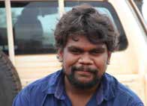
Sharing Success, Measuring Impact project
Assessing research impact is a critical element of AIATSIS’ aspirations to collaborate with Aboriginal and Torres Strait Islander partners and create meaningful change within communities as well as an impact on society more generally. However, a method for defining and assessing impact has not been clearly articulated, and there is no established methodology for assessing the unique research that AIATSIS carries out.
Throughout the course of the Preserve, Strengthen and Renew in Communities project, project partners commented on the positive outcomes that they had experienced as a result of the project. Through impact evaluations we can gather this information and use it to improve our practice and work with communities to articulate what is significant to them.
Following the development of a detailed annotated bibliography of impact assessment tools, we established an appropriate methodology that would capture these qualitative responses detailing the impacts for individuals and communities of AIATSIS research projects.
In an impact assessment interview, Wynston commented:

‘For me personally, it, in a way, taught me to strengthen my culture and bring my culture back alive. So it’s a highlight for me, just being part of working with AIATSIS and reviving my culture.’ Wynston Shovellor, Karajarri Ranger
This project provides a way in which to demonstrate the value of research that is qualitative in nature and deals with intangible, yet important, impacts for individuals and communities.

Wynston Shovellor during impact assessment interview on Karajarri country.

38

Provide advice to government on Indigenous research priorities

AIATSIS native title priorities 2018–21
In early 2018, AIATSIS was successful in obtaining a further three-year grant from the Department of the Prime Minister and Cabinet (PM&C) for continuation of our research projects and activities that support the native title sector. This extends the funding partnership with the Commonwealth over more than twenty-five years and recognises the important contribution that AIATSIS has made, and continues to make, to improving the outcomes from the native title system for Aboriginal and Torres Strait islander peoples.
After consultation and collaboration with the native title sector about their priorities and challenges, the new three-year plan includes existing services and new research projects in the areas of:
  - surveying and mapping the native title sector
  - regional representation and economic development
  - youth and succession in native title
  - native title compensation.

AIATSIS proposal for a national languages strategy
In response to growing community need, AIATSIS drafted a Languages Strategy to guide our own research investment in language revitalisation over the next three years. The strategy is based on previous research about the needs of the sector (including the Ernst & Young review in 2015), current stakeholder demands and the experience of AIATSIS staff with a background in language work. Three ambitious goals were identified:
- Every Australian language is documented.
This goal seeks to ensure that every language is as well documented as possible as a knowledge basis to support language maintenance, revival and learning for current and future generations.
- Every language community has the capability to strengthen their language.
It is crucial for communities to have control over their own language, to be deeply involved in any work on/with their language and to have authority over materials collected. This requires access to expertise to support their aspirations, preferably within their own community, and the opportunity to develop their capability.
- Every Australian has the opportunity to learn and take pride in an Australian language.
This goal encompasses the full range of learning of Australian languages: in schools, by natural acquisition, or by other means. It also presupposes community control over languages such that they will not be taught or disseminated without community approval and deep engagement.
At the national Languages Convention in November 2017, AIATSIS proposed these goals as a basis for the development of a National Indigenous Languages Strategy to drive the development of the national infrastructure to support Indigenous languages.

Our Performance 39

Our Performance

Review GERAIS to support a broad disciplinary and interdisciplinary research base
AIATSIS has a legislated mandate to provide a leadership role in Aboriginal and Torres Strait Islander research ethics. For twenty years, AIATSIS has provided guidance on ethical practice in Aboriginal and Torres Strait Islander research. As part of this commitment, AIATSIS is undertaking a review of the AIATSIS GERAIS to ensure that it remain at the forefront of ethical research practice.
GERAIS supports a critical form of practice that ensures that research is done, policy is made and information is gathered in a way that supports the rights of Indigenous peoples to control and maintain their culture and heritage.
A public call for feedback and submissions was made in June 2018. This will be followed by targeted consultation with universities, human research ethics committees and topical experts. The revised guidelines will inform the current and future ethics services and products that bolster, AIATSIS standard setting in this area. The guidelines are expected to be released in early 2019.

Increase take-up, training, resources, external clearance, best practice advice and forums to support the Guidelines for Ethical Research and the ethical publishing guidelines.
During this year AIATSIS completed a comprehensive review of the AIATSIS ethics program, including our leadership role, ethics assessment services, training and resources. The team established a new system for management of clearances by the AIATSIS Research Ethics Committee; and new procedures that will be fully implemented next financial year, including a review of the pricing structure.
To promote best practice, AIATSIS made a public submission to the National Health and Medical Research Council (NHRMC) review of the National statement on human research ethics, Section 4, ‘Ethical considerations specific to participants’, and met with NHMRC to discuss strengthening references to ethical requirements in the national statement. This was reflected in revisions to Section-3 of the national statement. In addition, the Australian Research Council (ARC) Funding Guidelines have been revised to strengthen requirements for compliance with AIATSIS guidelines.
AIATSIS is responding to the need for training in other human research ethics committees (HRECs) and universities around the country on the best practices for Aboriginal and Torres Strait Islander research. This year AIATSIS engaged with four new institutions across academic, private and public sectors to establish agreements, training and advice regarding ethics.
AIATSIS has entered into a partnership with PM&C to provide advice and training for evaluations conducted under the Indigenous Advancement Scheme Evaluation Framework. The partnership will foster stronger ethical practice in evaluation methodologies—in particular, leading to greater partnership with and involvement of Indigenous organisations and communities in evaluations of their programs. The PM&C partnership will also examine ways to reduce duplication in ethics clearance processes and greater compliance with AIATSIS ethics guidelines.
We exceeded our performance target with an exponential increase in downloads of website materials and external applications to our Research Ethics Committee. For more information, see page 43.

40

Develop a curriculum for cultural competency in Indigenous public policy (in partnership with Sydney University)
AIATSIS’ continuing partnership with the University of Sydney has a current focus on cultural competency. Joint activities that have been undertaken include seminars and international guest visits, including a joint seminar by international cultural competency expert Tawara Goode. The
project to develop a curriculum for cultural competency will be initiated in 2018–19.

Develop training materials and curriculum for ethical publishing
AIATSIS ran a successful webinar pilot program for the curriculum for ethical publishing in 2016–17. This project will be revisited in 2018–19 with a view to developing online training for publishers.
AIATSIS continued to provide personalised, ad hoc advice to publishers and editors.

Providing advice and guidance on culturally sensitive and appropriate Indigenous collection management and access
As part of the Preserve, Strengthen and Renew in Communities project, AIATSIS works with communities to return materials held in the AIATSIS archive and seeks advice on appropriate care and management of this material. Recently, Karajarri cultural advisors worked with an orphan collection to determine the conditions for future access.
AIATSIS also supports national conversation on collections access and management. In 2017–18 it coordinated the Digitised and Digital Indigenous Collections seminar. Dr Ricardo Punzalan, from the University of Maryland, discussed his research on assessing the value and impact of institutions’ digitisation programs; Kirsten Thorpe, University of Technology Sydney, spoke about designing Indigenous digitisation and digital projects for impact; and Dr Shannon Faulkhead spoke about how digitisation and digital files in the Monash Country Lines Archive support an Indigenous community as an archive of cultural knowledge. The seminar created a forum in which to explore complex political and cultural issues that management and access to Indigenous collections raise, especially where many Indigenous communities have been concurrently creating their own archives drawing on digitised and digital sources.

Our Performance 41

Our Performance

Increase international engagement
Two-way learning is a central component of how AIATSIS conducts its business. AIATSIS expertise in the fields of Indigenous knowledge protection, collection management, native title law and policy and community governance has been sought by other government agencies to build Australia’s international contribution.
In November 2017, AIATSIS signed an MoU with the Smithsonian’s National Museum of the American Indian which sets out terms for a consultative and planning process across research and operations between the institutions. The agreement will collaborate on areas of mutual interest and concern, which allows for the two organisations to learn from each other’s strengths and expertise and to build capability.
In April 2018, we hosted Associate Professor Tawara Goode, (National Centre for Cultural Competency, Georgetown University), as part of the AIATSIS Seminar Series. The seminar delineated a cultural competence framework within the contexts of academia and public services and lessons learned on how to move from theory to implementation.
AIATSIS formalised agreements with Oxford University and King’s College London. The two individual MoU’s outline agreements to collaborate in fields including Aboriginal and Torres Strait Islander collection management, cultural protocols, academic research and staff exchanges.
CEO, Craig Ritchie gave a presentation at Australia House in London on ‘Being Australian: the Work of AIATSIS and Our National Story’ highlighting the importance of our role advising government on the state of Indigenous culture and heritage.
More recently AIATSIS was approached to share its native title expertise with the Myanmar Advancing Life and Regenerating Mother Land (ALARM). ALARM supports research in partnership with ethnic and Indigenous communities on the legal recognition of customary land tenures.
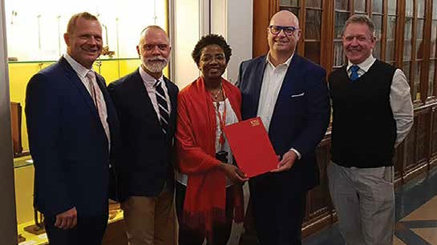
AIATSIS CEO, Craig Ritchie, and AIATSIS Chairperson, Professor Michael McDaniel, with Professor Shaun Ewen (Poche Centre Melbourne), Dr Ian Anderson (Director, Kenzie Centre for Australian Studies) and Professor Funmi Olonisalin Vice Principal International, Kings College, London.

42

2017–18 RESULTS

REACH AND TAKE-UP OF STANDARDS AND GUIDANCE OUTSIDE OF AIATSIS
MEASURE AND TARGET | 2016–17 | 2017–18 | OUTCOME
Reach and take up of best practice in research–approvals | 16 | 25 | +156%
Target for this measure | +100% | +100% | TARGET EXCEEDED
Guidelines for Ethical Research in Australian Indigenous Studies (GERAIS)–downloads | 4 604 | 12 546 | +272%
Collections access and use policy–downloads | 280 | 1 350 | +482%
Ethical publishing guidelines  –downloads | 242 | 1 292 | +534%
Target for this measure | +50% | +50% | TARGET EXCEEDED

ANALYSIS
AIATSIS’ leadership and standard setting in ethical practice across the areas of research, publishing, collecting and access has continued to grow exponentially. Already ambitious performance targets of a 50 per cent increase across all indicators of reach and take-up of standards and guidance (outside of AIATSIS) were vastly exceeded. Some indicators saw an increase of 400 and 500 per cent from the previous year, while the average increase across all indicators was 361 per cent. In contrast, 2016–17 figures showed only a modest increase in some indicators from 2015–16.
This year’s results reflect increasing demand for our publications and resources to support ethical engagement with Indigenous communities and organisations and an increasing awareness of the leadership role AIATSIS plays in setting ethical standards as well as the trust and respect for AIATSIS guidance and advice in this area.
In response to this demand AIATSIS initiated a public review of GERAIS to ensure that we remain at the forefront of ethical research practices. Organisationally, we also conducted an internal review of the business model for our ethics leadership and services to ensure we are meeting the needs of the sector efficiently and effectively.
AIATSIS currently has no performance indicators for international engagement. However, AIATSIS staff gave eight international lectures, hosted three international guest speakers and welcomed three international delegations to tour AIATSIS. The number of international partnership agreements increased from one to three.

Our Performance 43

Our Performance

AIATSIS Collection Highlight: Film
The Australian Institute of Aboriginal Studies (AIAS) Film Unit operated from 1961 to 1991. Footage that the unit produced represents one of the largest assemblies of ethnographic films created in the world within that time.
During 2017–18, footage related to the AIAS Film Unit was promoted and developed in a number of ways.

Rhys Jones, Barry Blain and Eric Stadler undertaking archaeological investigations in south West Tasmania, from Tasmanian Film Project (1984), AIATSIS Collection
Tasmanian Film Project (1988)
Moving image collection management auditioned footage from the Tasmanian Film Project (1988)— film about archaeological investigations in southwest Tasmania. The unfinished film sought to document not only these archaeological investigations and their findings but also the shifting dynamics emerging between archaeologists and Aboriginal people within the context of the Franklin Dam controversy in Tasmania. Footage from this collection presented at the annual Australian Archaeological Association conference in Melbourne received a positive response, and an article based on this footage is due to be published in the journal Australian Archaeology in the near future.

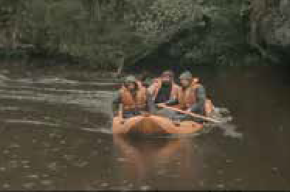

44

Make it right! (1988)
Previously unseen rushes from the last film produced and released by the Film Unit—Make It Right! (1988), a documentary about the 1988 Barunga Sport and Cultural Festival where the Barunga Statement was painted and handed over to then Prime Minister Bob Hawke—were auditioned this year. The film became a centrepiece to an exhibition undertaken in collaboration with Parliament House for the 30th anniversary of the Barunga Statement. There was a lack of available photographs of this event, so stills from the film were used throughout the physical exhibition at Parliament House and the exhibition’s online component. For more information about the Barunga Statement, see page 96.

AIAS / AIATSIS collection name project
Catalogue records for 372 records of footage produced by the AIAS Film Unit (1964–1988) and AIATSIS (1988 to present) were successfully upgraded with new collection names to reflect the distinct phases of filmmaking that AIAS undertook. We now have new, standardised collection names for footage related to the first phase of the Film Unit (1964–1973), footage related to films for general release produced during the second phase of the Film Unit (1974–1988) and footage produced following AIAS’ closure (post-1988). Footage from this period coincided with the time that AIAS became known as AIATSIS. The new collection names allow us to easily find and manage footage held from these significant distinct filmmaking periods.

Painting of Barunga Statement film still, from Make It Right!, 1988, Australian Institute of Aboriginal Studies with Northern and Central Land Councils, AIATSIS Collection, courtesy of Ronin Films.



Our Performance 45

Our Performance

Improving discoverability and uses of the Olive Pink collection

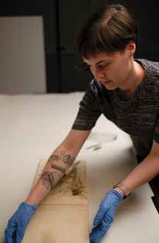
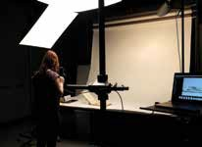
This year AIATSIS invested a significant collaborative effort in re-describing, rehousing, revising the access regime for and digitising the multi-format Olive Pink collection. The project involved the Print and Manuscripts team, the Print Digitisation team, the Conservator, the Rights Manager, the Director Collection Development and Management, and the Executive Director Collections.
Olive Muriel Pink (1884–1975) was an artist, anthropologist, Aboriginal rights activist and gardener. She is still well remembered in Central Australia as a feisty woman dedicated to her Aboriginal friends. A determined advocate, she proposed ideas that were precursors to Aboriginal people’s contemporary aspirations—for example, the outstation movement and self-determination. Ms Pink trained as an artist. She then completed some university courses in anthropology, and through this study she came to see anthropology as a means of advancing the cause of Aboriginal people and through which land, mining and civil rights might be secured. She conducted research with the Eastern Arrernte and the Warlpiri, recording language and information about male rituals.
Her respect for the secrecy of the rituals she described meant that her data was sequestered for fifty years—a decision that did not endear her to her academic peers. Her lack of complete qualifications and the difficulties for a woman working in the then male-dominated field of anthropology also created obstacles to her achievements. Eventually, the harsh Central Australian climate prevented her and the Warlpiri from achieving the permanent establishment of a ‘sanctuary’ from which police, government and missionaries could be excluded.

46

Studio session with Emily Hanlon capturing the ethnobotanical specimens

Amelia O’Donnell assisting with the studio processing of the ethnobotanical specimens from the Olive Pink Collection during her Conservation work experience at AIATSIS

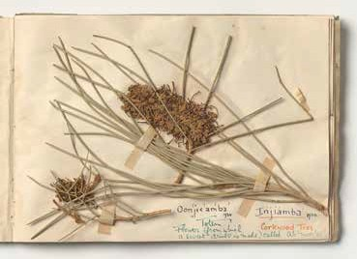

The collection comprises nineteen boxes of material, including botanical specimens. This year the Print and Manuscript team redescribed the collection in a new finding aid of fifty-two pages. In digitising it, the Print Digitisation team created 15 238 digital preservation assets. They developed solutions for capturing complex, large-format objects, continuously reviewed and updated technical capture standards, and defined their best-practice applications. The Registry files relating to administration of this collection were read closely and a proposal for lifting the access restrictions was developed. After the Rights Manager had reviewed the proposal, it was approved by the Executive Director Collections.
This collection is complemented by Ms Pink’s rarely seen Arrernte and Warlpiri artefact collection, currently held at the National Museum of Australia (NMA). On completion of digitisation, the Print and Manuscript team met with an NMA curator, and the groundwork was laid for potential collaboration on a joint exhibition. If a decision is made to pursue this opportunity, this use of the collection will have been made possible only through this initiative.
As a case study, this project exemplifies cross-unit collaboration: the development of best practice and the achievement of continuous improvement in workflow, products and access. Outcomes of the project are much improved discoverability of the collection and expanded potential uses for it. Ms Pink’s commitment, her achievements, and the life and culture of her Warlpiri and Arrernte friends deserve this exposure.

Page from book of botanical specimens featuring a pressed corkwood flower and the Arrente name for its nectar (modern spelling: untyeyampe), Papers of Olive Muriel Pink. Photographer: Emily Hanlon.

Our Performance 47

Our Performance



48

STRATEGIC PRIORITY 3

STRENGTHENING INSTITUTIONAL AND COMMUNITY UNDERSTANDING OF ABORIGINAL AND TORRES STRAIT ISLANDER CULTURE AND HERITAGE
AIATSIS builds partnerships across the full spectrum of government, industry, academic and community stakeholders. We provide policy insights, leadership and advice to enhance understanding of Indigenous people’s culture and heritage, including policy development and program delivery. Through us, institutions and the community better understand:
  - native title economies
  - Indigenous languages and knowledge systems
  - the importance of family history and cultural determinants of wellbeing
  - Indigenous collections, knowledge and information management.

KEY OUTCOMES OVER FOUR YEARS
  - National research priorities aligned to key Aboriginal and Torres Strait Islander policy areas with a focus on translating research into practice.
  - AIATSIS is recognised by Indigenous peoples and governments as a centre of excellence in Indigenous policy, bringing together policymaking and academic expertise in areas of importance to Indigenous peoples’ culture and heritage.
  - Regular publication of unique and thought-provoking content that articulates and applies Aboriginal and Torres Strait Islander peoples’ knowledge, histories and cultures.
  - Program of appropriate repatriation of existing collections and new collections focused on broader areas of Indigenous knowledge.

Our Performance 49

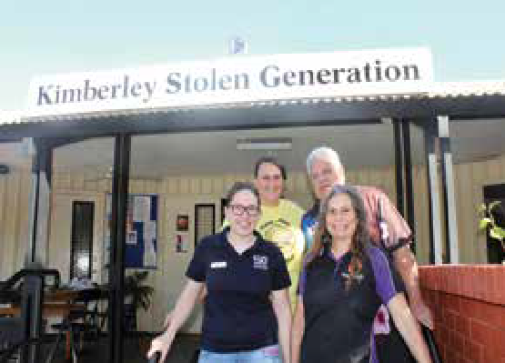
Our Performance

Making connections in the Kimberley
This year the Family History Unit attended the 2018 National Native Title Conference, held in Broome. With the Collection Access Unit, the Family History Unit hosted a stall to assist conference attendees with accessing AIATSIS Collection items and to learn more about their family history. While in Broome, Family History Unit staff were able to meet with staff from Kimberley Stolen Generation Aboriginal Corporation (KSG) to provide an update on the services the unit provides. The team at KSG was very impressed by the pictorial database and got the word out to the community—including those visiting Broome—to ensure as many people headed to the AIATSIS stall as possible.
The Family History Unit team was invited back to KSG to speak to a group of Elders about the services provided by AIATSIS. Sherilyn Dean, who has connections to the Broome area, spoke to the seven Elders who were doing an activity painting healing stones. She was able to find family connections with some of the participants while providing an overview of the family history support services offered at AIATSIS. Participants were interested in how the Family History Unit can support their family history research journeys, and three of the Elders later visited the NNTC stall.
The Family History Unit staff was able to support the Elders by assisting them to search the pictorial database and view family history books and information on display. Imagine the delight when they found photos of family members in the database! Three of the Elders then asked for assistance to find out more and the team will be undertaking research on their behalf. The team values the opportunity to get out to communities and provide personalised, face-to-face support. For Sherilyn this was a special opportunity to provide support to community members close to home.

Visiting Kimberley Stolen Generation: Liz Koschel, Sherilyn Dean (FHU) and James Feehan, Paula Ellis (KSG)

50

Strong community engagement in research
In early 2017, the Victorian organisation Taungurung Clans Aboriginal Corporation invited AIATSIS, along with other Victorian organisations and the Victorian Government, to participate in a project-scoping meeting in Melbourne. The purpose of the meeting was to provide some advice to Taungurung Clans about how they might address two issues they were experiencing as a traditional owner corporation:
  - how to re-engage family groups with the corporation
  - how to develop a decision-making guide or materials for use by Taungurung Clans officers and members.
From this initial meeting, the Taungurung Clans engagement and decision-making partnership and research project was born. Taungurung selected AIATSIS and Right People for Country, Aboriginal Victoria, to work with them in designing the project, identifying and applying for funding, conducting family meetings and producing project materials.
After a research partnership agreement was developed and ethics approvals were obtained, AIATSIS, Right People for Country and Taungurung Clans held a planning workshop and then a series of facilitated family meetings to answer the following questions:
- Why were they not involved in land justice and the corporation?
- What would help them to become involved?
- What could they offer the corporation?
After a series of confidential and closed family meetings in Victoria during late 2017 and early 2018, AIATSIS prepared a series of closed family reports and a larger engagement report, which Taungurung Clans Aboriginal Corporation is using to design an implementation plan for the findings of the report.
Additionally, AIATSIS collected and collated information on Taungurung decision-making and has worked with members of the Taungurung Clans board of directors to produce the Taungurung decision-making guide—an information pack and series of lift-outs that can be used by any prescribed body corporate (PBC) or Indigenous corporation that is also addressing challenges in decision-making and meetings.
This short project is an example of the practical and relevant post-determination native title research that can be done by working closely with communities—from determining the initial issues or priorities that will be the focus of the research through the project design and to the production of project resources and communication of results and translation for use by others.
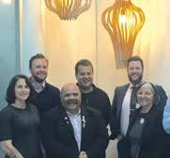
The aim, process and results of the project were shared with other Aboriginal and Torres Strait Islander corporations through a presentation at the 2018 National Native Title Conference The presentation, entitled ‘Strengthening Family Engagement and Decision Making in Traditional Owner Corporations’, is available on the AIATSIS website.

Photo: Belinda Burbidge and Toni Bauman (AIATSIS) with Matt Burns (CEO), Stephen Walsh (Director), Grant Hansen (Chair), Marcus Stewart (Ex CEO) and Chris Marshall (Manager), Taungurung Clans Aboriginal Corporation.

Our Performance 51

Our Performance

2017–18 STRATEGIES
Develop and implement the Research and Reporting Framework to determine the current state of Indigenous cultural heritage (both tangible and intangible), including relationships and indicators of change over time
This year AIATSIS initiated a project to identify existing mechanisms in place for the recognition and representation of intangible Indigenous cultural heritage, including:
  - the scope of different conceptions of heritage (with a focus on how heritage is conceived from an Indigenous perspective)
  - representations of heritage (map points, threatened species, environmental health etc.)
  - assessment of the relative value and merits of each approach based on Indigenous priorities for cultural heritage protection.
This work has been carried out in parallel to the international review of the Convention on Biological Diversity, which is seeking ways to integrate provisions related to Indigenous peoples and communities. A scoping paper, entitled (Re)defining Indigenous intangible cultural heritage, published in 2018, highlighted some of these issues.
In 2018–19 AIATSIS will engage stakeholders in determining the final design of a framework for reporting on the state of Indigenous culture and heritage, including government performance and community action.
Report and provide advice on the state of Indigenous culture and heritage
For Aboriginal and Torres Strait Islander peoples, culture and heritage is central to life and to wellbeing. It is also a key part of Australia’s heritage, yet many aspects are seriously endangered. AIATSIS works with Indigenous communities to maintain an understanding of the state of their culture and heritage and to assist them to identify pathways for the strengthening and resurgence in the enjoyment and transmission of culture and identity.
Language is central to culture. AIATSIS is working to support language maintenance and revival in a number of locations across Australia and promoting awareness of and interest in supporting language use and revitalisation. The National Indigenous Languages Report is a key element of the AIATSIS reporting framework. It is discussed below.

52

Report on the state of Indigenous research as represented in Excellence in Research Australia data 2006–2013
The project proposal for this project has been completed and accepted. Work on the project will begin in 2018–19.

Conduct external and internal evaluation of AIATSIS research impact and engagement
Sharing Success, Measuring Impact is an ongoing project to develop methodologies for assessing the impact of research undertaken with Aboriginal and Torres Strait Islander peoples and communities. Internal impact assessments have been carried out for the Preserve, Strengthen and Renew in Communities projects, the Singing the Train project and the Ngunnawal Language Revival project.

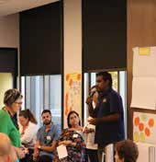
Talking about research: connecting cultural institutions to communities
In March 2018, AIATSIS coordinated a workshop with policymakers, national cultural and collecting institutions, researchers and our community partners from the Preserve, Strengthen and Renew in Communities project to discuss how national processes can better connect with community needs and priorities in accessing and protecting cultural information and knowledge. The workshop was a valuable opportunity to connect conversations between communities, regions and national institutions, and it identified a number of key research gaps in community access and archiving.
The report from the workshop, entitled Preserve, strengthen and renew in community: workshop report, is available on the AIATSIS website.

Wynston Shovellor at the Preserve, Strengthen and Renew in Communities workshop in Canberra, March 2018.

Our Performance 53

Our Performance

Papers of Alick and Merle Jackomos: glimpsing a life of activism
The Papers of Alick and Merle Jackomos (MS 5113) fills out the picture of a couple who had a decades-long public profile in Victorian Aboriginal communities. The papers were deposited by their daughter Esmai in 2016; arrangement and description were completed this year.
Merle Morgan, a Yorta Yorta woman, was born on Cummeragunja Aboriginal Station in New South Wales. She left the station when she was sixteen to work as a domestic in northern Victoria for several years, after which she moved to Melbourne, where she met Alick Jackomos.
Alick was born in North Carlton, the son of Greek parents. He grew up in a succession of inner-city suburbs, many of them places where Aboriginal people also lived. He suffered racial abuse due to his appearance and social stigma because of his heritage. This, the friends he made as a boy with Aboriginal children, his enlistment in the Second World War and employment in the boxing tents, which also provided employment to Aboriginal men, contributed to his establishment as an integral member of Aboriginal campaigning organisations and to his acceptance into Aboriginal communities.
Merle and Alick were married in 1951. They had three children and were an inseparable team, as parents and as campaigners, until Alick’s death in 1999. Their involvements spanned fundraising for families needing assistance–for example, with medical costs or funerals–to becoming key players in the Aboriginal rights movement, which began to emerge in Victoria during the 1950s. Their memberships included the Victorian Aboriginal Advancement League, the National Aboriginal and Islander Women’s Council, the Australian Aborigines League, the Federal Council for the Advancement of Aborigines and Torres Strait Islanders, the 1967 Referendum, and NAIDOC celebrations.
After Alick sold his business—he sold potatoes in Melbourne’s northern suburbs—through which he met people like Mollie Dyer, co-founder of the Victorian Aboriginal Child Care Agency, he was employed by the Aboriginal Advancement League, the Victorian Aboriginal Welfare Board and the Commonwealth Department of Aboriginal Affairs. During this time he compiled and updated extensive genealogies for Victorian Aboriginal families. (These are held in the AIATSIS Collection at MS 2707, MS 2518, MS 2519, MS 2520 and PMS 4490.)
The first two series in the collection—‘Writings and collations by Merle and Alick Jackomos’; and Subject files—comprise biographical, genealogical and historical material and correspondence that underpin the activities outlined above. Series 3, ‘Loose miscellaneous documents, photographs and publications’, and Series 4, ‘Posters’, give an intriguing, perhaps unexpected insight into a life lived in the framework of a commitment to Aboriginal advancement. Series 3, ‘Loose miscellaneous documents, photographs and publications’ comprising postcards,
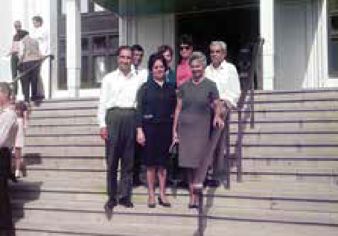
greeting cards, dance tickets, invitations, stickers, business cards and photographs, documents a (hectic) social life. Series 4, ‘Posters’, depicts a life where boxing and other sporting activities occurred at the same time as protest marches, health education campaigns, theatrical productions and electioneering.

Group on steps of Parliament House, including: (Front, L–R) Alick Jackomos, Merle Jackomos, Wynne Onus, and (far right) Eric Onus. Canberra, ACT, 1960s.

54

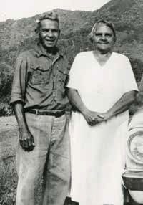

Family history research success for Fred
During National Family History Month 2017, the Family History Unit at AIATSIS hosted training sessions to help Aboriginal and Torres Strait Islander people do their own family history. The training aimed to help researchers to understand the types of records that exist for family history research, where to find them, why they were created and how to interpret them.
Fred Leftwich was one of the training session attendees. He later contacted the FHU help desk for further support. ‘I really got a lot out of that training session. It left me with a desire to find out more about my family’, Fred said.
Born in Cairns, Fred has family connections to the former Anglican mission of Yarrabah. While he had names and some information about his ancestors, he was looking to gain a better understanding of their lives. Fred said, ‘I had photos and stories about my family and a pretty good family tree but I wanted to know more, particularly about some of my female ancestors’.
Fred’s family was removed to Yarrabah from all over Queensland. His grandfather, Victor, was one of around 100 people forcibly relocated to Yarrabah from the abandoned Anglican mission at Fraser Island in 1904. AIATSIS was able to locate a photograph of Fred’s grandparents, Victor and Julia Leftwich, in the collection.
Like many Aboriginal and Torres Strait Islander people tracing their heritage, what was available to Fred depended on what was recorded in historical documents and other sources. Using the AIATSIS Collection, including photographs, audio and print materials, the Trove and Tindale Indexes and births, deaths and marriages records, the Family History Unit was able to provide further information to Fred about his family.

He said “It was so great to see the photos of my family from the early days of Yarrabah mission. There is one of my grandfather in the Yarrabah Mission Band—the band is an important part of Yarrabah’s history!”
While it is often difficult to find records about Aboriginal women, in Fred’s case women on both sides of his family were recorded in genealogies by Norman Tindale in the 1930s at Palm Island and Yarrabah.
For Fred, the Family History Unit provided a valuable service that was a combination of in- person support at the training on Aboriginal and Torres Strait Islander family history research and then further support from the unit. Together they helped him discover more about his family and their stories.
Fred’s grandparents Victor and Julia
Leftwich at Yarrabah.

Our Performance 55

Our Performance

Conduct the third National Indigenous Languages Survey
The National Indigenous Languages Report (NILR) (formerly NILS) will provide a valuable snapshot of the situation and status of Australian Indigenous languages. This snapshot informs government policy in this specialised area and also provides guidance to research activities in language documentation and revitalisation. Previous surveys have taken place in 2004 and 2013, and the present NILR final report is planned for 2019. For this third report, AIATSIS is partnering with the Department of Communications and the Arts, which has previously provided grant funding for the survey. By developing a stronger partnership approach, the scope of the reporting framework will be wider and the sustainability of the reporting and gathering of evidence will be specifically addressed.
AIATSIS has also sought grant funding and sponsorship through the AIATSIS Foundation to support the publication of Aboriginal and Torres Strait Islander language dictionaries.

Mayi Kuwayi longitudinal study of Aboriginal and Torres Strait Islander wellbeing
AIATSIS is a partner in the Mayi Kuwayi national longitudinal study of Aboriginal and Torres Strait Islander adults that examines the connection between culture, health and wellbeing. ‘Mayi Kuwayu’ means ‘to follow Aboriginal people over a long time’ in Ngiyampaa language.
The study is based at the Australian National University (ANU) in Canberra. The Mayi Kuwayi study, entitled Our cultures count, responds to calls from Aboriginal and Torres Strait Islander peoples that strong culture is important to health and wellbeing. However, there is a lack of evidence to show how and why this may be so. The Mayi Kuwayu study aims to provide this evidence.
After nearly thirty focus groups and speaking to just over 300 Aboriginal and Torres Strait Islander people, the survey is in its final phase of preparation for rollout. It is expected that the survey will initially be sent out to 20 000 Aboriginal and Torres Strait Islander people in mid-2018. This will be followed by the rollout of the main survey to 180 000 Aboriginal and Torres Strait Islander people approximately two months later.
The project has attracted a range of grants. The study protocol was published in BMJ Open; and further papers addressing the evidence, project scoping and pilot projects are in final stages of publication.

56

Develop collaborative community-driven projects
for the Preserve, Strengthen and Renew Communities project
The pilot of the Preserve, Strengthen and Renew in Communities project has been completed, culminating in a two-day workshop. The workshop provided a forum for project partners to discuss the issues they face in asserting authority over their cultural heritage. The workshop is discussed in the feature article that follows.

Transfer of copyright to Martu communities
Kanyirninpa Jukurrpa (KJ) is a Martu organisation based in Western Australia. Its aim is to work with Martu to build strong sustainable communities. KJ’s programs and activities have a broad range of social, cultural, economic and environmental outcomes.
KJ contacted AIATSIS about obtaining digital copies of cassette tapes held of recordings made by Marlene Jackmarra (nee Chesson) from 1979 to 1982. AIATSIS had a copy and the audio digitisation team had already digitally preserved these recordings.
The recordings on these cassettes contain traditional Martu stories and oral histories and were classed as restricted materials, so AIATSIS consulted with Marlene Jackmarra, as copyright owner and depositor of the material. Marlene generously granted AIATSIS permission to provide KJ with a digital copy of the materials as well as to publish them electronically to Martu people. At the same time, cultural permission to publish was sought from, and granted by, Martu people.
Marlene also assigned copyright in the recordings to the Martu people and the responsibility of controlling access to the material to KJ. As a result of the dialogue brokered by AIATSIS, Marlene’s recordings are now under the control of the Martu communities.
As well as the digital copies of the recordings, AIATSIS has provided KJ with additional information and resources, including accompanying documentation, time-coded description, and other archival metadata created by AIATSIS staff. These additional resources enhance the material’s discoverability and usability. Since receiving the recordings from AIATSIS, KJ has been busy identifying all the storytellers within the recordings to return to their descendant families. In some cases, there are storytellers of which there are no other known recordings, making them an invaluable cultural and family resource. Once returned directly to the descendant families, the recordings will be made accessible to the Martu communities through KJ’s Community Access Library and on-country ranger and culture programs.This work by AIATSIS Collection services, management and digitisation teams means important cultural material is accessible to and managed by the relevant community, in accordance with Indigenous intellectual and cultural property rights.

Our Performance 57

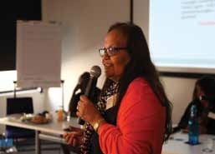
Our Performance

Preserve, Strengthen and Renew in Communities
The Preserve, Strengthen and Renew in Communities project supports Aboriginal and Torres Strait Islander communities to gain greater control and authority over their information and archives. The project enables community access to cultural material held within the AIATSIS Collection and aims to facilitate culturally guided protocols for knowledge recording, documentation and preservation.
A project pilot began in 2016 and engaged three case study partners: the Karajarri Traditional Lands Association, the Kiwirrkurra community (via Desert Support Services) and Wangka Maya Pilbara Aboriginal Language Centre. Each group had varying interests and concerns about their cultural heritage. The Karajarri group has lost a number significant cultural Elders in the last few years, losing critical cultural knowledge with them. Therefore, they wanted to access older material held in archives to build their own online cultural database so as to revive cultural practices.

‘Back in our home, a lot of our old people are very old and a lot of our younger generations are losing that knowledge. We knew there was a lot of recordings from anthropologists and archaeologists and people who work on the mission. At the time we thought they didn’t respect our Elders and were asking them stupid questions. But by collecting this information, today it is very valuable.’ Mervyn Mulardy, Karajarri Senior Cultural Advisor.
The group from Kiwirrkurra included women who had first made contact with non-Aboriginal people in 1986. Language and culture are still an unquestionable part of everyday life for the Pintupi and Luritja people living at Kiwirrkurra. They are at the initial stage of thinking about an archive, recording cultural knowledge and conceptualising future access to this material. In the AIATSIS Collection, they found film and photographic material, recorded by Fred Myers and Ian Dunlop in the 1980s, in which they identified themselves as children or young women.
Wangka Maya have been collecting and recording language material since their inception in 1987. Following the loss of a significant amount of men’s material to fire, the vulnerability of their collections became apparent and it was decided that much of their material would also be held at AIATSIS.

Julie Walker presenting at the Preserve, Strengthen and renew in Communities workshop, 14 March 2018

58

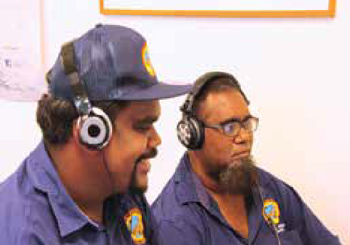
This provided security for the material but added complexity regarding the administration of future access to these collections. Their interest lay in developing efficient processes for the future joint management of this material.

‘We were managing all our archives … people kept that material in their heads, walked around with it—they were living human archives. But that was taken off us during the colonisation process. So there needs to be a proper partnerships. Where we get our policies from, some of it comes from traditional ways of doing things that we’ve been practicing for 40 000 years.’ Julie Walker, Yinhawangka woman and manager of the Wangka Maya Pilbara Aboriginal Language Centre, March 2018.
The pilot culminated in a workshop, bringing project partners together with practitioners also interested in the management of cultural material to discuss the issues raised during the project and to connect people and ideas. The workshop was held in Canberra from 14 to 15 March 2018. It aimed to explore the issues identified in the case studies; identify what is working and what is not working from community and institutional perspectives; build relationships among relevant stakeholders; and explore tensions created by moving to a ‘community access model’.

‘We just thought about recording information and collecting this information but for Karajarri we are also grabbing that information and taking it out on country and physically practising it. We’re putting it in the computer and getting the younger ones to learn the songs and learn the language and learn the dance.’ Mervyn Mulardy, Karajarri Senior Cultural Advisor.
The workshop shed light on the gap between community priorities and state and national collecting institutions; the challenges created by conceptions of control, copyright and ownership; and the protection of existing, but as yet unrecognised, rights.

Mervyn Muladry and Wynston Shovellor listening to audio recordings from the AIATSIS archive

Our Performance 59

Our Performance
2017–18 RESULTS

QUALITY AND EFFICIENCY OF OUTPUTS
MEASURE AND TARGET | 2016-17 | 2017-18 | OUTCOME
Staff publications–no | 46 | 65 | +41%
Staff presentations–no | 57 | 76 | +33%
Externally funded research projects–no | 11 | 16 | +45%
Size of grants and research contracts–revenue | $1 873 040 | $3 119 000 | +166.5%
Target for this measure | +10% | +10% | TARGET EXCEEDED
Revenue from research activities–income investment ratio | 4:13 | 5:14 | +151%
Target for this measure | 4:13 | 4:13 | TARGET EXCEEDED
Staff publications  –per researcher | 6 | 3.25 | –2.75
Staff presentations  –per researcher | 5 | 3.8 | –1.2
Target for this measure | 6 | 6 | TARGET NOT MET

ENGAGEMENT AND IMPACT OF OUTPUTS
MEASURE AND TARGET 2016-17 2017-18 OUTCOME
Research partnerships–no | 9 (26) | 39 | +50%
Research impact assessments  –no | 2 | 5 | +250%
Target for this measure | +2% | +2% | TARGET EXCEEDED

COMPLETION OF RESEARCH CONTRACTS
MEASURE AND TARGET 2016-17 2017-18 OUTCOME
Contracts completed on time | 100% | 100% | 100%
Target for this measure | +100% | +100% | TARGET MET

60

ANALYSIS
Academic publication and citation rates have never been a driver of AIATSIS research. However, they are an important indicator to our clients and partners of the quality of our research and critical professional career development of our people.
It is interesting to observe that the number of publications and presentations per researcher is significantly below targets set in 2015–16 (of six per researcher). However, overall, the number of publications has increased from thirteen to forty-six and presentations have increased from fifteen to more than fifty over this period (more than +300 per cent). The dramatic increase in 2016–17 has held steady in 2017–18, so this sets a new baseline for AIATSIS staff publications and presentations.
The increase in research outputs shown in the last two years reflects a greater investment in capacity building of junior staff and an overall increase in the number of AIATSIS staff actively participating in research activities.
However, this emphasis on capacity building and participation has impacted negatively on the rates of publication and presentation per researcher (where researcher is defined as any staff member who is a named author or presenter). For example, the number of co-authored publications has increased: a paper that previously may have been by a single author may now have two or more contributing authors. This effectively halves or further dilutes the number of publications per researcher. Senior staff are also mentoring and coaching researchers, and this impacts on individual output. This has led to an overall increase in the number of active researchers publishing within the organisation to twenty.
AIATSIS is largely dependent on external grants and funding to support our research activities. The continued increase and renewal of funding agreements and partnerships demonstrates the demand for AIATSIS research support and the quality and impact of our contribution.

Our Performance 61

Our Performance

AIATSIS Highlight: Digitisation Studio
The new AIATSIS Digitisation Studio, established in 2016, has allowed the Print and Photographic Digitisation teams to address a range of oversized, fragile and complex two-dimensional and three-dimensional items in the Collection.
The studio acts as a versatile shared space that allows our teams to undertake digitisation of various items from all parts of the Collection that are not suitable for traditional flatbed scanning.
In partnership with curatorial, registration and conservation staff, the AIATSIS Photographic Digitisation team are now undertaking work on the Art and Object collection, allowing items to be preserved in great detail using specialist high-resolution camera equipment. Often there are details or intricacies—for example, in at least one instance, the artist’s fingerprint—that are only illuminated once an item is captured. As well as the digitisation of large and fragile two- dimensional works, the studio also allows for the digitisation of three-dimensional objects of varying materials, size and complexity. A particular focus under the new Collection Development Strategy is the acquisition of contemporary works that celebrate cultural resurgence using non- traditional materials and practices. This has presented opportunities for photographic staff to undertake work on stunning and unique objects to create a sympathetic and faithful reproduction of the original.
The process presents a ranges of challenges. For example, the contemporary work Acceptance, by Torres Strait Islander artist and fashion designer Grace Lillian Lee, has many different elements, including feathers, beads and extensive ruffled red fabric. The digitisation of such a complex item required careful adjustment and placement, with advice from our conservation team, in order to get the desired results. The armature sits on a clear perspex frame built especially for the item, and a number of shots were needed to ensure each element was suitably illuminated to give a balanced composition that highlights the textures and symmetry of the object. Post-processing was undertaken to blend the different shots of each element together and discreetly remove the perspex frame to float the item unobstructed. The end result is a extraordinary detailed digital representation of this beautiful and important work.

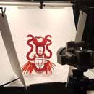
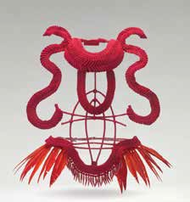
The contemporary work
- Acceptance by Torres Strait Islander artist and fashion designer Grace Lillian Lee Newberry, WA.


Detail from the work – Acceptance, Newberry, WA.

Studio setup, detailing the complexity of lighting required to adequately record such works.

62

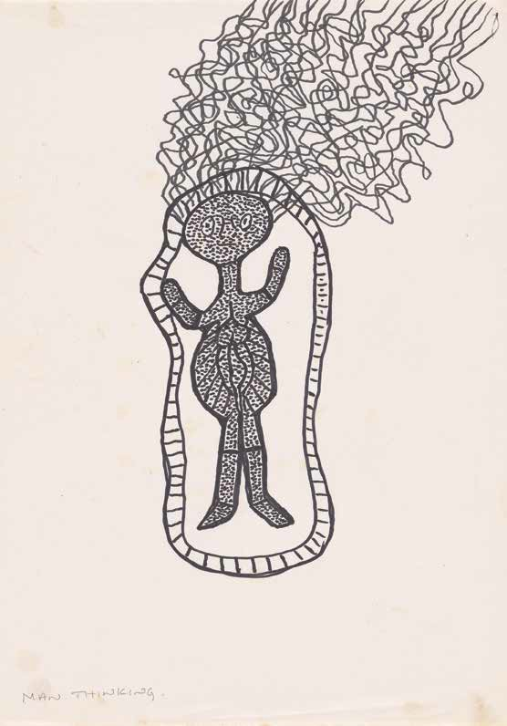

Our Performance 63

Our Performance

STRATEGIC PRIORITY 4
PROMOTING AND SHARING ABORIGINAL AND TORRES STRAIT ISLANDER CULTURE AND HERITAGE
AIATSIS uses its integrated public education strategy to promote and share authoritative content on Indigenous histories, peoples and cultural heritage. Key components of AIATSIS’ education strategy are its public programs, including exhibitions; and its stakeholder management and engagement. These strategies combine to provide all sectors of the public with fresh, meaningful, relevant and thought-provoking content and experiences.

KEY OUTCOMES OVER FOUR YEARS
  - Improved knowledge and understanding of Aboriginal and Torres Strait Islander people, cultures and heritage.
  - A more nuanced and sophisticated public engagement with our diverse communities.
  - Greater awareness of our work with and for Aboriginal and Torres Strait Islander peoples and communities.
  - Timely publication of relevant, high-quality works, informed by research, that contribute to the wellbeing of Aboriginal and Torres Strait Islander communities.

64

2018 National Native Title Conference

‘I have been to a number of native title conferences, but feel this year’s was quite special—the best I have been to in a while (if ever!)—The atmosphere was positive, sessions were interesting, great location and well organised/good use of large tents etc. and wonderful inclusion of youth. The conference dinner was particularly special—open air, history and music. The KLC, Yawuru people and AIATSIS did a fantastic job—Congratulations!’ Conference delegate.
In June 2018, the National Native Title Conference was convened by AIATSIS and the Kimberley Land Council (KLC). It was hosted by the Yawuru people on their traditional lands and waters in Broome, Western Australia.
The 2018 conference theme, ‘Many Laws, One Land: Legal and Political Co-existence’, acknowledged that, at any one place in Australia, different systems of law coexist. The theme acknowledged that in the twenty-five years since the passage of the Native Title Act 1993 (Cth) the intersection of non-Indigenous law and Indigenous law is most beneficially conceptually realised through the perspective of legal pluralism.
This year, AIATSIS and the KLC established a temporary purpose-built outdoor conference venue on the amphitheatre and public grounds of Cable Broome. This was the first native title conference held in the remote North West. It represented a historical and significant event for the Aboriginal communities of the Kimberley, which are celebrating forty years of the KLC.
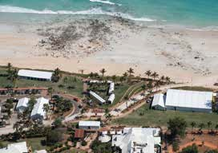
The conference program featured sixty-nine presentations and over 170 speakers, with nearly half of those speakers being Aboriginal and Torres Strait Islander people.

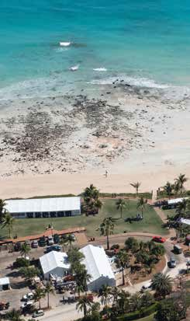
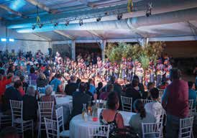
Our Performance 65

Our Performance

Youth Forum
The third annual youth forum was convened at the 2018 National Native Title Conference in Broome. The forum, facilitated by Wynston Sesar-Shovellor, brought together young Aboriginal and Torres Strait Islander people from across the country with a mutual interest in native title. The forum explored the challenges and opportunities for participation by young people in native title matters. It focused on succession of native title rights and governance structures of the native title corporations that hold and manage native title.
The forum featured presentations by Wynston Sesar-Shovellor and Amarah Treacy from the Karajarri Traditional Lands Association, Naomi Appleby, Bianca Graham and Jacob Smith from Nyamba Buru Yawuru and Mirrika Councillor from the Kimberley Land Council on how their organisations involve young people in their work and plan for succession. This year three judges of the Federal Court of Australia—Justice Barker, Justice Murphy and Justice Mortimer— attended the youth forum to engage with delegates.
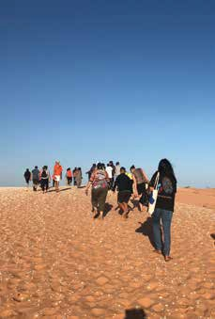
As part of the forum, Bart Pigram of Narlijia Cultural Tours led delegates on a cultural tour of Broome, giving youth forum delegates the opportunity to visit some of the sites significant to Yawuru people.
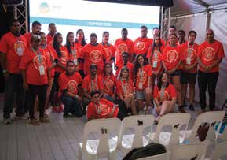
Youth forum delegates

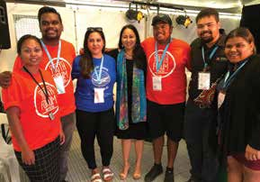
Youth delegates visiting the Didirrgun (Kennedy Hill) site during the cultural tour

Amarah Treacy, Wynston Sesar-Shovellor, Naomi Appleby, Ninielia Mills, Johnathon Pearson, Jacob Smith and Bianca Graham at the youth forum

66

2017–18 STRATEGIES

Optimise digital platforms for improved discoverability, access and use of the collection
In 2017–18 AIATSIS undertook a review of two major digital communications platforms: the AIATSIS social media accounts and the e-newsletter.
The Communications and Public Engagement team implemented a social media strategy throughout the year. As part of this strategy several AIATSIS social media accounts were consolidated and a new platform—an AIATSIS Instagram account—was launched. Regular review of social campaign analytics was also introduced to help assess the success of campaigns. The AIATSIS social media accounts had 41 261 followers in 2017–18—an audience growth of 10 per cent from the previous financial year.
A review of like institution’s e-newsletters led to the introduction of a refreshed AIATSIS e-newsletter in January 2018. The new e-newsletter incorporates the members e-newsletter and has a contemporary look and feel. At the end of 2017–18 the newsletter was distributed to 4080 subscribers—an increase of 14 per cent on the previous year. It has maintained a consistent average of 30 per cent subscriber open rate. The most visited e-newsletter item was the Day of Mourning—26th January 1938 online exhibition, which received over 270 clicks.
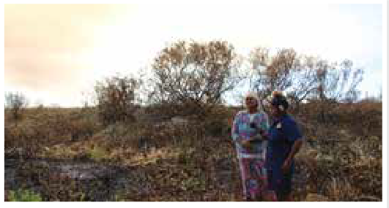
The work on the new collections access platform achieved significant milestones this year. The focus was the Art and Object collection, merging the three existing databases to create a new, single set of data that would be migrated to the new platform. The process followed the successful migration of the photographic collection in the previous year and substantially expanded the number of data fields available to describe collection materials. The preparatory work included data clean-up to ensure that the data is accurate and that terminology for key fields like rights and licensing statements is consistent. The Art and Object collection will be available to the public online in the next financial year.
Training researchers: community recording on country
AIATSIS has proactively worked with the Karajarri traditional owners to build skills exchange via research activity. This has included the creation of opportunities to present on research findings at national forums such as at the National Native Title Conference 2018 and opportunities to build recording, governance and data management skills and publish research results.
KTLA administrative officer Janine Shovellor recording Aunty Rosie Munro.

Our Performance 67

Our Performance

Photographs now available through the access database
The Social Impacts of Uranium (SIU) Study Groups collection documents the lives of Aboriginal people at Gunbalanya and Kakadu National Park in the early 1980s. It holds 3427 photographs in total. The material was deposited with AIATSIS under restricted access conditions, as it was deemed politically sensitive at the time following the federal government’s decision to allow mining in the region.
The SIU collection provides insights into the lives of the Dirdi and Bumarda families as well as their country, their daily activities and their homes. It documents Albert Dirdi collecting, preparing and painting a bark of a Gumutigen and Wakih (freshwater crocodile and river prawn), his family’s engagement with this painting and the connections between art production and the teaching of culture in Northern Australia.
The SIU group documented the range of homes present at Gunbalanya and the surrounding outstations, from recently constructed government-built fibro houses to smaller shelters, which utilised traditional building forms and corrugated iron sheets. The SIU group also observed the early forays of tourists into Kakadu and some of the places they visited, including Ubirr and the Cahill’s Crossing. This collection is likely to prove extremely valuable to the Aboriginal communities of the region, as it contains a snapshot of their early lives or the lives of their parents and grandparents.
The Pictures Access database is one of a developing suite of new platforms which complement the Mura® catalogue to improve discoverability of a number of elements of the collection.
A successful data mapping and image migration project involving nearly 300 000 digital images and accompanying captions being transferred from the old unstable Perfect Pictures database to the new Pictures Access database using the Drupal platform was completed in June 2017. In the 2017–18 financial year a further 12 267 images and captions were uploaded, meaning that approximately 50 per cent of the total photographic collection can now be searched and perused by AIATSIS staff and clients in the Stanner Reading Room. Another important development is the ability to facilitate remote access to the database through a secure password that is provided for a defined period.
Photographic collection management staff undertake item level descriptions to make the collection more accessible to clients. Important details include the provision of names, dates, places, subject matter and language group when known. Item–level data entry takes into account information provided by the donor or collector, the staff member’s specialist knowledge, research on other related holdings in the AIATSIS collections, and other available information. It may also involve contacting depositors, community members and other relevant and knowledgeable people.

68

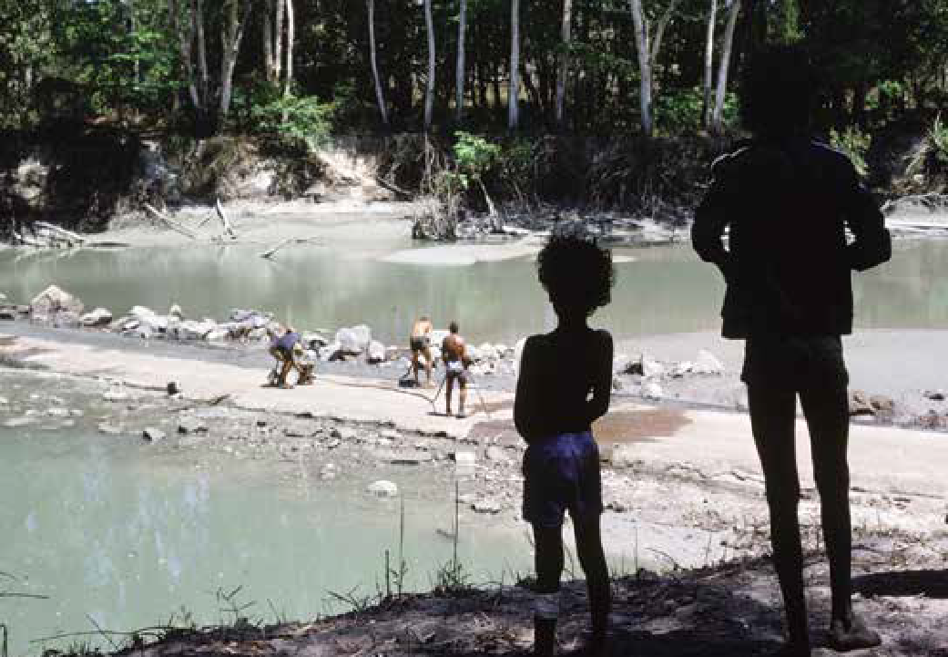
Photographic collection management staff use resources such as Austlang to ensure that consistent terms are used to enhance discoverability, but they take into account different spellings and descriptions and incorporate those in the records where helpful. Staff also update records– as further information is received through community access visits, clients visiting the library or suggested amendments from the wider AIATSIS staff and other interested parties. During 2017–18, 412 item–level records were amended following feedback from users of the database.
The Pictures Access database will be subject to ongoing enhancements such as the inclusion of an ‘About’ page to provide background information on the breadth of the AIATSIS photographic collection with some of the most significant sub-collections highlighted.

Watching work being undertaken on the widening of the East Alligator River Crossing, Manbiyarra, NT, 1979. Photo: Jon von Sturmer

Our Performance 69

Our Performance

Produce relevant and engaging online content and collateral communication and promoting Aboriginal and Torres Strait Islander heritage
AIATSIS is evolving into a public-facing institution that requires an engaging and intuitive online presence. In 2017–18 AIATSIS continued to focus on delivering engaging online content to enable us to reach a national audience. We were rewarded with an increase in traffic and online communities across the board. A steady stream of new blog, ‘Explore’, multimedia, news and online exhibition content ensured that our social media and newsletters were constantly promoting fresh stories from around the country, illustrating the diversity of Aboriginal and Torres Strait Islander Australia.
The ‘Explore’ section of the AIATSIS website continues to perform exceptionally. It provides entry-level information about Aboriginal and Torres Strait Islander peoples, histories, cultures and rights for the general public. This financial year, ‘Explore’ had 658 539 page views—28.35 per cent of all views of the AIATSIS website. This represented an increase of 238 000 views over last year (+56 per cent). The page featuring the AIATSIS map of Indigenous Australia remains the most popular webpage, with 203 075 page views. It is followed by the ‘Mabo case’ webpage, which received 95 964 page views; and an ‘Eddie Koiki Mabo’ biographical page, which received 67 818 page views.
Two online exhibitions were completed this year to mark significant anniversaries for Aboriginal and Torres Strait Islander peoples: Day of Mourning—26th January 1938 and The Barunga Statement. The online exhibitions are long-form storytelling, allowing in-depth exploration of topics of public interest and currency; and increasing public access to our collections.
The Day of Mourning—26th January 1938 online exhibition was refreshed by the curatorial team ahead of the 80th anniversary of the event. The enhanced exhibition, featuring a number of digitised resources from the AIATSIS Collection, was enhanced not only because of the significant anniversary but also because website visitor analytics identified high visitor interest.
The 1965 Freedom Ride online exhibition continues to be exceptionally popular, with over 90 000 page views for the year. Demographic analysis of the visitor data suggests it is a heavily used resource by schools.
AIATSIS’ publishing arm, Aboriginal Studies Press, publishes local and international stories, capturing the unique heritage and diverse lives of Australia’s first peoples. From Aunty Sue Hasseldine’s native title experience in outback South Australia to the reconnection of many Indigenous communities with their material heritage held with the Vatican Museums Indigenous Collection, these stories and more promote Aboriginal and Torres Strait Islander heritage to a global audience.

70

Maintain an innovative public program and services to strengthen community participation and attract partners and sponsors
AIATSIS is relied upon as a knowledge broker and forum for national meetings and discussion. Demand for AIATSIS to hold forums and events reflects our capacity to support, monitor and engage with strategic conversations of importance to Indigenous communities and equally to policy makers.
AIATSIS ran a diverse public program consisting of a range of events to strengthen community participation and engaged audiences, partners and sponsors. The program of events was held around the country, ensuring that AIATSIS maintains its national focus.
In total AIATSIS hosted or partnered to host 12 public events, including the 2017 Stanner Award; three Aboriginal Studies Press book launches—for example, Australia: The Vatican Museums Indigenous Collection by Katherine Aigner with the Vatican Museum; a film screening; a partner NAIDOC 2017 event at Tjapukai Cultural Park; the annual Indigenous Art Market; and a series of lectures and seminars.
The 2018 National Native Title Conference built on the success of last year’s event. The conference was co-convened with the Kimberley Land Council and the Yawuru Traditional Owners in Broome. More than 50 per cent of the 850 delegates identified as Aboriginal and Torres Strait Islander peoples, representing more than 131 Indigenous Nations across Australia.
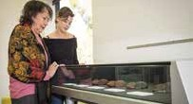
Total attendance for AIATSIS public program events for the year was approximately 3700—an increase of 12 per cent. Sponsorship raised for events was $424 000—an increase of 21 per cent from the previous year.
AIATSIS Blog
The AIATSIS blog, launched in 2016, enables AIATSIS staff to promote their expertise and their intimate knowledge of collections. Topics for the fourteen blog posts this year included items on display in the AIATSIS Reading Room, Indigenous languages in Australian parliaments, the audiovisual heritage of Torres Strait singing and dancing, and AIATSIS family history research.
The most popular blog post this year was about the Bennelong Letter (the first known use of written English by an Aboriginal Australian), which is held in the AIATSIS Collection.
Kerry Reed-Gilbert with her granddaughter Kaylarnie looking over the display of her collection in the AIATSIS Reading Room 2018. Photo: Andrew Turner

Our Performance 71

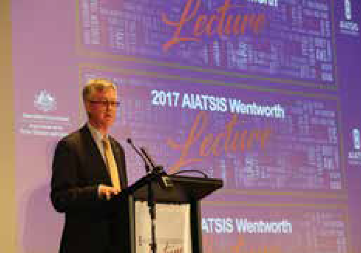
Our Performance

2017 Wentworth Lecture
The 2017 Wentworth Lecture, entitled ‘The Promise of 1967: Commonwealth Public Administration of Indigenous Affairs 50 Years On’, delivered by Dr Martin Parkinson AC PSM, Secretary of PM&C, reflected on what the 1967 Referendum has meant for the evolution of Indigenous affairs policy in Australia.
Established in 1978, the Wentworth Lectures are held in honour of the Hon. W.C. Wentworth AO.
The lecture series pays tribute to Wentworth’s contribution to Indigenous studies in Australia. They are a means to encourage all Australians to gain a better understanding of issues that go to the heart of our development as a nation.
The 1967 Referendum ‘yes’ vote gave the Commonwealth constitutional power to act positively and decisively in Indigenous affairs interests and, for the first time, Aboriginal and Torres Strait Islander peoples were given statistical visibility through inclusion in the Census.
Importantly, Dr Parkinson reflected on whether the promise of these changes has been met and what lessons the Australian Public Service should take from the past to map out a new way of working in the future.

Dr Martin Parkinson AC PSM, Secretary of the Department of the Prime Minister and Cabinet

72

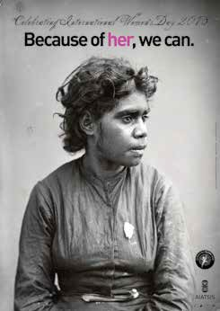
#IWD2018 campaign report
AIATSIS celebrates International Women’s Day each year with a staff award and event and a poster that generally features an image from the AIATSIS Collection. The 2018 International Women’s Day (IWD) poster adopted the 2018 National NAIDOC theme ‘Because of Her, We Can!’ to extend our celebration and recognition of the achievements of Aboriginal and Torres Strait Islander women.
The image featured on the 2018 poster is part of the Kerry King collection of nineteenth century portraits taken in New South Wales, Queensland, Victoria and the Northern Territory between 1870 and 1900. AIATSIS holds the Kerry King portraits in our Collection. The woman featured in the image remains unknown, but she is not forgotten, and the poster allowed us to pay our respects to women like her. Her image is now spread around the country in a statement about the power of women.

The IWD posters are always very popular, but this year it proved to be a runaway success. A social media campaign to promote the 2018 IWD saw Facebook posts reach over 39 600 people and the creation of over 26 200 impressions on Twitter. The IWD posters have also become a collectable set, with many requests for the posters produced for past IWD themes. The 2018 campaign generated 408 poster orders, so the images of inspirational Aboriginal women are now spread through offices, tearooms and classrooms around Australia.

International Women’s Day poster 2018

Our Performance 73

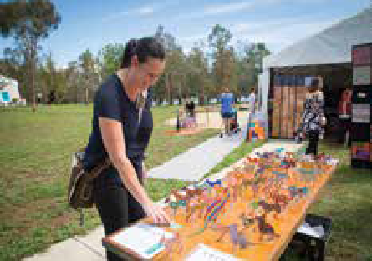
Our Performance

Indigenous Art Market
In December 2017, AIATSIS held its fifth Indigenous Art Market. It was the largest market yet, with six community art centres travelling over 20 000 kilometres from around the country to sell art, crafts, fashion and jewellery. All proceeds go back to the Aboriginal artists, their communities and art centres.
It was the first year we collected feedback from our attendees and supporters with the aim of making improvements to future Indigenous Art Markets. We also wanted to ensure that the artists, art centres and art market attendees were seeing value in being involved. We surveyed over 100 people in person and online and over 200 people on social media.
The survey indicated the majority of the art market attendees were from Canberra, but some attendees either travelled from or were normally based in Murrumbateman, Goulburn, Sydney, Melbourne and even the USA. We received an overwhelmingly positive response about the location of the art market and the time frame within which it is held. Most of the attendees found the price range and variety of products to be fairly reasonable. Suggestions to improve the art market included increasing the size of the marquees, providing food and drinks, and offering a summer festival atmosphere by providing entertainment.
This year we focused on promoting the Indigenous Art Market online using Facebook and Twitter. We also took the opportunity to launch the AIATSIS Instagram account. Our survey of attendees found that over 75 per cent had heard about the art market on social media.

AIATSIS Council member, Donisha Duff shopping at the Art Market

74

2017–18 Volunteers and Interns
AIATSIS attracts volunteers and interns from across Australia and internationally. In the 2017–18 AIATSIS hosted eighteen volunteers and interns who contributed to both short-term and ongoing projects in collections access and management as well as research. Students interning at AIATSIS are able to find immersive tasks and duties that provide a firsthand perspective on their future careers. During their time at AIATSIS, interns’ tasks give them a deeper understanding of Indigenous culture and history. They also learn about the processes, practices and disciplines that enable material to be accessed and used by all AIATSIS stakeholders; and they engage with research practice directly linked to community and social benefit.
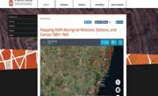
In 2018 Jane Berry, from Washington University in St Louis, contributed to an AIATSIS web resource about the Australian Welfare Board Map of New South Wales Missions, Stations, and Camps.
Stacey Zarifopoulos, an employee from the University of Melbourne, contacted AIATSIS to see if she could volunteer her time and learn more about the AIATSIS Collection. Stacey worked with the Print and Manuscripts team for

Aboriginal Welfare Board map on the
AIATSIS website
one week to rehouse the important languages collection. She learnt about our audio and video digitisation processes

and compared our resources to those of her workplace. Stacey is a member of the Australian Libraries and Information Association (ALIA), and a letter outlining her volunteering experience with AIATSIS was published in the May–June 2018 issue of INCITE magazine.
AIATSIS has also partnered with the Aurora Project internship program. In 2017–18 the Native Title Research Unit (NTRU) hosted several outstanding law students.
Lucy Schroeder, a Darug woman, University of Sydney Indigenous student-at-law and recipient of the prestigious Katrina Dawson Foundation scholarship, came to AIATSIS. During her six- week internship, Lucy made a valuable contribution to our Youth Engagement in native title project, which examines youth participation in the native title process as well as succession of knowledge, responsibilities and rights in the native title context. Lucy advised us that her six- week placement has increased her confidence and research skills and has positioned her well for her future studies.
Angela interned at AIATSIS in 2018 as part of her Master of Information Studies program at RMIT, Melbourne. Angela spent three weeks as a full-time intern in Canberra on rotation. In the Registration team, Angela worked on the newly acquired Elizabeth Durack collection of artworks on paper; and in the Print and Manuscripts team she completed a box list and conducted contextual research for the seminal Alice Moyle collection. Angela’s contribution will enhance the discoverability and useability of this donation of a leading Australian musicologist. As part of her placement, Angela was introduced to the late Alice Moyle’s long-term research assistant, Grace Koch, who knew that creator and her collection deeply.
Teresa McCarthy, Information Officer (Archives) at Central Land Council (CLC), spent six weeks at AIATSIS. The visit was a CLC/AIATSIS collaboration to provide professional development to Indigenous staff. The key objective of the placement was for Teresa to gain experience in digital preservation, archival curation and collections development and management.

Teresa says that the placement was an excellent experience. As an Aboriginal woman, she is proud of the AIATSIS Collection. As a professional, she felt welcomed and was impressed by staff knowledge, professionalism and dedication.

Our Performance 75

Our Performance

Share and promote the results and impact of AIATSIS research
AIATSIS researchers work closely together with the Communications and Public Engagement team and Aboriginal Studies Press to ensure that the results and impact of AIATSIS research are disseminated as widely as possible through a range of online materials, publications and events.
For example, in March 2018 AIATSIS researchers held a workshop in Canberra as part of the Preserve, Strengthen and Renew in Communities project. The workshop provided an opportunity for case study partners to engage with representatives from cultural institutions to share project activities, results and issues relating to the Collection and management of cultural heritage materials. AIATSIS invited stakeholders and others interested in the management of cultural materials to develop networks, enabling the continuation of these discussions and activities beyond the life of the Preserve, Strengthen and Renew in Communities project (see page 58 for further information about this project).

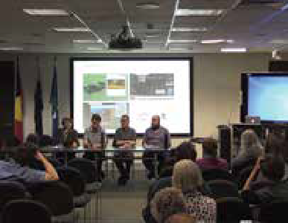
Sharing research processes: Hearing Histories of the Western Pilbara
In November 2017, AIATSIS and the University of Melbourne co-convened a seminar about the ARC Discovery project, Hearing Histories of the Western Pilbara, which aims to record and document the public songs used as tools for managing social, cultural and economic change in the Pilbara. The project brings together contemporary custodians and old song recordings through an online content management system to support efforts to maintain these performance traditions.
AIATSIS researcher Dr Mary Anne Jebb, along with Dr Sally Treloyn, Dr Nick Thieberger, PhD student Andrew Dowding, software specialist Jared Kuvent and Dr Rueben Brown, detailed the process of segmenting and describing songs with community song experts and developing a digital song and metadata interface. The project has involved substantial archival research, drawing largely on the AIATSIS audio collection. Researchers have then revisited archived song collections with living singers and family members in the Pilbara region. Additional metadata relating to the collections has been gathered through this process, with researchers adding information about sung and spoken segments of the recordings as people remember the singers and the songs. This information helps to close a circuit between AIATSIS and communities, as information is fed back to AIATSIS and added to the collection items. This makes the collections more meaningful and improves future access.
The community curated and controlled content management system currently in development will support the management of repatriated and newly created records of intangible cultural heritage and facilitate community access to the recordings.

Dr Mary Anne Jebb, Dr Rueben Brown, Dr Nick Thieberger and Jared Kuvent at the Hearing Histories seminar.

76

Identify opportunities that draw on the collection to produce publications that strengthen and share knowledge and understanding of Aboriginal and Torres Strait Islander peoples, histories and cultures
The AIATSIS Collection holds many stories to be shared. Aboriginal Studies Press facilitates the sharing of those stories in a diversity of publications, using the collection to strengthen and promote knowledge and understanding of Aboriginal and Torres Strait Islander culture and heritage. We present some current projects below.

Black Pearls: The Aboriginal and Islander Sports Hall of Fame
Aboriginal Studies Press used the Black Gold image collection, donated by Colin and Paul Tatz in 2004, in this new edition of The Aboriginal and Islander Sports Hall of Fame.

Kerry Reed-Gilbert collection
AIATSIS began discussions with Kerry Reed-Gilbert on the publication of a book based on her Aboriginalia collection, which was donated to AIATSIS in 2016.

The Little Red Yellow Black Book (fourth edition)
Aboriginal Studies Press’ bestseller, The Little Red Yellow Black Book has a new edition due out in September 2018. The AIATSIS photo and art collection has been heavily drawn on: artist Jimmy Pike’s Yakarn-Moon is used on the cover and as a design element throughout.

School curriculum materials
AIATSIS is partnering with Nelson Cengage to produce an educational series for primary schools that aligns with the central cross-curriculum priority of Indigenous cultures and histories. The series, entitled ‘Our Land Our Stories: Aboriginal and Torres Strait Islander Peoples, Histories and Cultures’, draws extensively on the AIATSIS collections. It will include three series of Big Books (years K–2, 3–4 and 5–6), themed student cards, teacher resource books and an online gallery of selected AIATSIS collections material that ties in with the series content. During the year, collections staff searched through more than 45 000 images and identified over 1000 images for the series. Of these, 300 images were selected and processed for copyright and community approval. The series is due to be launched in May 2019. For more information, see the story on page 68.

Explore options for an AIATSIS public space
While AIATSIS continues to explore options for new space, we are also utilising our existing space to its potential. The Singing the Train exhibition, currently housed in the foyer at AIATSIS, continues to attract external local and international visitors. This exhibition, curated with Pilbara Aboriginal communities, provides a space for Aboriginal people to tell their story and for the public to engage with this story. An assessment of audience responses to the exhibition showed overwhelmingly positive interactions, with many visitors praising the presentation of Aboriginal cultural heritage material in a multimedia format and particularly its interactivity and ease of engagement. This pilot demonstrates the need for multifunctional exhibition spaces which are being explored as a part of a broader capital works program.

Our Performance 77

Our Performance

Cengage visit Cosmo Newbury
In May 2018 Mr Colin MacDougall travelled to Yilka country in central Western Australia to photograph the Murray family and, in particular, eight-year-old Orlando Murray. The photos will form the content for a series of books and teaching resources for primary schools entitled ‘Our Land Our Stories: Aboriginal and Torres Strait Islander Peoples, Histories and Cultures’—a joint project of educational publisher Nelson Cengage and AIATSIS. Similar photo assignments were also conducted with families in Thursday Island and the Queensland Sunshine Coast.
The Murray family is one of four families that, in 1989, resettled the then abandoned remote community of Cosmo Newberry. Cosmo Newberry, situated 600 kilometres north-east of Kalgoorlie, is now a thriving community where, according to Harvey Murray, the residents

‘have been committed to continuing to improve their community so that the young people can lead healthy and happy lives on their traditional lands without sacrificing the quality of life’.
Harvey’s grandson Orlando is to appear in three books: Our culture; Our people; and Our country. The idea was to photograph him and his family both the normal things all eight-year- olds do—such as going to school, playing with cousins and doing homework –as well as some activities that may have been more unique to Orlando’s environment and culture, such as, going to waterholes with grandpa, collecting bush tucker and medicines and riding quadbikes on red dirt roads. There was not a strict plan for each day of photography, as it was really up to Orlando and his family to decide what activities they wanted to have photographed. The narrative for the books will largely be determined by the content of the photography, which in turn was created as a result of choices made by the family itself.
Orlando’s grandparents and his mother, Kassey, were enthusiastic about the project and more than happy to suggest ideas for things to photograph. Orlando was a star and showed great patience for the often slow process of such a specific photographic shoot. He initially appeared to be mildly shy and a boy of few words. However, soon enough, he confidently directed the action and Colin was able to follow his lead. Highlights included a visit to a nearby waterhole at sunset with Orlando and his grandfather, as well as a session of quadbike riding.
For all involved the project was a rewarding experience. In particular, Orlando seemed quietly proud that he had the opportunity to represent his family and his place, both of which clearly meant a lot to him.
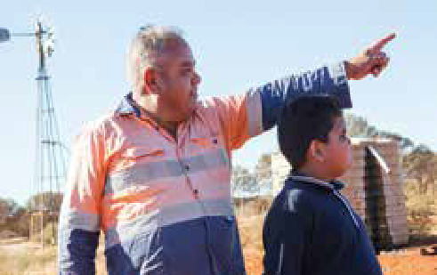
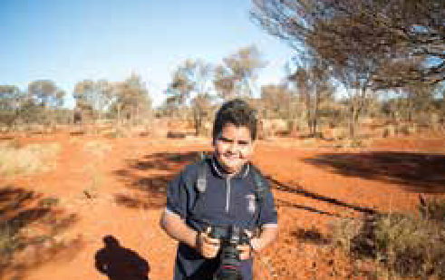

Harvey Murray and grandson Orlando Murray exploring one of their family waterholes near their township Cosmo Newberry, WA.

78
Orlando Murray (8) helping with the Cengage photography project, Yilka country, WA.

2017–18 RESULTS

PUBLISHING ACTIVITY
MEASURE AND TARGET 2016-17 2017-18 OUTCOME
Books–no | 6 | 5 | –1
Target for this measure | 6 | 6 | TARGET NOT MET
Other publications–no | 7 | 9 | +2
Target for this measure | 7 | 7 | TARGET EXCEEDED
Journal editions–no | 2 | 2 | 100%
Target for this measure | 2 | 2 | TARGET MET
AIATSIS e-newsletters–no | 12 | 12 | 100%
Target for this measure | 10 | 10 | TARGET EXCEEDED

PUBLISHING VALUE
MEASURE AND TARGET 2016–17 2017–18 OUTCOME
Books—revenue | $337 594 | $432 168 | +177%
Target for this measure | $243 000 | $243 000 | TARGET EXCEEDED
Journal editions—revenue | $13 281 | $14 672 | -26.6%
Target for this measure | $20 000 | $20 000 | TARGET NOT MET

Our Performance 79

Our Performance

WEB PUBLISHER
MEASURE AND TARGET 2016-17 2017-18 OUTCOME
Publisher and Editors trained—no | 12 | 13 | +10.8%
Target for this measure | 10 | 10 | TARGET EXCEEDED

INDIGENOUS AUTHORSHIP
MEASURE AND TARGET | 2016-17 | 2017-18 | OUTCOME
Contributions from Indigenous authors—no. | 5 out of 6 publications  (83%) | 3 out of 5 publications  (60%) | +60%
Target for this measure | +50% | +50% | TARGET EXCEEDED

MEDIA ACTIVITY
MEASURE AND TARGET | 2016-17 | 2017-18 | OUTCOME
Media releases, alerts and web news—no | 91 media items featuring  AIATSIS | 94 media items featuring  AIATSIS | +59
Target for this measure | 35 | 35 | TARGET EXCEEDED
Media interviews by AIATSIS staff or affiliates—no | 53 interviews with staff and  affiliates | 44 interviews with staff and  affiliates | +9
Target for this measure | 35 requests | 35 requests | TARGET EXCEEDED
Requests for content or information by media—no | 29 | 26 | 0%
Target for this measure | 26 | 26 | TARGET MET

80

DIGITAL ENGAGEMENT
MEASURE AND TARGET | 2016–17 | 2017–18 | OUTCOME
Website traffic—visit | 1 910 640 | 2 322 820 | +21.5%
Target for this  measure | 10% | 10% | TARGET EXCEEDED
Website traffic  —unique visitors | 608 009 | 807 096 | +32.7%
Target for this  measure | 10% | 10% | TARGET EXCEEDED
Social Media Reach  Facebook Twitter Instagram YouTube | N/A | - 1.232 million Facebook  impressions  - 1.847 million Twitter  impressions  - 31 254 Instagram  impressions | New measure
Vimeo |  | - 3 900 views on YouTube
—no |  | - 27 664 views on Vimeo
Social Media
Activity |  | - 200 Facebook posts
Facebook |  | - 556 Tweets
Twitter  Instagram | N/A | - 54 Instagram posts (launched October 2017) | New measure
YouTube |  | - 4 posts on YouTube
Vimeo |  | - 52 posts on Vimeo
—no
Social Media Followers |  | - 31 194 Facebook  followers
Facebook |  | - 9 304 Twitter followers
Twitter  Instagram | Total 37 202  (2016–17) | - 1 345 Instagram  followers | +12.7%
YouTube |  | - 34 followers on YouTube
Vimeo |  | - 62 followers on Vimeo
—no |  | Total: 41 939
Target for this  measure | +10% | +12.5% | TARGET EXCEEDED

Our Performance 81

Our Performance

ENGAGEMENT ACTIVITY THROUGH PARTNERSHIPS
MEASURE AND TARGET | 2016-17 | 2017-18 | OUTCOME
 | 3 new strategic | 4 new strategic
Partnerships | partnerships | partnerships
—no | 4 new partnership | 6 new partnership
 | projects | projects
Target for this  measure | +10% | 10% | TARGET EXCEEDED
Value of public program  —$ |  | Measure in development
Target for this  measure | N/A | +5% | NOT AVAILABLE

ENGAGEMENT ACTIVITY THROUGH MEMBERSHIPS
MEASURE AND 2016-17 2017-18 OUTCOME TARGET
Indigenous memberships—no | 25% | 35% | +10%
Target for this  measure | +8% | +8% | TARGET EXCEEDED
Memberships—no | 671  (3% increase) | 598  (11.5% decrease) | -11.5%
Target for this  measure | +5% | +5% | TARGET NOT MET

82

ANALYSIS
Our engagement with audiences and communities is still improving, with our results consistently exceeding our targets.
Our social media presence and engagement increased: all platforms showed a major increase in our reach through the community. A 33 per cent increase in traffic to the website is also an increase on last year.
Our twelve public program events across the year were all major successes and highlighted the strategic direction being taken by the organisation to be outward focused.
The 2018 National Native Title Conference was one of the most successful: a total of 864 delegates across 131 Indigenous nations attended. AIATSIS took a calculated risk in holding the conference in a remote location. Increased costs were offset by increased sponsorship, ensuring the conference remained at break-even.
The members’ newsletter was again included with the general AIATSIS newsletter, and members received updates from the Chairperson of the Council directly. For information on strategic engagement with members, see page 110.
While the number of trade titles (books) was down, the overall number of publications remained steady, and revenue increased overall by 27 per cent from $350 875 in 2016–17 to $446 840 in 2017–18.

Our Performance 83

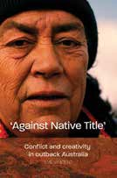
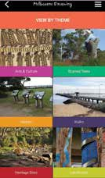
Our Performance

AIATSIS publications in 2017–18

‘Against Native Title’: conflict and creativity in outback Australia by Eve Vincent (August 2017)
‘Against Native Title’ is about a divisive native title claim in the town of Ceduna where the claims process has thoroughly reorganised local Aboriginal identities over the course of the past decade. The central character in this story is senior Aboriginal woman Sue Haseldine, who, with her extended family, have experienced native title as an unwelcome imposition: something that has emanated from the state and out of which they gained only enemies. But this is not simply a tale of conflict. Threaded throughout is the story of a twice-yearly event called ‘rockhole recovery’: trips that involve numerous days of four-wheel-drive travel to a series of permanent water sources and Dreaming sites. Through rockhole recovery Sue Haseldine and her family continue to care for, and maintain connections to country, outside of the native title process.
This is a vivacious and very human story, which pursues a controversial and much neglected line of enquiry in which native title is not necessarily seen as a force for recognition and Indigenous empowerment.

Melbourne Dreaming app by AIATSIS (October 2017)
Beneath Melbourne’s busy city landscape lie layers of a turbulent history and an ongoing vibrant Aboriginal culture. Told thorough precincts of significance to the city’s Aboriginal people, the Melbourne Dreaming app assists users to appreciate Aboriginal people’s enormous cultural, historical, social and economic contribution to the city.
From the edges of Port Phillip Bay to the hunting grounds of Chapel Street or the Burnley Ngargee (corroboree) tree in the heart of Richmond, Aboriginal Melbourne’s rich cultural heritage from the past and the present can be explored using the app.
The app is designed for self-guided tours of historical and contemporary places of significance. Users can choose to spend from thirty minutes to a full day exploring one of Australia’s largest and busiest cities.

84

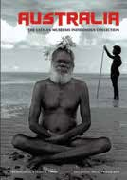

Australia: the Vatican Museums Indigenous Collection by Katherine Aigner (ed) (January 2018)
The Vatican Museums present aspects of the history of humanity, from the ancient Etruscans and Romans to the Renaissance, through art. The Indigenous Australian collection is a little known and an unexplored part of the Vatican Museums’ story. The Indigenous collection contains some of the earliest known documentations of Australian Indigenous cultures. It includes the earliest extant set of Pukumani poles from Melville and Bathurst Islands, art from the Tiwi Islands in the Northern Territory, and more recent contributions of artworks and cultural objects. The collection contains materials that have never been exhibited in Australia.
On 7 December, 2017 Aboriginal Studies Press and the Vatican Museums launched the art catalogue Australia: the Vatican Museums Indigenous collection in Canberra. Pedro Wonaeamirri travelled from Melville Island to represent his community at the catalogue launch.
The responsibility to culturally reconnect relevant contemporary Indigenous communities to their material heritage that is held in the museum has been realised and is documented in the catalogue. The publication includes a catalogue of objects as well as essays by Indigenous and non-Indigenous authors. During the Vatican Museum’s community visits and consultations, images of the objects brought old and young people together, instigating intergenerational dialogue about the past.
Now, in collaboration with communities, the Indigenous collection can be seen in this catalogue and is represented at the heart of the Vatican Museums. These Indigenous objects have become cultural ambassadors at the museum, and they enable visitors to learn more about Australian Indigenous cultures.

Italian edition—Australia: the Vatican Museums Indigenous collection by Katherine Aigner (ed.) (May 2018)
Australia: the Vatican Museums Indigenous collection by Katherine Aigner (ed.), published by AIATSIS Aboriginal Studies Press, is AIATSIS’ first book to be translated into Italian. The book was launched at the Vatican in Rome.

Our Performance 85

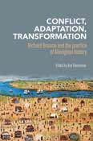
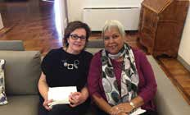
Our Performance

Conflict, adaptation, transformation: Richard Broome and the practice of Aboriginal History by Ben Silverstein (ed). (March 2018)
Conflict, adaptation, transformation: Richard Broome and the practice of Aboriginal history brings together prominent and emerging scholars to discuss a range of issues from the histories of frontier violence and missions, Aboriginal participation in sport and education, ways of framing relationships with land, and the critical relevance of Aboriginal life history and memoir to the reconsideration of Australian history.
This valuable collection traces the legacy of Richard Broome’s groundbreaking work in Aboriginal history and presents analyses that inform and transform a broad range of important debates that have captured both scholarly and popular attention in recent years.
In the context of recent efforts to reanimate the History Wars, this is a sober analysis of Aboriginal history that emphasises the role and agency of Aboriginal people.

‘His contribution to normalizing the presence of Aboriginal agency at the heart of Australian history is no small achievement’ Ben Silverstein

Auntie Rita by Jackie Huggins and Rita Huggins (May 2018)
‘Most people call me Auntie Rita, whites as well as Aboriginal people. Auntie is a term of respect of our older women folk. You don’t have to be blood-related or anything. Everyone is kin. That’s a beautiful thing because in this way no one is ever truly alone, they always have someone they can turn to.’ Rita Huggins
Rita Huggins told her memories to her daughter Jackie, and some of their conversation is in this book. We witness their intimacy, their similarities and their differences, the ‘fighting with their tongues’. The book presents two voices and two views on a shared life.
Auntie Rita was first published in 1994 and continues to be a landmark memoir. The book was
translated into Italian by Francesca Di Blasio—a former student of Jackie Huggins—and published by Delmiglio Publishing House. The Italian edition of Auntie Rita was launched at the Australian Embassy in Rome on 3 May 2018.

Translator Francesca Di Blasio and Author Jackie Huggins at the launch in Rome.

86

Black Pearls: The Aboriginal and Islander Sports Hall of Fame by Colin Tatz and Paul Tatz (May 2018)
Black Pearls: the Aboriginal and Islander Sports Hall of Fame is more than a sports book. It reveals a history of inclusion and exclusion, Aboriginal determination in the face of enormous obstacles, and resilience in overcoming remoteness and discrimination. Spanning 36 sports across a period of 166 years, the book presents some of our Olympic heroes, superb sportswomen, football giants, boxing legends, lightning sprinters and more—from darts champions to world class weightlifters and woodchoppers.
Evonne Goolagong, Cathy Freeman, Nova Peris, Lionel Rose, Artie Beetson and Polly Farmer are just a few of our Australian sporting heroes who, since the mid-1880s, have helped shape Australia’s identity as a great sporting nation. They, along with 261 other individual sporting greats, are showcased in this new edition of The Aboriginal and Islander Sports Hall of Fame.
In May, 2018 AIATSIS launched Black Pearls at the National Centre of Indigenous Excellence in Redfern, Sydney.

‘Black Pearls shares the proud history of First Nations sportspeople in shaping the sporting history of Australia. It is a story that can be told and retold.’
Senator Patrick Dodson

AIATSIS CEO Craig Ritchie, Authors, Paul Tatz and Professor Colin Tatz with Hall
of Fame members Marcia Ella, AO and Dean Widders at the launch of Black Pearls.

‘This is a wonderfully insightful book, on a very important issue.’
Peter John FitzSimons AM

‘In sport, Aboriginal people have demonstrated excellence, determination and courage, often overcoming poverty, disadvantage, segregation and bigotry.’
Nyunggai Warren Mundine AO

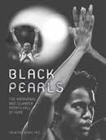
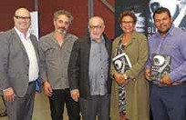

‘It is a national tragedy that a sporting nation like ours remains mostly unaware of these incredible feats by so many Aboriginal and Torres Strait Islander athletes. In Black Pearls Colin and Paul Tatz hold up a mirror reflecting the stories of champions that walk amongst us yet so few of us see.’
Tracey Holmes

Our Performance 87

Our Performance

Photographic collection additions of note
In 2017–18 Rhys Jones’ material from his various research projects in mainland Tasmania and the islands of Bass Strait (including Great Glennie Island and King Island), dating from the late 1960s to the early 1980s, were brought into the Collection. The works include over 2000 images, both colour transparencies and black and white negatives. The earliest photographs are associated with his PhD research while at the University of Sydney and detail the excavations of the Rocky Cape and Preminghana (Mount Cameron West) areas. These images show the rock art, stone artefacts and the excavation techniques of the period. Also included are photographs taken during the filming of Tom Haydon’s 1978 film, The Last Tasmanian. These images show Jones knapping stone and building a canoe (which features in the film). They also show what happens off-camera around the set.
While this collection captures a snapshot of the time, including the activities of other notable archaeologists such as Frederick (F.D.) McCarthy and Jim Allen, it also contains vast amounts of archaeological data that will be of value for future research and to the Traditional Owners of Tasmania.
An interesting challenge was presented by four sub-collections of photographs from the A. Abbie collection consisting of 148 35-millimetre black and white negative reels that have been stored in metal film cylinders for many years, possibly since they were processed in the late 1950s and early 1960s. These films were housed with Abbie’s papers in the vaults since they were lodged with the Institute in the 1970s. In 2010 the films were rehoused and placed in the quarantine room freezer because they were affected by vinegar syndrome. Levels of preservation range from fair to critical.
The 4700 images are predominantly of naked individual people being recorded and measured as part of Abbie’s comparative studies in physical anthropology at Maningrida, Beswick, Kalumburu, Yalata and Yuendumu between 1957 and 1963. While this collection constitutes a valuable visual record of Abbie’s research methodology and the community members photographed, it nevertheless requires sensitive handling due to the confronting nature of many of the images. There are a small number of rolls that include general scenes and community activities which are of wider relevance and require no restrictions to access.
This collection presented further challenges to collection management and technical staff due to the poor storage and condition of the negatives. The films were excessively curled due to the long-term wound storage. Technicians used magnetic film holders to ensure the film strips remained flat for digitisation to enable best capture outcomes. Because of vinegar syndrome, accessioning and digitisation was undertaken in a ventilated space in the former darkroom with a large range hood to remove acetic acid fumes and limit contamination of other Collection material and equipment.
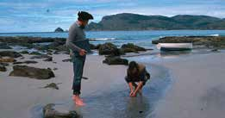
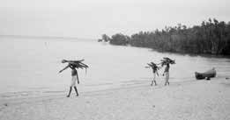

Jim Allen (left) and Rhys Jones during the filming of ‘The Last Tasmania, Bruny Island, Tasmania, 1977, AIATSIS.
88
Group of women collecting firewood, Maningrida, NT, 1959 AIATSIS.

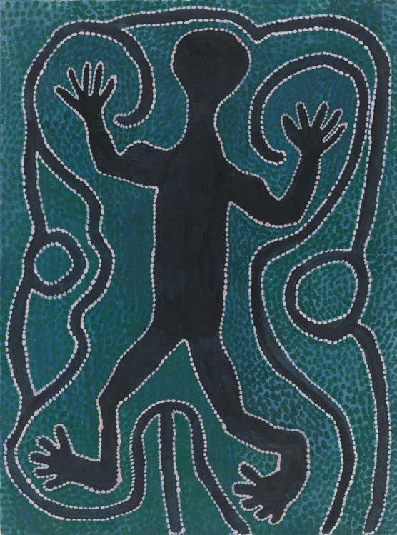

Our Performance 89

Our Performance

STRATEGIC PRIORITY 5
DELIVERING ADVICE TO THE COMMONWEALTH
AIATSIS occupies a unique place between the academic and cultural sectors, government and Indigenous communities.
Changes to the AIATSIS Act in 2016 reinforced AIATSIS’s internationally recognised credentials as leading experts on Aboriginal and Torres Strait Islander culture and heritage.
As a result, AIATSIS is developing capacity and capability to provide sound advice to the Commonwealth and others in relation to Aboriginal and Torres Strait Islander culture and heritage.

KEY OUTCOMES OVER FOUR YEARS
- Provide regular advice to the Commonwealth and others.
- Highly developed advisory capacity.
- Network of relationships.
- Recognised as an authoritative and trusted source of advice on issues relating to Aboriginal and Torres Strait Islander culture and heritage.

ABI improvement continues
The Aboriginal and Torres Strait Islander Biographical Index (ABI) is an internationally recognised name index containing references to Aboriginal and Torres Strait Islander persons. Names are indexed from generally available publications held by AIATSIS and other libraries, including selected memoirs, autobiographies and histories with genealogical information about families and communities. All names of Indigenous persons in a publication are indexed.
The ABI serves Aboriginal and Torres Strait Islander people and communities, Link-Up services around Australia, and other information seekers within and outside AIATSIS. It is an important resource for members of the Stolen Generations who are reconnecting with family members. It also supports the work of the Family History Unit and AIATSIS research activities.
The 2018 review of the ABI recognised that, although the ABI has served the community well since its inception in 1985, in its current format the index could be more user-friendly and operate more effectively with external platforms. At the end of May 2018 indexing was paused to allow for work to commence on a new ABI discovery and dissemination platform, which will still be able to contribute to national aggregators such as Trove. Once completed, the new platform will enable clients better access to the wealth of knowledge in the database.

90

Native Title Research Unit celebrates 25 years of research, policy advice and support for native title holders
For twenty-five years, the NTRU at AIATSIS has worked toward greater recognition and enjoyment of rights for Aboriginal and Torres Strait Islander peoples.
Following the Mabo decision in 1992, the AIATSIS Council appointed a research fellow and established the NTRU in January 1993. AIATSIS brought together academics, lawyers and anthropologists to assist Indigenous peoples with their native title claims. The NTRU has focused on maximising the recognition of native title by actively engaging in law and policy reform.
The NTRU continues to look beyond the limitations of native title to pursue research that secures Indigenous peoples’ rights, strengthens Indigenous self-determination and creates a political and legal breathing space for Indigenous resurgence. AIATSIS has made dozens of submissions and appearances at parliamentary and other inquiries. For example, from 2006, the NTRU was instrumental in securing tax reform for native title holders to reduce uncertainty in the management and administration of compensation and benefits deriving from the loss or impact upon native title.
AIATSIS played a pivotal role in assisting the Treasury to develop the government’s policy position on the tax treatment of native title benefits received by Australian Indigenous communities. The emergence of PBCs was largely ignored by policymakers for the first fifteen years of native title. The notion of a ‘post-determination’ native title era had barely registered as the focus remained on ‘gaining certainty’ by resolving claims.
The NTRU took the initiative to support PBCs to articulate their aspirations and challenges and, in doing so, to assert themselves as a sector to be taken seriously by government. In partnership with the Native Title Representative Bodies (NTRBs), AIATSIS held a series of regional and national meetings of PBCs between 2007 and 2015 and conducted case studies from PBCs across the country. When the Australian Government’s policy focus turned towards PBCs in 2015, AIATSIS’s research evidence base and network of PBCs that had emerged as a part of its work proved influential.
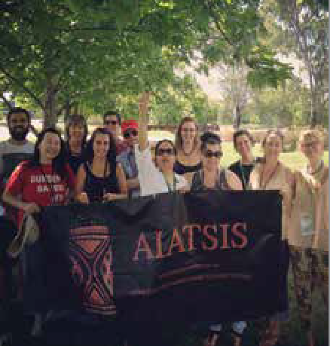
Over the past twenty-five years, the NTRU has run various forums, including legal workshops for practitioners, to share knowledge, improve practice and consider policy reform.
The annual National Native Title Conference is the cornerstone for the native title sector. From 2001, this event has provided a forum for all actors in the sector to engage in debate, identify challenges and celebrate successes.
The native title conference remains the largest Indigenous policy event of Indigenous peoples in the country. Over 130 nations were represented at the 2018 conference in Broome.

Past and present NTRU staff.

Our Performance 91

Our Performance

2017-18 STRATEGIES
Undertake exercise to clearly identify the scope of advice on Aboriginal and Torres Strait Islander culture and heritage
Incorporating Aboriginal and Torres Strait Islander knowledge and culture through collaborative policymaking processes provides a space for Aboriginal and Torres Strait Islander peoples to define themselves and to represent their thoughts and imaginations out of their contemporary experiences. How this should occur has been an ongoing challenge. AIATSIS research and policy advice is driven by community demand and backed by research such as that of the National Indigenous Languages Survey and our existing native title policy advice function.
Throughout 2017–18 AIATSIS mapped the ways in which Indigenous knowledges and heritage are currently ‘measured’ in order to identify existing conceptual and practical gaps in recognition. Some of this work is already occurring via the National Indigenous Languages Report. From this initial scoping exercise, AIATSIS will seek to develop qualitative performance measures to contribute to policy development in this space.

Proactively build advice capability and capacity
There are increasing demands on AIATSIS staff to provide policy-related advice and expertise, translate research into policy-relevant materials, explain evidence bases and input into policy and program design. This will require an ongoing need to build the capability and capacity of our own staff but also to connect policymakers with our communities and stakeholders.
AIATSIS’ outward capability and capacity development occurs via research and information sharing amongst our research and community partners. This sharing takes place through the creation of national forums to connect policymakers to communities and the provision of direct training for Indigenous researchers.
In addition, AIATSIS is taking a leadership role in building cultural capability across government through our online training, ethics services, and advice. This year AIATSIS extended its cultural capability training to the academic and private sectors.

Translating research: native title policy papers
In response to the requests from PM&C for succinct and precise research information to feed into policy discussions, over the past year AIATSIS developed the Native Title Policy Paper report series. This report series feeds high-quality, evidence-based research into current native title policy conversations.
The Native Title Policy Paper report series is available on the AIATSIS website.

92

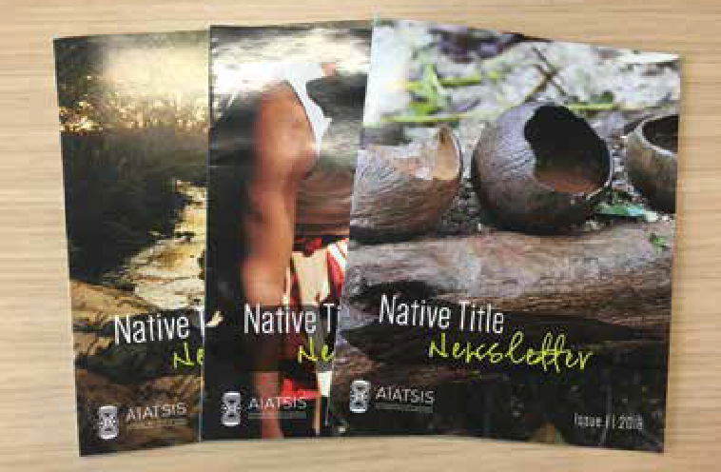

Keeping the native title sector informed
AIATSIS produces a number of regular publications to keep the native title sector informed. Our publications provide readers with the latest information about native title cases and determinations, agreements, events and news.
What’s New in Native Title provides a monthly round-up of native title information, publications and events. It is designed to assist organisations, practitioners and individuals involved in native title to access news, information and resources from a broad range of sources.
For more detailed stories and articles, see our Native Title Newsletter, published biannually and available on the AIATSIS website. The Native Title Newsletter contains contributions from practitioners working in the sector, stories from native title claim groups and corporations and developments on significant events and issues in native title.
If you would like to subscribe to the Native Title Newsletter, please go to www.aiatsis.gov.au/form/subscribe.
We are currently redeveloping our online native title resources into one publicly available, searchable native title database, which will be available on the AIATSIS website shortly.

AIATSIS Native Title Newsletter

Our Performance 93

Our Performance

Collaborate with relative partners and stakeholders in relation to Aboriginal and Torres Strait Islander culture and heritage, such as the Department of the Prime Minister and Cabinet, Department of Education and Training, and Department of Communications and the Arts
AIATSIS partners with policymakers and funding bodies to ensure that research is co-designed based on shared values and mutual benefit. We have partnered with the Department of Communications and the Arts to design and deliver on the National Indigenous Languages Report (NILR) —a multi-party project involving the ANU, AIATSIS, the Department of Communications and the Arts and Cox Inall Ridgeway. The National Indigenous Languages Report (NILR) will develop enduring indicators to measure language health and vitality in Australia in order to inform policy work and funding investment. AIATSIS expertise will specifically contribute to a survey to collect data to determine the state and endangerment level of each Indigenous language. This will feed into an analysis of productive gains of language use as well as a review of existing funding in the sector.
AIATSIS works in partnership with PM&C to provide language expertise and training to senior staff on the use of Australian languages in their roles.
AIATSIS continues to collaborate with the Stolen Generations support sector though the Family History Unit. AIATSIS is actively involved with the work of the sector to ensure the best outcomes for members of the Stolen Generations and their families. The Family History Unit works closely with Link-Up organisations and the Link-Up leadership group to support their clients, including through the provision of research support and the delivery of the Certificate IV in Stolen Generations Family Research and Case Management. The unit actively participates in sector- wide consultations, such as the recent Knowledge Circle hosted by the Healing Foundation. This focused on best practice for access to records that relate to members of the Stolen Generations and identifying and prioritising actions to improve access to these records.
Another significant collaboration for AIATSIS in 2017–18 has been the ongoing work to formalise to and hand over the management of the Lake Eyre Basin ‘Aboriginal Way’ Map. The map was developed by the Department of Agriculture and Water Resources over twelve years, and it will be launched in mid-2018. Following a constructive and positive negotiation process, AIATSIS will be responsible for the ongoing management of this resource.
The map is a single, integrated image of the wide range of Aboriginal groups, places, cultures and histories across the Lake Eyre Basin that will inform, inspire and transform people’s understanding of this region and its diverse peoples.
AIATSIS continues to work closely with PM&C Indigenous Affairs Group, both generally in the provision of advice and on specific funded projects and services contracts.
AIATSIS participates in various public sector networks and interdepartmental forums and meetings.

94

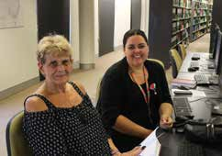
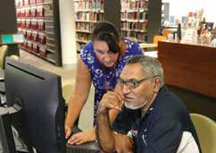
Apology 10 visit from Link-Up Queensland
In February 2018 many members of the Stolen Generations visited Canberra to celebrate the 10th anniversary of the National Apology to the Stolen Generations. This led to a busy week for the Family History Unit at AIATSIS. One of the highlights was the visit from staff and clients from Link-Up (Qld). The Family History Unit works closely with Link-Up services across Australia to support the important work they do with members of the Stolen Generations who are trying to reconnect with their family, community and country.
Two Link-Up (Qld) staff and two clients—Brian and Dot—arranged to visit AIATSIS to learn more about the organisation, our Collection and the work we do. Kayannie Denigan and Sherilyn Dean from the Family History Unit were able to provide a short tour of AIATSIS to give them an overview of the organisation and the services we provide. Brian and Dot searched for information on their families and communities using Mura® and the pictorial collection database. Link-Up staff were able to gain a better understanding of how the Family History Unit can support their research and their clients, and this should result in improved outcomes for those searching for their families and communities.

FHU researcher Sherilyn Dean with Brian Gray, Link-Up Queensland Client (Photo: Link-Up (QLD)
FHU Manager Kayannie Denigan with Dorothea (Dot) Bardell, Link-Up (QLD) Client (Photo: Link- Up (QLD)

Our Performance 95

Our Performance

The Barunga Statement
The 30th anniversary of the creation of the Barunga Statement was marked in 2018.
The Barunga Statement is an enduring document recording an important moment in Australia’s political history. In 1988, the Jawoyn community in Barunga, Northern Territory, invited people from across Australia and the world to their annual Barunga Sport and Cultural Festival. Then Prime Minister the Hon. Bob Hawke, along with Galarrwuy Yunupingu AM and Wenten Rubuntja AM, chairs of the Northern and Central Land Councils, accepted the invitation.
At the festival, Yunupingu and Rubuntja presented the Barunga Statement to then Prime Minister Hawke. The statement is a painted declaration that articulated the aspirations of ‘the Indigenous owners and occupiers of Australia’ and requested that the Australian Government and people ‘recognise our rights’. These significant events were recorded by Kim McKenzie and Wayne Barker for the Australian Institute of Aboriginal Studies Film Unit, resulting in the 1988 documentary Make It Right!
In 2018, in recognition of the anniversary of this important occasion, AIATSIS and the Department of Parliamentary Services undertook a collaborative project that included a physical exhibition at Australian Parliament House (29 May – 29 July 2018), an accompanying website and activities to build knowledge about related items in the collections of both institutions.
The project was launched at Australian Parliament House on 29 May 2018. The launch featured a speech by Senator Patrick Dodson, who gave his personal recollections and reflections on this important history; and a screening of the film Make It Right!

‘Anwerne painting antheke ikwere. Land rights for country line, land rights-ke arratye anetyeke. [We gave him that painting. Land rights for country line—so that there really would be land rights.]’ Wenten Rubuntja—excerpted from his 2002 autobiography, The Town Grew Up Dancing, page 128.
The Barunga Statement is held in the Australian Parliament House Art Collection. It has been on permanent display at Australian Parliament House since December 1991.
The 30th anniversary of the Barunga Statement was a timely opportunity for both institutions to collaborate to identify and build knowledge about relevant collection material and to share these items and their stories to increase public awareness and understanding of this nationally significant artwork and its history.
A key part of the project was engaging with stakeholders—including the Northern Land Council, Central Land Council, Jawoyn Association, Buku-Larnggay Mulka Centre, Galarrwuy Yunupingu and Mervyn Rubuntja—to ensure that the presentation of the Barunga Statement and other items was accurate and appropriate. Materials from the project, including the film, website and digitised collection items, were also made available to stakeholders for their own use in community commemorations.
The project placed the creation and presentation of the statement within the context of the 1988 Barunga Sport and Cultural Festival. The Jawoyn people have hosted an annual festival at Barunga since 1985. Barunga and other festivals are important venues for the celebration and sharing of Aboriginal and Torres Strait Islander cultural practices, and they provide opportunities

96

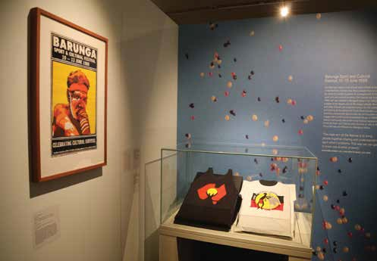

for communities to engage with current social and political issues. The 1988 Barunga Sport and Cultural Festival had the theme ‘Celebrating Cultural Survival’, which was reflected in the selection of items and the curation of the exhibition and website.

‘The main aim of the festival is to bring people together, sharing and understanding each other’s problems. This way we can get to know one another properly.’ Bangardi Robert Lee, quoted in Land Rights News vol. 2, no. 9, July 1988, page 22.
The project showcased unique items from the AIATSIS Collection, including cultural objects—a djirrk (feathered string-bag), clapsticks and headbands—that were gifted to Hazel Hawke as part of the official proceedings at the festival. These items were recent acquisitions to the Collection, having been transferred from the Official Gifts Collection at PM&C. Also featured were promotional items for the festival, including a t-shirt and a poster, the latter designed by renowned artist Chips Mackinolty. AIATSIS is the only public institution to hold copies of these items. While the Barunga Statement itself has been on permanent display at Australian Parliament House since 1991, this project was the first time that many of the other items and their stories had been publicly shared.
The website can be viewed at aiatsis.gov.au/barunga-statement.

Installation view of The Barunga Statement exhibition at Australian Parliament House, featuring items from the AIATSIS Collection including the 1988 Barunga Sport and Cultural Festival poster designed by Chips Mackinolty . Photograph by Andrew Turner

Our Performance 97

Our Performance

Proactively participate in national and international policy debate, expert mechanisms and forums relative to Aboriginal and Torres Strait Islander culture and heritage
AIATSISresearchandgovernanceexpertiseisoftensoughtafterinreviewandreformprocesses. We contributedirectlytolegislativereformanddecision-makingaswellasthestructuresandprocesses that influence our own operations as an organisation.

Informing legislative and government decision-making
During 2017–18, AIATSIS provided advice through written submissions and appearances before parliamentary, government and international inquiries in the areas of specialist research expertise:
- native title and Indigenous corporations
- legal rights, including access to justice and intellectual property
- the integration of culture into policymaking
- marine and water management
- Australian Indigenous languages and interpreting services, including the critical health, social and economic function of language revitalisation
- the OECD’s Environmental Performance Review, including the unique function and status of Aboriginal and Torres Strait Islander knowledges in contributing to Australia’s environmental performance
- the UN Convention on Biological Diversity and the protection of Indigenous knowledges
- Australia’s national research conduct and research ethics frameworks
- copyright modernisation consultations
- Indigenous engagement and employment at galleries and museums in Australia
- Closing the Gap refresh public discussion paper
- reforms to the Native Title Act 1993 (Cth) options paper
- the Parliamentary Inquiry into inauthentic Aboriginal and Torres Strait Islander ‘style’ art and crafts products.
We have also contributed to reviews to ensure effective longer term investment in AIATSIS and the unique services it provides to the government and the Australian public, including:
- the Parliamentary Inquiry into Canberra’s national institutions
- the PGPA Act review.

98

Inaugural National Indigenous Languages Convention
In February 2018, AIATSIS CEO, Craig Ritchie, delivered the keynote address at the inaugural National Indigenous Languages Convention, held at the Gold Coast.
He opened the address remarking:

‘It was only recently that I had] the opportunity to really engage with my language, and it’s really hard to describe what a transforming effect it has on you, and the way you think.’
Mr Ritchie spoke about the significant work of AIATSIS on the preservation, maintenance and revitalisation of Indigenous languages. Since it began in the early 1980s, the Australian Indigenous Languages Collection has grown to over 8000 rare books, pamphlets, school materials; and 40 000 hours of audio recordings. Over 80 per cent of the audio is digitised. The majority of the more than 250 Indigenous languages are represented.
AIATSIS itself has made a start on a language strategy. Mr Ritchie outlined AIATSIS’ Indigenous Languages Strategy. It has three objectives:
- to document every Australian language for use by current and future generations
–requiring focus, effort, resources and partnerships, and needing leadership from communities
- to build the capability of every language community to strengthen their language
- to provide opportunities for every Australian to learn and take pride in an Australian language.
The AIATSIS CEO also called for the development of a National Indigenous Languages Strategy to provide coordination and to link people together at a strategic level.

Our Performance 99

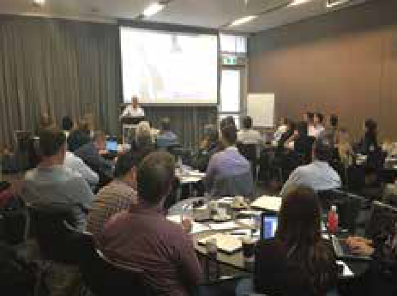
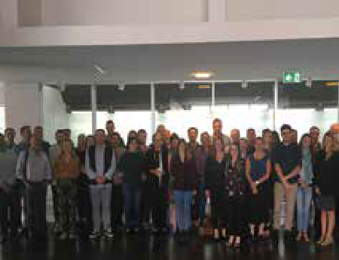
Our Performance

The Native Title Legal Workshop
NTRB and Native Title Service Provider lawyers are at the forefront of native title law, policy and practice.
In February 2018 AIATSIS and the Jumbunna Institute for Indigenous Education and Research at the University of Technology Sydney, co-convened the NTRB Legal Workshop.
The workshop provides an opportunity for NTRB lawyers to share and develop their knowledge of contemporary native title legal issues. This year featured presentations from native title lawyers and barristers on a range of topics including agreement making, taxation of native title payments, the model litigant in native title litigation, fiduciary duties, the proposed amendments to the Native Title Act 1993 (Cth) updates on significant cases.
The workshop was facilitated by Dr Lisa Strelein, Executive Director of Research and Education at AIATSIS, and attended by close to fifty NTRB lawyers.

Vance Hughtson SC presents at the workshop Workshop delegates

100

The new native title corporations website
Over the past year, AIATSIS has worked in collaboration with PM&C and the native title sector to develop the new native title corporations website.
The website provides clear and practical information for native title corporations and stakeholders and also celebrates the successes and achievements of native title groups.
In 2017–18, the department asked AIATSIS to redevelop the PBC website into a ‘one-stop shop’ for native title holders and their corporations. The new website assists native title holders to better understand their rights, obligations and governance functions and contains information that is useful to their PBCs. AIATSIS collaborated with government agencies, native title specialists and PBCs to write and develop the new content.
During 2018, the beta version of the PBC website was presented across the country to PBCs at the PM&C and National Native Title Council Regional PBC Forums. These forums provided participants with the opportunity to interact with the website and make suggestions to ensure the website was responsive to their needs and useful to their corporations. The feedback from these forums was positive, and participants liked the ‘one-stop shop’ concept.
Understanding the pattern of use of technology in Indigenous communities, the new site was built with mobile users as a priority and has many features and services targeted at assisting new and existing PBCs. These new features include an interactive map with data from each PBC, including determination outcomes; links and news; greater information about setting up PBCs; reporting requirements; templates and guides; and detailed information and statistics about PBCs, including PBC size, location and incorporations. Further key developments of the new website are interviews and information from PBCs that successfully undertake different aspects of PBC business and that want to share their stories and successes with other PBCs.
The new PBC website was officially launched during the 2018 National Native Title Conference.

Native title timeline–nativetitle.org.au nativetitle.org.au

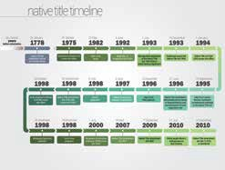
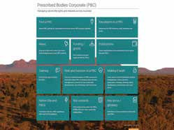
Our Performance
101

Our Performance

2017-18 RESULTS

QUALITY AND EFFICIENCY OF OUTPUTS
MEASURE AND TARGET 2016-17 2017-18 OUTCOME
Policy Submissions–no. | 4 | 11 | +300%
Presentations and workshops for government–no. | N/A | 10 | New measure
Target for this measure | N/A | N/A | New measure

IMPACT MEASURES
MEASURE AND TARGET 2016-17 2017-18 OUTCOME
Institutions utilising Core–no. | 56 | 70 | +22.6%
Enrolments in Core–no. | *2 770 | *6 058 | +119%
Completions of Core–no. | *717 | *2 775 | 287%
Target for this measure | N/A |  | New measure
Completion rate of Core–% | *25.8% | *45.8% | +77%
Target for this measure | N/A |  | New measure

*Figures for Shared Services Commonwealth online learning platform only

102

ANALYSIS
The introduction of a specific strategy related to our advice-giving role provides the opportunity to set baselines for the growth in demand and the improvements to the quality of our advice and services. Initial performance measures identified in this annual report reflect existing strengths that have been relied upon more heavily this year as we promote our advice-giving role.
The impact of the rollout of the Core Cultural Competency Program (Core) across Commonwealth agencies is more evident this year, with an increase in agencies now utilising Core and a significant number of enrolments and completions. At this stage, enrolment and completion statistics are sourced only from the Commonwealth LearnHub shared services delivery platform (fifty-two of seventy agencies), as these are verifiable results. Actuals may be significantly higher.
This function is now integrated into our work practices, with strong community and policy engagement in order to support better connections between community need and policy design. Our success in this area is reflected in requests for policy advice and training; and formal requests to submit expertise and knowledge to review processes both nationally and internationally. In areas such as language revitalisation and native title, our research results are directly translatable to policy discussions through, for example, the Native Title Policy Paper report series and direct training on Australian languages to key policymakers and senior government staff.

Our Performance

103

Our Performance



104

STRATEGIC PRIORITY 6

BUILDING STRONG GOVERNANCE AND ORGANISATIONAL RESILIENCE
AIATSIS recognises that organisational security and sustainability depends greatly on building capability.
For this reason, AIATSIS people management practices strive to:
- promote forward-thinking behaviours
- increase Indigenous employment
- enhance professional competence.
AIATSIS is diversifying its resource base. This has been enabled by changes to the AIATSIS Act, along with modernised governance and additional ongoing funding to support delivery and growth of our program of work.

KEY OUTCOMES
- Governance that reflects best practice, and is achievement-oriented, transparent, and in accord with the expectations of our stakeholders.
- Corporate services that meet the needs of AIATSIS and its staff.
- A knowledge management strategy supports the opening of digital materials to the public, in ways that are meaningful and sustainable.
- A strong profile with government.
- Resources to provide long-term viability and sustainability.
- To be a place where people want to work—a high-performing culture that balances work, life and wellbeing.
- Culturally competent staff.
- More than 35 per cent of staff are Aboriginal or Torres Strait Islander people.

Our Performance
105

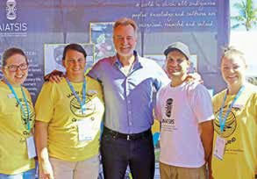
Our Performance

Access stall at National Native Title Conference
In June 2018 members of AIATSIS’ Collection Access Unit (CAU) and Family History Unit attended the National Native Title Conference in Broome, Western Australia. From Tuesday 5 June to Thursday 7 June 2018, conference delegates had the opportunity to seek information, and to view and search AIATSIS’ new pictorial collection discovery platform, the Mura® catalogue and the Aboriginal and Torres Strait Biographical Index (ABI).
At previous national native title conferences, the CAU team used an earlier Perfect Pictures database, which was locally saved and increasingly unstable. As a result of the migration of Perfect Pictures to the new discovery platform, the Pictures Access database, the CAU team was able to offer a browser-based experience, operating off a Drupal platform. This provides a more stable, modern, and searchable interface for clients to interrogate and view over 300 000 images from the AIATSIS Collection. The CAU team found the stall set- up and pack-up much quicker and easier than in previous years due to the reliability and simplicity of the system.
Delegates also found the new tool more user friendly, as they could navigate their way with less assistance than in previous years. Popular features include the ability to filter/ refine searches and for users to edit or add metadata to existing images. The latter allows delegates to provide information and context for images for which there is little to no documentation available. This new function enhances the future discoverability of one of AIATSIS’ most frequently used collection resources.
The conference stall was very well received by the conference delegates in attendance from all over Australia, including locations such as Nambucca Heads, Fitzroy Crossing, South Hedland, Townsville and Port Augusta. Over the conference’s three days, eighty-six visitors kept staff busy. Visitors included community members from around Australia; Senator the Hon. Nigel Scullion; AIATSIS CEO, Craig Ritchie; and Senator Patrick Dodson. As a result, CAU received thirty-three requests for collection material, including photographs, manuscripts and other published print material.

Senator the Hon Nigel Scullion, Minister for Indigenous Affairs, with Family History Unit staff (Elizabeth Koschel and Sherilyn Dean, on left) and Collection Access staff (Heath Garrett and Kylie Simson on right).

106

2017–18 STRATEGIES:

Develop a capital plan to identify the assets and infrastructure that AIATSIS needs to undertake its deliverables and ensure that is funded within the budget process
During 2017–18 Apis Group Pty Ltd completed an independent review of AIATSIS’ sustainability. The resulting Sustainability Plan contains sixteen recommendations over four phases. We have begun to implement the recommendations across the organisation with a focus on revenue and capability.

In conjunction with the AIATSIS Foundation, develop and implement a funding strategy by seeking input from corporate, private and philanthropic sources which allows AIATSIS to undertake work that is in accord with its strategic direction
In February 2018, AIATSIS launched the Dictionaries Project to support the publication of Indigenous language dictionaries. Dictionaries of Aboriginal and Torres Strait Islander languages play a significant role in revitalising and strengthening language. There are many cases where a good dictionary database has been created, but a lack of funding has impeded publication; or where publication has taken place but in low-quality physical formats which have now deteriorated, leaving the community without a dictionary.
Language workers and community speakers working on dictionaries are able to apply for funding so that they are able to publish their dictionaries. The first dictionary to be published through this program is a dictionary of the Warlpiri language. It will be the largest published dictionary of an Aboriginal or Torres Strait Islander language.
The Dictionaries Project will result in many much-needed, high-quality dictionaries of Indigenous languages, promoting and sharing the diverse and rich languages of Australia. More importantly, the project will contribute to foundational resources that will support the maintenance and revival of the many Aboriginal and Torres Strait Islander languages across Australia that are no longer spoken or that are no longer being taught to children.

Redevelop our human resource strategy focused on career advancement for succession planning; high levels of cultural competency; and effective Human Resources support and services for AIATSIS staff and management
In 2017–18, AIATSIS provided access for all staff to the Core Cultural Competency Program. A Learning and Development Program was developed for implementation in 2018–19, which includes leadership training, communications training and technical development training.
AIATSIS is also transitioning some HR services, including payroll, to a shared services provider with direct experience in the cultural sector, which is expected to support business innovation through improved reporting and transparency.
Further information on Core is provided on page 109

Our Performance
107

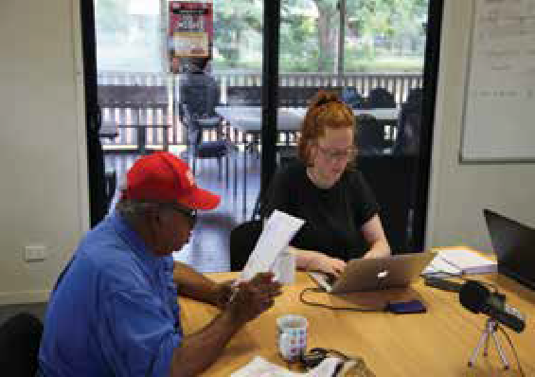
Our Performance

Songlines
The songlines that traverse the Australian landscape hold the unique knowledges of Aboriginal and Torres Strait Islander peoples. They tell of the law, history and culture of diverse groups across the country and have been created, maintained and practised for thousands of years. However, since European arrival this practice has been dramatically disrupted by colonial pressures.
The Songlines Project is an AIATSIS initiative to strengthen, record and revive these songs. The project supports communities concerned by the loss of their knowledge held in song and aims to connect communities, songs and singers.
As part of the Songlines Project, AIATSIS staff worked with Guugu Yimidhirr Elder Frankie Deemal to identify Guugu Yimidhirr songs held in the AIATSIS archive. These songs contain specific Guugu Yimdhirr knowledge and histories. They tell of hunting and fishing techniques and cosmogonic stories. Frankie identified two songs sung by Baru Wilson and one story told by George Bowen, recorded by Jan De Zwaan in 1966, to focus on. Frankie said:

‘Sadly a lot of that kind of knowledge has been lost, but these old fellas here on the recording, they’ve got it, there’s no doubt. What we’ve got to do with those songs, we’ve got to teach the kids. You’ve just got to revive it … you’ve just got to write it out and teach people, somebody’s got to learn it and that’s what we want young people to do.’
Frankie worked with AIATSIS staff to transcribe and map the songs. It is hoped that this will facilitate re-engagement with the songs. The project thus far has seen the return of 111 items from the AIATSIS Collection, including 103 audio recordings, as well as the production of eight new recordings to be added to the AIATSIS archive.

Frankie Deemal dictating in Guugu Yimidhirr to AIATSIS researcher Nell Reidy.

108

Core Cultural Competency Program

Background
In June 2015 AIATSIS partnered with PM&C and the Department of Social Services to develop an Aboriginal and Torres Strait Islander cultural capability e-learning program for use across the Australian Public Service (APS).
The first phase of the Core Cultural Competency Program was completed in 2016, with the original ten-module foundation course designed specifically for Commonwealth employees. The course was made available through the Australian Government’s Shared Services LearnHub platform and directly to other agencies. It is now used by fifty-two agencies, with over 46 per cent completions and 6058 enrolments.
The response to the Core Cultural Competency Program, and its impact and take-up across the public service, created a lot of interest from state agencies and organisations outside of the APS.
This year saw the Core Cultural Competency Program move into its second phase. This meant that, as well as supporting the continued rollout and use within the APS, the course was also adapted for use in states and territories and organisations outside of the APS.

ANU–the first university to adopt Core Cultural Learning
In May 2018 the ANU became the first university in the country to make the Core Cultural Learning: Aboriginal and Torres Strait Islander Australia Foundation Course available to staff and students.
The course was launched as part of ANU’s reconciliation week activities by ANU Vice-Chancellor, Professor Brian Schmidt, and AIATSIS Director of Research and Education, Dr Lisa Strelein.
‘We are very excited because this is such an amazingly high quality set of resources’, Professor Schmidt said at the launch.
‘Core Cultural Learning is designed to enhance cultural capability across ANU and build greater awareness of the vast history and cultural heritage of Aboriginal and Torres Strait Islander peoples.’
‘The University is committed to a renewed partnership with Indigenous Australia and is the first Australian university to implement the program in the higher education sector. I am extremely proud of that’, Professor Schmidt continued.
‘The purpose of having a foundation course that introduces Aboriginal and Torres Strait Islander philosophies but also some fundamental conceptions around the way that Indigenous people engage with policy ... provides a foundation for all of us to actually open up the opportunities for communication’, Dr Strelein commented at the launch.
Dr Strelein, an ANU alumnus who led the development of the course, said the Core Cultural Learning program is only a first step in a lifelong journey of not just recognition but also learning about Indigenous culture.
The course is designed as a first step, to give users and organisations the confidence to engage in further learning to enrich their engagement with Aboriginal and Torres Strait Islander peoples. AIATSIS encourages agencies that are adopting the course to work with local communities and service providers to develop face-to-face training and cultural experiences to build on the course.

Our Performance
109

Our Performance

Maintain strategic engagement with government
In 2017–18 AIATSIS had an opportunity to host the Prime Minister, the Hon. Malcolm Turnbull MP; the Minister for Indigenous Affairs, Senator the Hon. Nigel Scullion and the Minister for Aged Care and Indigenous Health, The Hon. Ken Wyatt AM MP.
AIATSIS also has the pleasure of providing Mr Trevor Evans MP and Ms Cathy McGowan AO MP with a tour of the building and sponsoring the Parliamentary Friends of AIATSIS, which will be launched in late 2018.
A machinery of government change saw the AIATSIS portfolio agency move to PM&C. This relationship has been enhanced and strengthened, with AIATSIS already having a relationship through funding provided for the Family History unit and NTRU.
AIATSIS was invited to sit on two interdepartmental committees for the 2019 Year of the Indigenous Language.

Engage membership in strategic thinking and innovation
The AIATSIS Council reviewed membership options over three meetings in 2017–18, resulting in a number of changes. The implementation of changes is currently being reviewed in line with legislative and regulatory requirements.
One change is the creation of a Membership Standing Committee which reports to the AIATSIS Council on membership applications and engagement strategies.
The changes will be communicated to current members, and a strategy will be developed to increase membership in late 2018.
The membership database has been comprehensively reviewed and updated. This has resulted in a decline in membership numbers this year with the removal of a number of uncontactable members. This year AIATSIS acknowledged the passing of a number of valued members.
As part of the data update, members have been engaged on an individual level, with many playing an active role within the organisation as researchers, depositors, committee members or key advisors.

110

Vale Luise Hercus

16 January 1926 – 15 April 2018
The renowned linguist Dr Luise Anna Hercus has been described as a ‘national treasure’. She made an immense contribution by recording fifty-six Australian Indigenous languages over five decades, culminating in more than 1000 sound recordings and numerous publications. This achievement is astounding in itself. But Dr Hercus’ legacy runs deeper than these impressive figures. She extended her work practice beyond the usual research remit and rigid academic linguistic methodologies of the time by adopting an oral history approach to language elicitation. By forging relationships and trust with Aboriginal people, Dr Hercus gathered more than just strict word elicitation—her warm personal approach encouraged a more relaxed conversational flow, which encouraged participants to recount anecdotal and mythological stories, discuss geographical totems and perform songs in her presence.
Although Dr Hercus’ initial academic studies were in Sanskrit, her interest in Aboriginal languages was first piqued after meeting some children from an Aboriginal reserve in Victoria. She understood the risk of the loss of traditional language due to the prohibitive policies of the day and consequently set out to document languages throughout Victoria, often at her own expense. In 1963 Dr Hercus won an Australian Institute of Aboriginal Studies (the precursor to AIATSIS) grant, additionally supported by loans of tape reels, recording equipment and vehicles, to conduct fieldwork on languages in Victoria. This was just the beginning of a longstanding working relationship with the Institute, which awarded a further ten grants to Dr Hercus, allowing her to expand her field work into South Australia, New South Wales and Western Australia. The resulting enriched recordings form thirty-nine sound collections held at AIATSIS. Dr Hercus took great interest in knowing who was using the collection material and why, often offering extra assistance and knowledge for their endeavours.
Dr Hercus once wrote that she believed she had spoken to or questioned every middle-aged to elderly Aboriginal person throughout Victoria and southern New South Wales. Furthermore, a large proportion of her work was with the Wangkangurru elder Mick Irinyili McLean from the Simpson Desert in South Australia—a man who was deeply committed to preserving the language and cultural knowledge of the people of the northern Lake Eyre basin. Dr Hercus wanted to fulfil Mick McLean’s wish to preserve the cultural history of this area and worked extensively with him over twelve years. Mick McLean attended many field trips with Dr Hercus— field trips which would often end each night with Mick singing songs around the campfire. Mick McLean once remarked, after performing a song, ‘This song will still be there when I am dead and gone. It will be there in the tape recordings’.
This cultural preservation could not have eventuated to such an extent without the tireless,
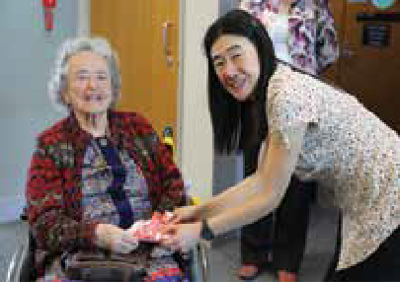
passionate and diligent work of Dr Hercus.
At the Australasian Sound Recordings Association Conference hosted by AIATSIS in 2017, Dr Hercus was awarded the Australasian Sound Recordings Association Award for Excellence for her contributions in linguistic sound recording and research. Dr Hercus was working on a final book of a series when she passed away in April 2018 at the age of ninety-two. Her legacy lives on in her recordings.

Dr Luise Hercus was awarded the Australasian Sound Recordings Association 2017 Award For Excellence: Luise Hercus, and Audio Collection Manager Kazuko Obata. Photograph by Andrew Turner, AIATSIS.
Our Performance 111

Our Performance

2017–18 RESULTS:

EMPLOYEE SATISFACTION
MEASURE AND TARGET | 2016-17 | 2017-18
Employee engagement–APS
Employee Census approval
rating–%  - Job  - Team  - Supervisor  - AIATSIS | Job: 77%  Team: 75%  Supervisor: 80%  AIATSIS: 60% | Job: 59%  Team: 88.5%  Supervisor: 87%  AIATSIS: 39%
Voluntary departure–% | 4.22% | 26.45%
Unscheduled absence–days | 12.08 days per full-time equivalent employee | 12.90 days per full-time equivalent employee

ABORIGINAL AND TORRES STRAIT ISLANDER EMPLOYMENT
MEASURE AND TARGET 2016-17 2017-18 OUTCOME
Proportion of Indigenous staff–% | 25 | 26.5 | –8.5
Target for this measure | N/A | +8% | TARGET NOT MET

ANALYSIS:
The review of functions, an increased focus on sustainability and implementation of recommendations and changes resulted in a decrease in employee satisfaction across the year.
Strategies have been implemented throughout the year which are expected to increase satisfaction among staff for 2018–19. These include staff development opportunities and an amended recruitment and retention strategy, which are all aimed at achieving this function.
The strategic direction setting of the AIATSIS Council across the year focused heavily on reconnection and engagement with AIATSIS members as a key underutilised resource and stakeholder group across many different networks.

112

AIATSIS highlight: audiotape preservation digitisation
The AIATSIS audio collection holds 41 000 hours of recorded sound material, mostly on two common analogue recording formats: compact audio cassette and ¼ inch reel-to-reel tape.
The Audio Digitisation team has made excellent progress on preserving this material over a number of years, with approximately 83 per cent of materials held now preserved through digitisation.
However, the remaining audio collection materials are the most complex and difficult to digitise, as they are commonly in poor condition and subject to a decomposition process known as ‘sticky shed’ syndrome. This is more accurately described as the deterioration of the synthetic glues that bind the sound-carrying magnetic oxide to the acetate tape substrate—so much so that it can ‘shed’ from the substrate during playback, rendering the audio content almost completely unrecoverable.
The CAAMA_27 collection is a mixed collection of materials containing broadcast oral histories, discussion, stories, news and music from the Central Australian Aboriginal Media Association created during the period 1980 to 1994. This collection holds examples of deteriorated sound material. Fortunately, it was successfully digitised this year after careful treatment by AIATSIS audio technical staff assisted by Ms Molly Culbertson—a Master of Conservation intern from the University of Melbourne who has previously assisted AIATSIS with the on-country preservation needs assessment of the Kimberley Aboriginal Law and Culture Centre (KALACC) archive in Fitzroy Crossing, WA.
Tape materials from this collection presented particular difficulties and included an example of Ampex 406 tape—a brand and variety known for rapid deterioration. One tape in particular was strongly affected and showed signs of tape blocking and interlayer adhesion which needed extensive treatment before proceeding to digitisation.
A variety of recovery practices were implemented, including ‘baking’ the tape and then placing it in cold storage with a silica gel moisture scavenger over a period of weeks. Both techniques assisted in reducing the extent of glue binder failure and thereby created a window of opportunity to play back and successfully digitise the affected tape, saving a unique recording.

AIATSIS audio staff, Cameron Burns and Andrew Mooney, assisted by conservation intern, Ms Molly Culbertson, working with deteriorated audio recordings from the CAAMA_27 collection.

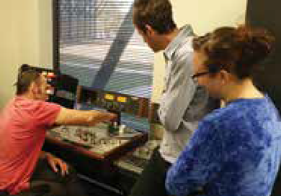
Our Performance
113

Our Performance

AIATSIS highlight: digitisation preservation
–engineering
The AIATSIS archives engineering section maintains the devices and ancillary machines that are needed to play back the sound and vision recorded on the 55 000 hours of video and audio held on magnetic tape in the AIATSIS Collection.
Little is straightforward in the world of digital preservation. Each tape format needs its own specific playback device, and even then that particular machine may only play a proprietary brand of tape.
AIATSIS locates and acquires machines from online auctions, depositors and decommissioned audiovisual suites from as far afield as Korea, Canada and Germany. Some work, some almost work and some of the machines are bought only for spare parts, while some are used to calibrate others. However, as time passes, there are fewer machines around and their rarity is driving up the cost.
There is uniform agreement amongst audiovisual archives locally and internationally that the possibility of playback and digitisation of the majority of magnetic tape-based media will not be possible beyond 2025 because of a combination of the deterioration of the media, the lack of functioning playback devices and the reduction of those skilled in the maintenance of the equipment in the workforce.
Playback device maintenance can be a significant and hidden challenge. For example, the use of plastic parts simplified manufacture and reduced the cost of playback devices, but those plastic parts have become very brittle. When they break, replacements are mostly unavailable. Fortunately, one of the staff at AIATSIS has the skills to mill and cut new gears from brass, and this has successfully extended the operating life for those particular playback devices.
As a result of creating a simple replacement gear, recordings of Indigenous languages and songs on audio cassettes can still be played, digitised and provided to the originating communities. This and many similar examples are commonplace in AIATSIS and Australia’s other audiovisual and cultural heritage institutions.

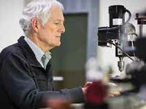
Doug Smith milling new parts to keep the equipment working.

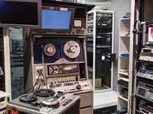
Some of the playback devices needed for the video collection.

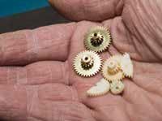
The freshly manufactured brass gears and their nylon counterpart.

114



Our Performance
115

Our Performance

PERFORMANCE
RESULTS
The following three tables summarise the three AIATSIS programs’ performance against the 2017-18 Key Performance Indicators (KPIs) specified in the PBS. More detailed discussion and analysis is presented in the “Strategic Priorities” section, starting at page nn.
The PBS sets this single outcome for AIATSIS:

Further understanding of Australian Indigenous cultures, past and present through undertaking and publishing research, and providing access to print and audiovisual collections

PROGRAM 1.1–AIATSIS Collections
Through collection, preservation, research and promotion AIATSIS will continuously expand its collections and their accessibility to both Aboriginal and Torres Strait Islander peoples and non- Indigenous communities of Australia

KPI MEASURE TARGET MET/ NOT MET
Ability to accept new material that is offered to and accepted into the collection; the rate at which it is preserved and made discoverable and accessible | Percentage increase in the rate at which material is accepted into the collection: TARGET: +2%  Percentage increase in the rate at which the collection is made discoverable: TARGET: +1.5%  Percentage increase in the rate at which the collection is accessed: TARET: +10% | Target met  Target not met  Target not met
Preservation of Aboriginal and Torres Strait Islander cultural heritage to enable all Australians to appropriately access and experience knowledge of Aboriginal and  Torres Strait Islander cultures, traditions, languages and stories, past and present | Percentage increase in the rate of preservation of the collection:  TARGET: +5% | Target not met

116

PROGRAM 1.2: AIATSIS research and education
Through research AIATSIS will support Aboriginal and Torres Strait Islander peoples to secure and strengthen their knowledge and cultural heritage and encourage non-Indigenous Australians to understand and value Aboriginal and Torres Strait Islander knowledge and cultural heritage.

KPI MEASURE TARGET MET/ NOT MET
Delivery of contracted outputs and outcomes to actively strengthen, preserve, and  renew Indigenous knowledge, promote understanding of Indigenous peoples and contribute positively to the wellbeing of Aboriginal and Torres Strait Islander peoples | Contracts completed: TARGET: 100% | Target met
 | Monitor levels of quality and efficiency:
 | Number and value of research publications, grants and other outputs:  TARGET: +10%—maintain ratio | Target met
 | Number of staff publications  TARGET: +10% | Target exceeded
 | Number of researcher publications TARGET: 5 per researcher | Target not met
 | Number of staff presentations  TARGET: 5 per researcher | Target not met
 | Size of grants and research contracts | Target exceeded
 | Revenue from research activities (ratio income to investment) | Target exceeded
 | Number of staff presentations
 | Number and value of research partnerships and applied research:  TARGET: +2% | Target met
 | Number and value of research impact assessments: Evaluations | Target met
 | Reach and take-up of standards and guidance on best practice in research, engagement, publication and collections  TARGET:+100% | Target exceeded
 | External take-up of ethics assessment and approval:  TARGET: +50% | Target exceeded

Our Performance
117

Our Performance

PROGRAM 1.3: AIATSIS public program, publishing, communications and engagement
Through this program AIATSIS will engage with Aboriginal and Torres Strait Islander communities to build knowledge, to share Indigenous culture and heritage and will provide experiences to all Australians through a public program, digital engagement and access and publishing.

KPI MEASURE TARGET MET/ NOT MET
Enable all Australians to learn about and experience knowledge of Aboriginal and Torres Strait Islander cultures, traditions, languages and stories, past and present | Monitor the reach and impact of communication and community engagement activity through:
 | Reach and impact of media coverage:
 | TARGET: 35 media releases, alerts and web news stories (includes media stories featuring AIATSIS) | Target exceeded
 | TARGET: 10 AIATSIS e-newsletters | Target met
 | TARGET: 10 member e-newsletters | N/A
 | TARGET: 35 interviews by media outlets with AIATSIS staff or affiliates | Target exceeded
 | TARGET: 26 request for content/ information by media completed | Target met
Harness digital technology to communicate with quality online content and resources about Aboriginal and Torres Strait Islander Peoples | Reach and impact of website:
 | Percentage increase in website traffic  TARGET: +10% | Target exceeded
 | Train and develop web publishers and editors  TARGET: 10 | Target exceeded
Target groups include: Aboriginal and Torres Strait Islander peoples and communities; non- Indigenous Australians; academic researchers; students; governments; industry; practitioners;  people world-wide who are interested in Aboriginal and Torres Strait Islander culture and heritage | Number of AIATSIS members:
 | Percentage increase in Indigenous members  TARGET: +5% | Target exceeded
 | Percentage increase in members  TARGET: +5% | Target not met
 | Number and value of partnerships:
 | Percentage increase in partnerships  TARGET: +5% | Target met
 | Percentage in value of partnerships  TARGET: +5% | Target not met
Enhance community access to collections online and through public program | Percentage increase in value of a public program  TARGET: +5% | Target met

118

Quality publications for trade and a variety of open access formats | Number and value of publications:
 | TARGET: 6 books  ($243 000 revenue) | Target not met
 | TARGET: 2 journal editions ($20 000 revenue) | Target not met
 | TARGET: 5 other publications | Target exceeded
 | Increase in Indigenous author contribution  TARGET: +8% | Target met

Our Performance
KPI
MEASURE
TARGET MET/ NOT MET
119

OUR
ORGANISATION

Our Organisation

GOVERNANCE
Minister
Portfolio responsibility for AIATSIS from mid-February 2018 was held by the Minister for Indigenous Affairs, Senator the Hon. Nigel Scullion.
Prior to this, the Minister for Education and Training, Senator the Hon. Simon Birmingham, was the responsible Minister for AIATSIS.

AIATSIS Council
The AIATSIS Council is the accountable authority under the Public Governance, Performance and Accountability Act 2013 (Cth) (PGPA Act). It consists of nine members.
Four members are elected from and by AIATSIS members. (Since the Australian Institute of Aboriginal and Torres Strait Islander Studies Act 1989 (Cth) (AIATSIS Act) was amended in March 2016, at least two of the elected members must be Aboriginal or Torres Strait Islander people and two must be women.)
Five members are appointed by the Minister. (The Minister’s appointments must ensure a majority of Indigenous representation and take into account gender balance, skills and experience.)
Council members are appointed or elected for four-year terms and may not serve more than two consecutive terms.
Council members are remunerated in accordance with the Remuneration Tribunal determination for part-time statutory office holders. All members of the AIATSIS Council are non-executive members.
Table 1 provides further information on each of the Council members during 2017–18, including their period of appointment and number of meetings attended.


122

Table 1

Name Gender Position State Start Date End Date Meetings Meetings
Eligible Attended
ELECTED COUNCILORS
Professor Michael McDaniel | M | Chair person | NSW | 17 May  2017 | 16 May  2021 | 4 | 4
Mr Stephen Kinnane | M | Member | WA | 17 May  2017 | 16 May  2021 | 4 | 4
Ms Rachel Perkins | F | Member | NT | 17 May  2017 | 16 May  2021 | 4 | 3
Dr Myfany Turpin | F | Member | NT | 17 May  2017 | 16 May  2021 | 4 | 4
APPOINTED COUNCILORS
Ms Donisha Duff | F | Member | QLD | 10 February  2015 | 9 February  2019 | 4 | 4
Ms Jodie Sizer | F | Member | VIC | 10 February  2015 | 9 February  2019 | 4 | 3
Emeritus Professor Cindy Shannon | F | Member | QLD | 10 February  2015 | 9 February  2019 | 0 | 0
Mr Geoffrey Winters | M | Member | NSW | 10 February  2015 | 9 February  2019 | 4 | 4
Council members’ experience and qualifications are outlined below.


Our Organisation
123

Our Organisation


Professor Michael McDaniel is a member of the Kalari Clan of the Wiradjuri Nation of Central New South Wales. His career in Indigenous higher education and service to the arts, culture and the community spans almost three decades. He is Pro-Vice-Chancellor (Indigenous Leadership and Engagement) and Director of Jumbunna at University of Technology Sydney.
He has held government appointments, including the Minister’s Aboriginal and Torres Strait Islander Advisory Council, National Native Title Tribunal and the NSW Land and Environment Court.
He is Chair of the Board of Bangarra Dance Theatre, a Director with the Australian Major Performing Arts Group, a Director with the Museum of Contemporary Art (Australia), Chair of the MCA (Australia) Indigenous Advisory Group, and Chair of the Sydney Living Museums Aboriginal Advisory Committee. Professor McDaniel is also a member of the National Aboriginal and Torres Strait Islander Higher Education Council (NATSIHEC). Through NATSIHEC he is a member of the World Indigenous Higher Education Consortium (WINHEC) and has participated in the United Nations Permanent Forum on Indigenous Issues (UNPFII) as a NATSIHEC delegate.


Donisha Duff is of Torres Strait Islander descent from Moa and Badu Islands and the Yadhaigana and Wuthathi people (Cape York).
Awarded a Roberta Sykes Fellowship to Harvard University, she is currently a Board Trustee of the Roberta Sykes Indigenous Education Foundation. She is a Board member of the Stars Foundation to empower the educational development of Aboriginal and Torres Strait Islander girls and young women. She is also appointed to the Australia and New Zealand Dialysis and Transplant Registry (ANZDATA) Indigenous Working Group.
Donisha completed a Master of Business Administration (ANU) and was National NAIDOC Scholar of the Year 2014.


Geoffrey Winters is a descendant of the Kamilaroi nation from Walgett in north-west New South Wales. He is currently an associate in Sydney at international law firm Clyde & Co LLP. He was judicial associate to the Honourable Justice Basten of the New South Wales Court of Appeal and to the Honourable Justice Wright of the Supreme Court of New South Wales. Mr Winters graduated with a Bachelor of Arts with Honours in Political Economy and Laws from the University of Sydney, where he was President of the Australian Law Students’ Association.

124


Stephen Kinnane is a Marda Marda man from Miriwoong country in the East Kimberley. A researcher, writer and lecturer for more than twenty years, his interests encompass Aboriginal history, creative documentary and tensions surrounding the ideals of sustainability and the relationships between individuality, community, country, economy and human development.
He has lectured at Murdoch University in Australian Indigenous Studies and Sustainability; and completed a Visiting Research Fellowship at AIATSIS, Canberra. He has been a Senior Researcher for the Nulungu Research Institute of the University of Notre Dame Australia, Broome and remains involved as an Adjunct Research Fellow.
His book Shadow lines was awarded the WA Premier’s Award for Non- Fiction 2004, the Federation of Australian Writer’s Award for Non- Fiction 2004 and the Stanner Award 2004, and it was short-listed for the Queensland and South Australian Premier’s Awards. He co-wrote and produced The Coolbaroo Club (1996)—an ABC TV documentary awarded the Human Rights and Equal Opportunity Commission Human Rights Award for the Arts. He is a member of the boards of Magabala Books, the Australian Dictionary of Biography (ANU) and Indigenous Community Stories WA.


Rachel Perkins is a member of the Arrernte nation, whose lands surround Alice Springs, and the Kalkadoon people from the Mt Isa region.
Ms Perkins has served on agencies including Screen Australia, the Australian Film Commission and the Australian Film Television and Radio School. She was a founding board member of NITV, which she was instrumental in establishing. She is on the board of the Australian Heritage Commission, and has served on the boards of Aboriginal organisations and industry associations, including Bangarra Dance Theatre.
Her company Blackfella Films, established in 1993, is a leader in the creation of Indigenous content, including the series First Contact, Redfern Now, First Australians, Ready For This and its latest production, DNA Nation. Her work as director includes documentaries such as Freedom Ride and the more recent Black Panther Women as well as movies Bran Nue Dae, One Night the Moon, Mabo and the newly released film Jasper Jones.
She also works in the cultural sector, directing festivals such as the Yeperenye Festival for the Centenary of Federation. She researched and published The Black Book—a directory of Indigenous people working in the cultural sector. In more recent times she has focused on the development of Arrernte culture, the first project being an Arrernte Women’s Camp, which recorded and revived the repertoire of Arrernte women’s traditional musical heritage.

Our Organisation
125

Our Organisation


Council member until September 2017


Emeritus Professor Cindy Shannon is a descendent of the Ngugi people from Moreton Bay. In 2011 she was appointed as the Pro-Vice- Chancellor (Indigenous Education) at the University of Queensland and is the Director of the Poche Centre for Indigenous Health.
Professor Shannon was previously the Director of the Centre for Indigenous Health at the University of Queensland and guided the development and implementation of Australia’s first degree- level program to specifically target Aboriginal health workers. She has contributed to Indigenous health policy development and implementation nationally and undertaken a number of independent primary health care service reviews, including a major report for the 2003 interdepartmental review of primary health care service delivery to Aboriginal and Torres Strait Islander communities. Professor Shannon was a member of the National Health and Medical Research Council and chaired its Aboriginal and Torres Strait Islander Research Advisory Committee from 2005 to 2012. Currently a Fellow of the Queensland Academy of Arts and Sciences, she is also a member of the Health and Hospital Fund Advisory Board, Chair of the Queensland Aboriginal and Torres Strait Islander Foundation, a member of the Greater Brisbane Metro South Medicare Local Board and a member of the board of Lives Lived Well.

Dr Myfany Turpin is a linguist and ethnomusicologist at the University of Sydney. She holds an Australian Research Council Future Fellowship to investigate the relationship between words and music in Aboriginal songs in central Australia. She has been conducting research with Aboriginal communities since 1994, focused on Aboriginal song-poetry and Arandic languages.
Her research on the Kaytetye language resulted in a co-authored encyclopaedic dictionary, picture dictionary and collection of stories with Kaytetye speaker Alison Ross. She has written scholarly articles in the areas of semantics, music, phonology and ethnobiology and produced audiovisual publications of Aboriginal songs.
She supports school language and culture programs in central Australia and works with local organisations to produce resources and provide opportunities for Aboriginal people to assist them in their struggle for cultural and linguistic survival.
She is a member of the Musicological Society of Australia, the Australian Linguistics Society and the organising committee for the 2017 Linguistics conference.

126

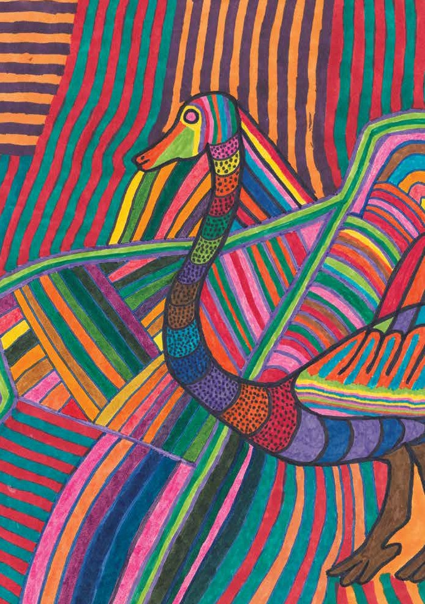
Our Organisation
127

Our Organisation

Organisation Structure
AIATSIS is a national institution based in Canberra. Its main offices are at 51 Lawson Crescent, Acton. AIATSIS also had offices in Childers Street, Canberra City, during 2016–17.
As at 30 June 2017, AIATSIS had 116 employees in total (headcount), with a full-time equivalent workforce of 106.2. Of the total, 53.85 per cent were female and 26.5 per cent identified as Indigenous.

MINISTER FOR INDIGENOUS AFFAIRS
STANDING COMMITTEES
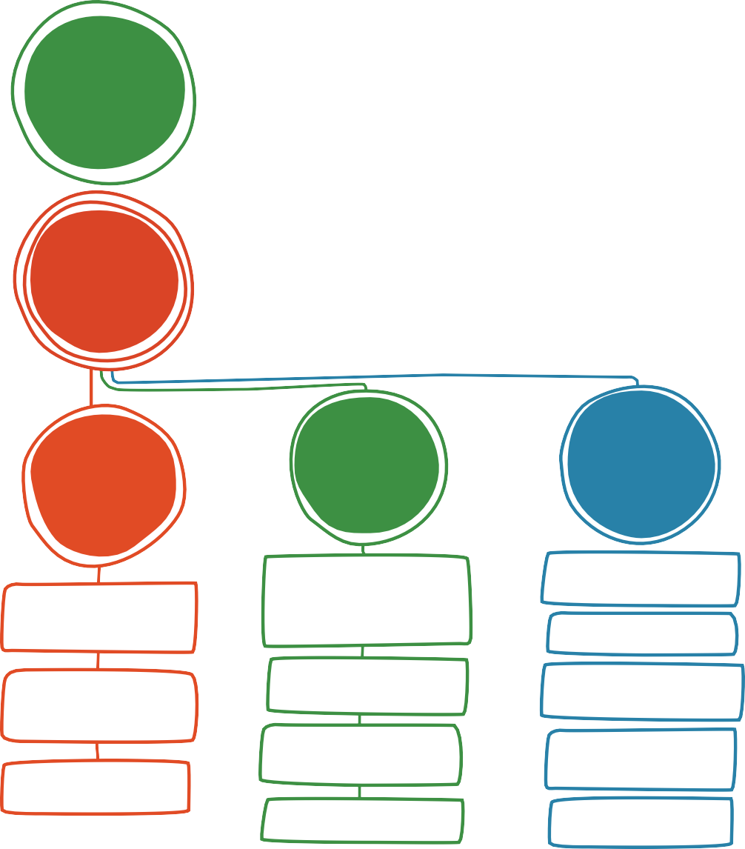
Audit Assurance Committee Foundation Committee Membership Standing Committee Research Ethics Committee

COUNCIL
ADVISORY COMMITTEES
Collections Advisory Committee Native Title Advisory Committee Publishing Advisory Committee Research Advisory Committee

CHIEF EXECUTIVE OFFICER
INTERNAL COMMITTEES
Senior Executive Board Consultative Committee Indigenous Caucus
Cross Program Working Group RAP Working Group
Work Health and Safety

COLLECTIONS GROUP
RESEARCH & EDUCATION GROUP
STRATEGY & OPERATIONS GROUP

COLLECTION MANAGEMENT & DEVELOPMENT

COLLECTION PRESERVATION & INFRASTRUCTURE

COLLECTION SERVICES

128

PUBLISHING & PRODUCT DEVELOPMENT INC. ABORIGINAL STUDIES PRESS

INDIGENOUS CULTURE & HERITAGE

NATIVE TITLE RESEARCH UNIT

RESEARCH GOVERNANCE
BUSINESS DEVELOPMENT INC. FOUNDATION

BUSINESS SERVICES

COMMUNICATION & PUBLIC ENGAGEMENT

EXECUTIVE SUPPORT UNIT

PEOPLE & ASSURANCE

CORPORATE GOVERNANCE
The AIATSIS Council meets four times each year to consider strategic directions and matters of operational significance. It operates under a charter.
A number of committees are established to provide the AIATSIS Council and the CEO with advice about particular issues and areas of business. These committees are listed, along with their membership during 2017–18, in Appendix B.
The Senior Executive Board is the organisation’s main internal governance forum. It comprises the group heads from across AIATSIS, with other members and attendees by invitation of the CEO. The board meets monthly to advise the CEO on strategy and operational matters.
In 2017–18, AIATSIS did not make any related entity transactions.
In 2017–18, AIATSIS did not issue any indemnities to the AIATSIS Council, to its members or to any officers of AIATSIS.

Policy, business and operational environment
There are no government policy orders in effect that applied to AIATSIS during 2017–18, including significant judicial decisions or decisions of administrative tribunals; or reports by the Auditor- General, any parliamentary committee, the Commonwealth Ombudsman or the Office of the Australian Information Commissioner.

Corporate planning and evaluation
The AIATSIS Corporate Plan is updated in line with the PGPA Act and published via our website by 31 August each year.
A quarterly evaluation and assessment of targets and measures is completed by the AIATSIS Council and the Senior Executive Board.

External audit
The Australian National Audit Office is responsible for auditing AIATSIS’ annual financial statements. An unqualified audit opinion precedes the annual financial statements (see page 136).

Our Organisation
129

Our Organisation

Fraud management
AIATSIS is subject to the Commonwealth Fraud Control Framework 2017. As a Corporate Commonwealth Entity (CCE) we must also comply with the Fraud Rule and utilise the Resource management guide 201—Preventing, detecting and dealing with fraud as better practice guidance. The key governance elements of our Fraud Control Framework include a Fraud Control Plan, Fraud Control Policy, Fraud Risk Assessment and the AIATSIS Code of Conduct.
Overseen by our Senior Executive Board, AIATSIS promotes fraud prevention and awareness to staff through mandatory fraud awareness training and executive messaging on a regular basis. We also use a range of strategies to prevent and respond to internal fraud through internal and external reporting, rigorous exercise and monitoring of delegations and use of established systems and processes for prevention, detection, monitoring, evaluation, reporting of and response to fraud within the organisation. We regularly review our fraud prevention and control measures, including our Fraud Risk Assessment and Fraud Control Plan.
There have been no instances of fraud in the 2017–18 year.

Work Health and Safety
AIATSIS ensures the Work, Health and Safety (WHS) of employees through annual health and wellbeing surveys, an active and proactive WHS committee, regular face-to-face and online WHS training, walkarounds, and dedicated WHS resources on the online ‘HR Hub’.
During 2017–18 there were no notifiable incidents or investigations under the Work Health and Safety Act 2011 (Cth).

Financial Resource Management
AIATSIS total financial result is a small surplus of $10,000. The financial results show that AIATSIS has effectively allocated resources to achieve a balanced position in 2017–18.
The Minister received no reports resulting relating to noncompliance with the finance law involving AIATSIS in 2017–18.

Advertising and Market Research
AIATSIS made no payment to advertising agencies, market research organisation, media advertising organisations, polling organisation or direct mail organisations that are reportable under section 311A of the Commonwealth Electoral Act 1918 (Cth).

130

Ecologically sustainable development and environmental performance
AIATSIS contributes to ecological sustainability through both collection and research programs.
Our research activity includes projects related to land and water, culture and heritage and native title that continue to contribute providing understanding of social, cultural and economic factors.
The Collection Group continues to utilise conservation and management practices and products that meet world’s best practice and, where possible, are environmentally responsible. As an example, our motion picture film cleaning solvents are water based and represent the lowest possible impact on the environment both in their use and eventual disposal.
This year the Collections Group also purchased a Teracycle Gloves Recycling Box for recycling nitrile gloves. This is a zero-waste solution for the gloves used by staff handing Collection material.
AIATSIS has been recognised by the ACT Government for our contribution to the environment by reducing waste including diverting over thirty-five kilograms of waste toner from landfill.

People management
AIATSIS’ people management services, including recruitment, workforce planning, reporting, performance and incident management, Work Health and Safety policy, learning and development program, staff entitlements, Shared Services payroll services and negotiations on the AIATSIS Enterprise Agreement, are overseen by the Director, People and Assurance, reporting to the Senior Executive Board.
In 2017–18, negotiations continued on the Enterprise Agreement (EA), with further adjustments required with the implementation of the government’s new Bargaining Policy Framework in February 2018. In May 2018, AIATSIS staff voted against the EA offered. Based on advice from staff representatives, changes to the EA were not required. Instead, staff were seeking further considerations relating to consultative mechanisms in the supporting attachments to the EA. AIATSIS is scheduled to present the EA to staff, with the amended supporting side documents, in the first quarter of 2018–19.
In 2017–18 a Learning and Development Plan and Indigenous Pathway Project were developed and approved for implementation in the second half of 2018.
The Learning and Development Plan will support staff in obtaining and maintaining critical professional skills, in addition to their technical capabilities, such as leadership and communications. The plan also includes an updated online induction package, as well as face- to-face APS Mastery training, including Ethics and Expectations and Work Health and Safety.
In 2017–18 staff development programs were also implemented across AIATSIS, including a 360-degree feedback program for Senior Executive Service (SES) and Executive Level staff and a cognitive awareness process for all staff and contractors.

Our Organisation
131

Our Organisation

Risk management
The AIATSIS Risk Management Framework aligns with the principles of the PGPA Act and the Commonwealth Risk Management Policy.
The framework provides a solid foundation for ensuring a consistent approach to the identification, treatment and monitoring of risks by all staff on an ongoing basis. Documents that assist staff and management to incorporate risk effectively into decision-making include our Risk Appetite Statement, Strategic Risk Assessment, Risk Management Policy, Fraud Control Plan, Business Continuity and Disaster Recovery Plan, and Work Health Safety and Human Resource policies.
Our Audit and Assurance Committee provides independent advice and assurance to the AIATSIS Council on the appropriateness of our accountability and control framework of risk oversight and management.
During 2017–18 we embedded risk appetite and tolerance levels into the framework to help guide day-to-day decision-making. Our AIATSIS Council—Risk Appetite Statement reflects the acceptable level of risk-taking and tolerance to achieve a specific objective or to manage a category of risk. AIATSIS is committed to ensuring the incorporation of risk management into the culture and everyday business operations.
Business continuity management is integral to our risk management framework. It ensures careful planning to enable continuation or timely resumption of critical functions and eventual restoration to normal operations following a Business Interruption Event (BIE). If a BIE occurs, our Business Continuity Management team is convened by the CEO. The team is the central point of communications and coordination for our response and recovery. Through the Internal Audit (IA) Plan we strive to accomplish our objectives by bringing a systematic, disciplined approach to evaluate and improve the efficiency and effectiveness of risk management, internal controls and governance. We currently contract Curijo to provide IA services along with other management initiated reviews.
Our internal audit function is established under the authority of the AIATSIS Council. The Chief Audit Executive is responsible for managing IA effectively and reporting to the Senior Executive Board and Audit and Assurance Committee. Our IA function provides independent, objective assurance designed to add value and improve AIATSIS operations.

132



FINANCIAL
STATEMENTS

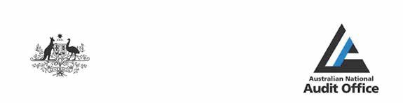

INDEPENDENT AUDITOR’S REPORT
To the Minister for Indigenous Affairs Opinion
In my opinion, the financial statements of the Australian Institute of Aboriginal and Torres Strait Islander Studies for the year ended 30 June 2018:
- comply with Australian Accounting Standards – Reduced Disclosure Requirements and the Public Governance, Performance and Accountability (Financial Reporting) Rule 2015; and
- present fairly the financial position of the Australian Institute of Aboriginal and Torres Strait Islander Studies as at 30 June 2018 and its financial performance and cash flows for the year then ended.
The financial statements of the Australian Institute of Aboriginal and Torres Strait Islander Studies, which I have audited, comprise the following statements as at 30 June 2018 and for the year then ended:
  - Statement by the Accountable Authority, Chief Executive Officer and Chief Financial Officer;
  - Statement of Comprehensive Income;
  - Statement of Financial Position;
  - Statement of Changes in Equity;
  - Cash Flow Statement; and
  - Notes to the financial statements comprising an Overview and other explanatory information.
Basis for Opinion
I conducted my audit in accordance with the Australian National Audit Office Auditing Standards, which incorporate the Australian Auditing Standards. My responsibilities under those standards are further described in the Auditor’s Responsibilities for the Audit of the Financial Statements section of my report. I am independent of the Australian Institute of Aboriginal and Torres Strait Islander Studies in accordance with the relevant ethical requirements for financial statement audits conducted by the Auditor-General and his delegates. These include the relevant independence requirements of the Accounting Professional and Ethical Standards Board’s APES 110 Code of Ethics for Professional Accountants (the Code) to the extent that they are not in conflict with the Auditor-General Act 1997. I have also fulfilled my other responsibilities in accordance with the Code. I believe that the audit evidence I have obtained is sufficient and appropriate to provide a basis for my opinion.
Accountable Authority’s Responsibility for the Financial Statements
As the Accountable Authority of the Australian Institute of Aboriginal and Torres Strait Islander Studies, the Council is responsible under the Public Governance, Performance and Accountability Act 2013 for the preparation and fair presentation of annual financial statements that comply with Australian Accounting Standards – Reduced Disclosure Requirements and the rules made under that Act. The Council is also responsible for such internal control as the Council determines is necessary to enable the preparation and fair presentation of financial statements that are free from material misstatement, whether due to fraud or error.
In preparing the financial statements, the Council is responsible for assessing the Australian Institute of Aboriginal and Torres Strait Islander Studies’ ability to continue as a going concern, taking into account whether the entity’s operations will cease as a result of an administrative restructure or for any other reason. The Council is also responsible for disclosing, as applicable, matters related to going concern and using the going concern basis of accounting unless the assessment indicates that it is not appropriate.

GPO Box 707 CANBERRA ACT 2601
19 National Circuit BARTON ACT
Phone (02) 6203 7300 Fax (02) 6203 7777

136

Auditor’s Responsibilities for the Audit of the Financial Statements
My objective is to obtain reasonable assurance about whether the financial statements as a whole are free from material misstatement, whether due to fraud or error, and to issue an auditor’s report that includes my opinion. Reasonable assurance is a high level of assurance, but is not a guarantee that an audit conducted in accordance with the Australian National Audit Office Auditing Standards will always detect a material misstatement when it exists. Misstatements can arise from fraud or error and are considered material if, individually or in the aggregate, they could reasonably be expected to influence the economic decisions of users taken on the basis of the financial statements.
As part of an audit in accordance with the Australian National Audit Office Auditing Standards, I exercise professional judgement and maintain professional scepticism throughout the audit. I also:
  - identify and assess the risks of material misstatement of the financial statements, whether due to fraud or error, design and perform audit procedures responsive to those risks, and obtain audit evidence that is sufficient and appropriate to provide a basis for my opinion. The risk of not detecting a material misstatement resulting from fraud is higher than for one resulting from error, as fraud may involve collusion, forgery, intentional omissions, misrepresentations, or the override of internal control;
  - obtain an understanding of internal control relevant to the audit in order to design audit procedures that are appropriate in the circumstances, but not for the purpose of expressing an opinion on the effectiveness of the entity’s internal control;
  - evaluate the appropriateness of accounting policies used and the reasonableness of accounting estimates and related disclosures made by the Accountable Authority;
  - conclude on the appropriateness of the Accountable Authority’s use of the going concern basis of accounting and, based on the audit evidence obtained, whether a material uncertainty exists related to events or conditions that may cast significant doubt on the entity’s ability to continue as a going concern. If I conclude that a material uncertainty exists, I am required to draw attention in my auditor’s report to the related disclosures in the financial statements or, if such disclosures are inadequate, to modify my opinion. My conclusions are based on the audit evidence obtained up to the date of my auditor’s report. However, future events or conditions may cause the entity to cease to continue as a going concern; and
  - evaluate the overall presentation, structure and content of the financial statements, including the disclosures, and whether the financial statements represent the underlying transactions and events in a manner that achieves fair presentation.
I communicate with those charged with governance regarding, among other matters, the planned scope and timing of the audit and significant audit findings, including any significant deficiencies in internal control that I identify during my audit.

Australian National Audit Office

Peter Kerr Executive Director
Delegate of the Auditor-General Canberra
20 September 2018


Australian Institute of Aboriginal and Torres Strait Islander Studies

137

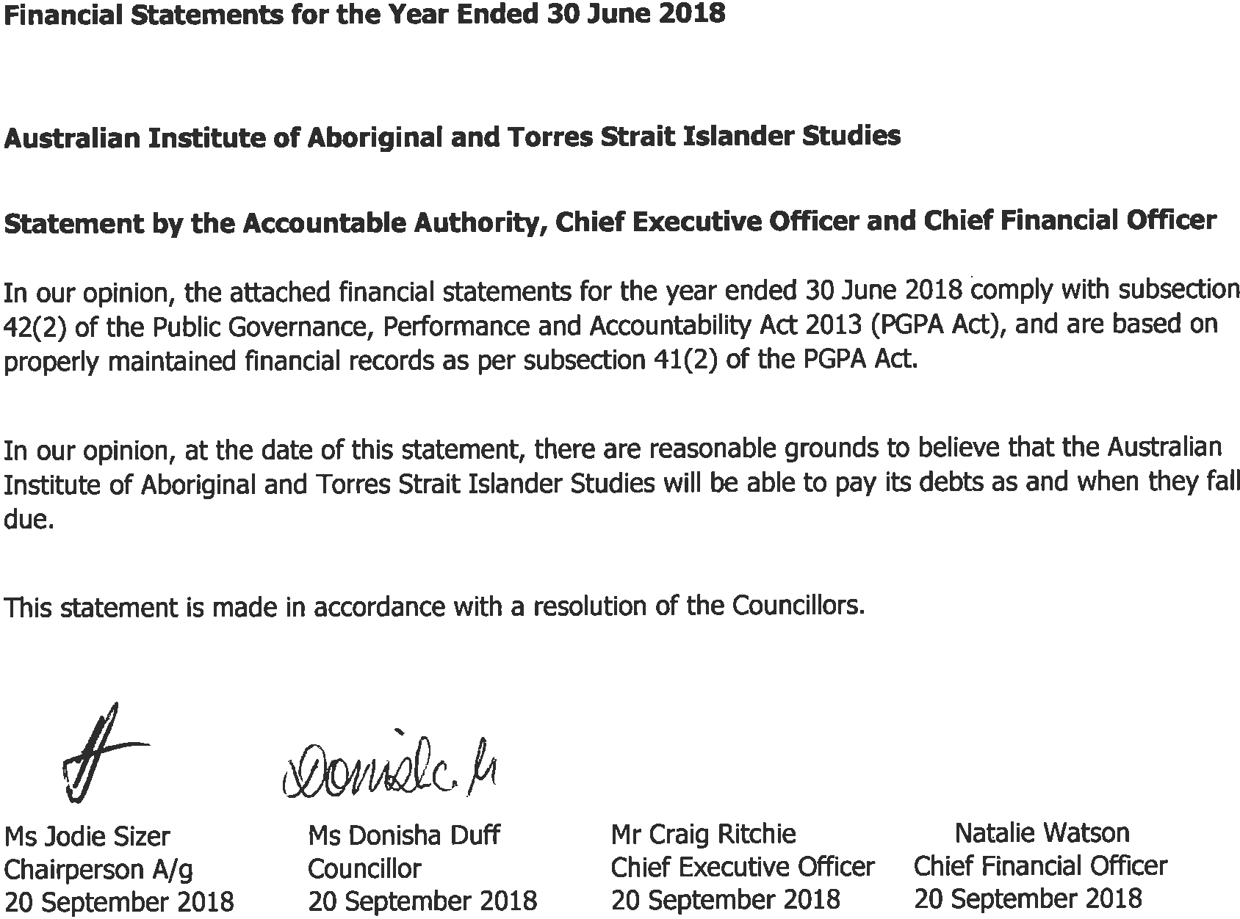

138

Australian Institute of Aboriginal and Torres Strait Islander Studies CONTENTS

Certification
Primary financial statement Statement of Comprehensive Income Statement of Financial Position Statement of Changes in Equity
Cash Flow Statement

Overview

Notes to the financial statements
- Financial Performance
  - Expenses
  - Own-Source Revenue and gains
- Financial Position
  - Financial Assets
  - Non-Financial Assets
  - Payables
- People and relationships
  - Employee Provisions
  - Key Management Personnel Remuneration
  - Related Party Disclosures
- Managing uncertainties
  - Financial Instruments
  - Fair Value Measurement

Australian Institute of Aboriginal and Torres Strait Islander Studies
139

Australian Institute of Aboriginal and Torres Strait Islander Studies STATEMENT OF COMPREHENSIVE INCOME
for the period ended 30 June 2018
 |  |  |  |  |  | Original
 | Notes | 2018 |  | 2017 |  | Budget
 |  | $'000 |  | $'000 |  | $'000
NET COST OF SERVICES
Expenses
Employee Benefits | 1.1A | 11,232 |  | 15,649 |  | 10,822
Suppliers | 1.1B | 11,864 |  | 12,577 |  | 13,435
Depreciation and amortisation | 2.2A | 984 |  | 1,329 |  | 1,196
Total expenses |  | 24,080 |  | 29,555 |  | 25,453
Own-Source Income
Own-source revenue
Sale of Goods and Rendering of Services | 1.2A | 548 |  | 644 |  | 797
Interest | 1.2B | 466 |  | 415 |  | 450
Grants | 1.2C | 2,283 |  | 6,993 |  | 4,713
Other revenue | 1.2D | 1,290 |  | 1,516 |  | -
Total own-source revenue |  | 4,587 |  | 9,568 |  | 5,960
Gains
Reversal of write-downs and impairment | 1.2E | 10 |  | 157 |  | -
Gains from sale of assets | 1.2F | - |  | 8 |  | -
Other gains | 1.2F | - |  | 885 |  | -
Total gains |  | 10 |  | 1,050 |  | -
Total own-source income |  | 4,597 |  | 10,618 |  | 5,960
Net cost of services |  | 19,483 |  | 18,937 |  | 19,493
Revenue from Government | 1.2G | 19,493 |  | 19,817 |  | 19,493
Surplus on continuing operations |  | 10 |  | 880 |  | -
Total comprehensive surplus attributable to the
Australian Government |  | 10 |  | 880 |  | -
The above statement should be read in conjunction with the accompanying notes.

Budget Variances Commentary
Overall result was on target with actuals meeting budget expectations with a small surplus of $0.010m.
Own-source revenue is $1.373m less than predicted. This is mainly due to contracts being negotiated for longer periods than originally anticipated. Other revenue including sale of goods and rendering of services is less than anticipated. It should be noted that Grants and Other revenue are shown as a single line item in the original budget.
Employee benefits was $0.410m higher than budget due to a number of positions budgeted as suppliers being filled by employees.
Supplier Expenses are $1.571m less than the budget due to project timeframes being extended under contract terms. Depreciation and amortisation expense is $0.212m lower than budget due to changes in timing of completion of capital building and equipment purchases.
Original budget is as published in the 2017-18 Portfolio Budget Statements.

140

Australian Institute of Aboriginal and Torres Strait Islander Studies STATEMENT OF FINANCIAL POSITION
as at 30 June 2018
 |  |  |  |  |  | Original
ASSETS | Notes | 2018  $'000 |  | 2017  $'000 |  | Budget  $'000
Financial Assets  Cash and Cash Equivalents | 2.1A | 10,179 |  | 5,028 |  | 144
Trade and Other Receivables | 2.1B | 864 |  | 556 |  | 2,164
Other Investments | 2.1C | 16,716 |  | 14,107 |  | 12,495
Total financial assets |  | 27,759 |  | 19,691 |  | 14,803
Non-financial assets  Buildings | 2.2A | 11,475 |  | 11,670 |  | 12,336
Plant and equipment | 2.2A | 2,192 |  | 2,091 |  | 3,707
Heritage and cultural | 2.2A | 11,280 |  | 11,239 |  | 10,203
Computer software | 2.2A | 89 |  | 180 |  | 181
Inventories | 2.2B | 206 |  | 215 |  | 43
Other Non-Financial Assets | 2.2C | 526 |  | 153 |  | 230
Total non-financial assets |  | 25,768 |  | 25,548 |  | 26,700
Total assets |  | 53,527 |  | 45,239 |  | 41,503
LIABILITIES  Payables  Suppliers | 2.3A | 2,092 |  | 2,458 |  | 655
Other Payables | 2.3B | 10,343 |  | 1,786 |  | 1,043
Total payables |  | 12,435 |  | 4,244 |  | 1,698
Provisions  Employee Provisions | 3.1A | 3,147 |  | 3,134 |  | 2,657
Total provisions |  | 3,147 |  | 3,134 |  | 2,657
Total liabilities |  | 15,582 |  | 7,378 |  | 4,355
Net assets |  | 37,945 |  | 37,861 |  | 37,148
EQUITY  Contributed equity |  | 3,835 |  | 3,761 |  | 3,835
Reserves |  | 13,971 |  | 13,971 |  | 13,971
Retained earnings |  | 20,139 |  | 20,129 |  | 19,342
Total equity |  | 37,945 |  | 37,861 |  | 37,148

The above statement should be read in conjunction with the accompanying notes.

Budget Variances Commentary
Cash and investments are higher than anticipated due to cash received in advance of commencement of new projects, and the timing of completion of planned capital upgrades to the Acton building, plant and equipment. Non-financial assets including Buildings and Plant and equipment are also lower than expected as a result.
Total payables increase of $10.737m is mainly due to funds received in advance for projects commencing in 2018-19.

Australian Institute of Aboriginal and Torres Strait Islander Studies

141

Australian Institute of Aboriginal and Torres Strait Islander Studies STATEMENT OF CHANGES IN EQUITY
for the period ended 30 June 2018
 |  |  |  |  | Original
 | 2018 |  | 2017 |  | Budget
 | $'000 |  | $'000 |  | $'000
CONTRIBUTED EQUITY
Opening balance
Balance carried forward from previous period | 3,761 |  | 3,687 |  | 3,761
Adjusted opening balance | 3,761 |  | 3,687 |  | 3,761
Transactions with owners
Contributions by owners
Equity injection | 74 |  | 74 |  | 74
Total transactions with owners | 74 |  | 74 |  | 74
Closing balance as at 30 June | 3,835 |  | 3,761 |  | 3,835
RETAINED EARNINGS
Opening balance
Balance carried forward from previous period | 20,129 |  | 19,249 |  | 19,342
Adjusted opening balance | 20,129 |  | 19,249 |  | 19,342
Comprehensive income
Surplus for the period | 10 |  | 880 |  | -
Total comprehensive income | 10 |  | 880 |  | -
Closing balance as at 30 June | 20,139 |  | 20,129 |  | 19,342
ASSET REVALUATION RESERVE
Opening balance
Balance carried forward from previous period | 13,971 |  | 13,971 |  | 13,971
Adjusted opening balance | 13,971 |  | 13,971 |  | 13,971
Closing balance as at 30 June | 13,971 |  | 13,971 |  | 13,971
TOTAL EQUITY
Opening balance
Balance carried forward from previous period | 37,861 |  | 36,907 |  | 37,074
Adjusted opening balance | 37,861 |  | 36,907 |  | 37,074
Comprehensive income
Surplus for the period | 10 |  | 880 |  | -
Total comprehensive income | 10 |  | 880 |  | -
Transactions with owners
Contributions by owners
Equity injection | 74 |  | 74 |  | 74
Total transactions with owners | 74 |  | 74 |  | 74
Closing balance as at 30 June | 37,945 |  | 37,861 |  | 37,148

The above statement should be read in conjunction with the accompanying notes.
Accounting Policy
Equity Injections
Amounts appropriated which are designated as ‘equity injections’ for a year (less any formal reductions) are recognised directly in contributed equity in that year.

Budget Variances Commentary
The opening balance of equity is higher than the original budget as published in the 2017-18 Portfolio Budget Statements. This is due to post budget valuation of artworks donated in 2016-17.

142

Australian Institute of Aboriginal and Torres Strait Islander Studies CASH FLOW STATEMENT
for the period ended 30 June 2018
 |  |  |  |  |  | Original
 | Notes | 2018 |  | 2017 |  | Budget
 |  | $'000 |  | $'000 |  | $'000
OPERATING ACTIVITIES
Cash received
Receipts from Government |  | 19,493 |  | 19,817 |  | 19,493
Sales of goods and rendering of services |  | 9,442 |  | 1,673 |  | 797
Interest |  | 478 |  | 427 |  | 450
Grants |  | 2,073 |  | 8,392 |  | 4,713
Other |  | 1,630 |  | 1,425 |  | -
Net GST Received |  | 643 |  | 958 |  | -
Total cash received |  | 33,759 |  | 32,692 |  | 25,453
Cash used
Employees |  | 11,279 |  | 15,614 |  | 10,822
Suppliers |  | 13,954 |  | 11,390 |  | 13,435
Total cash used |  | 25,233 |  | 27,004 |  | 24,257
Net cash from operating activities |  | 8,526 |  | 5,688 |  | 1,196
INVESTING ACTIVITIES
Cash received
Proceeds from sales of property, plant and equipment |  | - |  | 29 |  | -
Net proceeds from matured deposits |  | - |  | - |  | 304
Total cash received |  | - |  | 29 |  | 304
Cash used
Purchase of property, plant and equipment |  | 840 |  | 476 |  | 1,574
Net reinvestment in term deposits |  | 2,609 |  | 2,620 |  | -
Total cash used |  | 3,449 |  | 3,096 |  | 1,574
Net cash from /(used by ) investing activities |  | (3,449) |  | (3,067) |  | (1,270)
FINANCING ACTIVITIES
Cash received
Contributed equity |  | 74 |  | 74 |  | 74
Total cash received |  | 74 |  | 74 |  | 74
Net cash from /(used by ) financing activities |  | 74 |  | 74 |  | 74
Net increase in cash held |  | 5,151 |  | 2,695 |  | -
Cash and cash equivalents at the beginning of the reporting period  Cash and cash equivalents at the end of the reporting |  | 5,028 |  | 2,333 |  | 144
period 2.1A |  | 10,179 |  | 5,028 |  | 144

The above statement should be read in conjunction with the accompanying notes.

Budget Variances Commentary
Cash at the end of the period is $10.035m higher than budget. This is mainly due to cash received in advance of commencement of new projects. Other factors include timing of completion of planned capital upgrades to the Acton building, plant and equipment.
Cash investments - The proceeds from matured investments offset by reinvestments. Net cash increased from timing changes of spending on capital and funds in advance for projects planned for 2018-19 onwards.

Australian Institute of Aboriginal and Torres Strait Islander Studies

143

Australian Institute of Aboriginal and Torres Strait Islander Studies Overview
for the period ended 30 June 2018

The Basis of Preparation
The financial statements are general purpose financial statements and are required by section 42 of the Public Governance, Performance and Accountability Act 2013.
The financial statements have been prepared in accordance with:
- Public Governance, Performance and Accountability (Financial Reporting) Rule 2015 (FRR); and
- Australian Accounting Standards and Interpretations – Reduced Disclosure Requirements issued by the Australian Accounting Standards Board (AASB) that apply for the reporting period.
The financial statements have been prepared on an accrual basis and in accordance with the historical cost convention, except for certain assets and liabilities at fair value. Except where stated, no allowance is made for the effect of changing prices on the results or the financial position. The financial statements are presented in Australian dollars and values are rounded to the nearest thousand dollars unless otherwise specified.

New Accounting Standards
All new or revised standards that were issued prior to the sign-off date and are applicable to the current reporting period did not have a material effect on the entity’s financial statements.
All other new accounting standard and/or interpretations issued prior to the sign-off date and applicable to future reporting periods are not expected to have future material impact on the entity’s financial statements.

Change of Ministerial Portfolio
Australian Institute of Aboriginal and Torres Strait Islander Studies moved from the Department of Education and Training to the Department of the Prime Minister and Cabinet Portfolio on 19 April 2018.

Taxation
The Institute is exempt from all forms of taxation except Fringe Benefits Tax (FBT) and the Goods and Services Tax (GST).

Events After the Reporting Period
There are no known events occurring after the reporting period that could impact on the financial statements.

Contingencies
There are no known contingent assets or liabilities.

144

Australian Institute of Aboriginal and Torres Strait Islander Studies NOTES TO AND FORMING PART OF THE FINANCIAL STATEMENTS
for the period ended 30 June 2018
Financial Performance | 2018 |  | 2017
 | $'000 |  | $'000
Note 1.1 Expenses
Note 1.1A Employee Benefits  Wages and salaries | 8,861 |  | 12,158
Superannuation  Defined contribution plans | 913 |  | 1,399
Defined benefit plans | 613 |  | 722
Leave and other entitlements | 845 |  | 1,370
Total employee benefits | 11,232 |  | 15,649
Accounting Policy
The accounting policy for employee related expenses is contained in the People and relationships section.

Note 1.1B Suppliers
Goods and services supplied or rendered
Consultants | 1,691 |  | 1,214
Contractors | 3,476 |  | 1,943
Travel | 718 |  | 2,914
Building Expenses | 1,265 |  | 621
ICT Expenses | 1,349 |  | 1,093
Other | 2,752 |  | 4,287
Total goods and services supplied or rendered | 11,251 |  | 12,072
Goods supplied | 2,294 |  | 3,254
Services rendered | 8,957 |  | 8,818
Total goods and services supplied or rendered | 11,251 |  | 12,072
Other suppliers  Operating lease rentals | 523 |  | 365
Workers compensation expenses | 90 |  | 140
Total other suppliers | 613 |  | 505
Total suppliers | 11,864 |  | 12,577
Leasing Commitments

In its capacity as lessee, the Australian Institute of Aboriginal and Torres Strait Islander Studies holds a lease at 14 Childers St, Canberra City, which expires on 30 June 2020. The lease does not contain an option for renewal on expiry.

Commitments for minimum lease payments in relation to non-cancellable operating leases are payable as follows:
Within 1 year 554 531
Between 1 to 5 years 578 1,132
Total operating lease commitments 1,132 1,663

Accounting Policy
Operating lease payments are expensed on a monthly rent charged basis which is representative of the pattern of benefits derived from the leased asset.

Australian Institute of Aboriginal and Torres Strait Islander Studies

145

Australian Institute of Aboriginal and Torres Strait Islander Studies
NOTES TO AND FORMING PART OF THE FINANCIAL STATEMENTS
for the period ended 30 June 2018
 | 2018 |  | 2017
 | $'000 |  | $'000
Note 1.2: Own-Source Revenue and gains
Own-Source Revenue
Note 1.2A: Sale of Goods and Rendering of Services
Sale of goods | 489 |  | 351
Rendering of services | 59 |  | 293
Total sale of goods and rendering of services | 548 |  | 644
Accounting Policy
Revenue from the sale of goods is recognised when:
- the risks and rewards of ownership have been transferred to the buyer;
- the Institute retains no managerial involvement or effective control over the goods;
The stage of completion of contracts at the reporting date is determined by reference to the proportion that costs incurred to date bear to the estimated total costs of the transaction.
Receivables for goods and services, which have 30 day terms, are recognised at the nominal amounts due less any impairment allowance account. Collectability of debts is reviewed at the end of the reporting period. Allowances are made when collectability of the debt is no longer probable.

Note 1.2B: Interest  Deposits | 466 |  | 415
Total interest | 466 |  | 415
Accounting Policy
Interest revenue is recognised using the effective interest method.
Note 1.2C: Grants
From related entities | 2,183 |  | 6,811
From external parties | 100 |  | 182
Total grants | 2,283 |  | 6,993
Accounting Policy
Project linked grant revenue is recognised to the extent that the project has occurred. Other grant revenue is recognised to the extent that it was provided for the reporting period. Any grants received in advance for a future period are recorded as liabilities. The exception to this policy is for grants received for non-reciprocal purposes which are recognised when the Institute gains control over the funds.

Note 1.2D: Other Revenue
Conference fees | 1,155 |  | 1,291
Other revenue | 135 |  | 225
Total other revenue | 1,290 |  | 1,516

146

Australian Institute of Aboriginal and Torres Strait Islander Studies
NOTES TO AND FORMING PART OF THE FINANCIAL STATEMENTS
for the period ended 30 June 2018
 | 2018 |  | 2017
 | $'000 |  | $'000
Note 1.2E: Reversal of write -down and impairment
Reversal of writedowns and impairments | 10 |  | 157
Total reversals of previous asset writedowns and impairments | 10 |  | 157
Note 1.2F: Other Gains
Resources received free of charge - donation of Art work received | - |  | 885
Other - sale of assets | - |  | 8
Total Other gains | - |  | 893
Accounting Policy
Sale of Assets
Gains from disposal of assets are recognised when control of the asset has passed to the buyer.
Resources Received Free of Charge
Contribution of assets at no cost of acquisition or for nominal consideration are recognised as gains at the fair value when the asset qualifies for recognition.

Note 1.2G: Revenue from Government
Corporate Commonwealth entity payment item
Department of Education and Training | 16,244 |  | 19,817
Department of Prime Minister and Cabinet | 3,249 |  | -
Total revenue from Government | 19,493 |  | 19,817
The two departments are due to Machinery of Government (MoG) changes.
Accounting Policy
Revenue from Government
Funding received or receivable from non-corporate Commonwealth entities (appropriated to the non-corporate Commonwealth entity as a corporate Commonwealth entity payment item for payment to the Institute) is recognised as Revenue from Government by the Institute unless they are in the nature of an equity injection or a loan.

Australian Institute of Aboriginal and Torres Strait Islander Studies
147

Australian Institute of Aboriginal and Torres Strait Islander Studies NOTES TO AND FORMING PART OF THE FINANCIAL STATEMENTS
for the period ended 30 June 2018

 | 2018 |  | 2017
 | $'000 |  | $'000
Note 2.1: Financial Assets
Note 2.1A: Cash and Cash Equivalents
Cash on hand or on deposit | 10,122 |  | 4,971
Cash on call deposit | 57 |  | 57
Total cash and cash equivalents | 10,179 |  | 5,028
Note 2.1B: Trade and Other Receivables
Goods and services receivables
Goods and services | 373 |  | 443
Total goods and services receivables | 373 |  | 443
Other receivables
GST receivable from the Australian Taxation Office | 497 |  | 191
Total other receivables | 497 |  | 634
Total trade and other receivables (gross) | 870 |  | 634
Less impairment allowance | (6) |  | (78)
Total trade and other receivables (net) | 864 |  | 556
Accounting Policy
Loans and Receivables
Trade receivables and other receivables that have fixed or determinable payments and that are not quoted in an active market are classified as 'loans and receivables'. Receivables are measured at amortised cost using the effective interest method less impairment.
Accounting Judgements and Estimates
There are no material accounting judgements and estimates that impact the above.

Reconciliation of the Impairment Allowance Movements in relation to 2018
 |  | Goods and |  | Total
 |  | Services
 |  | $'000 |  | $'000
As at 1 July 2017 |  | 78 |  | 78
Amounts written off |  | (62) |  | (62)
Adjustments to impaired debts |  | (10) |  | (10)
Total as at 30 June 2018 |  | 6 |  | 6
Movements in relation to 2017
 |  | Goods and |  | Total
 |  | Services
 |  | $'000 |  | $'000
As at 1 July 2016 |  | 203 |  | 203
Amounts written off |  | (52) |  | (52)
Adjustment to impaired debts |  | (73) |  | (73)
Total as at 30 June 2017 |  | 78 |  | 78
Accounting Policy
Financial assets are assessed for impairment at the end of each reporting period.
Note 2.1C: Other Investments
Deposits |  | 16,716 |  | 14,107
Total other investments |  | 16,716 |  | 14,107

148

Australian Institute of Aboriginal and Torres Strait Islander Studies NOTES TO AND FORMING PART OF THE FINANCIAL STATEMENTS
for the period ended 30 June 2018
Note 2.2 : Non Financial Assets

Note 2.2A: Reconciliation of the opening and closing balances of property, plant and equipment (2017-18)

 | Buildings | Plant and equipment | Heritage and  Cultural1 | Computer software2 | Total
 | $’000 | $’000 | $’000 | $’000 | $’000
As at 1 July 2017
Gross book value | 11,865 | 3,100 | 11,274 | 270 | 26,509
Accumulated depreciation, amortisation and impairment | (195) | (1,009) | (35) | (90) | (1,329)
Total as at 1 July 2017 | 11,670 | 2,091 | 11,239 | 180 | 25,180
Additions:
- Purchase | - | 764 | 76 | - | 840
Depreciation and amortisation | (195) | (663) | (35) | (91) | (984)
Other movements:
- Writeback depreciation on disposal | - | 52 | - | - | 52
Disposals:
- Other | - | (52) | - | - | (52)
Total as at 30 June 2018 | 11,475 | 2,192 | 11,280 | 89 | 25,036
Total as of 30 June 2018 represented by:
Gross book value | 11,865 | 3,812 | 11,350 | 270 | 27,297
Accumulated depreciation, amortisation and impairment | (390) | (1,620) | (70) | (181) | (2,261)
Total as at 30 June 2018 | 11,475 | 2,192 | 11,280 | 89 | 25,036

- Land, buildings and other property, plant and equipment that met the definition of a heritage and cultural item were disclosed in the heritage and cultural asset class.
Australian Institute of Aboriginal and Torres Strait Islander Studies
- The carrying amount of computer software included $0.036m purchased software and $0.052 m internally generated software.
- No property, plant and equipment and intangibles are expected to be sold or disposed of within the next 12 months.
- No indicators of impairment were found for non-financial assets.
- The Institute's land and building may not be disposed of without prior Ministerial approval.
Valuation of non-financial assets
A desktop review of the asset values in the AIATSIS asset register as at 30 June 2018 was completed by an independent valuer, Pickles Pty Ltd, and concluded they are in line with their Fair Value, as defined within the AASB 13 Fair Value Measurement standard.
149

Australian Institute of Aboriginal and Torres Strait NOTES TO AND FORMING PART OF THE FINANCIAL
for the period ended 30 June 2018
Accounting Policy - non financial assets
Assets are recorded at cost on acquisition except as stated below. The cost of acquisition includes the fair value of assets transferred in exchange and liabilities undertaken. Financial assets are initially measured at their fair value plus transaction costs where appropriate.
Assets acquired at no cost, or for nominal consideration, are initially recognised as assets and income at their fair value at the date of acquisition, unless acquired as a consequence of restructuring of administrative arrangements. In the latter case, assets are initially recognised as contributions by owners at the amounts at which they were recognised in the transferor’s accounts immediately prior to the restructuring.
Asset Recognition Threshold
Asset purchases are recognised initially at cost in the statement of financial position, except for purchases costing less than $2,000, which are expensed in the year of acquisition (other than where they form part of a group of similar items which are significant in total).
Desktop and laptop computers, heritage and cultural assets are recognised as assets regardless of cost.
The initial cost of an asset includes an estimate of the cost of dismantling and removing the item and restoring the site on which it is located.
Revaluations
Following initial recognition at cost, property, plant and equipment are carried at fair value less subsequent accumulated depreciation and accumulated impairment losses. Valuations are conducted with sufficient frequency to ensure that the carrying amounts of assets did not differ materially from the assets’ fair values as at the reporting date. The regularity of independent valuations depended upon the volatility of movements in market values for the relevant assets.
Revaluation adjustments are made on a class basis. Any revaluation increment is credited to equity under the heading of asset revaluation reserve except to the extent that it reversed a previous revaluation decrement of the same asset class that was previously recognised in the surplus/deficit. Revaluation decrements for a class of assets are recognised directly in the surplus/deficit except to the extent that they reverse a previous revaluation increment for that class.
Any accumulated depreciation as at the revaluation date is eliminated against the gross carrying amount of the asset and the asset restated to the revalued amount.
Depreciation
Depreciable property, plant and equipment assets are written-off to their estimated residual values over their estimated useful lives to the Institute using, in all cases, the straight-line method of depreciation.
Depreciation rates (useful lives), residual values and methods are reviewed at each reporting date and necessary adjustments are recognised in the current, or current and future reporting periods, as appropriate.
Depreciation rates applying to each class of depreciable assets are as follows:
2018 2017
years years
Buildings on lease land 40 to 70 40 to 70
Property, plant and equipment 1 to 20 1 to 20
Heritage and cultural 50 to 99 50 to 99

The Institute has items of property, plant and equipment including heritage and cultural assets that have limited useful lives and are depreciated.
Impairment
All assets were assessed for impairment at 30 June 2018. Where indications of impairment exist, the asset’s recoverable amount is estimated and an impairment adjustment made if the asset’s recoverable amount is less than its carrying amount. The recoverable amount of an asset is the higher of its fair value less costs of disposal and its value in use. Value in use is the present value of the future cash flows expected to be derived from the asset. Where the future economic benefit of an asset is not primarily dependent on the asset’s ability to generate future cash flows, and the asset would be replaced if the Institute were deprived of the asset, the recoverable amounts are expected to be materially the same as fair value.

150

Australian Institute of Aboriginal and Torres Strait NOTES TO AND FORMING PART OF THE FINANCIAL
for the period ended 30 June 2018
Accounting Policy - non financial assets - continued
Derecognition
An item of property, plant and equipment is derecognised upon disposal or when no further future economic benefits are expected from its use or disposal.
Heritage and Cultural Assets
The Institute collects and preserves heritage and cultural assets. The collection includes moving images, photos, art, artefacts and manuscripts.
The Institute has a Digital Preservation Policy which ensures the long-term digital preservation of collection assets held in the Collection. The Institute digitally preserves items identified on the prioritisation schedule within the Collection in adherence to cultural protocols, intellectual property rights and using internationally recognised standards.
Intangibles
The Institute's intangibles comprise internally developed software for internal use and purchased software. These assets are carried at cost less accumulated amortisation and accumulated impairment losses.
Software is amortised on a straight-line basis over its anticipated useful life. The useful lives of the Institute's software are 3 to 5 years.
All software assets were assessed for indications of impairment as at 30 June 2018.

Australian Institute of Aboriginal and Torres Strait Islander Studies
151

Australian Institute of Aboriginal and Torres Strait Islander Studies
NOTES TO AND FORMING PART OF THE FINANCIAL STATEMENTS
for the period ended 30 June 2018
 | 2018 |  | 2017
 | $'000 |  | $'000
Note 2.2B: Inventories
Inventories held for sale
Finished goods | 300 |  | 309
Provision for obsolete inventory | (94) |  | (94)
Total inventories | 206 |  | 215

During 2018, $229,624 of inventory held for sale was recognised as an expense (2017: $265,055).
Accounting Policy
Inventories held for sale are valued at the lower of cost and net realisable value.
Finished goods and work-in-progress inventory that are brought to its present location and condition are costed on the basis of direct materials and labour plus attributable costs that can be capable of being allocated on a reasonable basis.

Note 2.2C: Other non-financial assets
Prepayments | 366 |  | 153
Work in progress -non-financial assets | 160 |  | -
Total other non-financial assets | 526 |  | 153
No indicators of impairment were found for other non-financial assets.
Note 2.3: Payables
Note 2.3A: Suppliers  Trade creditors and accruals | 2,092 |  | 2,458
Total suppliers | 2,092 |  | 2,458
Settlement is usually made within 30 days or as per terms in the contractual arrangements.
There are no contingent assets and liabilities.
Note 2.3B: Other payables  Salaries and wages | 110 |  | 81
Superannuation | 12 |  | 15
Unearned Income | 10,221 |  | 1,690
Total other payables | 10,343 |  | 1,786
Accounting Policy
Contract and project linked grant revenue is recognised with reference to the stage of completion of contracts at the reporting date or extent that the project has occurred. Unearned income remaining at the reporting date and any grants received in advance for a future period are recorded as liabilities.

152

Australian Institute of Aboriginal and Torres Strait Islander Studies NOTES TO AND FORMING PART OF THE FINANCIAL STATEMENTS
for the period ended 30 June 2018
People and relationships
Note 3.1: Employee Provisions | 2018  $'000 |  | 2017  $'000
Note 3.1A: Employee provisions  Leave | 3,147 |  | 3,134
Total employee provisions | 3,147 |  | 3,134
Accounting policy
Liabilities for short-term employee benefits and termination benefits expected within twelve months of the end of reporting period are measured at their nominal amounts.
Other long-term employee benefits are measured as the net total of the present value of the defined benefit obligation at the end of the reporting period minus the fair value at the end of the reporting period of plan assets (if any) out of which the obligations are to be settled directly.

Leave
The liability for employee benefits includes provision for annual leave and long service leave.
The leave liabilities are calculated on the basis of employees’ remuneration at the estimated salary rates that will be applied at the time the leave is taken, including the Institute’s employer superannuation contribution rates to the extent that the leave is likely to be taken during service rather than paid out on termination.
The liability for long service leave has been determined by reference to the short hand method prescribed by Department of Finance. The estimate of the present value of the liability takes into account attrition rates and pay increases through promotion and inflation.

Separation and Redundancy
Provision is made for separation and redundancy benefit payments. The Institute recognises a provision for termination when it has developed a detailed formal plan for the terminations and has informed those employees affected that it will carry out the terminations.

Superannuation
The Institute's staff are members of the Commonwealth Superannuation Scheme (CSS), the Public Sector Superannuation Scheme (PSS), or the PSS accumulation plan (PSSap), or other superannuation funds held outside the Australian Government. The CSS and PSS are defined benefit schemes for the Australian Government. The PSSap is a defined contribution scheme.
The liability for defined benefits is recognised in the financial statements of the Australian Government and is settled by the Australian Government in due course. This liability is reported in the Department of Finance’s administered schedules and notes.

The Institute makes employer contributions to the employees' defined benefit superannuation scheme at rates determined by an actuary to be sufficient to meet the current cost to the Government. The entity accounts for the contributions as if they were contributions to defined contribution plans.
The liability for superannuation recognised as at 30 June represents outstanding contributions.
Accounting Judgements and Estimates
There are no material accounting judgements and estimates that impact the above.

Australian Institute of Aboriginal and Torres Strait Islander Studies
153

Australian Institute of Aboriginal and Torres Strait Islander Studies NOTES TO AND FORMING PART OF THE FINANCIAL STATEMENTS
for the period ended 30 June 2018

Note 3.2: Key Management Personnel Remuneration

Key management personnel are those persons having authority and responsibility for planning, directing and controlling the activities of the Institute, directly or indirectly, including any director of the Institute. The Institute has determined the key management personnel to be Council Members, Chief Executive Officer, Deputy Chief Executive Officer, and Executive Directors. Key management personnel remuneration is reported in the table below:

 | 2018 |  | 2017
 | $'000 |  | $'000
Short-term employee benefits | 983 |  | 923
Post-employment benefits | 149 |  | 117
Other long-term employee benefits | 31 |  | 64
Total key management personnel remuneration expenses1 | 1,163 |  | 1,104

The total number of key management personnel that are included in the above table are 12 (2017: 13).
1. The above key management personnel remuneration excludes the remuneration and other benefits of the Portfolio Minister. The Portfolio Minister's remuneration and other benefits are set by the Remuneration Tribunal and are not paid by the Institute.

Note 3.3: Related Party Disclosures Related party relationships:
The Institute is an Australian Government controlled entity. Related parties to the Institute are Council Members, Key Management Personnel including the Portfolio Minister and Executive and other Australian Government Entities.
Transactions with related parties:
Giving consideration to relationships with related entities, and transactions entered into during the reporting period by the Institute, it has been determined that there are no related party transactions to be separately disclosed.

154

Australian Institute of Aboriginal and Torres Strait Islander Studies NOTES TO THE FINANCIAL STATEMENTS
for the period ended 30 June 2018

Managing uncertainties
4.1 Financial Instruments
 | 2018 |  | 2017
 | $'000 |  | $'000
4.1A: Categories of Financial Instruments
Financial Assets
Loans and receivables
Cash on hand or on deposit | 10,122 |  | 4,971
Cash on call deposit | 57 |  | 57
Fixed Term Deposits with Bank | 16,716 |  | 14,107
Receivables for goods and services | 367 |  | 365
Total financial assets | 27,262 |  | 19,500
Financial Liabilities
Financial liabilities measured at amortised cost
Trade creditors | 2,092 |  | 2,458
Total financial liabilities | 2,092 |  | 2,458
Accounting Policy
Financial assets
The Institute classifies its financial assets in the following categories:
- financial assets at fair value through profit or loss;
- held-to-maturity investments;
- available-for-sale financial assets; and
- loans and receivables.
The classification depends on the nature and purpose of the financial assets and is determined at the time of initial recognition. Financial assets are recognised and derecognised upon trade date.
Effective Interest Method
Income is recognised on an effective interest rate basis except for financial assets that are recognised at fair value through profit or loss.
Impairment of Financial Assets
Financial assets are assessed for impairment at the end of each reporting period.
Financial assets held at amortised cost - if there is objective evidence that an impairment loss has been incurred for loans and receivables or held to maturity investments held at amortised cost, the amount of the loss is measured as the difference between the asset's carrying amount and the present value of estimated future cash flows discounted at the asset's original effective interest rate. The carrying amount is reduced by way of an allowance account. The loss is recognised in the Statement of Comprehensive Income.
Financial liabilities
Financial liabilities are classified as either financial liabilities ‘at fair value through profit or loss’ or other financial liabilities. Financial liabilities are recognised and derecognised upon ‘trade date’.
Other Financial Liabilities
Other financial liabilities, including borrowings, are initially measured at fair value, net of transaction costs. These liabilities are subsequently measured at amortised cost using the effective interest method, with interest expense recognised on an effective interest basis.
Supplier and other payables are recognised at amortised cost. Liabilities are recognised to the extent that the goods or services have been received (and irrespective of having been invoiced).

4.1B: Net Gains or Losses on Financial Assets | 2018 |  | 2017
 | $'000 |  | $'000
Loans and receivables
Interest revenue | 466 |  | 415
Net gains on loans and receivables | 466 |  | 415
Net gains on financial assets | 466 |  | 415

Australian Institute of Aboriginal and Torres Strait Islander Studies
155

NOTES TO THE FINANCIAL STATEMENTS
as at 30 June 2018
4.2 Fair Value Measurement 4.2A: Fair Value Measurement

Fair value measurements at the end of the reporting period

ASSETS | Notes | 2018  $'000 |  | 2017  $'000
Assets measured at fair value  Buildings | 2.2A | 11,475 |  | 11,670
Plant and equipment | 2.2A | 2,192 |  | 2,091
Heritage and cultural | 2.2A | 11,280 |  | 11,239
Total assets measured at fair value |  | 24,947 |  | 25,000
Assets measured at other than fair value, but approximate fair value  Cash and Cash Equivalents | 2.1A | 10,179 |  | 5,028
Trade and Other Receivables | 2.1B | 864 |  | 556
Other Investments | 2.1C | 16,716 |  | 14,107
Assets measured at other than fair value, but approximate fair value |  | 27,759 |  | 19,691
Assets measured at cost  Computer software | 2.2A | 89 |  | 180
Inventories | 2.2B | 206 |  | 215
Other Non - Financial Assets | 2.2C | 526 |  | 153
Total assets measured at cost |  | 821 |  | 548
Total assets stated in the Statement of Financial Position |  | 53,527 |  | 45,239
LIABILITIES  Liabilities measured at other than fair value, but approximate fair value  Suppliers | 2.3A | 2,092 |  | 2,458
Other Payables | 2.3B | 10,343 |  | 1,786
Liabilities measured at other than fair value, but approximate fair value |  | 12,435 |  | 4,244
Liabilities measured at fair value  Employee Provisions | 3.1A | 3,147 |  | 3,134
Liabilities measured at fair value |  | 3,147 |  | 3,134
Total liabilities stated in the Statement of Financial Position |  | 15,582 |  | 7,378
Accounting policy
The assets measured at fair value are valued by an independent valuer at the end of each financial year as outlined in the Accounting Policy note following note 2.2A. For assets measured at cost or other than fair value, their carrying amounts are considered to be equivalent to fair value.

156

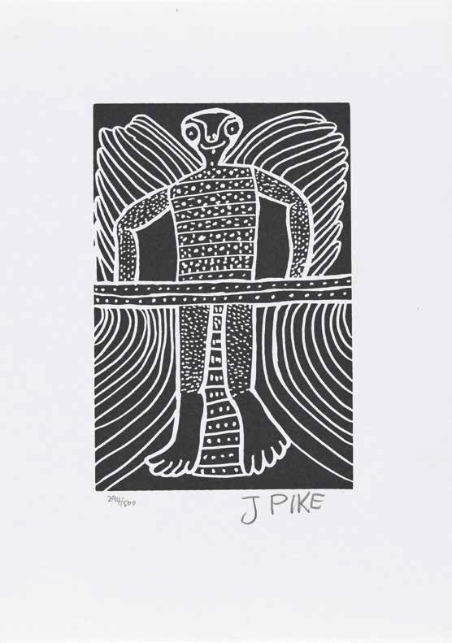

Australian Institute of Aboriginal and Torres Strait Islander Studies
157

APPENDICES

Appendices

APPENDIX A –
RESEARCH PROJECT SUMMARIES

NEW PROJECTS 2017-18

PROJECT NAME: SONGLINES
Start date: 1 March 2018
Completion due: Ongoing
Project summary: The project aims to revive, record and strengthen Aboriginal and Torres Strait Islander songs holding cultural knowledge and history.
Partners: Cape York Land Council

PROJECT NAME: NATIONAL INDIGENOUS LANGUAGES REPORT (NILR)
Start date: 1 May 2018
Completion due: 30 July 2019
Project summary: The National Indigenous Languages Report is the third iteration of the National Indigenous Languages Survey.
Partners: Department of Communication and the Arts, Australian National University, Cox Inall Ridgeway

PROJECT NAME: AIATSIS FOUNDATION DICTIONARIES PROJECT
Start date: 1 July 2017
Completion due: 30 June 2020
Project summary: In response the alarming rates of language loss in Australia, this project supports the publication of Indigenous language dictionaries.
Partners: Department of the Prime Minister and Cabinet, AIATSIS Foundation


160

PROJECT NAME: DECISION-MAKING IN NATIVE TITLE
Start date: July 2017
Completion due: September 2018
Project summary: This project aims to examine decision-making structures, processes and models which best fulfil the demands of native title decision-making and provide options for dispute resolution and management.
Partners: Right People for Country, Aboriginal Victoria and Taungurung Clans Aboriginal Corporation

PROJECT NAME: YOUTH ENGAGEMENT IN NATIVE TITLE
Start date: July 2017
Completion due: August 2018
Project summary: This pilot project examines how youth are being included or not included in native title and what younger people require to increase their participation within native title, including an introductory exploration of succession within native title corporations.
Partners: Australian Indigenous Governance Institute

PROJECT NAME: CORE CULTURAL LEARNING FOR CORRECTIVE SERVICES
Start date: July 2017
Completion due: September 2018
Project summary: In response to the Prisons to Work report, this project will develop a targeted online training course for those employed and working in prisons and corrective services to improve their cultural capability and understanding of Aboriginal and Torres Strait Islander peoples, including their lived experience of incarceration.
Partners: Department of the Prime Minister and Cabinet


Appendices
161

Appendices

PROJECTS COMPLETED IN 2017-18

PROJECT NAME: SINGING THE TRAIN
Start date: January 2014
Completion due: July 2017
Project summary: This was a collaborative history research, recording and exhibition production, connecting Aboriginal communities in the Pilbara with Collection material at AIATSIS.
Partners: Wangka Maya Pilbara Aboriginal Language Centre, Revolutions Transport Museum of Western Australia

PROJECT NAME: UNDERSTANDING NATIVE TITLE ECONOMIES
Start date: 1 July 2014
Completion due: 31 August 2017
Project summary: This project was an economic and socio-cultural analysis of the costs, benefits and values of enacting native title work in the pre-and post-determination periods—from native title claim groups to prescribed bodies corporate (PBCs).
Partners: Nyangumarta Aboriginal Corporation, Eastern Maar Aboriginal Corporation

PROJECT NAME: EQUITY IN NATIVE TITLE
Start date: 1 October 2015
Completion due: 30 June 2018
Project summary: This was a project aimed at reviewing potential options for the leasing of native title lands.
Partners: Department of the Prime Minister and Cabinet

162

PROJECT NAME: NTRB KNOWLEDGE MANAGEMENT DATABASE
Start date: 1 September 2009
Completion due: 30 June 2018
Project summary: This project historically supported the work of legal officers at Native Title Representative Bodies and Native Title Service Providers by providing and managing a knowledge database containing easy to access agreement precedents, advice and court documents.
Partners: Native Title Representative Bodies and Service Providers

PROJECT NAME: ALTERNATIVE SETTLEMENTS AND COMPENSATION
Start date: 1 July 2015
Completion due: 30 June 2018
Project summary: Alternative settlements and Indigenous Land Use Agreements provide some indication as to how Indigenous peoples seek to structure compensatory packages, including an examination of the limited alternative settlements and other compensation packages, with a particular emphasis on seemingly ‘irreparable’ damage to land access.
Partners: The University of Victoria

Appendices
163

Appendices

APPENDIX B
GOVERNANCE COMMITTEES
COMMITTEES ADVISING THE AIATSIS COUNCIL
Audit and Assurance Committee
The Audit and Assurance Committee provides independent assurance and assistance in developing and overseeing the control, risk and compliance framework and external accountability responsibilities.
The committee comprises at least three independent members. Two of the members will be AIATSIS Council members. During 2017–18 members were:
- Ms Karen Hogan FCPA, GAICD (independent member; Chair)
- Mr Andrew Cox (independent member)
- Mr Geoffrey Winters (AIATSIS Council member)
- Prof Cindy Shannon (AIATSIS Council member)—until 2 September 2017
- Ms Donisha Duff (AIATSIS Council member)
- Ms Jodie Sizer (AIATSIS Council member)—from 28 September 2017 to 14 March 2018
- Mr Stephen Kinnane (AIATSIS Council member)—from 15 March 2018.

AIATSIS Foundation
The AIATSIS Foundation works to raise funds to secure the future of the world’s largest and most significant collection of Indigenous Australian culture, history and heritage. The Chair of the AIATSIS Foundation reports to the AIATSIS Council. During 2017–18 members were:
- Ms Rachel Perkins (Chair)
- Mr Geoffrey Winters (AIATSIS Council member)
- Mr Glenn Johnson (Board member)
- Ms Lisa Siganto (Board member)
- Mr Craig Ritchie (Chief Executive Officer)
- Ms Letitia Hope (Deputy Chief Executive Officer).

164

AIATSIS Membership Standing Committee
The AIATSIS Membership Standing Committee provides advice to the AIATSIS Council on membership applications and engagement. During 2017–18 members were:
▪ Ms Donisha Duff (Chair)
▪ Mr Steve Kinnane (AIATSIS Council member)
▪ Professor Michael McDaniel (AIATSIS Council member)
▪ Ms Rachel Perkins (AIATSIS Council member)
▪ Dr Myfany Turpin (AIATSIS Council member)
▪ Ms Letitia Hope (Deputy Chief Executive Officer).

Research Ethics Committee
The AIATSIS Research Ethics Committee is a registered Human Research Ethics Committee that provides independent review of the ethical aspects of research projects, against the National Statement on Human Research Ethics and the AIATSIS Guidelines for Ethical Research in Australian Indigenous Studies. The committee receives internal and external applications.
Members of the committee are in line with categories established by the National Health and Medical Research Council (NHMRC). Membership must include at least five Indigenous members and, as far as practicable, should reflect a gender and age balance. Members normally serve for three-year terms. Members may be reappointed by the AIATSIS Council. During 2017–18 members were:
▪ Ms Kerry Sculthorpe (Chair)
▪ Dr Andrew Crowden
▪ Mr Rob Clifton-Steele
▪ Dr Lorraine Muller
▪ Dr Margaret Raven
▪ Reverend Karen Kime
▪ Ms Melanie Gentgall
▪ Ms Caroline Marsh
▪ Dr Jillian Marsh.
COMMITTEES ADVISING THE CEO

Senior Executive Board
The Senior Executive Board (SEB) supports the CEO in the leadership and strategic management of AIATSIS’ operations. During 2017–18 members were:
▪ Mr Craig Ritchie (Chair, Chief Executive Officer)
▪ Ms Letitia Hope (Chief Operating Officer)
▪ Dr Lisa Strelein (Executive Director Research and Education)
▪ Ms Lyndall Osborne (Executive Director Collections)

Appendices
165

Appendices

Collections Advisory Committee
The Collections Advisory Committee (CAC) was established to provide advice to the AIATSIS CEO and the Executive Directors of Collections on matters in relation to collection development, management and access. This includes providing advice on proposals for major donations or deposits, policy development, risks to the collections, major projects and strategic issues.
The committee comprises four external independent members, the CEO of AIATSIS and the Executive Director of Collections. During 2017–18 members were:
- Dr Veronica Noble
- Mr Daniel Featherstone
- Ms Leilani Bin-Juda
- Ms Kirsten Thorpe
- Mr Craig Richie
- Ms Lyndall Osborne.

Native Title Research Advisory Committee
The Native Title Research Advisory Committee provides advice to the CEO on AIATSIS native title activities. During 2017–18 members were:
- Mr Craig Ritchie (Chair, Chief Executive Officer)
- Dr Lisa Strelein (Executive Director, Research and Education)
- Wayne Beswick (Department of the Prime Minister and Cabinet Representative)
- Natalie Rotumah
- Dr Valerie Cooms
- Ms Melissa George
- Mr Jason Behrendt.

Publishing Advisory Committee
The Publishing Advisory Committee provides general advice to the CEO on publishing policy and strategic matters related to AIATSIS publishing and specific advice on manuscripts. During 2017–18 members were:
- Mr Craig Ritchie (CEO, AIATSIS)
- Ms Rachel Ippoliti (Acting Director, Aboriginal Studies Press)
- Dr Lisa Strelein (Executive Director, Research)
- Dr Tess Lea
- Dr Shino Konishi
- Dr Sandy O’Sullivan.

166

Research Advisory Committee
The Research Advisory Committee provides advice to the CEO on strategic research matters and research priorities. During 2017–18 members were:
▪ Mr Craig Ritchie (Chair, Chief Executive Officer)
▪ Professor Bronwyn Fredericks
▪ Professor Shane Houston
▪ Professor Maggie Walter
▪ Dr Lyndon Ormond-Parker.

Indigenous Caucus
The Indigenous Caucus consists of a voluntary membership of Aboriginal and Torres Strait Islander staff members. It is an energetic, supportive, and cohesive network supporting AIATSIS. Caucus’ key roles are to:
▪ promote and monitor progress towards cultural competency within AIATSIS
▪ promote and monitor recruitment at all levels
▪ provide advice to management on tender and consultancy appointments
▪ participate in AIATSIS planning workshops
▪ lead relevant AIATSIS policy and procedure development
▪ promote AIATSIS in relevant forums
▪ where required, broker cultural knowledge on issues such as artefacts and their storage
▪ coordinate a range of public forums.

Consultative Committee
The AIATSIS Consultative Committee is a joint employee, management and union committee established under the AIATSIS Enterprise Agreement (EA). The purpose of the committee is to discuss matters affecting employment. They work within the framework of the EA to progress employment matters for AIATSIS employees, exercise functions under the EA, and address such matters as are agreed to at the request of the CEO.
The committee comprises representatives of employees, management, and union. There are up to four employee representatives elected by AIATSIS employees, including one representative from the AIATSIS Indigenous Caucus.

Reconciliation Action Plan Working Group
The Reconciliation Action Plan (RAP) Working Group is responsible for developing the new AIATSIS Reconciliation Action Plan and coordinating reporting on the existing RAP. It is made up of staff representatives.

Appendices
167

Appendices

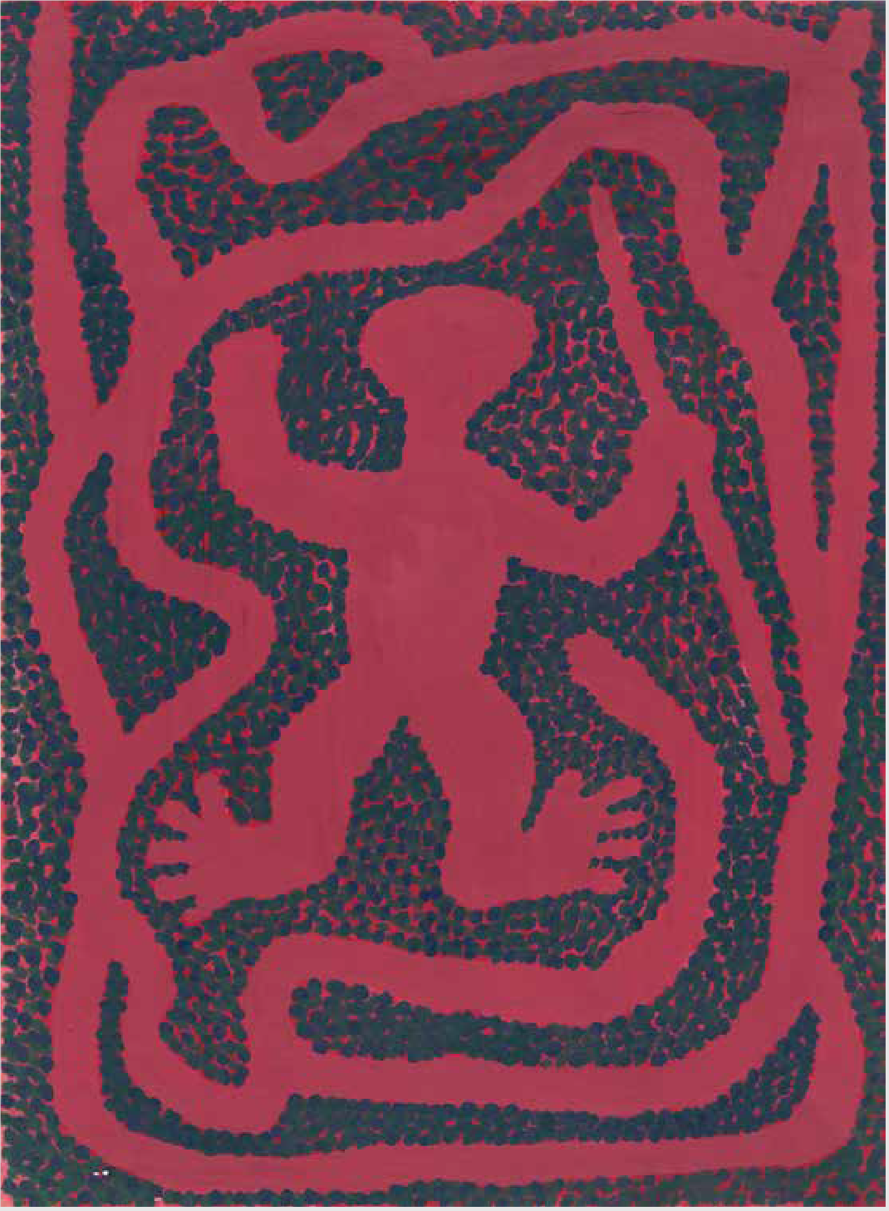

168

APPENDIX C –
STRATEGIC PARTNERSHIPS

NETWORK/PURPOSE | PARTNERS | AIATSIS ROLE
 | Right People for Country,
Decision-making in native title project | Aboriginal Victoria  Taungurung Clans Aboriginal | Project partner
 | Corporation
Youth engagement in native title | Australian Indigenous Governance Institute | Project partner
Develop a curriculum for cultural competency | University of Sydney | Project partner
Songlines project | Cape York Land Council, Dhubbi Warra Aboriginal Corporation, Walmbaar Aboriginal Corporation, Ngan Aak-Kunch Aboriginal Corporation, Abm Elgoring Ambung Aboriginal Corporation, Kuuku Ya-u Aboriginal Corporation, Bromley Aboriginal Corporation, Wuthathi Aborignal Corporation | Project partners
National Indigenous Language Report | Department of Communications and the Arts, Australian National University, Cox Inall Ridgeway | Project partner
2018 National Native Title Conference | Kimberley Land Council, Yawuru Nyamba Buru Aboriginal Corporation | Co-convenor
To run the proposed Breath of Life workshop | Research Network for Linguistic Diversity | Project partner
To carry out the National Indigenous Languages Report | Department of Communications and the Arts | Project partner

Appendices
169

Appendices

NETWORK/PURPOSE | PARTNERS | AIATSIS ROLE
Memorandum of Understanding | Kimberley Aboriginal Law and Culture Centre (KALAAC) | Project partner
Memorandum of Understanding | King’s College London | Collaboration partner
 | Pitt Rivers Museum
Memorandum of Understanding | (The Chancellor Masters and Scholars of the University of | Collaboration partner
 | Oxford)
Memorandum of Understanding | The Smithsonian Institution’s National Museum of the American Indian | Collaboration partner

170

CONTINUING
PARTNERSHIPS 2017–18

Network/Purpose | Partners | AIATSIS Role
 | Queensland University of Technology
 | (lead), Central Queensland University,
 | Charles Darwin University, Australian
 | National University, University of
National Indigenous Research and Knowledges Network (NIRAKN) ARC Strategic Research Initiative | Newcastle, University of Melbourne, University of Tasmania, University of Technology Sydney, University of Western Australia, University of Wollongong,  United Nations University, Aboriginal and | Collaborating organisation
 | Torres Strait Islander Healing Foundation,
 | National Congress of First Peoples,
 | NintiOne, South Coast Women’s Health
 | and Welfare Aboriginal Corporation
ARC Centre of Excellence for the Dynamics of Language | Australian National University (lead), University of Melbourne, University of Queensland, University of Western Sydney, ten international institutions | Partner organisation
 | Lowitja Institute, Edith Cowan University,
Lowitja Institute Cooperative Research Centre for Aboriginal and Torres Strait Islander Health (CRCATSIH) (2014–2019) | James Cook University, Menzies School of Health Research, University of New South Wales, Charles Darwin University, La Trobe University, University of Melbourne,  Griffith University, Queensland Institute of Medical Research Berghofer Medical  Research Institute, Department of Health, Central Australian Aboriginal Congress, Aboriginal Medical Services Alliance  Northern Australia, The George Institute | Essential participant  CRC-funded projects  Collaborative research projects and contract research
 | for Global Health
 |  | Partner
Memorandum of | University of Sydney and Georgetown | steering
Understanding | University (USA) | committee
 |  | coordinator

Appendices
171

Appendices

CONTINUING
PARTNERSHIPS 2017–18

NETWORK/PURPOSE PARTNERS AIATSIS ROLE
Aboriginal and Torres Strait Islander peoples, histories and cultures—develop  a series of educational resources for primary  schools | Cengage Learning Australia | Collaborating organisation—knowledge, expertise, collection materials
Memorandum of Understanding | Australian National University | Partner
Indigenous Desert Alliance | Desert Support Services, Kimberley Land Council | Partner organisation
University of Melbourne’s Grimwade Centre | University of Melbourne | Partner organisation
Memorandum of Understanding | Indigenous Remote Communities Association | Partner

172



Appendices
173

Appendices

APPENDIX D –
RESEARCH OUTPUTS– PUBLICATIONS AND
PRESENTATIONS
Book chapters
Hassing, C., 2018, Untitled section in The Little Red Yellow Black Book, 4th edition, AIATSIS Research Publications, Canberra, pp. 158–178.
Hercus, L. & Koch, G., 2017. ‘Lone Singers: the others have all gone’, in Wafer, J & Turpin, M (eds), Recirculating Songs: Revitalising the Singing Practices of Indigenous Australia, Asia- Pacific Linguistics, College of Asia and the Pacific, Australian National University, Canberra, pp. 102–118.
Koch, G. & Obata, K., 2018, ‘“I am sorry to bother you”: a unique partnership between Luise Hercus and the Australian Institute of Aboriginal and Torres Strait Islander Studies’, in Austin, P.K., Koch, H. & Simpson, J. (eds), Language, Land and Song: Studies in Honour of Luise Hercus, EL Publishing, London, pp. 44–56. http://www.elpublishing.org/PID/2003
Singley, B., 2018, ‘The uncultivated taste: explorers’ accounts of Aboriginal foodways in nineteenth century Australia’, in Piatti-Farnell, L. & Brien, D. (eds), The Routledge Companion to Literature and Food, Routledge, London.
Strelein L., 2018, ‘Representing Indigenous peoples in the landscape’, in Corntassel, J., Alfred, T., Goodyear Ka‘ōpua, N., Silva, N.K., Aikau, H. & Mucina, D. (eds), Everyday Acts of
Resurgence: People, Places, Practices, Daykeeper Press, Olympia, pp. 69–74.
Walsh, M, 2017, ‘Language reclamation and mental health: Revivalistics in the service of the wellbeing of Australian Aboriginal people’ (with Ghil’ad Zuckermann), in Day, D., Rewi, P. & Higgins, R. (eds), The Journeys of Besieged Languages, Cambridge Scholars Publishing, Newcastle upon Tyne, pp. 94–122.
Walsh, M., 2018, ‘Language is like food: links between language revitalization and health and wellbeing’, in Hinton, L., Huss, L. & Roche, G. (eds), The Routledge Handbook of Language Revitalization, Routledge, London, pp. 5–12.
Journal Articles (peer reviewed)
Hayward, J., Johnston, I.G., May, S.K. & Tacon, P.S.C., 2018, ‘Memorialization and the stencilled rock art of Mirarr Country, northern Australia’, Cambridge Archaeological Journal, 28(3), pp.
361-378.
Jones, R, Thurber, K.A., Chapman, J., D’Este, C., Dunbar, T., Wenitong, M., Eades, S., Strelein, L., Davy, M., Du, W., Olsen, A., Smylie, J., Banks, E. & Lovett, R. (on behalf of the Mayi Kuwayu Study Team), 2018, ‘Study protocol: Our Cultures Count—The Mayi Kuwayu Study, a national longitudinal study of Aboriginal and Torres Strait Islander wellbeing’, BMJ Open, 8(6).

174

Tran, T. & Barcham, C., 2018, ‘(Re)defining Indigenous intangible cultural heritage’, AIATSIS Discussion Paper Series, 37, pp. 1–25.
Wiltshire, K.D., 2017, ‘From archaeologist to archivist: exploring the research potential, content and management of a moving image archive’, Advances in Archaeological Practice, 5(3), pp.
289–296.

Articles and reports (non-peer reviewed)
Australian Institute of Aboriginal and Torres Strait Islander Studies, 2017, ‘Creating archives’, AIATSIS, Canberra, https://aiatsis.gov.au/sites/default/files/products/research_outputs creating_archives.pdf, accessed 9 August 2018.
Battin, J. & Mills, A., 2017, ‘Sharing success, measuring impact: annotated bibliography’, AIATSIS, Canberra, https://aiatsis.gov.au/sites/default/files/products/research_outputs_web_ publication/sharing_success_measuring_impact_annotated_bibliography.pdf, accessed 9
August 2018.
Blechynden, A., 2017, ‘Decision-making: constitutions of prescribed bodies corporate’, AIATSIS Native Title Policy Paper 2, pp. 1–4.
Blechynden, A., 2017, ‘Dispute management: constitutions of prescribed bodies corporate’, AIATSIS Native Title Policy Paper 3, pp. 1–4.
Blechynden, A., 2017, ‘Kuruma Marthudunera: finding a pathway through the cultural, legal and administrative maze’, Native Title Newsletter, Issue 2, October 2017.
Blechynden, A., 2017, ‘National picture: constitutions of prescribed bodies corporate’, AIATSIS Native Title Policy Paper 1, pp. 1–3.
Brand, S., 2018, ‘Aboriginalia: conversations and connections’, Tony Albert: Visible, Gallery of Modern Art, Queensland Art Gallery, Brisbane.
Burbidge, B., 2017, ‘Distribution of wealth and growth of PBCs by size’, AIATSIS Native Title Policy Paper 5, pp. 1–4.
Burbidge, B., 2017, ‘PBC financial growth: national picture’, AIATSIS Native Title Policy Paper 4, pp. 1–4.
Hassing, C. & Barcham, C., 2018, ‘Summary of proposed reforms to the Native Title Act 1993’, AIATSIS Native Title Newsletter, Issue 1, April 2018.
Hassing, C. & Burbidge, B., 2018, ‘Managing RNTBC membership decisions’, AIATSIS Native Title Newsletter, Issue 1, April 2018.
Lang, C. & Burbidge, B., 2017, ‘Mabo anniversary commemorations on Mer: native title symposium’, AIATSIS Native Title Newsletter, Issue 2, October 2017.
Proctor, E., 2018, ‘Sustainability and disposable gloves’, AICCM National Newsletter, No. 142, https://aiccm.org.au/national-news/sustainability-and-disposable-gloves, Reidy, N. & Tran, T., 2017, ‘Keeping the Desert Stories Alive: Community report — Kiwirrkurra’, September, AIATSIS, Canberra.
Smyth L., 2018, ‘Aboriginal fishing values of the far west coast of South Australia: community report for the Livelihood Values of Indigenous Customary Fishing project’, AIATSIS Community Report, Canberra.

Appendices

175

Appendices

Smyth L., 2018, ‘Aboriginal fishing values of the south coast of NSW: community report for the Livelihood Values of Indigenous Customary Fishing project’, AIATSIS Community Report, Canberra.
Smyth L., 2018, ‘Livelihood Values of Indigenous Customary Fishing’, AIATSIS Project Report, Canberra.
Smyth L., 2018, ‘Yolŋu fishing values of the Crocodile Islands: community report for the Livelihood
Values of Indigenous Customary Fishing project’, AIATSIS Community Report, Canberra.
Strelein, L., 2018, ’25 years of the Native Title Research Unit’, AIATSIS Native Title Newsletter, Issue 1, April 2018.
Walsh, M., 2018, ‘Exploring possibilities of acquiring papers of former AIATSIS grantees’. AIATSIS Collections Consultancy, 15 January 2018.
Walsh, M., 2018, ‘Preliminary report on Wamba Wamba / Wemba Wemba’, Consultancy report for Wiradjuri Condoblin Corporation, 18 April 2018.
Walsh, M., 2018, ‘Preliminary report on Wiradjuri’, Consultancy report for Wiradjuri Condoblin Corporation, 8 June 2018.
Walsh, M., 2018, ‘Report on the Laves Collection MSS 2188 and 2189’, AIATSIS Collections Consultancy, 15 January 2018.
Woods, R., Rigney, G. & Smyth, L., 2017, ‘The National Cultural Flows Research Project’, AIATSIS Native Title Newsletter, Issue 2, October 2017.

Submissions
Barcham, C., Tran, T. & Strelein L., 2018, AIATSIS submission to OECD Environmental Performance Review, May 2018.
Kincaid, H. & Hassing, C., 2017, Inner City Legal Centre Sydney submission to The Justice Project, September 2017.
Smyth, L. & Egan, G., 2017, submission on the draft Marine Estate Management Strategy 2018–2028, December 2017.
Strelein, L. & Burbidge, B., 2018, AIATSIS submission to issues paper: review of National Statement on Ethical Conduct of Human Research, Section 4—Ethical considerations specific to participants, May 2018.
Strelein, L. & Hassing, C., 2017, AIATSIS response to Office of the Registrar of Indigenous Corporations (ORIC) Technical Review of the Corporations (Aboriginal and Torres Strait Islander Act) 2006, October 2017.
Strelein, L. & Tran, T., 2017, comments on papers being put to the next intersessional meetings for the Convention on Biological Diversity Working Group for Indigenous Peoples and Communities, November 2017.
Strelein, L., 2017, questions for targeted consultation on the review of the Australian Code for the Responsible Conduct of Research, National Health and Medical Research Council, November 2017.
Strelein, L., Hassing, C., Tran, T., Barcham, C., Burbidge, B. & Little, S., 2018, Reforms to the Native Title Act 1993 (Cth), February 2018.

176

Strelein, L., Kennett, R. & Smyth, L., 2017, AIATSIS submission to the Productivity Commission Inquiry into Marine Fisheries and Aquaculture, October 2017.
Strelein, L., Tran, T. & Barcham, C., 2018, AIATSIS submission: Closing the Gap Refresh public discussion paper, April 2018.
Tran, T., Allen, T. & Ippoliti, R., 2017, AIATSIS submission to the Productivity Commission Inquiry into Intellectual Property Arrangements, July 2017.
Tran, T. & Barcham, C., 2018, AIATSIS submission to the departmental inquiry into Commonwealth rights and interests in Indigenous property, Department of the Prime Minister and Cabinet, June 2018.

Book Reviews
Blechynden, A., 2017, ‘Gularabulu: stories from the West Kimberley’, book review, Australian Aboriginal Studies, Issue 2, December 2017, pp. 103–105
Reidy, N., 2018, ‘Film review: Remembering Yayayi’, Australian Aboriginal Studies, Issue 1, June 2018, pp. 76–78.

Multimedia publications and exhibitions
AIATSIS 2018, The Barunga Statement (online exhibition), https://aiatsis.gov.au/barunga- statement
AIATSIS 2018, A Possum Skin Cloak (online exhibition expansion) https://aiatsis.gov.au/ exhibitions/possum-skin-cloak
AIATSIS 2018, Day of Mourning (online exhibition) https://aiatsis.gov.au/exhibitions/day- mourning-26th-january-1938
Hassing, C. & Little, S., 2017, What’s New in Native Title, June 2017. Hassing, C. & Little, S., 2017, What’s New in Native Title, July 2017. Hassing, C. & Little, S., 2017, What’s New in Native Title, August 2017. Hassing, C. & Little, S., 2017, What’s New in Native Title, September 2017. Hassing, C. & Little, S., 2017, What’s New in Native Title, October 2017.
Hassing, C. & Little, S., 2017, What’s New in Native Title, November 2017. Hassing, C. & Little, S., 2018, What’s New in Native Title, December 2017. Hassing, C. & Little, S., 2018, What’s New in Native Title, January/February 2018. Hassing, C. & Little, S., 2018, What’s New in Native Title, March 2018.
Hassing, C. & Little, S., 2018, What’s New in Native Title, April 2018. Hassing, C. & Little, S., 2018, What’s New in Native Title, May 2018.
Jebb, M.A. & Russell, L., on behalf of the project team, 2018, The NSW Aborigines Protection/ Welfare Board 1883–1969 Map, available on the AIATSIS website, June 2018.
Lissarrague, A., 2018, Austlang (beta), available at https://collection.aiatsis.gov.au/language, May 2018.

Appendices
177

Appendices

Conference and Seminar presentations
Bayley, S., Dwyer, A., Mulardy, M., Shovellor, W. & Tran, T., 2018, ‘Return of materials’, National Native Title Conference, Broome, 6 June.
Blackburn, F., 2018, ‘Arranging and describing archival collections: changing theories, changing practices’, Central Australian Linguists’ Circle Meeting, Alice Springs, 5 April.
Blackburn, F., 2018, ‘Indigenous collections and archives: an overview of the issues for collecting institutions—reflecting on the past, making tracks for the future’, Friends of the Strehlow Research Centre, Alice Springs, 6–7 April.
Blackburn, F., 2018, ‘Parallel provenance or simultaneous multiple provenances?’, Innovation in Native title Anthropology, Centre for Native Title Anthropology Annual Conference, Melbourne, 8–9 February.
Blackburn, F. & Maidment, E., 2017, ‘Administration of the Aurukun archives held at the Australian Institute of Aboriginal and Torres Strait Islander Studies’, Diverse People, Diverse Collections, Diverse Worlds, Australian Society of Archivists, Melbourne, 25–28 September.
Burbidge, B., 2017, ‘The PBC website redevelopment project’, presentation to the South Australian PBC regional forum, Adelaide, 12–13 December.
Burbidge, B., Smith, S., Bauman, T., Coombs, J. & Stewart, M., 2018, ‘Strengthening family engagement and decision making in traditional owner corporations’, National Native Title Conference, Broome, 7 June.
Ferris, M., Reidy, N., Mason, C. & Koschel, E., 2018, presentation of Core Corrective Services Package prototype to the Department of the Prime Minister and Cabinet, Canberra, 7 February 2018.
Hope, L., 2017, Introduction to AIATSIS and the AIATSIS Foundation, PTID anniversary celebration, Sydney, 26 October 2017.
Koch, G., 2017, ‘Acoustic justice: roundtable discussion’, presentation on land claim documentation in the form of song and ceremony, School of Law, University of Melbourne, 14 July.
Koch, G., 2017, ‘We have the song so we have the land’, presentation in conjunction with performance group Liquid Architecture, Federal Court, Melbourne, 15 July.
Koch, G., 2018, ‘Australian Aboriginal languages: an adventure in pronunciation’, seminar presentation to trainee guides at the National Gallery of Australia, Canberra, 15 March.
Koch, G. & Macdonald, C., 2018, ‘Luise Hercus’ documentation of Aboriginal songs and traditions’, presentation at colloquium in celebration of the work of Luise Anna Hercus (nee Schwarzschild), University House, Canberra, 13 July.
Jebb, M.A., 2017, ‘Singing the Train’, presentation of the exhibition to postgraduate students from University of Technology Sydney, Canberra, 14 November.
Johnston, I.G., 2018, ‘Exploring ritual in north Australia rock art’, Archaeology of Ritual and Religion (ARCH6030), Australian National University, Canberra, 9 May.
Little, S. & Williamson, B., 2018, ‘Introduction to native title’, presentation to Youth Forum, National Native Title Conference, Broome, 5 June.
Marmion, D., 2018, ‘Part 1: Ngunawal language, acknowledgement’, presentation to Dr Martin Parkinson, Secretary of the Department of the Prime Minister and Cabinet, Canberra, 24 May.

178

Marmion, D., 2018, ‘Part 2: How to pronounce words from Australian languages’, presentation to Dr Martin Parkinson, Secretary of the Department of the Prime Minister and Cabinet, Canberra, 27 June.
Marmion, D., 2018, ‘Pronouncing words from Australian languages’, presentation to ACT Education Department, Canberra, 15 June.
Obata, K. & Koch, G., 2017, ‘Making audio recordings then and now: the audio collections of Luise Hercus’, paper presented at annual Australasian Sound Recordings Association Conference, AIATSIS, Canberra, 25–26 October.
Proctor, E., 2018, ‘Renovated, rebuilt, saved: how they survived WWII—conservation, preservation and prevention of items from the years 1939–1945’ (title translated from the original Polish), Warsaw Rising Museum, Warsaw, 12–13 April.
Reidy, N., 2017, presentation of the Singing the Train exhibition to Ernst & Young Canberra’s Indigenous Sector, Canberra, 7 July.
Reidy, N., 2017, presentation of the Singing the Train exhibition to the Department of Human Services Indigenous Apprentices Program, Canberra, 27 November.
Reidy, N., 2017, presentation of the Singing the Train exhibition to the Australia–Indonesia Muslim Exchange Program, Canberra, 12 December.
Ritchie, C., 2017, ‘Aboriginal and Torres Strait Islander culture, traditions, languages and stories, past and present’, lecture to Theology of Social Justice Class, Hillsong Church, Sydney 12 September.
Ritchie, C., 2017, ‘Aboriginal and Torres Strait Islander Australia in the 21st Century’, Australian American Association, New York, 31 October.
Ritchie, C., 2017, ‘AIATSIS’ work on Indigenous languages and cultural heritage repatriation’, Indigenous and Northern Affairs Canada, Global Affairs Canada, Department of Canadian Heritage, Ottawa, 26 October.
Ritchie, C., 2017,’Delivering outcomes at or above your current level’, APS5–6 High Performance and Leadership Conference, Canberra, 21 November.
Ritchie, C., 2017, ‘Insights and perspectives on Indigenous affairs and policy making in Australia from 1967–present’, National Center for Cultural Competence and Center for Australian, New Zealand and Pacific Studies, Edmund A. Walsh School of Foreign Service, Georgetown University, Washington, DC, 19 October.
Ritchie, C., 2018, keynote address, Aboriginal Affairs NSW Research Seminar, ANU College of Business and Economics, Canberra, 10 April.
Ritchie, C., 2018, keynote address, National Indigenous Languages Convention, Gold Coast, 22 February.
Ritchie, C., 2018, speech at launch of the Right Wrongs exhibition, Australian Ambassador to the Holy See Official Residence, 28 May.
Ritchie, C., 2018, speech at launch of Australia: the Vatican Museums Indigenous Collection (Italian edition), Vatican, 29 May.
Ritchie, C., 2017, ‘Aboriginal policymaking’, lecture, Australian National University, Canberra, 21 August.

Appendices
179

Appendices

Ritchie, C., 2018, panellist, Health, Leadership and Data: Collecting Indigenous Health Partners Roundtable, Poche Leadership Program, Melbourne, 22 May.
Ritchie, C., 2018, panellist, Seeing the Unseen: A Forum and Workshop for Delivering Public Sector and Professional Leadership on Institutional Racism, Sydney, 14 June.
Ritchie, C., 2017, presentation, ANZSOG Indigenous Public Servants Roundtable, Crawford School of Public Policy, Australian National University, Canberra, 14 December.
Ritchie, C., 2018, ‘Being Australian: the work of AIATSIS and our national story’, Australia House, London, 21 May.
Ritchie, C., 2018, ‘Indigenous policymaking’, Indigenous Seminar, School of Medicine, University of Sydney, 11 May.
Ritchie, C., 2018, ‘Priorities for Indigenous collections and services’, 12th GLAM Peak meeting, State Library of Western Australia, 26 June.
Ritchie, C., 2018, welcome address day 3, National Native Title Conference, Broome, 6 June.
Singley, B., 2017, ‘The 1967 Referendum exhibition’, ACT Region Heritage Symposium, Canberra, 16 August.
Smyth, L., 2017, presentation to AIATSIS staff on the Livelihood Values of Indigenous Customary Fishing project, AIATSIS, 16 November.
Strelein, L., 2018, speech at launch of Indigenous Core Cultural Learning online, ANU Reconciliation Week, Australian National University, Canberra, 25 May.
Strelein, L. & Cooms, V., 2018, Alternative dispute resolution & Elders’ Councils as decision making bodies, National Native Title Conference: Many Laws One Land, Broome 5 June.
Strelein, L., Dodson, M., McAvoy, T., Rigney, D., Stewart, M., Pigram, D. & Bourke, E., 2018, ‘What might a treaty mean?’, National Native Title Conference: Many Laws One Land, Broome, 5 June.
Strelein, L., 2018, ‘Taxation and native title: current practice and challenges’, NTRB Legal Workshop, 22 February.
Strelein, L. & Barlow, J., 2018, ‘Cultural competency and Indigenous diplomacy’, Diplomatic Academy, Department of Foreign Affairs and Trade, Canberra, 27 March.
Strelein, L., 2017, panellist, ‘Access to and underutilisation of current data in Indigenous sector’, Indigenous Data Sovereignty Forum: The Importance of Indigenous Data Sovereignty for Indigenous Communities, University of Melbourne and AIATSIS, Melbourne, 11–12 October.
Strelein, L., 2017, panellist, ‘Future of Indigenous data sovereignty: part II’, Indigenous Data Sovereignty Forum: The Importance of Indigenous Data Sovereignty for Indigenous Communities, University of Melbourne and AIATSIS, Melbourne, 11–12 October.
Strelein, L., 2017, facilitator, ‘How can universities support Indigenous leadership in the modern public sector’, Indigenous academic administrators roundtable, Australia and New Zealand School of Government, Melbourne, 9 October.
Tran, T. & Reidy, N., 2017, ‘Keeping the desert stories alive’, Preserve, Strengthen and Renew project presentation, Kiwirrkurra, Western Australia, 12 September.
Tran, T., Reidy, N., Denigan, K. & Pollock-Harris, A., 2018, Songlines project presentation, Hope Vale, Queensland, 1 May.

180

Walsh, M., 2017, ‘The role of Catholic clergy in the documentation of Australian languages’, Symposium on Fr Angelo Confalonieri’s Legacy in the History of European-Indigenous Encounters in the North of the Continent, Darwin, 12 July.
Walsh, M., 2017, ‘The lexicon of linguistics and linguists from A to Z’, Australex, University of the South Pacific, Rarotonga, 28 August.
Walsh, M., 2017, ‘Issues in language revival’, Barngarla Workshop, Port Augusta, South Australia, 14 November.
Walsh, M., 2017, ‘Topics in language revival’, Barngarla Workshop, Port Lincoln, South Australia, 18 November.
Walsh, M., 2017, ‘More than empty rhetoric? The role of AIATSIS in Australia’s Indigenous language policy’, Research Centre for Languages and Cultures Symposium: 30 years of language policy in Australia, University of South Australia, Adelaide, 20 November.
Walsh, M., 2017, ‘More than words: the challenge of incorporating new concepts into Australian languages’, Australian Linguistic Society Workshop: Lexical development in Australian language revival and maintenance,Sydney, 4 December.
Walsh, M., 2017, ‘What is a songline?’, Australian Linguistic Society Workshop: The Language of Song, University of Sydney, 5 December.
Walsh, M., 2018, ‘Language revival and mental health’, co-presented with Ghil’ad Zuckermann, International Symposium and Launch of the ANU Institute for Communication in Health Care, Canberra, 13 February.
Walsh, M., 2018, ‘Language, law and land rights in Aboriginal Australia’, guest lecture for Language and Law (LNGS4116), MA (Applied Linguistics), University of Sydney, 26 May.
Walsh, M., 2018, ‘The language of money in Aboriginal Australia’, Central Australian Linguistic Circle, Alice Springs, 5 April.
Walsh, M., 2018, ‘The language of money in Aboriginal Australia’, Top End Linguistic Circle, Charles Darwin University, Darwin 9 April.
Walsh, M., 2018, ‘Raising languages from the dead: some examples of Australian language revival’, Australian National University Emeritus Faculty Projects Symposium, Australian National University, Canberra, 6 June.
Wiltshire, K.D., 2017, ‘Excavating archaeology: using moving image to illuminate archaeological research in Tasmania’, Australian Archaeological Association Conference, La Trobe University, Melbourne, 6–8 December.
Wiltshire, K.D., 2017, ‘The odd broken bottle: using auto-ethnographic perspectives in archaeological practice to illuminate the settler-colonial silences, segregations and entanglements’, Australian Anthropological Society Conference, University of Adelaide, 11–15 December.
Wiltshire, K.D., 2018, ‘The reality of archaeology’, lecture for Archaeology in Film and Fiction (ARCH2052), Australian National University, Canberra, 27 March.
Wiltshire, K.D., 2018, ‘Working as a consultant and in government’, lecture for Archaeology Uncovered (ARCH1111), Australian National University, Canberra, 18 April.
Wood, J., 2018, AIATSIS Pathways Thesaurus, University of Melbourne, June 2018.

Appendices

181

Appendices

Workshops and conferences convened
AIATSIS staff incl. Burns, C. & Ingall, R., 2017, ‘Taking it on—Audio archiving for the next generation’, Australasian Sound Recordings Association (ASRA) Conference, AIATSIS, Canberra, 25–26 October.
AIATSIS staff, 2018, Preserve, Strengthen and Renew in Communities: Workshop, AIATSIS, Canberra, 13–15 March.
AIATSIS staff, 2018, National Native Title Conference, Broome, Western Australia, 5–7 June.
Allen, T., 2017, Copyright and ICIP in Language Collections, Roebourne, Western Australia, 10 –11 October.
Blackburn, F., 2018, Describing and Consulting for Indigenous Collections, University of Melbourne, 19 July.
Reidy, N. & Pollock-Harris, A., 2018, Songlines workshop, Hope Vale, Queensland, 25 June.
Strelein, L., Hassing, C. & Little, S., 2018, NTRB Native Title Legal Workshop, co-hosted with Jumbunna Institute of Indigenous Education and Research, University of Technology Sydney, 14–15 February.
Tran, T. & Reidy, N., 2018, Karajarri Wankayi Muwarr project workshop, Bidyadanga, Western Australia, 23 May.

182



Appendices
183

Appendices

APPENDIX E –
RESEARCHER MEMBERSHIPS AND OFFICES
Dr Belinda Burbidge
- Fellow member, Australian Anthropological Society
- Member, National Native Title Conference Committee, AIATSIS
- Member of the Consultative Committee, AIATSIS
- Member of the Research Publications Operations Committee, AIATSIS
Cedric Hassing
- Solicitor member of the Law Society of NSW
- Member of Australian Lawyers for Human Rights — committee member and submission writer for Indigenous rights subcommittee and disability rights subcommittee
- Member of Touching Base
- CIRCA Researcher

Dr Mary Anne Jebb
- Visitor, ANU School of History
- Member, Oral History Association of Australia
- Member, Australian History Association
- Panel member, Indigenous Community Stories
- External Member of the Digital Humanities Research Group Western Sydney University

Dr Doug Marmion
- Adjunct Research Professor, Batchelor Institute of Indigenous Tertiary Education
- Member, Australian Linguistic Society
- Member, ARC Centre of Excellence for the Dynamics of Language
- Member, Foundation for Endangered Languages
- Board member, ACT Branch of the International Mother Language Movement
- Visiting Fellow, School of Language Studies, Australian National University
- Member, AIATSIS Digital Collection Object Storage System Committee
- Member, AIATSIS Digital Mapping Committee

184

Dr Blake Singley
- Visiting Fellow, School of History, Australian National University
- Member, Australian Historical Association
- Member, International Australian Studies Association

Dr Lisa Strelein
- Editor, Australian Aboriginal Studies journal
- Honorary Professor, Australian National University
- Adjunct Professor, University of Victoria, British Columbia

Dr Tran Tran
- Member, AIATSIS Enterprise Agreement Employee Bargaining Team
- Member, AIATSIS National Indigenous Research Conference Committee
- Member of the Research Publications Operations Committee, AIATSIS

Kelly Wiltshire
- Member, Australian Archaeological Association
- Member, World Archaeological Congress
- Member, Ngarrindjeri Regional Authority Research Policy and Planning Unit

Appendices

185

Appendices



186

APPENDIX F –
ANNUAL REPORT ARTWORK
All artworks by Jimmy Pike (c.1940-2002, Walmajarri people) from The Jimmy Pike Collection (R02059) held at the Australian Institute of Aboriginal and Torres Strait Islander Studies. Reproduced courtesy of Pat Lowe.



Cover Image Japingka Country, 1989 Screenprint on paper
ATS 1036_366

Page v

Larripuka Main Country, 1987
Screenprint on paper ATS 1036_369
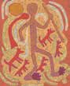
Page 16

Untitled
Screenprint on paper ATS 1036_332
Page i Jiljiwarnti (sandhills) Felt tip pen on paper
ATS1036_162

Page 10
Murungkurr (spirit baby) Felt tip pen on paper ATS 1036_205

Page 21

Untitled
Felt tip pen on paper ATS 1036_222

Appendices

187

Appendices



Page 36
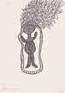
Murungkurr (spirit child) Felt tip pen on paper ATS1036_250
Page 63

Man thinking
Felt tip pen on paper, black ink ATS1036_136

Page 104

Windmill
Felt tip pen on paper ATS1036_199

Page 127

Swan
Felt tip pen on paper ATS 1036_241
188
Page 48

Untitled
Felt tip pen on paper, purple ink ATS 1036_430


Page 89
Untitled Paint on Paper ATS 1036_249

Page 115

Untitled
Linocut on paper ATS 1036_282
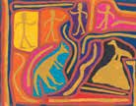
Page 133

Untitled (Animals and Figures)
Paint and crayon on paper ATS 1036_209

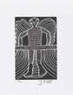

Page 157

Untitled
Screenprint on paper ATS 1036_023

Page 173
Jilji Country Screenprint on paper ATS 1036_335

Page 186

Untitled
Felt tip pen on paper ATS 1036_150

Page 202

Untitled
Screenprint on paper ATS 1036_025
Page 168 Jiljinga Kankarni Paint on paper ATS 1036_248

Page 183

Pitany (Star)
Felt tip pen on paper ATS 1036_064

Page 197 Jilji Kurrkuminti I Linocut on paper
ATS 1036_101

Appendices

189

AIDS
TO ACCESS

Aids to Access

ABBREVIATIONS
AND ACRONYMS
ABC Australian Broadcasting Corporation Australian Capital Territory
ABI Aboriginal and Torres Strait Islander Biographical Index
ACT Australian Capital Territory
AIAS Australian Institute of Aboriginal Studies (now AIATSIS)
AIATSIS Australian Institute of Aboriginal and Torres Strait Islander Studies
AIATSIS Act Australian Institute of Aboriginal and Torres Strait Islander Studies Act 1989 (Cth)
ALARM Advancing Life and Regenerating Motherland (Myanmar)
ALIA Australian Libraries and Information Association
AM Member of the Order of Australia
ANU Australian National University
ANZDATA Australia and New Zealand Dialysis and Transplant Registry
APS Australian Public Service
ARC Australian Research Council
AUSTRALEX Australasian Association for Lexicography
BIE business interruption event
CAC Collections Advisory Committee
CAU Collection Access Unit (AIATSIS)
CCE Commonwealth Corporate Entity
CEO Chief Executive Officer
CLC Central Land Council
CORE Core Cultural Learning Program
CRCATSIH Cooperative Research Centre for Aboriginal and Torres Strait Islander Health
Cth Commonwealth
EA Enterprise Agreement
Ed. editor
FACP Fellow of CPA Australia
FHU Family History Unit (AIATSIS)
GAICD Graduate of the Australian Institute of Company Directors GERAIS Guidelines for Ethical Research in Australian Indigenous Studies IA Internal Audit
IPA Indigenous Protected Area
IWD International Women’s Day
KALAAC Kimberley Aboriginal Law and Culture Centre
KJ Kanyirninpa Jukurrpa
KLC Kimberley Land Council


192

KPI key performance indicator
KSG Kimberley Stolen Generation Aboriginal Corporation
MoU Memorandum of Understanding
MP Member of Parliament
NAC National Aboriginal Centre
NAIDOC National Aboriginal and Islander Day Observance Committee NATISHEC National Aboriginal and Torres Strait Islander Higher Education Council NHMRC National Health and Medical Research Centre
NILR National Indigenous Languages Report formerly National Indigenous Languages Survey
NIRAKN National Indigenous Research and Knowledges Network
NMA National Museum of Australia
NNTC National Native Title Conference
NSW New South Wales
NITV National Indigenous Television
NT Northern Territory
NTRB native title representative body
NTRU Native Title Research Unit (AIATSIS)
PBC prescribed body corporate
PBS Portfolio Budget Statements
PGPA Act Public Governance, Performance and Accountability Act 2013 (Cth)
PM&C Department of the Prime Minister and Cabinet
Qld/QLD Queensland
RAP Reconciliation Action Plan
ROMTIC Return of Materials to Indigenous Communities
SA South Australia
SEB Senior Executive Board
SES Senior Executive Service
TAS Tasmanian Aboriginal Centre
UNPFII United Nations Permanent Forum on Indigenous Issues
USA United States of America
UTS University of Technology, Sydney
VIC Victoria
WA Western Australia
WHS Work, Health and Safety
WINHEC World Indigenous Higher Education Consortium


Aids to Access

193

Aids to Access

COMPLIANCE
REQUIREMENTS INDEX
The index below shows compliance with information requirements specified in the Public Governance Performance and Accountability Act 2013, sections 39, 43 and 46, and prescribed by the Public Governance, Performance and Accountability Rule 2014, Subdivision B – Annual report for corporate Commonwealth entities.
*N/A denotes that the requirement was not applicable to AIATSIS during 2017-18

REFERENCE | REQUIREMENT | SECTION | PAGE NO
Annual performance statements | PGPA Rule 16F  PGPA Rule 17BE paragraph (g) | Our Performance | 17-119
Audited financial statements | PGPA Act s43(4) | Financial Statements | 135-156
Approval by accountable authority | PGPA Rule 17BB | Letter of Transmittal | ii
Standard of presentation | PGPA Rule 17BC | All | -
Plain English and clear design | PGPA Rule 17BD | All | -
Enabling legislation | PGPA Rule 17BE, paragraph (a) | Introduction and Summaries | 4
Functions and purposes | PGPA Rule 17BE paragraph (b) | Introduction and Summaries | 4
Responsible minister | PGPA Rule 17BE paragraph (c) | Introduction and Summaries | 5
Ministerial directions and other statutory requirements | PGPA Rule 17BE paragraph (d) | Our Organisation | 129
Government policy orders | PGPA Rule 17BE paragraph (e) | Our Organisation | 129
Noncompliance | PGPA Rule 17BE paragraph (f) | N/A | 130
Noncompliance - finance law | PGPA Rule 17BE paragraphs  (h) and (i) | N/A | 130

194

REFERENCE | REQUIREMENT | SECTION | PAGE NO
Members of the accountable authority | PGPA Rule 17BE paragraph (j) | Our Organisation | 122-126
Outline of organisational structure | PGPA Rule 17BE paragraph (k) | Our Organisation | 127
Location of major activities and facilities | PGPA Rule 17BE paragraph (l) | Introduction and Summaries | 6
Statement on governance | PGPA Rule 17BE paragraph (m) | Our Organisation | 122-132
Related entity transactions | PGPA Rule 17BE paragraphs  (n) and (o) | Our Organisation  – Corporate  Governance | 129
Key activities and changes affecting the authority | PGPA Rule 17BE paragraph (p) | Our Organisation  – Corporate  Governance | 129
Compliance management and reporting | PGPA Rule 17BE paragraph (q) | Our Organisation  – Corporate  Governance | 130-31
External reports on the entity | PGPA Rule 17BE paragraph (r) | Our Organisation  – Corporate Governance | 129
Indemnities and insurance premiums for officers | PGPA Rule 17BE paragraph (t) | Our Organisation  – Corporate Governance | 131
Index of annual report requirements | PGPA Rule 17BE paragraph (u) | Aids to Access | 194-95

Aids to Access
195

Aids to Access

The index below shows compliance with Commonwealth statutory requirements for annual reporting which apply to AIATSIS

REFERENCE | REQUIREMENT | SECTION | PAGE NO
 |  | Our
Work Health and Safety | Schedule 2, Part 4 of the Work  Health and Safety Act 2011 | Organisation  – Corporate | 1
 |  | Governance
Environmental | Section 516A of | Our
performance and  environmentally | the Environment Protection and  Biodiversity Conservation Act | Organisation  – Corporate | 118
sustainable development | 1999 | Governance
Advertising and market research expenditure | Section 311A of the Commonwealth Electoral Act 1918 | Our Organisation  – Corporate  Governance | 118

196



Aids to Access

197

Aids to Access

ALPHABETICAL
INDEX

A
abbreviations and acronyms, 192-94 Aboriginal and Torres Strait Islander Biographical Index, 90
Aboriginal Studies Press, 70, 71, 76, 777, 85,
128
acquisitions and deposits,31, 33-35, 39, 62,
97, 147, 150, 166
address, 6
administrative tribunal decisions, 129 advertising and market research, 130 advice to government and other bodies, 39, 80-91
key outcomes, 90
performance results and analysis, 103 results 2017–18, 102
strategies 2017–18, 92-101
AIATSIS Collection, 23–31
access to, 12, 32, 41, 67, 70, 75-6, 88, 90,
93-4, 98
accessibility, 30, 116
accessioning, 88, 31
key outcomes, 23
Mura®online catalogue, 30, 32, 68, 95, 106 performance results and analysis, 28-30, 116,
repatriations, 49, 30
significant additions, 33-35
storage facilities, 23, 24, 26, 31, 167
targets, 23
see also digital preservation and storage AIATSIS Council, 24, 74, 91, 110, 112, 122, 129,
132
Chairperson, 11, 83, 165
member biographies, 124-26
AIATSIS Foundation, 7, 56, 107, 128, 160, 164
AIATSIS Membership Standing Committee, 110, 128, 165
AIATSIS Public Program, 71, 118
Alick and Merle Jackomos, Papers of, 54 annual performance statement, 17-107 annual report artwork,187-89
apps, 74
APS Values and Code of Conduct, 6

198
Art and Object collection, 12, 26,32-4, 62, 67
assets and infrastructure, 24, 26, 47, 94, 107
audio recordings, 35, 59, 99, 108, 113
audiovisual material, 18, 25-6, 114, 116
audit, external, 129
Audit and Assurance Committee (AIATSIS), 132, 164
audition sheets and caption lists, 29, 32 Auditor-General reports, 129
Australian Institute of Aboriginal and Torres Strait Islander Studies Act 1989, 5, 7, 19, 20,
90, 105, 122
Australian National Audit Office, 117 Australian National University, 56, 160, 169,
171-2

B
Barunga Statement, 12, 45,7, 94, 96-7, 109 Barunga Statement online exhibition, 70 ‘Because of Her, We Can!’ poster, 73 Beulah Lowe, Papers of, 35
Birmingham, Senator the Hon. Simon, (see Minister for Education and Training)
blog, 11, 31, 70-1
books, 83, 119
collection, 35,44,50
new, 77-8, 79, 84-7
rare, 99
revenue, 79, 119

C
Chairperson see McDaniel, Professor Michael (AIATSIS Chairperson and Council member) charter, 129
Chief Executive Officer see Ritchie, Craig (Chief Executive Officer)
Collection Development Strategy 2017–2021, 12, 24, 31, 62
Collections Advisory Committee (AIATSIS), 166
committees see governance committees Commonwealth Ombudsman, 129
community archives, 25
community engagement, 51, 118 conferences, forums, seminars and

lectures,40-1, 443, 50-1, 65-7, 71-2, 83, 91-2,
94, 98, 101, 106, 11, 167, 178-82
Consultative Committee (AIATSIS), 167 Core Cultural Competency Program, 102-3, 107, 109, 192
Corporate Plan 2017–18 to 2020–21, 5-6, 18-
19, 22, 129
cultural competency, 41, 167, 169
see also Core Cultural Competency Program culture and heritage, 42, 49-61
key outcomes, 49
performance results and analysis, 60-1 strategies 2017–18, 52-9
curriculum, educational, 77

D
databases, 50, 57-8, 67-9, 90, 93, 05, 106-7,
110
Day of Mourning—26th January 1938 online exhibition, 24 67, 70
Department of Agriculture and Water Resources, 94
Department of Communications and the Arts, 94, 169
Department of Education and Training, 94 Department of the Prime Minister and Cabinet, 5, 11, 39, 72, 94, 161-2, 166, 177-8
Dictionaries Project, 56, 107, 160
digital communications, 67
digital preservation and storage, 1-13, 19, 25,
28, 31, 47, 58, 75, 88, 99, 113, 114, 116
data protection, 24
results 2017–18, 27
see also assets and infrastructure discoverability aids, 32, 46-7, 67-9, 75, 106 E
e-newsletter, 67, 70, 79, 83, 118
ecologically sustainable development, 131 Employee Census, 112
Employees,
cultural competency, 107
engagement, 112
enterprise agreement, 131
female, 128
Indigenous, 112
learning and development, 131 number, 128
voluntary departures, 112 work health and safety, 130
environmental performance, 131
ethical publishing, 40-1
ethical research, 37-43 webinar pilot program, 41 events see public events exhibitions, 24, 64, 70
online, 70

F
family history research, 49,50, 55, 71
Familly History Unit (AIATSIS), 49, 90, 94, 95,
106, 110
film and video,23, 35-6
financial resource management, 129 financial statements, 135-156 finding aids see discoverability aids
forums see conferences, forums, seminars and lectures
fraud management, 130
Freedom Ride, 1965, online exhibition, 70
funding, 5

G
goals, 18, 39
governance and organisational resilience, 13, 105-112
key outcomes, 105
performance results and analysis, 112 strategies 2017–18, 107-10
governance committees
advising AIATSIS Council, 164-65 advising the CEO, 165-67

Guidelines for Ethical Research in Australian Indigenous Studies (GERAIS), 37, 40, 43

H
Healing Foundation, 94
health and wellbeing survey see Mayi Kuwayi study
Hercus, Luise, 111

I
impact assessment, research, 38, 53, 60, 117 Indigenous Art Market, 71
Indigenous Caucus (AIATSIS), 128. 167 Indigenous Pathway Project, 131 international engagement, 42-3 International Women’s Day, 73
interns see volunteers and interns

Aids to Access
199

Aids to Access

J
Jeff Doring collection, 35
Jimmy Pike Collection, 12, 77, 187-89
journals, 79
judicial decisions, 129

K
Kimberley Aboriginal Law and Culture Centre, 25, 113
Kimberley Stolen Generations Aboriginal Corporation, 50
Kings College London, 42

L
Lake Eyre Basin ‘Aboriginal Way’ Map, 94 languages, Indigenous, 11, 25, 31, 39, 49, 71,
98, 99, 107, 111, 114
national strategy for, 39
Learning and Development Plan, 107, 131 lectures see conferences, forums, seminars and lectures
legislation, 4
Link-Up services, 90, 94, 95
Little Red Yellow Black Book, The, 77 Lowitja Institute, 35, 171

M
Mabo case webpage, 70
machinery of government changes, 110 map of Indigenous Australia, 70
Mayi Kuwayi study, 56
McDaniel, Professor Michael (AIATSIS Chairperson
and Council member) biography, 123
statement 2017–18, 11
media, 80
Melbourne Dreaming app, 84 memberships, 72, 82, 97, 110 Minister for Education and Training
(Birmingham, Senator the Hon Simon), 5, 122 Minister for Indigenous Affairs (Scullion, Senator the Hon Nigel), ii, 5, 11, 106, 110, 122 Minister for Indigenous Health and Aged Care (Wyatt AM MP, The Hon Ken), 11, 110 mission, 4

N
National Aboriginal Council, 35
National Indigenous Languages Convention, 99
National Indigenous Languages Report, 52, 56, 92, 94, 169

200
National Indigenous Languages Survey, 15, 92 National Museum of the American Indian, 13, 42, 170
National Native Title Conference 2018, 50-1,
65-7, 71, 91, 98, 101, 103, 106
native title and traditional ownership corporations website, 101
national conference, 65-7
newsletter, 93
policy papers, 103
priorities 2018–2021, 39
research and advice, 81, 100
Native Title Legal Workshop, 91, 100 Native Title Research Advisory Committee, 166
National Health and Medical Research Committee, 40, 165
notifiable incidents, 130

O
Office of the Australian Information Commissioner, 129
Olive Pink collection, 12, 46-7
organisational structure, 128
outcome, 5
outlook, 5
overview, 4–7
Oxford University, UK, 13, 42, 170

P
Pallottines material, 27
partnerships and collaboration, 60-1, 82, 99,
117, 169-71
performance analysis, 19–20
performance framework, 18–20
performance results, 116-18
photographic images, 35, 62, 67-9, 88
Portfolio Budget Statements 2017–18, 18, 116 postcards of significant items, 24
Prime Minister of Australia
Turnbull, The Hon Malcolm, 11, 12, 110
Hawke, The Hon Bob, 45, 96
Public Governance and Performance Accountability Act 2013, ii, 17, 98, 122, 129, 132 Preserve, Strengthen and Renew in Communities project, 38, 42, 53, 57, 58-9 preservation see digital preservation and
storage;
assets and infrastructure
Print and Manuscripts collection, 35, 46, 75
programs, 6

public education and engagement, 64- 83
key outcomes, 64
performance results and analysis, 79 - 83 strategies 2017–18, 64-78
public events, 71-3
publications and presentations, 84 performance results, 69–72
see also books; e-newsletter; journals purpose, 4

R
Reconciliation Action Plan Working Group, 128. 167
reporting lines to Minister, 128 research, 37-43
current and completed projects, 160-3 key outcomes, 64
performance results and analysis, 43, 60 standards and guidelines, 38-43 strategies 2017–18, 64-78
Research Advisory Committee (AIATSIS), 166 Research Ethics Committee (AIATSIS), 165 researcher memberships and offices, 184-5 responsible Ministers, 5, 122
risk management, 132
Ritchie, Craig (Chief Executive Officer) report 2017–18, 11, 12-13, 42, 87, 99, 106 S
Scullion, Senator the Hon. Nigel, see Minister
for Indigenous Affairs
seminars see conferences, forums, seminars and lectures
Senior Executive Board (AIATSIS), 165 Sharing Success, Measuring Impact project, 38
Singing the Train exhibition, 53
Social Impacts of Uranium Study Groups collection, 68
social media, 81
Songlines project, 108, 160, 169
songs, 23, 25
songs, Indigenous, 76 staff see employees
Stolen Generations, 50, 90, 94-5
storage facilities see digital preservation and storage
strategic directions, 4
strategic priorities, 22
submissions, 40, 91, 98, 102, 176
Sustainability Plan, 107
T
Turnbull, the Hon. Malcolm MP, see Prime Minister of Australia

U
University of Sydney, 41, 75, 88 unscheduled absences, staff, 112 V
values see APS Values and Code of Conduct
Vatican Museums Indigenous Collection, 11, 70, 85
vision, 4
volunteers and interns, 75

W
websites
AIATSIS, 71, 81, 83, 106
native title corporations, 101 visit statistics, 81
Wentworth Lecture 2017, 72
work health and safety, 128, 130, 131, 132
workforce planning, 131
workshops, 11, 91, 102
Wyatt MP, The Hon Ken see Minister for Indigenous Health and Aged Care

Y
Youth Forum, 66

Aids to Access
201

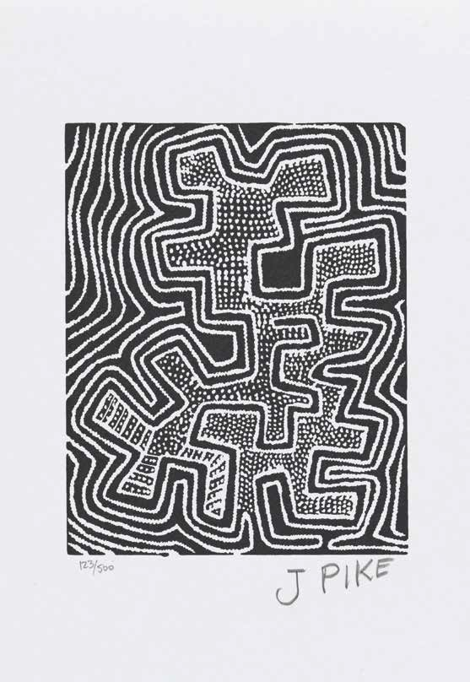

202

AIATSIS ANNUAL REPORT  2017–18 | PUBLISHED BY THE AUSTRALIAN INSTITUTE
 | OF ABORIGINAL AND TORRES STRAIT
 | ISLANDER STUDIES
 | GPO BOX 553, CANBERRA ACT 2601
 | TEL: (02) 6246 1111
 | FAX: (02) 6261 4285
 | WWW.AIATSIS.GOV.AU
 | © AIATSIS

