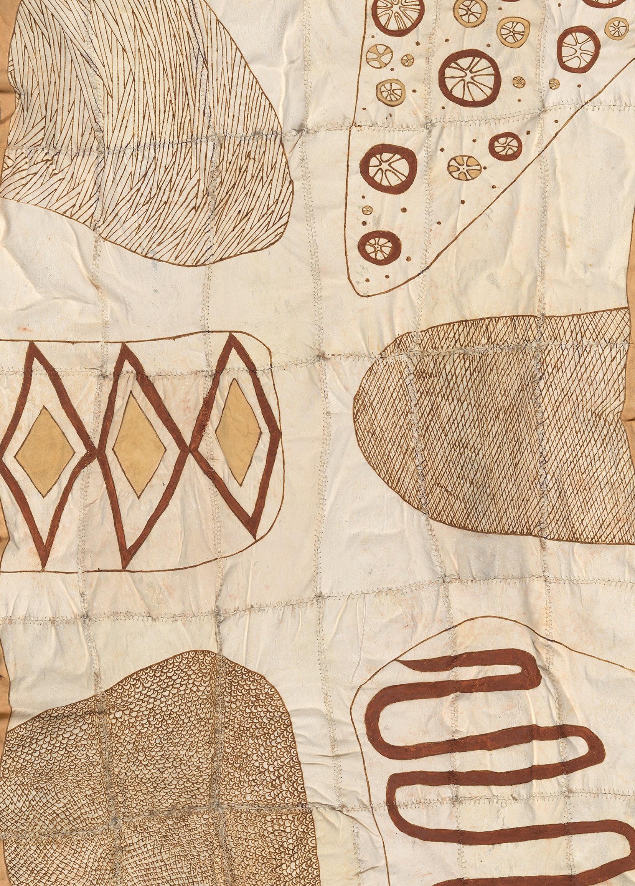
2016-2017 ANNUAL REPORT

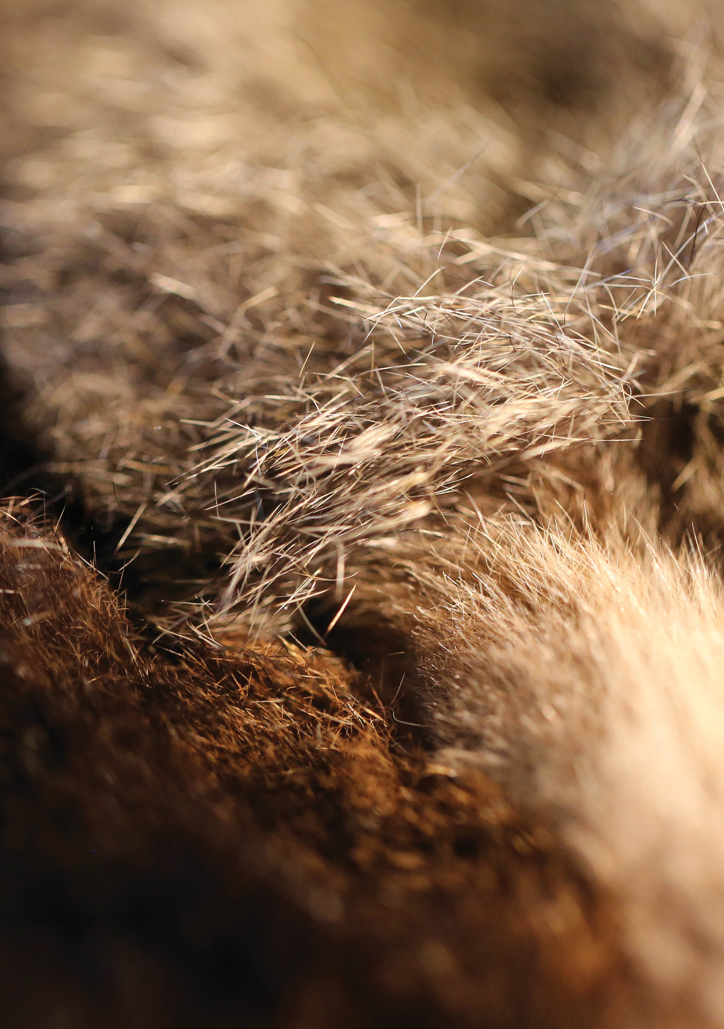

CONTENTS
Chairperson’s statement 4
CEO’s report 6
Vision 8
Legislation and purpose 9
AIATSIS Council members 10
OUR PERFORMANCE 20
AIATSIS Corporate Plan 2016-17 to 2019-20 22
AIATSIS Portfolio Budget Statements 2016-17 23
Strategic Priority 1 – Ensuring our collection is safe, accessible, valued and growing. 24
Strategic Priority 2 – Providing leadership in Indigenous research, and ethical engagement
in research, collections and publishing. 40
Strategic Priority 3 – Strengthening institutional and community understanding of Aboriginal
and Torres Strait Islander culture and heritage. 52
Strategic Priority 4 – Promoting and sharing Aboriginal and Torres Strait Islander cultures
and heritage. 66
Strategic Priority 5 – Building strong governance and organisational resilience. 84
Our organisation 91
AIATSIS Council members 92
Organisation structure 93
Governance 94
Financial results and compliance 94
Policy and operational environment 95
Work health and safety 95
Advertising and market research 95
Ecologically sustainable development and environmental performance 95
FINANCIAL STATEMENTS 96
APPENDICES 98
Appendix A — Research project summaries 100
Appendix B — Governance committees 109
Appendix C — Strategic partnerships 114
Appendix D — Research outputs — publications and presentations 116
Appendix E — Researcher memberships and offices 124
Appendix F — Abbreviations and acronyms 127
Appendix G — Index of compliance with PGPA Rule 2014 and other legislation 129

Chairperson’s statement

As the newly appointed Chairperson of the AIATSIS Council, it is a privilege to have the first word in the AIATSIS Annual Report for 2016–17 and to reflect on AIATSIS’ achievements and progress during the year. It was the first full year of AIATSIS’ new statutory functions, introduced through amendments to the Australian Institute of Aboriginal and Torres Strait Islander Studies Act 1989 (the AIATSIS Act) in March 2016. It was a year of significant change in AIATSIS’ leadership, and of important commemorations for Aboriginal and Torres Strait Islander Australians.
In May 2017 Professor Mick Dodson AM retired from the AIATSIS Council, after twenty-seven years as a member and seventeen years as the Chairperson. During that time Professor Dodson steered AIATSIS through a changing environment, while also continuing to contribute to Aboriginal and Torres Strait Islander society as a leader, a lawyer and a researcher. It is an honour to be his successor as the Chairperson, and I wish Professor Dodson the very best for his life and work.
Four of the nine members of the AIATSIS Council are elected by the members of AIATSIS, and in early 2017 the first election was held under the terms of the amended AIATSIS Act. It was encouraging to see that the majority of candidates for the four vacancies were Indigenous. The outcome was that Mr Stephen Kinnane, Ms Rachel Perkins, Dr Myfany Turpin and I were elected. On behalf of Council, I wish to acknowledge the long and dedicated service of former Council members Professor Robert Tonkinson, Professor John Maynard and Professor Sandy Toussaint, who stepped down from the Council this year.
In December 2016 we also said goodbye to another longstanding leader 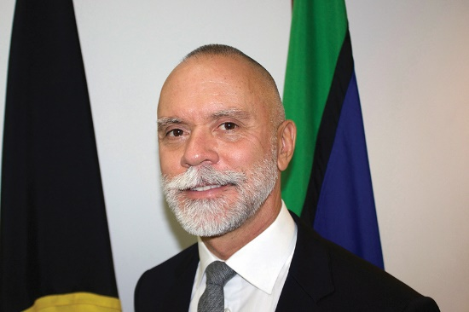at AIATSIS. Mr Russell Taylor AM was Principal, and then CEO of AIATSIS for fifteen of the past twenty years, and has overseen many significant developments in the organisation. We had a chance to hear Mr Taylor’s reflections on his career at the inaugural Russell Taylor Oration, a new annual event named in Mr Taylor’s honour to celebrate the achievements and contributions of senior Aboriginal and Torres Strait Islander leaders in the Australian Public Service. I wish Mr Taylor all the best for his retirement.
After a period acting in the role, former Deputy CEO Mr Craig Ritchie was appointed as the new CEO of AIATSIS. I congratulate Mr Ritchie on his appointment and look forward to working closely with him in the coming years.
National Reconciliation Week (NRW) is always bookended by the anniversaries of the 1967 Referendum and the historic Mabo decision, but in 2017 these were the 50th and 25th anniversaries respectively, making NRW especially significant. AIATSIS helped to mark these events by leading national cultural institutions in Canberra in the development of an NRW Trail, a series of events and exhibitions throughout the week. AIATSIS also partnered with the ABC and National and State Libraries Australasia (NSLA) to mount Right Wrongs, a comprehensive online exhibition about the lead-up, events and legacy of the 1967 Referendum.
This year the AIATSIS Foundation, under the leadership of Rachel Perkins, launched its first projects. They have been selected with a long view, and the goal of ensuring that the rich knowledge and culture kept in our languages and songlines will be collected, preserved and shared. At a showcase at the Tjapukai Cultural Park in Cairns on the eve of the national NAIDOC awards ceremony, it was energising to see so many supporters and advocates for the preservation, resurgence and sharing of our cultures and heritage gathered in one place.
AIATSIS was also proud to facilitate the consultation with Indigenous communities on constitutional recognition in this 50th anniversary year. AIATSIS’ cultural competence, knowledge and understanding of communities across Australia made it an obvious choice to support the Referendum Council in this process. Fourteen meetings, with nearly 1600 attendees, culminated in the release of the Uluru Statement from the Heart representing First Nations’ Australian delegates’ common position.
I thank all the Council members, CEOs and AIATSIS employees past and present who contributed to the achievements of 2016–17 and I look forward to the year ahead.

Professor Michael McDaniel

CEO’s report

AIATSIS was originally established to preserve as many components of Australian Indigenous cultures as possible, before they were lost forever. After more than fifty years, this Institute stands as a testament not to the disappearance of Aboriginal and Torres Strait Islander people but to the living and vibrant history of Aboriginal and Torres Strait Islander peoples. AIATSIS is sharing the story of self-agency, success beyond survival, and tremendous resilience.
While AIATSIS is part of a transformation in Australian society, we are also undergoing a process of transformation ourselves. Having been reinvigorated with our new legislation and new resources, AIATSIS is forging ahead in its new directions, and laying the foundations for long-term sustainability.
AIATSIS’ amended legislative functions are clearly reflected in its objectives, to support improved outcomes for Indigenous peoples, and to enable people to encounter and be transformed by the stories of Aboriginal and Torres Strait Islander peoples.
2016–17 has been a year of farewells and welcomes. With the departure of Professor Mick Dodson AM as Chairperson, and Mr Russell Taylor AM as CEO, we said goodbye to tremendous wisdom and experience. I want to acknowledge their contribution and legacy, and thank them for the advice and guidance they offered in my previous role as Deputy CEO and in my transition to the CEO role. I also welcome the newly elected members of the AIATSIS Council and look forward to working with them over the coming years.
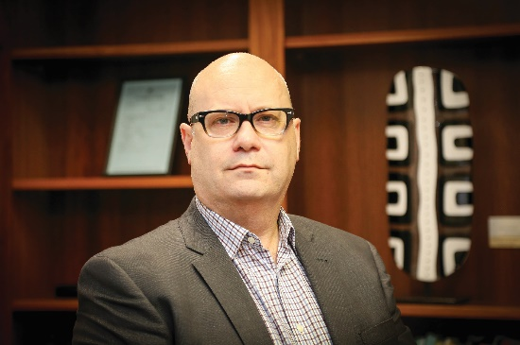AIATSIS is well positioned to continue its reform. As well as being supported by a new Council, there are also many new senior leaders within AIATSIS, including a new Chief Operating Officer, a formally appointed Head of Collections, as well as new executive officers in finance and governance.
Our achievements in preserving the collection, and making it discoverable and accessible, have exceeded our plans and expectations in nearly every regard. The introduction of new systems such as the Digital Asset Management System, alongside new employees and processes, was expected to involve some disruption but the transitions have been managed well. The impressive results achieved this year already show how dramatically they will transform how we create, care for and share this priceless collection.
AIATSIS is not an ‘owner’, but a custodian of the collection and the knowledge it contains, in partnership with Aboriginal and Torres Strait Islander communities all over Australia. For example, the Preserve, Strengthen, Renew in Community Project is linking Indigenous communities with AIATSIS’ best-practice research methods and collections management techniques to create new ways to manage, preserve and share cultural and historical records and artefacts, both on-country and in the AIATSIS collection. Alongside work to establish the technological platforms required to support it, this is the first step towards a truly collaborative approach to Indigenous collections.
How to measure and understand the impact of research, especially for the communities involved, has been a longstanding challenge that AIATSIS has been working on, with other publicly funded research agencies, for some years now. In 2016–17, AIATSIS developed and adopted a method to plan for and evaluate impact, and has commenced its first evaluations using the new method so that it can be tested and refined. Understanding impact is central to ethical research, and to maximising the return on research investment, for the communities involved and our society as a whole.
As well as continuing our leadership in research, publishing and collections practice, AIATSIS confirmed its position as a leader in cultural competency for the Australian Public Service (APS) and more widely. The Core Cultural Learning course was developed during 2015–16, based on AIATSIS’ research into, and demonstration of, ethical and culturally competent practice. The program was launched in July 2016 and made available to all APS departments and agencies by October. By June 2017, forty-five agencies were accessing Core, and state governments are now interested in using the program.
Our work to engage the Australian community in understanding and valuing our rich Aboriginal and Torres Strait Islander cultures was strong this year, with the striking Singing the Train exhibition in the AIATSIS foyer gallery, four new online exhibitions and our collaboration with the ABC and NSLA to create the Right Wrongs digital exhibition about the 1967 Referendum, and a rich and collaborative public program. Working with a large group of national institutions in Canberra, we created the National Reconciliation Week trail, and hosted events including an art market. The National Native Title Conference was a highlight, as it is every year, and this year we also co-hosted the Australian National Indigenous Research Conference with the University of Canberra.
The creation of the AIATSIS possum-skin cloak by Yorta Yorta artist Lee Darroch, and its presentation with ceremony to AIATSIS, was a touchstone event for this organisation. The process of its making, and the magnificent artefact that is now part of our collection, demonstrated the power of contemporary Indigenous culture. It is the living cultures and peoples, with deep traditional and historical roots, to which AIATSIS is committed.
I thank all of my colleagues throughout AIATSIS for their commitment in 2016–17, which has resulted in the achievements described in this report. These have prepared us for the next evolution in the journey of AIATSIS.

Craig Ritchie



Vision
A world in which Aboriginal and Torres Strait Islander knowledge and cultures are recognised, respected, celebrated and valued.

Legislation and purpose
AIATSIS is established and authorised by the Australian Institute of Aboriginal and Torres Strait Islander Studies Act 1989.
AIATSIS’ purpose, as set out in this Act, is to:
- Develop, preserve and provide access to a national collection of Aboriginal and Torres Strait Islander cultures and heritage.
- Use that collection to strengthen and promote knowledge and understanding of Aboriginal and Torres Strait Islander cultures and heritage.
- Provide leadership in the fields of:
  - Aboriginal and Torres Strait Islander research.
  - Ethics and protocols for research and other activities relating to collections related to Aboriginal and Torres Strait Islander peoples.
  - Use (including use for research) of the national collection and other collections containing Aboriginal and Torres Strait Islander cultures and heritage.
- Lead and promote collaborations and partnerships among the academic, research, non-government, business and government sectors and Aboriginal and Torres Strait Islander peoples in support of other functions.
- Provide advice to the Commonwealth on the situation and status of Aboriginal and Torres Strait Islander cultures and heritage.

AIATSIS Council members
AIATSIS is governed by a Council of nine members, four of whom are elected by the members of AIATSIS and five of whom are appointed by the Minister.
See ‘Our organisation’ (page 91) for more information about the Council and AIATSIS’ governance.
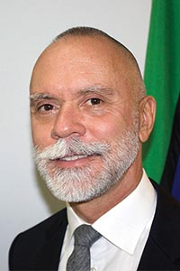
Professor Michael McDaniel (Chairperson and Council member) is a member of the Kalari Clan of the Wiradjuri Nation of Central New South Wales. His career in Indigenous higher education and service to the arts, culture and the community spans almost three decades. He is Pro-Vice-Chancellor (Indigenous Leadership and Engagement) and Director of Jumbunna at the University of Technology Sydney.
He has held Government appointments including on the Minister’s Aboriginal and Torres Strait Islander Advisory Council, National Native Title Tribunal and the NSW Land and Environment Court.
He is Chair of the Board of Bangarra Dance Theatre, a Director with the Australian Major Performing Arts Group, a Director with the Museum of Contemporary Art (Australia), Chair of the MCA (Australia) Indigenous Advisory Group and Chair of the Sydney Living Museums Aboriginal Advisory Committee. Professor McDaniel is also a member of the National Aboriginal and Torres Strait Islander Higher Education Council (NATSIHEC). Through NATSIHEC he is a member of the World Indigenous Higher Education Consortium and participated in the United Nations Permanent Forum on Indigenous Issues as a NATSIHEC delegate.

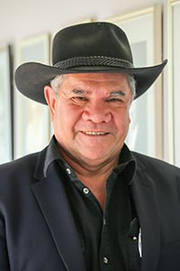
Professor Michael (Mick) Dodson AM (Chairperson and Council member until 16 May 2017) is a member of the Yawuru peoples, the traditional Aboriginal owners of land and waters in the Broome area of the southern Kimberley region of Western Australia. He is currently Director of the National Centre for Indigenous Studies at the Australian National University (ANU). He is a professor of law at the ANU College of Law and a fellow of the Academy of Social Sciences in Australia. He was Australia’s first Aboriginal and Torres Strait Islander Social Justice Commissioner with the Human Rights and Equal Opportunity Commission, a position he held from April 1993 to January 1998. Professor Dodson was Australian of the Year in 2009.
Professor Dodson retired from the AIATSIS Council in May 2017, after twenty-seven years on the Council and seventeen years as the Chairperson.
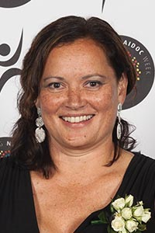
Donisha Duff is of Torres Strait Islander descent from Moa and Badu Islands and the Yadhaigana and Wuthathi people (Cape York).
Awarded a Roberta Sykes Fellowship to Harvard University she is currently a Board Trustee of the Roberta Sykes Indigenous Education Foundation. She is a Board member of the Stars Foundation to empower the educational development of Aboriginal and Torres Strait Islander girls and young women and is also appointed to the Australia and New Zealand Dialysis and Transplant Registry (ANZDATA) Indigenous Working Group.
Donisha completed a Master of Business Administration (ANU) and was National NAIDOC Scholar of the Year 2014.

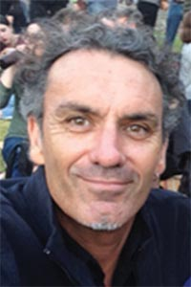
Stephen Kinnane is a Marda Marda man from Miriwoong country in the East Kimberley. A researcher, writer and lecturer for more than twenty years, his interests encompass Aboriginal history, creative documentary and tensions surrounding the ideals of sustainability and the relationships between individuality, community, country, economy and human development.
Stephen has lectured at Murdoch University in Australian Indigenous Studies and Sustainability; and completed a Visiting Research Fellowship at AIATSIS. He has been a Senior Researcher for the Nulungu Research Institute of the University of Notre Dame Australia, Broome and remains involved as an Adjunct Research Fellow.
His book, Shadow Lines was awarded the WA Premier’s Award for Non-Fiction 2004, the Federation of Australian Writer’s Award for Non-Fiction 2004, Stanner Award 2004, and was short-listed for the Queensland and South Australian Premier’s Awards. He co-wrote and produced The Coolbaroo Club (1996), an ABC TV documentary, and awarded the Human Rights and Equal Opportunity Commission Human Rights Award for the Arts.
Mr Kinnane is a board for Magabala Books, the Australian Dictionary of Biography (ANU), and Indigenous Community Stories WA.

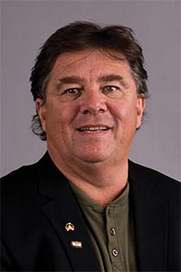
Professor John Maynard (until 16 May 2017) is a Worimi man from the Port Stephens region of New South Wales. He is currently a director of the Wollotuka Institute and Chair of Aboriginal History at the University of Newcastle. He obtained his doctorate in 2003, examining the rise of early Aboriginal political activism.
Professor Maynard was a member of the Executive Committee of the Australian Historical Association, the History Council of New South Wales and the Indigenous Higher Education Advisory Council, and has worked with and in many Aboriginal communities — urban, rural and remote.
He is the author of eight books, including Aborigines and the ‘Sport of Kings’, Fight for Liberty and Freedom and The Aboriginal Soccer Tribe.
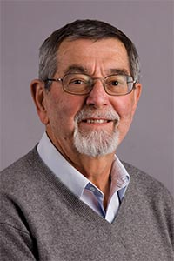
Emeritus Professor Bob Tonkinson (Deputy Chairperson and Council member until 16 May 2017) took Honours and Masters degrees in social anthropology at the University of Western Australia, where he later held the Chair in Anthropology (from 1984 until his retirement in 2004). He obtained his doctorate in anthropology at the University of British Columbia (1972) and taught at the University of Oregon (1968–80) and the ANU (1980–84) before returning to Western Australia. From the 1960s he conducted research with Western Desert Martu people and on the islands of Ambrym and Efate in Vanuatu. He was active in land claim research on behalf of the Martu, who gained title to the bulk of their traditional homelands in 2002.


Ms Rachel Perkins is a member of the Arrernte nation, whose lands surround Alice Springs, and the Kalkadoon people from the Mt Isa region.
Ms Perkins has served on agencies including Screen Australia, the Australian Film Commission, and the Australian Film Television and Radio School. She was a founding board member of NITV, which she was instrumental in establishing. She is on the board of the Australian Heritage Commission, and has served on the boards of Aboriginal organisations and industry associations, including Bangarra Dance Theatre.
Her company Blackfella Films, established in 1993, is a leader in the creation of Indigenous content, including the series’ First Contact, Redfern Now, First Australians, Ready For This and its latest production, DNA Nation. Her work as director includes documentaries such as Freedom Ride and the more recent Black Panther Women as well as movies Bran Nue Dae, One Night the Moon, Mabo and the newly released film, Jasper Jones.
She also works in the cultural sector directing festivals, such as the Yeperenye Festival for the Centenary of Federation. She researched and published The Black Book, a directory of Indigenous Australian people working in the cultural sector. In more recent times she has focussed on the development of Arrernte culture, the first project being an Arrernte Women’s Camp, which recorded and revived the repertoire of Arrernte women’s traditional musical heritage.

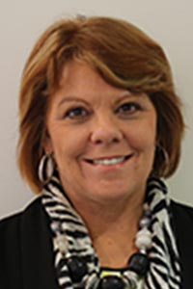
Professor Cindy Shannon is a descendent of the Ngugi people from Moreton Bay. In 2011 she was appointed as the Pro-Vice-Chancellor (Indigenous Education) at the University of Queensland and is the Director of the Poche Centre for Indigenous Health.
Professor Shannon was previously the Director of the Centre for Indigenous Health at the University of Queensland and guided the development and implementation of Australia’s first degree-level program to specifically target Aboriginal health workers. She has contributed to Indigenous health policy development and implementation nationally, and undertaken a number of independent primary health care service reviews, including a major report for the 2003 interdepartmental review of primary health care service delivery to Aboriginal and Torres Strait Islander communities.
Professor Shannon was a member of the National Health and Medical Research Council and chaired its Aboriginal and Torres Strait Islander Research Advisory Committee from 2005 to 2012. Currently a Fellow of the Queensland Academy of Arts and Sciences, she is also a member of the Health and Hospital Fund Advisory Board, Chair of the Queensland Aboriginal and Torres Strait Islander Foundation, a member of the Greater Brisbane Metro South Medicare Local Board and a member of the board of Lives Lived Well.

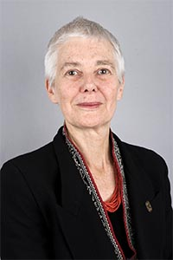
Professor Sandy Toussaint (Council member until 16 May 2017) is an anthropologist with an extensive track record in Aboriginal and Torres Strait Islander Studies. A former Visiting Research Fellow at Oxford University, and Senior Researcher on the Royal Commission into Aboriginal Deaths in Custody Commission, Professor Toussaint was also senior researcher on the Western Australia Aboriginal Land Inquiry, and Aboriginal Education.
The author and/or editor of five books and many book chapters, journal articles and commentary, she is on the Australian advisory of UNESCO’s Memory of the World Register (Australasia and the Pacific), a Trustee of the Kaberry Collection at AIATSIS, former director of the Berndt Museum at The University of Western Australian (UWA), and coordinator/curator of at least five Indigenous art exhibitions.
A successful PhD thesis supervisor, Professor Toussaint also lectured in Anthropology / Sociology — in particular Applied and Legal Anthropology, Contemporary Social Thought, and Honours — at UWA for twenty years. She is currently an Adjunct/Honorary Professor at UWA and the University of Notre Dame Australia (UNDA Fremantle, and the Nulungu Research Centre in Broome) and working on three interrelated projects (cultural heritage, documentary film, health and medicine) with Indigenous and academic organisations.

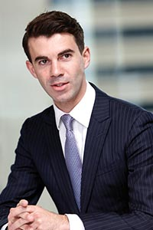
Geoffrey Winters is a descendant of the Kamilaroi nation from Walgett in north-west New South Wales. He is currently a director and lawyer at Chalk & Behrendt, Lawyers and Consultants in Sydney where he practices in the areas of Aboriginal land rights, native title, administrative and government law. He was previously the judicial associate to the Honourable Justice Basten of the Court of Appeal of New South Wales Court and the Honourable Justice Wright of the Supreme Court of New South Wales.
In addition, Geoffrey is a member of the Board of the New South Wales Justice Health & Forensic Mental Health Network and in 2017 was awarded the Sister Allison Bush Medal for Aboriginal and Torres Strait Islander achievement by the University of Sydney.
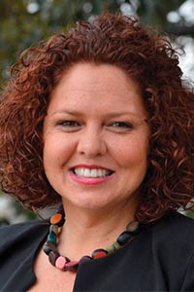
Jodie Sizer is a Gunditjmara woman and part of the Framlingham community of south-west Victoria. She was previously the Principal Consultant and Director of Ingenuity Australia, a consulting group that provides leadership, development and project management skills to Indigenous communities.
Ms Sizer was named as Victorian Aboriginal Young Achiever in 2000, when she was working as an auditor at a big-four accounting firm. She has also worked in Indigenous organisations and government, including as an Aboriginal and Torres Strait Islander Commission (ATSIC) regional councillor. She has been a finalist in the Telstra Business Women of the Year award, listed in Australian Women’s Who’s Who, inducted into the Victorian Honour Roll of Women, received the Prime Minister’s Centenary Medal and been listed as one of the Australian Financial Review’s 100 Women of Influence.


Dr Myfany Turpin is a linguist and ethnomusicologist at the University of Sydney. She holds an Australian Research Council Future Fellowship to investigate the relationship between words and music in Aboriginal songs in central Australia. She has been conducting research with Aboriginal communities since 1994, focused on Aboriginal song-poetry and Arandic languages.
Her research on the Kaytetye language resulted in a co-authored encyclopaedic dictionary, picture dictionary and collection of stories with Kaytetye speaker Alison Ross. She has written scholarly articles in the areas of semantics, music, phonology and ethnobiology and produced audio-visual publications of Aboriginal songs.
She supports school language and culture programs in central Australia and works with local organisations to produce resources and provide opportunities for Aboriginal people to assist them in their struggle for cultural and linguistic survival.
She is a member of the Musicological Society of Australia, the Australian Linguistics Society and the organising committee for the 2017 Linguistics conference.

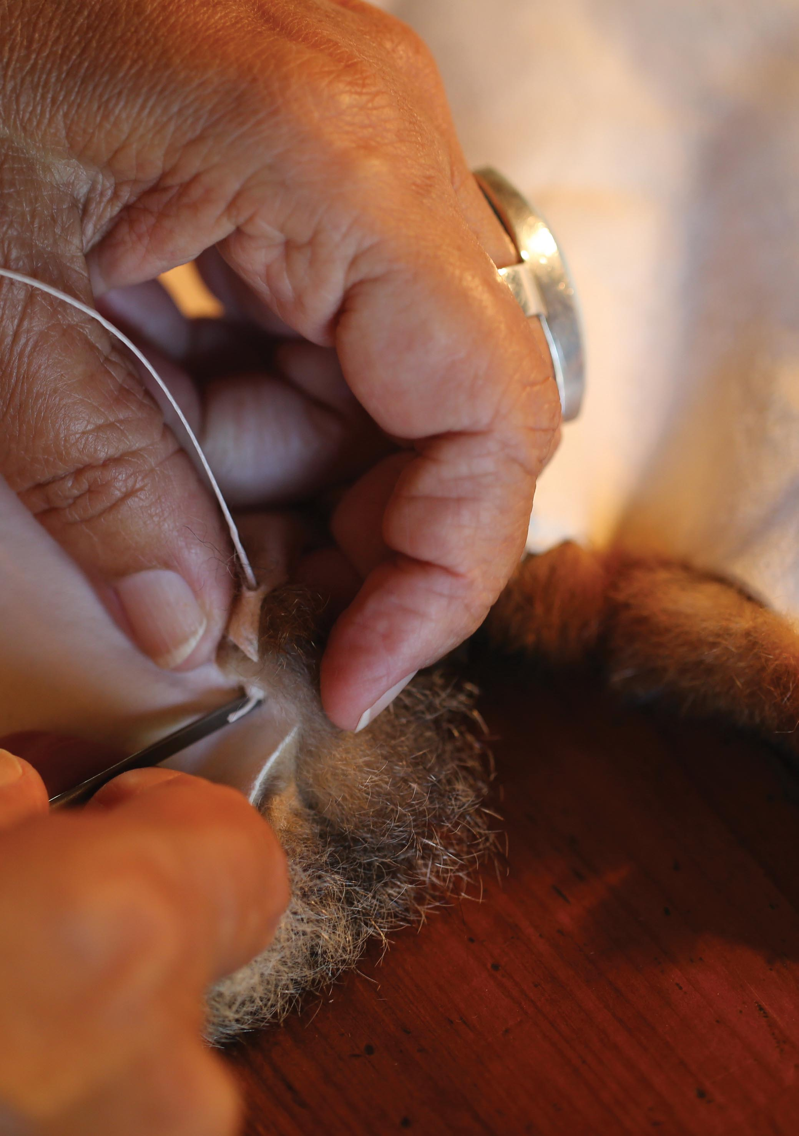

OUR PERFORMANCE
This section of the report constitutes AIATSIS’ Annual Performance Statements for 2015–16, prepared in accordance with paragraph 39(1) (a) of the Public Governance, Performance and Accountability Act 2013 (Cth) (PGPA Act).
In the opinion of the AIATSIS Council, the accountable authority, the performance statements:
- accurately present the entity’s performance in the reporting period; and
- comply with subsection 39(2) of the PGPA Act.

AIATSIS Corporate Plan 2016-17 to 2019-20
The AIATSIS Corporate Plan 2016-17 to 2019-20 (Corporate Plan) sets out how AIATSIS intends to achieve its vision and fulfil its purpose, as outlined in its legislated functions, over the next four years.
Alongside context including the operating environment and key challenges, it identifies five strategic priorities, with key outcomes, planned actions (strategies), and performance criteria, measures and targets:
- Ensuring our collection is safe, accessible, valued and growing.
- Providing leadership in Indigenous research, and ethical engagement in research, collections and publishing.
- Strengthening institutional and community understanding of Aboriginal and Torres Strait Islander culture and heritage.
- Promoting and sharing Aboriginal and Torres Strait Islander culture and heritage.
- Building strong governance and organisational resilience.
These performance statements outline the performance that was planned and related measures, the strategies pursued during the 2016-17 financial year, results achieved (including whether targets were met) and an analysis of the factors contributing to those results.

AIATSIS Portfolio Budget Statements 2016-17
The AIATSIS Portfolio Budget Statement (the PBS) sets out how we intend to expend our annual appropriation of $20 million to support our functions and pursue the strategic goals set out in the Corporate Plan. This appropriation includes the 2016-17 Budget measure of $10 million per year from 1 July 2016, ongoing. The PBS sets a single outcome for AIATSIS:
Further understanding of Australian Indigenous cultures, past and present, through undertaking and publishing research, and providing access to print and audio-visual collections.
This outcome is delivered through a single program – AIATSIS Research, Collections, Communications and Publications.

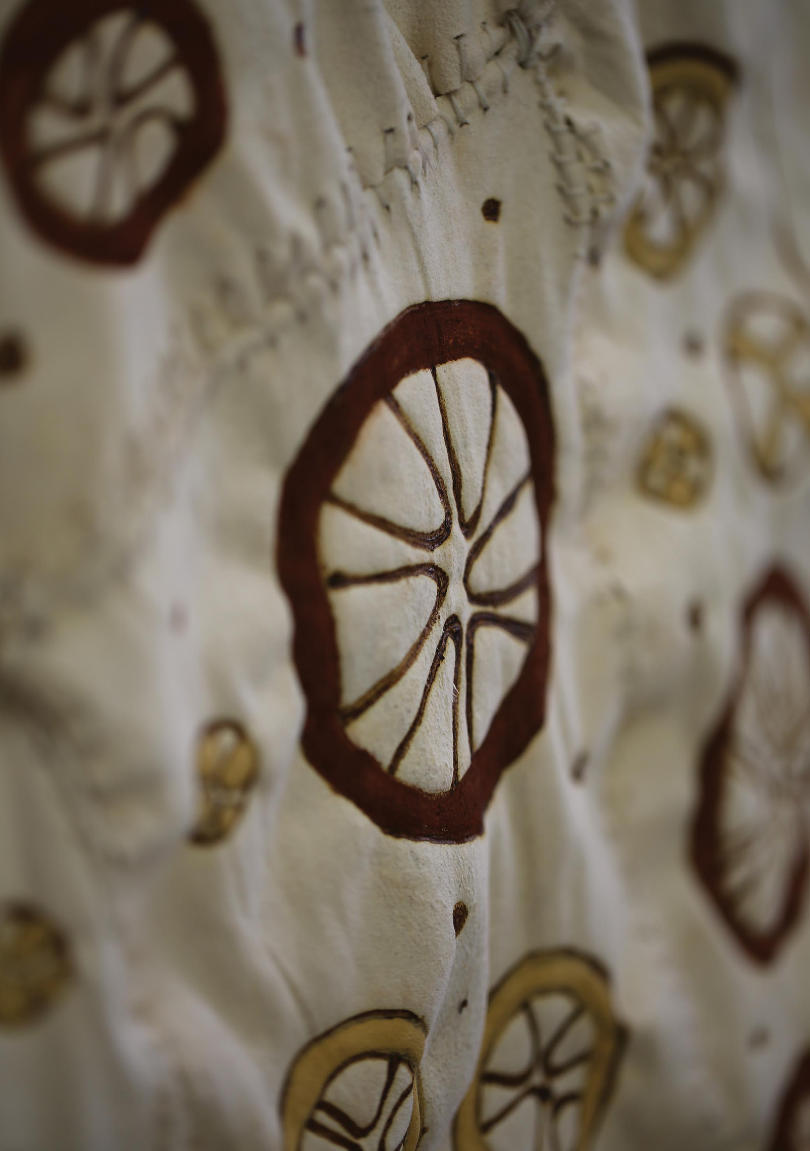

Strategic Priority 1 – Ensuring our collection is safe, accessible, valued and growing.
AIATSIS will work with Aboriginal and Torres Strait Islander peoples and communities to build a national collection and ensure preservation, discoverability and access to the collection.

Planned performance and measures
Key outcomes over four years:
- A refocused collection strategy and program aligned with policies and objectives that support improved outcomes for Aboriginal and Torres Strait Islander peoples, including a regional focus.
- Improved online discoverability, access and understanding of our collection.
- Increased scope and representation of Aboriginal and Torres Strait Islander peoples in the collection and increasing the national and international significance and value of the collection.
- Improved physical infrastructure for the storage, management and exhibition of the collection.
Performance criteria, measures and targets for 2016-17:
Performance criteria | Measures | Targets 2016-17
Ability to accept new material that is offered to and accepted into the collection, the rate at which it is preserved and made discoverable and accessible. | The rate at which material is offered to and accepted into the collection, by media.  The rate at which material is made discoverable at is accessed, by media. | 1% increase in the rate at which material is offered to the collection  1.5% increase in the rate at which material is accepted into the collection.  1% increase in the rate at which the collection is made discoverable  5% increase in the rate at which the collection is accessed.
Preservation of Aboriginal and Torres Strait Islander cultural heritage and enable all Australians to appropriately access and experience knowledge of Aboriginal and Torres Strait Islander cultures, traditions, languages and stories, past and present. | The rate of digital preservation of the collection, by media. | 5% increase in the rate of preservation of the collection.

Our strategies
Through collection, preservation, research and promotion, AIATSIS plans to continuously expand its collections and their accessibility to both Aboriginal and Torres Strait Islander peoples and non-Indigenous communities of Australia. The following strategies were our focus in 2016-17.
- Develop and implement a strategy to grow the collection and conduct research to promote the value, significance and understanding of the collection.

Collection development strategy
A draft Collection Development Strategy was developed in 2016–17. The Strategy will be considered by the AIATSIS Council and implemented in 2017–18. It will guide the growth of the collection through the acquisition of material offered for donation, as well as by purchase.
A priority this year was the integration into a whole-of-collection approach to our registration processes, through which items are first recorded in the collection for assessment and potential accession. New policies, procedures and controls were implemented, registration systems were integrated into AIATSIS’ new digital platforms, and a multi-team approach to assessing items for the collection was introduced. This brings together registrars, curators and collection managers to consider the provenance and significance of each article, alongside our goals for developing the collection.
Purchasing for the collection remained targeted at filling gaps in the collection, especially to ensure regional diversity.

Community engagement in the growth and management of the collection.
To achieve increased scope and representation of Aboriginal and Torres Strait Islander peoples in building and managing the collection, AIATSIS continued to work with communities to build relationships and deepen community knowledge of collections, both on-country and at AIATSIS. This included delivery of rights workshops with communities, working together to clarify access and use conditions for existing collections, creation and archival of additional collections material. The lessons learned will inform the future involvement of communities in the building and management of the AIATSIS collection. The Preserve, Strengthen, Renew in Community Project, in the communities of Bidyadanga, Kiwirrkurra and Port Hedland, was a significant element, discussed in more detail on page 60.
To widen the engagement of the research community, a collections stream was included in the Australian National Indigenous Research Conference (ANIRC) for the first time. Session themes included repatriation; infrastructure and research access; governance and knowledge management, community archives and archives of the future; and, Indigenous people engaged with and in research and collections.
Engagement was enthusiastic and feedback overwhelmingly positive:
“I’ve never come across a participatory record-keeping model like this and my project is to bring a collection to [a national institution] with as much metadata from the community as possible.”
“ANIRC was definitely thought stimulating and a re-energizing space where I have taken a lot away to try and bring back into [my institution] with the help of library colleagues. ANIRC was very empowering for stimulating ideas on enhancing our future practice with Aboriginal and Torres Strait Islander communities.”
More information about the conference is on page 49.
A Memorandum of Understanding (MOU) was signed between AIATSIS and the Indigenous Remote Communications Association (IRCA) to help IRCA to support community organisations to preserve and manage their own unique and culturally significant collections. The agreement will ensure that Aboriginal and Torres Strait Islander peoples have the opportunity and skills to care for community-produced audio-visual collections on country wherever. The MOU builds on already close ties between the two organisations, including the Indigenous Remote Archival Fellowship, a partnership scheme with the AIATSIS, IRCA and the National Film and Sound Archive of Australia (NFSA), now in its second year.

Facilitating access and use
Research and other use of the collection is facilitated by ease of access, combined with respect for rights, restrictions, and the need for appropriate permissions. After negotiating the donation of the ATSIC collection, including copyright, (see Significant additions to the Collection below) AIATSIS undertook a pilot project to contact other collection depositors to clarify and simplify pathways for access. As well as converting some deposits to donations and updating contact details, some collections have been released from outdated or incorrect restrictions or have been better-described. Better relationships have been developed with depositors and in some cases, new materials were also offered to AIATSIS.

SIGNIFICANT ADDITIONS TO THE COLLECTION IN 2016–17

Transfer of ownership and copyright of the ATSIC collection
A large collection of moving image, photographs, print, pictorial and audio materials was deposited with AIATSIS after ATSIC was abolished in 2005. It also included material from the Commonwealth Department of Aboriginal Affairs (1972–1990) and the Office of Indigenous Policy Coordination, which respectively preceded and succeeded ATSIC. While AIATSIS preserved the material, access to its rich content was impeded by complex processes to authorise its use. In 2016–17, the Department of the Prime Minister and Cabinet donated the material and its copyright to AIATSIS. As a result, AIATSIS is now making the collection more easily accessible.

Print and published materials

Altman collection
Professor Jon Altman has made a valuable addition to his research papers in the AIATSIS collections, amounting to twenty-five shelf-metres and dating from 1980 to 2013. Processing began on this new material in February 2017, and is approximately 90 per cent complete. It includes papers relating to Indigenous economic development, the Northern Territory Emergency Response, the Coronation Hill Project, the Century Mine and the Resource Assessment Commission, alongside field notebooks and photographs documenting his doctoral research in Maningrida and Momega in 1979 and 1980. The Altman collection is now nearing 400 archive boxes of manuscript material available for research into contemporary Indigenous social and environmental conditions in regional and remote Australia.

National Aboriginal Conference (NAC) archives
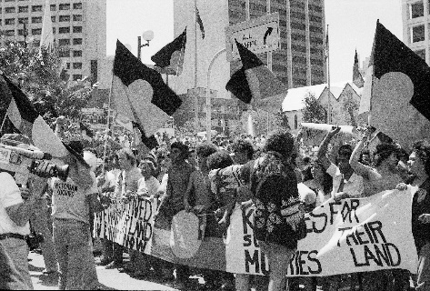
The NAC was established in 1977, the second elected Federal representative body for Indigenous people in Australia after the National Aboriginal Advisory Committee. Dr Lowitja O’Donoghue AC CBE DSG was the first National Chairperson. Their archives encompass forty-three shelf-metres of diverse and important materials covering most aspects of the NAC’s operations, with issues including land rights, Makarrata, education, housing, health, cultural heritage, mining and the environment, human rights, law and justice.
In 2016–17 this collection was rehoused and finding aids were produced to increase its discoverability and make the materials more accessible for researchers and the public.

Artwork and artefacts

Jimmy Pike collection
A significant addition to the Art & Object Collection was the major donation of the Jimmy Pike Collection by Pat Lowe, the artist’s wife and long-time collaborator. With more than 300 drawings and paintings on paper, 130 prints and a carved boab nut, the collection provides incredible insight into the practice of Walmajarri artist Jimmy Pike (1940–2002) and his life and country in the Great Sandy Desert. Many of the artworks in this collection were adapted by Desert Designs in the 1980s into internationally renowned fashions.

AIATSIS Possum Skin Cloak
The AIATSIS possum-skin cloak by Yorta Yorta, Mutti Mutti and Boon Wurrung artist, Lee Darroch, was completed this year. A smoking ceremony was held at AIATSIS in March to cleanse and welcome the cloak into the collection. You can find out more at the online exhibition: http://aiatsis.gov.au/exhibitions/possum-skin-cloak.
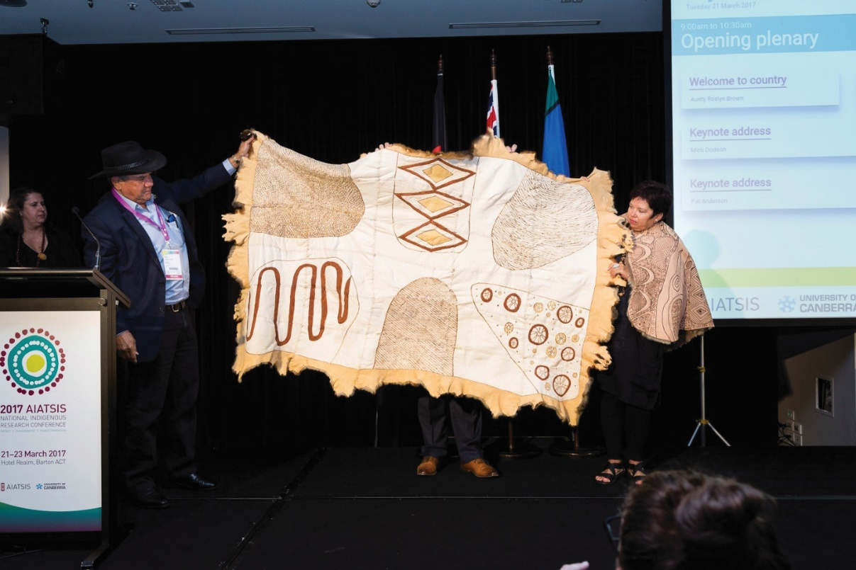

Audio recordings

Bryson cassettes
Out of the almost 700 hours of audio material AIATSIS acquired this year, one significant collection is a set of thirteen cassette tapes from Ian Bryson, the eminent anthropologist and ethnographic filmmaker. They complement a set of eight tapes Bryson deposited with AIATSIS in 1996. Bryson recorded interviews with people involved with the AIAS (the predecessor of AIATSIS) film unit in 1995–96 as part of his Masters studies, and his thesis, Bringing to Light, was published by Aboriginal Studies Press in 2002. The interviews trace the evolution in approach to ethnographic filmmaking at the point where there was a significant shift away from a focus on traditional Aboriginal life and towards documenting societal transition.

Photographic images

Wentworth collection
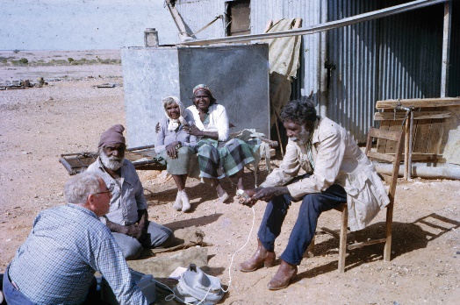
A large collection of colour transparencies, as well as prints, journals and documents, detailing the travels of William ‘Bill’ Wentworth, were donated by his daughter Georgina San Roque in 2016. Bill Wentworth became the first Minister-in-charge of Aboriginal Affairs in 1968, and was instrumental in the establishment of AIAS in 1964. The photographs were taken by his wife Barbara from 1962 to 1986 and record trips through Cape York, Arnhem Land, Lake Callabonna, the Kimberley, the Simpson and Gibson Deserts, Torres Strait, Canning Stock Route and the Bungle Bungles. As well as documenting Wentworth’s travels, these photographs identify many people and places around Australia and this collection will be of interest to many people today.

Film and video

Eddie Koiki Mabo’s videotapes
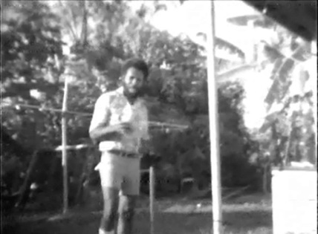
Historic footage recorded by Eddie Koiki Mabo between 1975 and 1977 was added to the collection. It includes early footage of Australia’s first Black Community School in Townsville, established by Eddie Koiki Mabo, Bonita Mabo and Harry Penrith (later known as Burnum Burnum) to teach children Mer songs and language. Despite their low quality, these 15 J-Format tapes are significant, highlighting achievements of Eddie and Gail Mabo prior to the landmark Native Title case.

Indigenous parliamentarians’ maiden speeches
Video of maiden speeches by Indigenous parliamentarians, including those of Patrick Dodson, Aiden Ridgeway, Nova Peris and Linda Burney, were deposited by the Department of Parliamentary Services.

Sand stories from Central Australia
145 Central Australian Sign Language recordings produced by Jenny Green were added to the collection. They feature sand stories from Central Australia — a traditional form of Indigenous narrative in which storytellers incorporate speech, song, sign, gesture and drawing.

Radiance production records
Rachel Perkins donated the production records of the film, Radiance, which she directed in 1997, and the manuscript component is now available for use. Adapted from Louis Nowra’s stage play, Radiance, which tells the story of three women returning home for their mother’s funeral, was nominated for seven Australian Film Industry Awards. Deborah Mailman won the AFI Best Actress Award for her role, the first Indigenous actor to do so, and Radiance won Audience Favourite at Melbourne, Sydney and Canberra film festivals. Radiance was significant in its focus on Indigenous people as characters rather than social problems, its positive critical and public reception, commercial release for an Indigenous content film, and Indigenous creative control.

- Upgrade and maintain capable digital infrastructure

Management and storage of digital materials and metadata
Significant progress was made in 2016–2017 with the multi-year implementation of the Digital Asset Management System (DAMS). The first stage of the DAMS system, dealing with the acceptance of new materials entering the collection, including depositor information and prioritisation assessments, was completed and fully operational in May 2017. The second phase is currently underway and will manage the assessment, documentation, preservation and description of collection items.
An Electronic Document Records Management System (EDRMS) was implemented during 2016–17, aligning AIATSIS with the National Archives’ (NAA) Digital 2020 Policy. In conjunction with this AIATSIS began a project to scan its corporate records, which through the EDRMS can be linked directly with collection item records, providing greater contextual information. This project will continue to develop in line with EDRMS and DAMS.
AIATSIS also adopted internationally accepted metadata standards such as Dublin Core, Preservation Metadata: Implementation Strategies and Categories for the Description of Works of Art for describing collection material. These standards ensure that AIATSIS’ metadata is consistent with international best practice. It has already increased the discoverability of the collection via search engines and other tools, placing AIATSIS records in front of thousands of new clients every day through a simple word search. It has also paved the way for the implementation of the DAMS.
In preparation for the final stage of DAMS implementation, AIATSIS is taking steps to procure a new data repository, one that will need to integrate with legacy systems. The AIATSIS network and digital holdings were reviewed in 2016–17 and a ‘proof of concept’ has begun. Once this has been finalised, the final phase of the DAMS can begin. This phase will allow archival information to be accessed by the public through different gateways and channels, and will support AIATSIS’ goals of increasing community involvement in the development and management of the collection, increasing collaboration with other institutions and increasing the accessibility of the collection. A key goal of EDRMS and DAMS is to allow information management systems within AIATSIS to interact with systems in community and other organisation and archives.

Digitisation equipment and technology
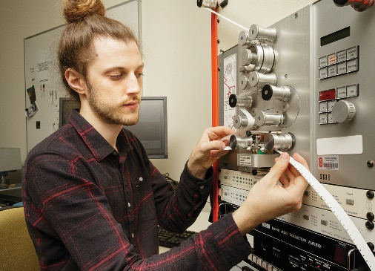
Following a successful pilot program in 2015–16, this year AIATSIS acquired a Hasselblad H5D camera and photographic studio facility, including colour-controlled light sources and artwork support systems, such as purpose-designed tables and frames to suit objects, mixed media and large art works. This camera is used by cultural institutions across the world to faithfully record the subtle detail and colours found in cultural and heritage works. This new facility has enabled preservation of the complete Jimmy Pike art collection (for more detail see ‘Significant new acquisitions’ on page 29) as well as sculptures, large works on paper and mixed media objects.
- Develop, implement and maintain a single platform for the discovery of and research into Australian Indigenous languages
Work continued this year on AIATSIS’ Australian Indigenous Languages datasets, Austlang and the Languages & Peoples Thesaurus. Austlang contains detailed records for every reported language variety including languages, dialects, patrilects, clan-based varieties, etc., and records information such as location, historical and linguistic documentation and estimates of speaker numbers. The terms in the Thesaurus refer to information about language varieties in items in the AIATSIS collection.
Over 180 records were researched, created and/or refined, including incorporation of community-preferred spellings and names where possible. The datasets were also prepared for consolidation and migration to a new single platform for discovery and research, which will occur in 2017–18.

- Develop and implement a digital technology program for the preservation of Indigenous community and organisational archives and knowledge
AIATSIS collaborated with the Wadeye Community on the Kanamekek-Yile Ngala Museum’s video collection which was deposited in June 2016. After digitising the collection, the community were provided with digital copies; they are providing detailed descriptions of the materials, greatly increasing the meaning of each item and its discoverability. Most importantly, this process provided the community with direct control over the descriptions, any possible sensitivities contained in the materials, and means they can set appropriate access and use conditions on the collection.
To tie in with the need to interact with collections management systems within communities and other organisations, AIATSIS commenced the Preserve, Strengthen, Renew in Community Project (see page 59–60) in 2016–17, a major two-year project, to begin establishing models and methods for working with communities on the development and management of their own collections.
- Plan and implement appropriate physical storage for the expanding collection
The employment of a full-time conservator has supported work to ensure the physical conservation and safety of the collection within existing on-site storage facilities, including:
- Preparation of a new Collections Disaster Response Plan and the delivery of disaster training - final approval of the plan and desk-top drills will occur in 2017-18.
- Progress towards a comprehensive Collection Conservation Plan, including an update of the Collections Business Continuity Plan, implementation of an Integrated Pest Management plan, Food and Drink Policy, environmental control monitoring regime and collection-wide condition surveys and treatment, which will continue into 2017-2018.
As not all of the Art & Object collection can now be safely housed on-site, an off-site storage strategy, costed plan and risk assessment and management plan were prepared during 2016-17 for implementation during the first half 2017-2018.

Warlpiri Drawings added to the UNESCO Australian Memory of the World Register
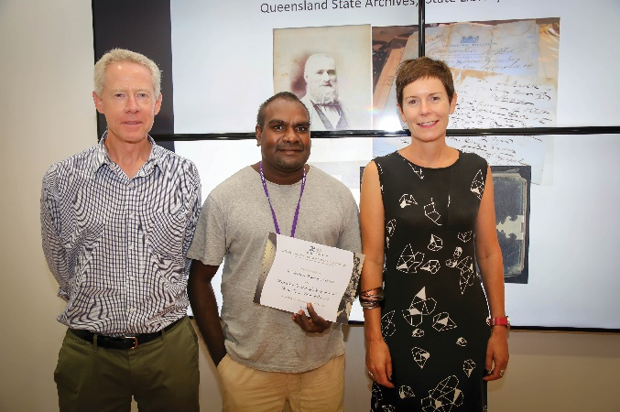
On 9 February 2017, the collection of artworks known as the Warlpiri Drawings was inscribed on the United Nations Educational, Scientific and Cultural Organisation (UNESCO) Australian Memory of the World Register in a ceremony in Canberra. The UNESCO Australian Memory of the World honours documentary heritage of significance for Australia and the world, and advocates for its preservation.
Noted anthropologist Mervyn Meggitt collected 169 crayon drawings while undertaking fieldwork with Warlpiri people at Lajamanu (Hooker Creek) between 1953 and 1954. Meggitt encouraged men and women to make crayon drawings to assist his research into elements of Warlpiri society. They were deposited with AIATSIS in 1965 along with original photographs and audio material, and officially donated by Meggitt’s widow, Joan Meggitt, in 2013.
The drawings’ historical significance lies in the unique way they document the relationship and obligations of the artists to their traditional country. They also predate by two decades the acrylic painting on canvas that emerged at Papunya in the early 1970s that began a revolution in modern Aboriginal art.

Our results
Measure and target | 2015–16 Results | 2016-17 Results | Change +/-%
Rate at which unpublished material is offered to the collection (registered)
TARGET EXCEEDED
Print (manuscripts) | 63,865 pages | 30,495 pages | -52%
Audio | 488 hours | 910 hours | +86%
Pictorial | 24,401 items | 25,237 items | +3%
Moving image  Film  Video | 150,182 feet  842 hours | 11,100 feet  1,608 hours | -93%  +91%
Art objects and artefacts | 372 items | 2260 items | +508%
Rate at which material accepted into the collection (accessioned)
TARGET NOT ACHIEVED
Print and published | 4,043 items | 5,960 items | +47%
Manuscripts | 63,865 pages | 18,514 pages | -71%
Audio | 942 hours | 790 hours | -16%
Pictorial | 19,340 items | 21,277 items | +10%
Moving image  Film  Video | 66,666 feet  454 hours | 32,100 feet  437 hours | -52%  -4%
Rate at which material is digitally preserved
TARGET EXCEEDED
Print | 114,413 items (including 58,641 manuscript pages) | 72,562 items  (including 64,426 manuscript pages) | -37%
Audio | 4,019 hours | 3,251 hours | -19%
Pictorial | 45,232 items | 59,826 items | +32%
Moving image  Film  Video | 329,396 feet  1,090 hours | 992,812 feet  583 hours | +201%  -47%
Film sound—preservation masters created | 170 hours | 240 hours | +41%
Art objects and artefacts | 123 items | 647 items | +426%
Discoverability aids produced
TARGET EXCEEDED
Manuscript-finding aids | 23 | 13 | -44%
Audio audition sheets | 524 | 664 | +27%
Audio-finding aids | 44 | 46 | +5%
Pictorial caption lists | 335 | 208 | -35%
Moving image audition sheets | 55 | 36 | -35%
Moving image finding aids | 10 | 10 | No change
Catalogue records — new and upgraded | 6,154 | 7,255 | +18%
New annotations to catalogue | 1,502 | 694 | -54%
RATE OF ACCESS TO THE COLLECTION
TARGET EXCEEDED
Research visits | 725 | 928 | +28%
Requests/inquiries | 5,554 | 6,379 | +15%
Client satisfaction survey results (rating out of 5)  General satisfaction  Finding materials  Helpfulness of staff | 4.92  4.56  4.97 | 4.95  4.50  4.97
Catalogue use—Mura  Page views  Unique users | 416,270  25,223 | 442,242  35,220 | +6%  +40%
Value of material returned to Indigenous communities* | $47,846 | $36,905 | -23%
*Value as per allowances under the Return of Materials to Indigenous Communities program, which funds the provision of a certain number of copies of relevant material to Indigenous people and communities at no cost to the client.

Analysis
AIATSIS’ Collections area experienced significant changes in 2016–17 as new systems and innovations were brought in to increase capacity and efficiency. Additional funding received in the previous year allowed for AIATSIS to bring its practices up to international standards in archive management and digitisation practices, with a focus on making the collection more accessible. The targets set accommodated these major changes, including the introduction of new equipment like high-speed film scanners, new staff, and staff training in all of the associated new workflows and processes. These included the introduction of new equipment like high-speed film scanners, and all of the associated new workflows and processes.
AIATSIS met all but one of the 2016–17 targets to ensure the collection is safe, accessible, valued and growing were exceeded. Securing the collection was AIATSIS’ primary focus this year, and the attention, resources and effort applied to use this funding effectively shows in these excellent results.
Across the collections, a great deal of effort has gone into implementation of the DAMS, a transformation which will support the effective operation of the collection many years into the future. While there has been a team dedicated to the rollout from a business analysis and technical perspective, employees across all areas of the collection have needed to divert time towards the transition to new systems and workflows and the integration of legacy systems.
Tackling the backlog in registration and accession — integral to implementation of the next phase of the DAMS — will change the size and distribution of the collection over time. This will reflect increased knowledge and understanding of the material already offered and/or accepted, not necessarily the content of the collection itself.
The revised collection development strategy, currently in draft, is designed to increase acquisition of material created by Aboriginal and Torres Strait Islander people, communities and organisations. Variation can be observed within media — for example, a reduction in moving image film deposits, which is expected given technological changes, while video and born-digital deposits are increasing.
The one target not achieved is in material accepted into the collection. This is due to reconsideration of priorities across the work program. The decision was taken to deal with existing backlogs before adding significantly more material to the collection, and to increase quality checks and ingest to ensure digital items added to the collection can be found and used.
Preservation digitisation has been a very high priority to secure the existing collection, and progress far above the target has been achieved. Within this outcome, a relatively lower rate of audio preservation can be observed. After a campaign to digitise high-risk audio material over several years, work is now focused on remaining fragile field tapes rather than archive tapes. Field tapes are often in poorer condition and require one or more conservation treatments to prepare them for digitisation. They also need close attention throughout the digitisation processes.
With so much work during the year to preserve and manage the collection, it is rewarding to see that access and use of the collection is increasing, evident in visits, inquiries and catalogue use, and that high levels of client satisfaction have been maintained. While the type and value of materials supplied to communities under the Return of Materials to Indigenous Communities resulted in a lower dollar value than the previous year, a greater number of communities received collection items.

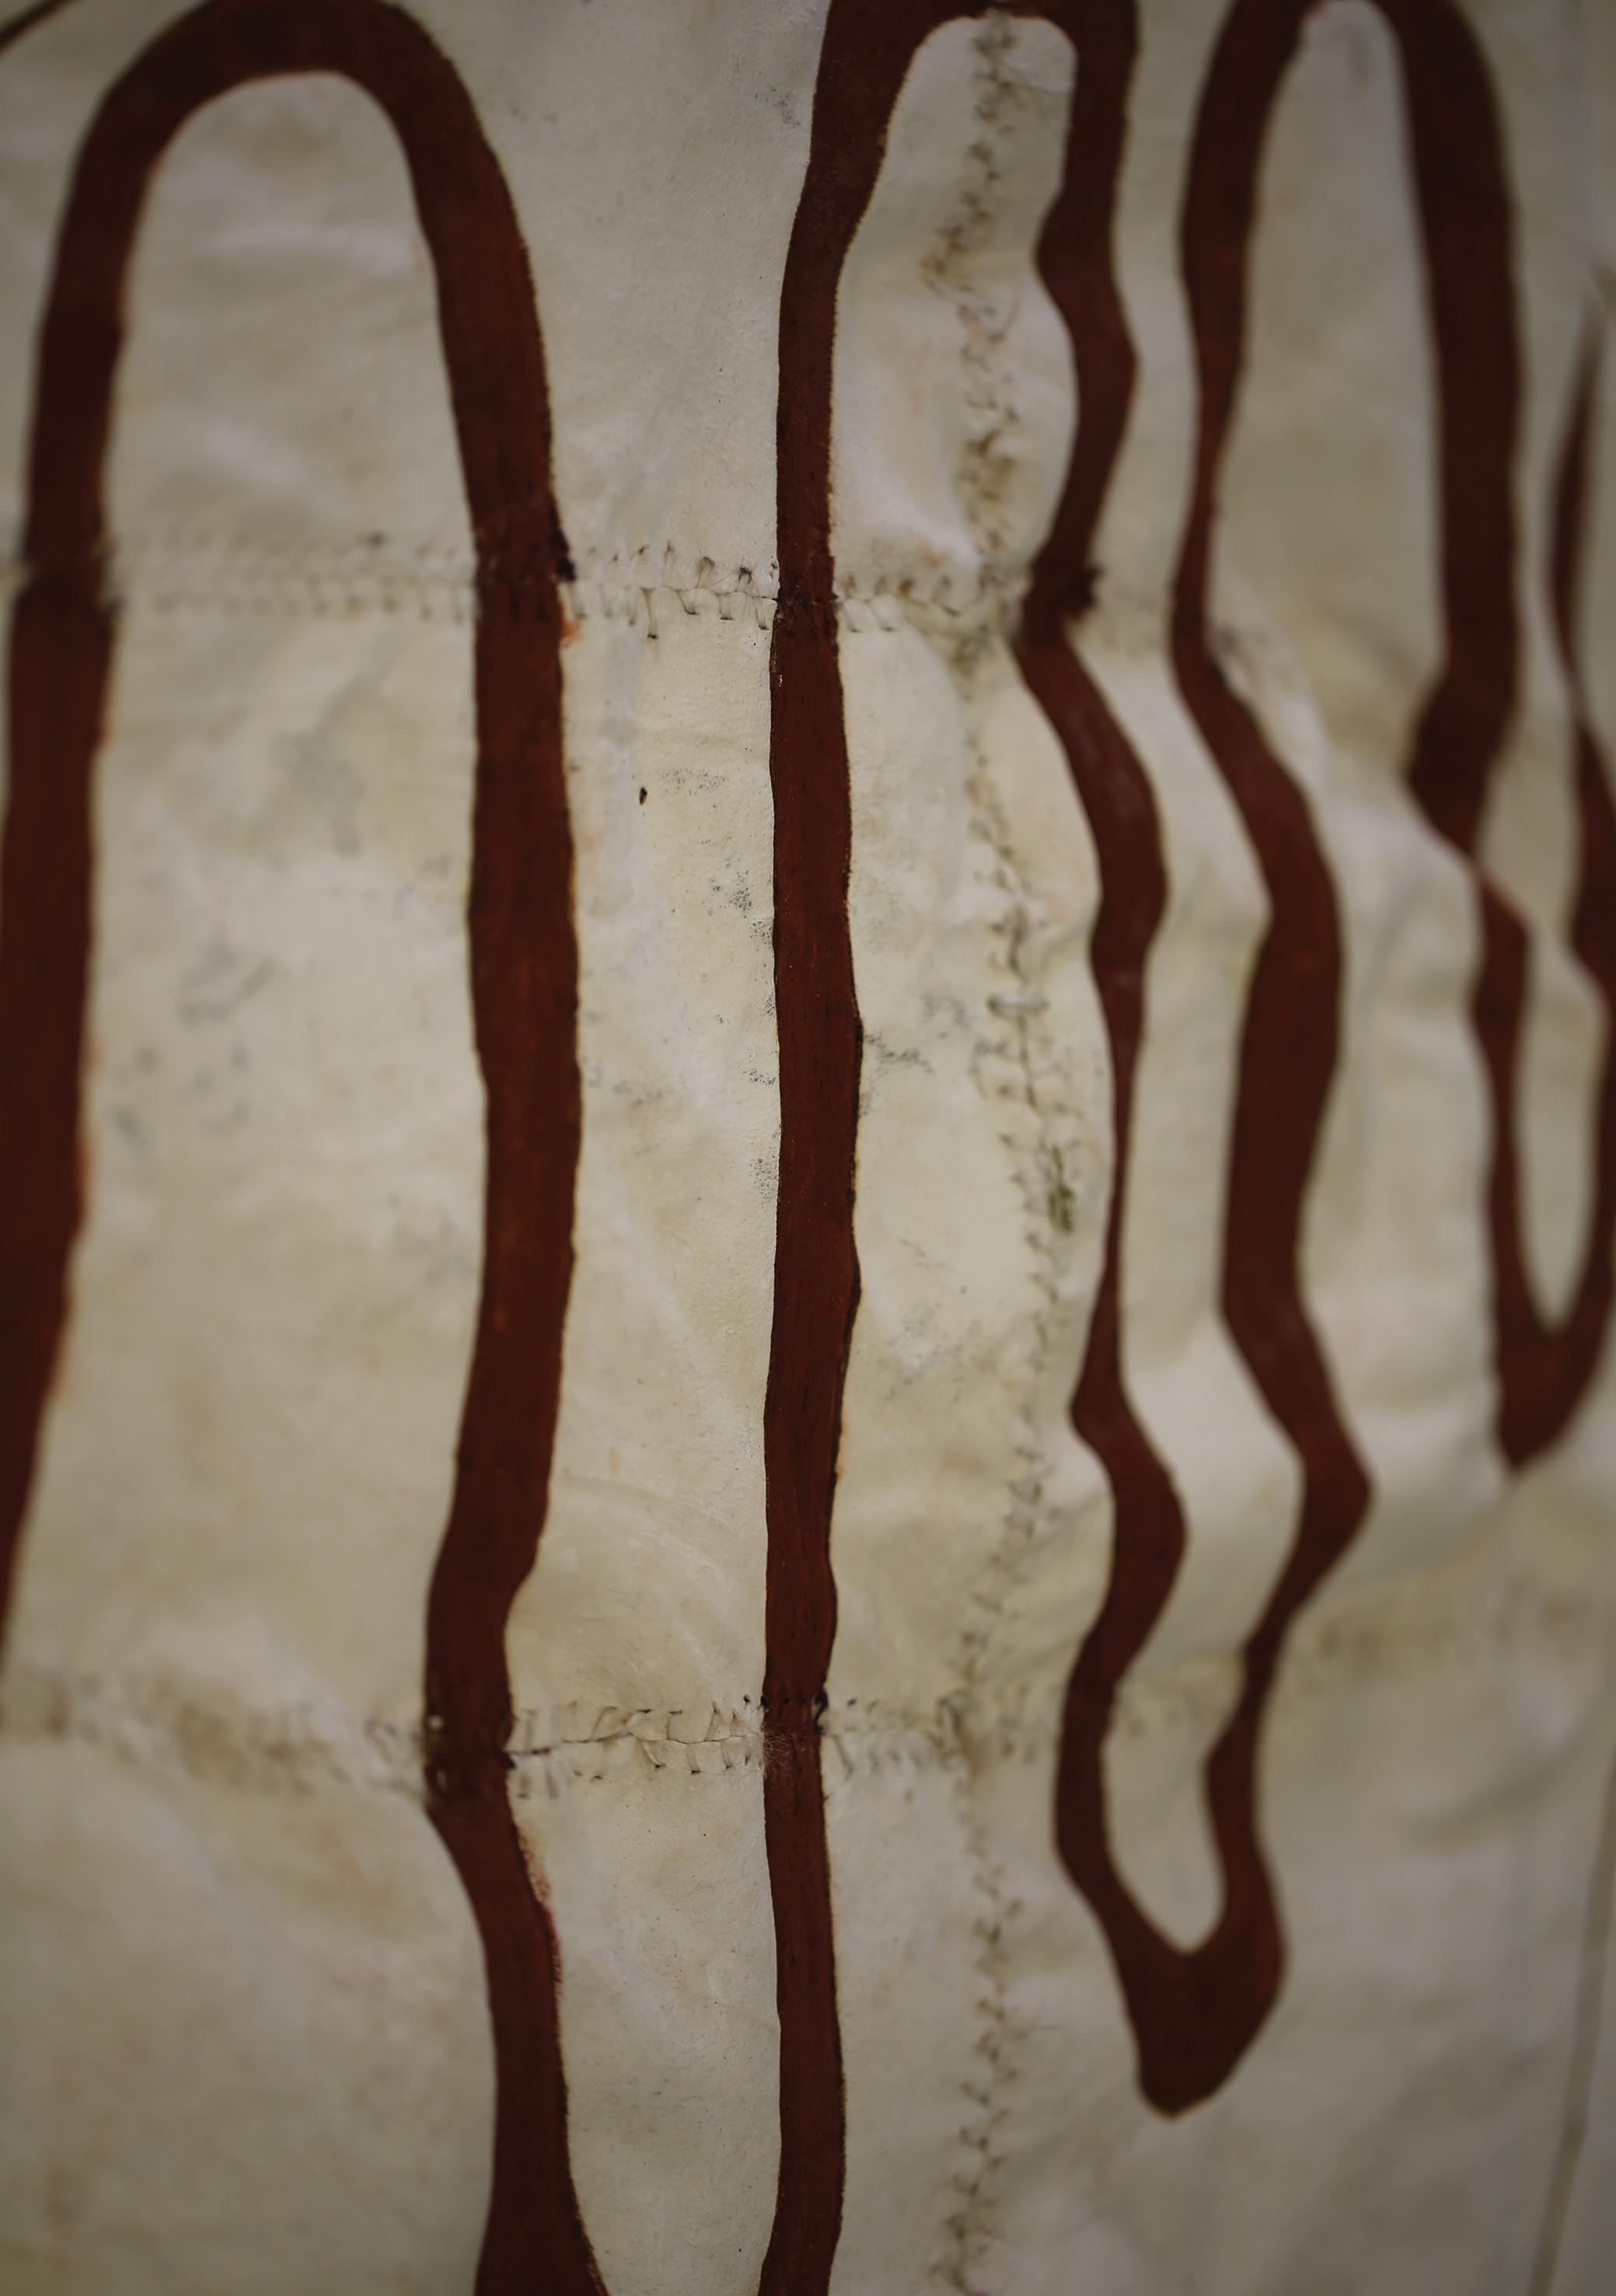

Strategic Priority 2 – Providing leadership in Indigenous research, and ethical engagement in research, collections and publishing.
AIATSIS will lead ethical practice in research, publishing and in creating, interpreting, maintaining and using collections of Indigenous knowledge and cultural heritage. We will further develop our international role in linking institutions, nations, researchers and Indigenous peoples, with an emphasis on sharing practice and understanding, exchange and mobility, collaborative development and use of Indigenous knowledge and engagement with Indigenous peoples.

Planned performance and measures
AIATSIS will lead ethical practice with a focus on training and resources to support the take-up of key AIATSIS guidelines for research, publishing and cultural learning.
Key outcomes over four years are:
- Ensuring AIATSIS is recognised as a centre of excellence in Indigenous research and collection practices across a broad disciplinary and interdisciplinary spectrum.
- Providing AIATSIS’ advice and training in ethical research, collections and publishing practice is sought out and recognised.
- Analysing the gaps in the Aboriginal and Torres Strait Islander evidence and knowledge base and of the state of Indigenous research.
- Revising the Guidelines for Ethical Research in Australian Indigenous Studies (GERAIS), and toolkit(s), and working to ensure they are adopted by Australian Universities.
- Developing a suite of resources in cultural learning and competency.
Performance criteria, measures and targets for 2016-17 were:
Performance criteria | Measures | Targets 2016-17
Delivery of contracted outputs and outcomes to actively strengthen, preserve and renew Indigenous knowledge, promote understanding of Indigenous peoples and contribute positively to the wellbeing of Aboriginal and Torres Strait Islander peoples. | Reach and take-up of standards and guidance on best practice in research engagement, publication and collections | 100% increase in the reach and take-up of standards and guidance on best practice in research, engagement, publication and collections  50% increase in external take-up of AIATSIS ethics assessment and approval.

Our strategies
- Develop best practice and tools for assessing research impact and engagement.
Assessing research impact is a critical element of AIATSIS’ aspirations to provide leadership in Aboriginal and Torres Strait Islander research, to ensure the quality of our own research and the return on investment for communities, and to contribute to the development of leading methodologies and practices in impact evaluation.
Our efforts under this strategy are consistent with the emphasis on impact and engagement in determining the value of research under the Australian Government National Innovation and Science Agenda. AIATSIS participated in the Australian Research Council (ARC) consultations on measuring impact and engagement and provided advice to the ARC on methods for measuring and reporting on impact and engagement in Indigenous research.

Planning for impact
All AIATSIS project proposals must be based on an AIATSIS Impact Pathway. Impact pathways are the leading-edge approach to ensure that research is impact-driven, clear about the change it is trying to achieve and is the research most needed to support this change. The AIATSIS research pathway was finalised and introduced in 2016–17.
AIATSIS has continued to contribute to the Publicly Funded Research Agencies (PFRAs) impact working group, working together to establish agreed methods for assessing research impact. Executive Director of Research and Education, Dr Lisa Strelein, partnered with colleagues from the Australian Research Council, Commonwealth Scientific and Industrial Research Organisation (CSIRO) and the Australian Nuclear Technology Organisation to convene a workshop on planning for impact at the International Network of Research Management Societies Conference in September 2016.
The ARC also held a ‘Planning your way to research impact’ workshop at the AIATSIS National Indigenous Research Conference in March 2017.

Evaluating impact
AIATSIS’ “Sharing success, measuring impact” project is designed to develop and test a methodology to evaluate research impact. AIATSIS first prepared an annotated bibliography and issues paper which summarises the gaps in the literature on research impact and engagement and examines existing approaches that may be best suited to AIATSIS research, consistent with the principles of the Guidelines for Ethical Research in Australian Indigenous Studies (GERAIS). “Sharing success, measuring impact” will be published later in 2017 in Indigenous Knowledge Forum vol.2. (Ed Natalie P Stoianoff) so others can also benefit from AIATSIS’ groundwork.
To test and refine the proposed methodology, AIATSIS also commenced two pilot research project impact evaluations:
- Singing the Train Project– see page 71
- Preserve, Strengthen, Renew in Community Project – see page 59–60
Sharing Success, measuring impact, Singing the Train and Preserve, Strengthen, Renew in Community Project are detailed in Appendix A: Research Project Summaries.
- Provide advice to government on Indigenous research priorities
AIATSIS provided input to the 2016 National Research Infrastructure Roadmap, prepared by the Department of Education and Training under the National Research and Science Agenda. The harmonisation of platforms for Indigenous research across the humanities, arts and social sciences has been identified as a priority.
AIATSIS continued to provide regular ad-hoc advice and input to Indigenous policy and program design, including research priorities to support evaluation. Native Title continues to be an area where AIATSIS’ unique expertise is valued.
AIATSIS and the Department of Prime Minister and Cabinet (PM&C) co-hosted a Native Title Representative Body (NTRB) Policy and Research Forum in Canberra from 7-8 November 2016, to provide an opportunity for engagement between native title organisations and policy makers in policy and program design and delivery. It also provided an opportunity to consider the existing evidence base for policy and identify any gaps and needs. 50 delegates from native title representative bodies and service providers provided input to policy formulation in critical areas of native title, such as capacity and capability building of native title organisations, funding models, regional coordination, and engagement and communication between stakeholders.
- Increase take up, training, resources, external clearances, best practice advice and forums to support the Guidelines for Ethical Research and the Ethical Publishing Guidelines
Training in the Guidelines for Ethical Research in Australian Indigenous Studies (GERAIS) was revamped in 2016, with a new structure and workshop materials to provide participants with an in-depth understanding of the broader framework for research ethics in Australia, how the GERAIS fit within that framework and how the principles are applied in practice.
In November 2016, Research Ethics Committee (REC) members delivered a preconference ethics workshop ‘Cultural Safety — Understanding the ethical considerations for research with Aboriginal and Torres Strait Islander Peoples’ for the Australasian Ethics Network Conference in Adelaide.
Membership of the REC was refreshed this year when seven positions expired. This was the first fully competitive appointment process and interest was strong — twenty-five applications for appointment were received. Professional development workshops were held for new REC members and AIATSIS researchers. Appendix B includes full details of REC membership and activity during 2016–17 (see page 135).
To promote best practice, AIATSIS made submissions to:
- the ARC review of the National Code for the Responsible Conduct of Research; and
- the National Health and Medical Research Council (NHMRC) consultation on the proposed revision of the Values and Ethics — Guidelines for Ethical Conduct in Aboriginal and Torres Strait Islander Health Research and Keeping Research on Track: a guide for Aboriginal and Torres Strait Islander peoples about health research ethics. An evaluation of these guidelines undertaken by AIATSIS and the Lowitja Institute in 2013 was published as part of this consultation process.
AIATSIS also provided ad-hoc advice to the Australian Government, Australian Universities and international researchers on how to apply the AIATSIS Guidelines and best practice in Australian Indigenous Research.


Core Cultural Learning: Aboriginal and Torres Strait Islander Australia (Core) Foundation Course
The Core e-Learning program was officially launched by Mr Russell Taylor AM on 5 July 2016 as part of the Department of the Prime Minister and Cabinet’s (PM&C) NAIDOC week celebrations. PM&C Secretary Dr Martin Parkinson AC PSM wrote to PM&C staff to encourage them to use the program and said: “Promoting diversity across PM&C and the broader public service is a priority for me and building cultural competence has to be a stepping stone to that outcome. The rollout of the Core course is central to this commitment.”
By October 2016 Core was available to every Commonwealth department and agency, through the Shared Service Centre’s LearnHub or streamed to their individual networks.
User testing feedback included a large number of positive responses, for example:
- “It was engaging, and the content was excellent overall. I thought it overcame the absence of a live facilitator very well.” — Stephen
- “Wowee. Fabulous. Lovin’ it. You guys are legends.” — Mel
- “Well written, well designed. Easy to go through and also very informative.” — Trang
- “I have some knowledge of native title and issues around it but this gave me more of an insight and the motivation to learn more. The images and videos also added to the module.” — Trevor
- “I enjoyed overall as it was informative and respectful.” — Taneshia
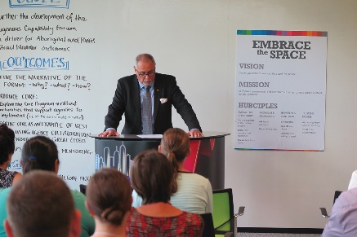
Core featured at an Indigenous Capability Forum hosted by the Department of Human Services in November 2016, where ninety participants from across the APS created and pitched creative methods to promote the course within a department or agency. These pitches have been used to prepare guides and resources to promote the implementation of Core throughout the APS and beyond.
By June 2017 forty-five agencies and departments were accessing Core, through LearnHub or directly from AIATSIS’ web servers. Over 2700 users have enrolled in the course via LearnHub, of which 717 have completed it so far.

- Develop training materials and curriculum for ethical publishing
The AIATSIS Guidelines for ethical research in Australian Indigenous studies (the Ethical Publishing Guidelines) continue to have strong uptake by the publishing industry. To capitalise on this, a scoping framework was developed in 2016–17 to deliver further training online training. The development and rollout of this training, alongside other AIATSIS online learning products, will be a priority for 2017–18.
To raise industry awareness of the Ethical Publishing Guidelines and the availability of guidance and training, Aboriginal Studies Press published articles in Bookseller and Publisher and the Society of Authors magazine, and participated in the Sydney Writers’ Festival in May 2017 as a guest of the First Nations publishers’ program. Workshops with publishers and First Nations writers to discuss strategies for supporting First Nations authors confirmed the strong demand for resources and training on ethical publishing practice.
- Increase international engagement
AIATSIS’ extended and deepened its relationships with several international institutions and forums this year, creating linkages, collaborating and developing good practice in the use of Indigenous knowledge and engagement with Indigenous peoples. Visitors to AIATSIS during the year included: Jim Enote, Executive Director of A:shiwi A:wan Museum New Mexico; Moana Jackson, a Mãori lawyer specialising in Treaty of Waitangi and constitutional issues; Ms Victoria Tauli-Corpuz, UN Special Rapporteur on the rights of indigenous peoples; Mr Peeni Henare, a Member of Parliament from New Zealand; Mr Walter Spurrier, economic and political commentator from Equador and Minister Counsellor (Culture) Yang Zhi and colleagues from the Chinese embassy.

Smithsonian Institutes, Washington DC, United States of America
AIATSIS Languages fellow Dr Doug Marmion visited the ‘National Breath of Life Institute’ for endangered languages held at the National Museum of the American Indian (a part of the Smithsonian Institutes) in Washington DC in June 2017. Originally inspired by the ‘Paper and Talk’ program run by AIATSIS in the 1990s, the Institute is a biennial workshop to provide Indigenous language activists and scholars the opportunity to explore the archives of the Smithsonian Institutes, the Library of Congress and other collections in the area. Participants receive training in practical linguistics and the use of archival documentation to support language revitalization in situations where there are few, or no speakers. This visit was a step towards the development of a similar program through AIATSIS in Australia.

University of Victoria, British Columbia, Canada
AIATSIS Executive Director of Research and Education, Dr Lisa Strelein, is a visiting professor with the University of Victoria’s Indigenous Governance Program (IGov) and a collaborator in a project on everyday acts of cultural resurgence. Euahlayi man, and AIATSIS research officer, Bhiamie Williamson completed his Masters Program in 2016-17 with IGov, supported by the AIATSIS Step Up program, culminating in his attendance at the Native American and Indigenous Studies Association Conference, in Vancouver in June 2017

University of Cologne, Germany
Professor Dany Adone of the University of Cologne is a visiting scholar at AIATSIS and AIATSIS researcher Dr Rod Kennett attended and presented at the Biennial Conference of the Association for Australian Studies, “Nature and Environment in Australia” in Cologne, 28 September – 1 October 2016.

The Vatican Museums
AIATSIS began discussions with the Vatican Ethnological Museum in relation to the publication of a catalogue based on the Museum’s collection of Indigenous Australian cultural objects.

First Global Encounter on Traditional Cuisines, Mexico City
Dr Charlotte Craw participated as the Australian representative in the First Global Encounter on Traditional Cuisines in Mexico City, 23–25 September 2016, presenting on Aboriginal and Torres Strait Islander food practices, initiatives to strengthen and promote Indigenous foods, related ecological and cultural knowledge, and the work of Indigenous chefs. Dr Craw also met with senior cultural and heritage officials and toured the National Museum of Anthropology.

Leading the Indigenous Consultations on Constitutional Recognition
At the invitation of the Referendum Council — appointed by the Prime Minister Malcolm Turnbull and Opposition Leader Bill Shorten at the end of 2015 — AIATSIS led the Indigenous Consultations on Constitutional Recognition in partnership with the National Congress of First Nations Peoples.
The First Nations Regional Dialogues were essential to the Referendum Council’s work in moving towards Constitutional recognition of Aboriginal and Torres Strait Islander peoples. This was the first time a constitutional convention had been convened with, and for, First Nation Peoples. They were also the most proportionately significant consultation process ever undertaken in Australia with First Nation Peoples, engaging 1200 Aboriginal and Torres Strait Islander delegates.
AIATSIS was the point of contact for all delegates, providing direct support for attendance including travel and accommodation. AIATSIS also provided logistics support including venue management and catering.
Starting in November 2016, AIATSIS issued a total of 3071 invitations, and facilitated 14 meetings with 1574 attendees. The regional meetings began in December 2016, were hosted by regional Indigenous Councils and Corporations across Australia and engaged leading Indigenous organisations. They culminated in the National Constitutional Convention at Uluru in May 2017.
The Dialogues included comprehensive legal explanations and evaluations as well as discussions on policy implications, political considerations and reform priorities.
Following intense discussions and exhaustive deliberations, the First Nations Regional Dialogues led to a consensus at Uluru with the Uluru Statement from the Heart representing a common position of the Regional Dialogues First Nations representatives.

- Stage the Indigenous Research Conference
AIATSIS and the University of Canberra co-convened the AIATSIS National Indigenous Research Conference (ANIRC), 21–23 March 2017. Researchers, policymakers, cultural and collecting institutions, the corporate sector and Indigenous organisations and communities came together around the theme ‘Impact, Engagement and, Transformation’, and examined how we can more effectively target research efforts to achieve better policy outcomes and practice with lasting impact.
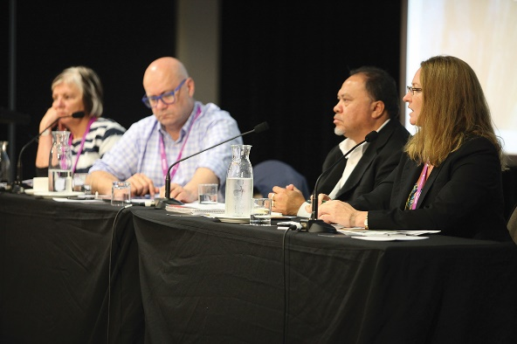
Over 150 speakers discussed issues including collections infrastructure and access, health, community development, governance, research and cultural capability, education, partnership and engagement models, research ethics and assessment, communication and storytelling. Keynote and other speakers included Professor Mick Dodson, Pat Anderson, Professor Marcia Langton, Moana Jackson, Joy Savage and Dr Lisa Strelein.
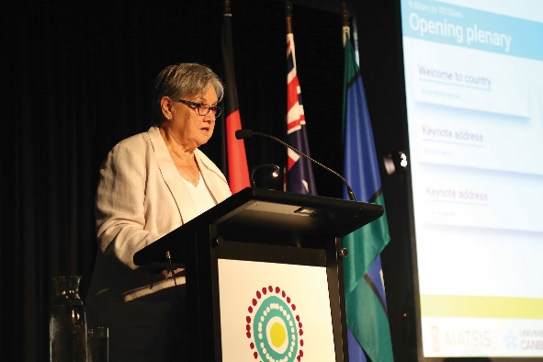
The $125,000 raised from eight sponsors was used to support eighteen Aboriginal and Torres Strait Islander people to attend the conference as speakers, chairs and delegates, and to keep the conference accessible through lower registration costs.
The ANIRC 2017 was considered an overall success, with many positive comments received in person and through the post-conference surveys. There were 383 registrations, 171 speakers and 96 Indigenous nations represented.

Our results
Measure and target | 2015–16 Results | 2016-17 Results | Change +/-%
Reach and take-up of standards and guidance on best practice in research engagement, publication and collections
50% increase in ethics approvals for external (non-AIATSIS) clients | 4 approvals | 16 approvals | +300%
100% increase in reach (PDF downloads from AIATSIS website)*
GERAIS | 3,154 | 4,604 | +46%
Collections access and use policy | 238 | 280 | +18%
Ethical publishing guidelines | 328 | 242 | -26%
*Please note that there was an error in the 2015-16 Annual Report. Figures provided were page views including the PDF, rather than PDF downloads. The figures presented here are correct.

Analysis
Alongside other research organisations, AIATSIS has been working to develop methods for planning, monitoring and evaluating research impact for some years now and 2016-17 saw significant progress in meeting this challenge, with the development and adoptions of the AIATSIS Impact Pathway, and the commencement of pilots to test and develop associated evaluation methodology. The pathway has received critical acclaim from funding partners for assisting in achieving a clear outcome focused approach to research investment.
We used the opportunity of the Australian National Indigenous Research Conference to demonstrate leadership in research and collections practice, as well as the importance of Indigenous engagement, empowerment and benefits from engaging in research. Translation of research into improved policy and practice was a consistent theme and feedback was very positive on the value and importance of the conference for academics, communities and policy makers to challenge each other and develop new relationships.
The reach of our best-practice guidelines increased overall in 2016-17, though not enough to meet all of our targets. The demand from external parties for ethical clearance by our REC was the exception, with a 300 per cent increase. The limited increase in downloads may reflect the delay in the start date for the review of GERAIS and the high interest in reviews of national codes for conduct of research and ethics in health research undertaken by NHMRC this year. AIATSIS made submissions to these reviews. Much of our work in 2016-17 was focused deepening stakeholders’ understanding of why and how to use them. Downloads of the publishing guidelines were fewer than last year, despite many anecdotal indications of interest and demand. Further targeted promotion aligned to the development of online training materials will be considered in 2017-18.
AIATSIS’ leadership in developing cultural competency across government has been firmly established with completion of the development and rollout of CORE during
2016-17. Forty-five Commonwealth departments and agencies have now accessed Core as a development resource for their employees.

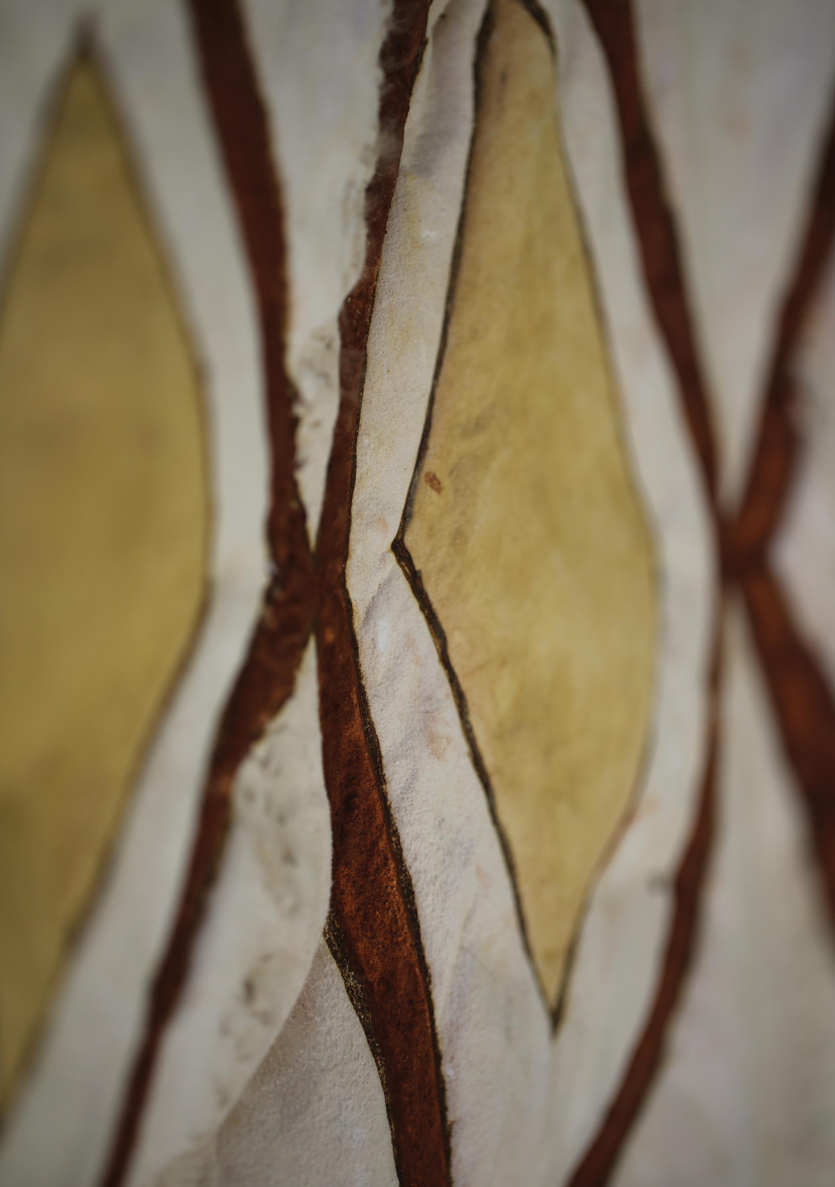

Strategic Priority 3 – Strengthening institutional and community understanding of Aboriginal and Torres Strait Islander culture and heritage.
AIATSIS will provide insights, leadership and advice to enhance understanding of Indigenous people’s culture and heritage, including policy development and program delivery. We will strengthen understanding of native title economies, Indigenous languages and knowledge systems, managing knowledge and information, family history and cultural determinants of wellbeing.

Planned performance and measures
AIATSIS will support Aboriginal and Torres Strait Islander peoples to secure and strengthen their knowledge and cultural heritage and encourage non-Indigenous Australians to understand and value Aboriginal and Torres Strait Islander knowledge and cultural heritage.
Key outcomes planned over four years are:
- Ensuring national research priorities align to key Aboriginal and Torres Strait Islander priority policy areas with a focus on translating research into practice.
- Ensuring AIATSIS is recognised by Indigenous peoples and governments as a centre of excellence in Indigenous policy, bringing together policy-making and academic expertise in areas of importance to Indigenous peoples’ culture and heritage.
- Publishing unique and thought-provoking content that articulates and applies Aboriginal and Torres Strait Islander peoples’ knowledge, histories and cultures.
- Developing a program of appropriate repatriation of existing collections and new collections focused on broader areas of Indigenous knowledge.
Performance criteria, measures and targets for 2016-17 were:
Performance criteria | Measures | Targets 2016-17
Delivery of contracted outputs and outcomes to actively strengthen, preserve and renew Indigenous knowledge, promote understanding of Indigenous peoples and contribute positively to the wellbeing of Aboriginal and Torres Strait Islander peoples. | Quality, innovation, engagement and impact of research activity | 28 staff publications (6 per researcher)  100% of project contracts completed on time.  24 staff presentations (5 per researcher)  $2,063,654 revenue from research activities (4.13 ratio income to investment)  10% increase in number of research publications, grants and other outputs.  Maintain ratio of research income to investment.  2% increase in the number and value of research partnerships and applied research:  Number and value of research impact assessments/evaluations

Our strategies in 2016-17
- Develop and implement a Research and Reporting Framework to determine the current state of Indigenous cultural heritage (both tangible and intangible), including relationships and indicators of change over time
As the first step in the development of a research and reporting framework to meet its new statutory function of providing advice on the status of Indigenous culture and heritage, AIATSIS undertook a review of intangible Indigenous cultural heritage to understand the scope and quality of Indigenous knowledge and existing mechanisms for its recognition and protection. The resulting discussion paper, which will be published in 2017-18, maps:
- the ways in which cultural heritage and Indigenous knowledge is defined and understood,
- how it is generated and recorded in Australia,
- the Australian and international framework for recognition and protection, and
- suggested pathways forward for the ongoing recognition, protection and renewal of Indigenous knowledge.
The central finding of this work is that intangible cultural heritage and physical heritage are interdependent and that actual practice of culture is a key protection mechanism over and above legal protection. It was used to provide advice to the Productivity Commission’s 2016 Review of Intellectual Property on how Indigenous Intellectual and Cultural Property relates to general copyright protection.

- Report and provide advice on the state of Indigenous culture and heritage
In parallel with the review of intangible Indigenous cultural heritage discussed above, AIATSIS continued to deliver a research program related to Indigenous culture and heritage, including native title. The program, valued at $1.8 million, is funded largely externally, through contracts and grants. The program is targeted to the following research priorities for 2015–18:
- Language renewal and revitalisation
- Understanding Indigenous knowledge systems
- Building Indigenous histories
- Strengthening and supporting oral traditions
- Cultural determinants of health and wellbeing
- Cultural competency of Australian governments
- Understanding native title law and its relationship with other legal regimes
- Valuing land and water livelihoods
AIATSIS also continued its role in five strategic research partnerships with:
- the National Indigenous Research and Knowledges Network,
- the ARC Centre of Excellence for the Dynamics of Language,
- the Lowitja Institute Cooperative Research Centre for Aboriginal and Torres Strait Islander Health,
- the Cooperative Research Network for Indigenous Research Capacity, and
- the National Centre for Cultural Competence, University of Sydney.
Details of these, and other strategic partnerships, are at Appendix C (see page 140).
The following table lists AIATSIS’ research projects. Where they are partnership projects, the partners are identified. Projects marked ‘(NTRU)’ are delivered as agreed outcomes of funding (2015–18) for the Native Title Research Unit (NTRU) from the Department of the Prime Minister and Cabinet (PM&C). The NTRU has been in place for over twenty years and has led research sector support as the native title legal framework has been developed and implemented.
More details of these projects can be found in Appendix A (see page 124).

NEW PROJECTS 2016-17
Sharing Success, Measuring Impact Literature Review and Case Studies
Started: February 2017 Completion due: December 2018
Partners: Karajarri Traditional Lands Association, Central Desert Native Title Services, Wangka Maya Pilbara Aboriginal Language Centre, Kimberley Land Council, Tjamu Tjamu Aboriginal Corporation
Understanding Native Title Economies (NTRU)
Started: October 2016 Completed: June 2017
Partners: Nyangumarta Aboriginal Corporation, WA, Eastern Maar Aboriginal Corporation, VIC, Native Title Services Victoria
Regional governance and economic coordination for Prescribed Bodies Corporates (NTRU)
Started: October 2016 Completed: June 2017
Preserve, Strengthen, Renew in Community Project
Started: July 2016 Completion due: July 2018
Partners: Karajarri Traditional Lands Association, Central Desert Native Title Services, Wangka Maya Pilbara Aboriginal Language Centre, Kimberley Land Council, Tjamu Tjamu Aboriginal Corporation
Foundation Dictionaries Project
Started: July 2016 Completion due: June 2019
Partners: AIATSIS Foundation
National Prescribed Bodies Corporate Website Redevelopment Project (NTRU)
Started: July 2016 Completion due: June 2018
Prescribed Body Corporate Capability Project (NTRU)
Started: July 2016 Completion due: June 2018
Breath of Life
Started: June 2017 Completion due: December 2018
Restoring Dignity: Networked Knowledge for Repatriation Communities (Return Reconcile Renew stage II)
Started: April 2017 Completion due: December 2019
Partners: ANU (lead), University of Queensland, University of Melbourne, University of Tasmania, University of Otago, Flinders University, National Museum of Australia, Association on American Indian Affairs, University of Amsterdam, Humboldt State University Kimberley Aboriginal Law and Culture Centre, Ngarrindjeri Regional Authority, Gur A Baradharaw Kod Sea and Land Council
CONTINUING PROJECTS
Core: Defence resource library
Started: January 2016 Completion due: August 2017
Partners: Department of Defence
Mapping Livelihood Values of Indigenous Customary Fishing
Started: July 2015 Completion due: November 2017
Partners: Fisheries Research and Development Corporation, Rural Solutions South Australia
Maximising Equity in Native Title Land (NTRU)
Started: July 2015 Completion due: June 2018
Native Title Representative Bodies Knowledge Management Project (NTRU)
Started: July 2015 Completion due: June 2018
History of NSW Aborigines Protection/Welfare Board 1883-1969 (ARC Discovery Project)
Started: July 2015 Completion due: June 2018
Partners: University of Newcastle
Hearing Histories of the Western Pilbara (ARC Discovery Project)
Started: 2015 Completion due: 2021
Partners: University of Melbourne
Centre of Excellence for the Dynamics of Language Corpora Project
Started: July 2016 Completion due: June 2019
Partners: Centre of Excellence for the Dynamics of Language
Managing Information in Native Title (NTRU)
Started: January 2015 Completion due: June 2018
Serving our Country (ARC Linkage Project)
Started: January 2014 Completion due: October 2017
Partners: ANU (lead), University of Newcastle, Australian Catholic University, Department of Defence, Australian War Memorial, National Archives of Australia, Department of Veterans’ Affairs
Longitudinal Study of Aboriginal and Torres Strait Islander Peoples’ Wellbeing
(Mayi Kuwayu)
Started: 2014 Completion due: Ongoing
Partners: ANU, National Aboriginal Community Controlled Health Organisations, Apunipima, University of Adelaide, University of Toronto, Winnunga AMS, Aboriginal Health Council of WA, Aboriginal Health Council of SA, Victorian Aboriginal Controlled Health Organisations, Aboriginal Medical Services Alliance Northern Territory, Baker IDI
Ngunnawal Language Project
Started: July 2016 Completion due: June 2019
Partners: Ngaiyuriidja Ngunnawal Language Group
Return, Reconcile, Renew: Understanding the history, effects and opportunities of repatriation and building an evidence base for the future (ARC Linkage Project)
Started: January 2014 Completion due: December 2017
Partners: ANU (lead), University of Queensland, University of Melbourne, Flinders University, Kimberley Aboriginal Law and Culture Centre, Ngarrindjeri Regional Authority, 5 other local/community organisations
PROJECTS COMPLETED IN 2016-17
Aboriginal and Torres Strait Islander Health Research in Practice—History of the Lowitja Institute
Started: July 2014 Completion due: August 2016
Partners: Lowitja Institute
Singing the Train Project
Started: January 2014 Completion due: July 2016
Partners: Wangka Maya Pilbara Aboriginal Language Centre
Core: Australian Public Service cultural capability e-learning program
Started: January 2014 Completion due: October 2016
Partners: Department of the Prime Minister and Cabinet, Department of Social Services
Integrating measures of Indigenous land management effectiveness
(ARC Linkage Project)
Started: November 2012 Completion due: November 2016
Partners: Charles Darwin University (lead), University of Queensland, CSIRO, 4 other organisations
Murray Darling Basin Wellbeing Survey
Started: September 2014 Completion due: June 2019
Partners: University of Canberra (funding partner), University of Sydney, Murray Local Land Services
Reducing Incarceration Using Justice Reinvestment: an exploratory case study
Started: April 2013 Completion due: March 2016
Partners: Australian Research Council (funding partner), Australian National University, University of New South Wales, Cowra Shire Council, Cowra Aboriginal Land Council, New South Wales Children’s Court
- Report on the state of Indigenous research as represented in Excellence in Research Australia (ERA) Data 2006-13
The Australian Research Council completed the Excellence in Research Australia report in late 2016, and agreement was reached for AIATSIS to access the data. When the data is provided by the ARC, AIATSIS will conduct its analysis and prepare its report.
- Conduct external and internal evaluations of AIATSIS research impact and engagement
AIATSIS started using its new impact evaluation methodology to assess the impact of its own research projects, as well as to test and refine the methodology in action, though the Sharing success, measuring impact project. It was first applied in evaluation of the Singing the Train project. In March 2017, researchers interviewed participants in the Pilbara using a narrative-based methodology, informed by the Most Significant Change technique, while a parallel review of the impact, for audiences, of presenting cultural knowledge in an exhibition format was carried out in Canberra.
This impact assessment allows us to develop our understanding of the impact of legacy song repatriation projects and of audience engagement with public production of cultural heritage. At a broader level, this work helps us to understand whether we are meeting the aspirations of the Indigenous communities we work with, and enables our research to evolve to better support these aspirations. The impact evaluation methodology will also be applied to Preserve, Strengthen and Renew in Community during its pilot phase, and will then be applied over time to a sample of AIATSIS’ research projects.

- Develop collaborative community driven projects for the Preserve, Strengthen and Renew initiative
The Preserve, Strengthen and Renew initiative aims to protect, strengthen and renew Indigenous knowledge and heritage utilising AIATSIS’ national cross sectoral role, unique collection and collaborative approach to research and engagement. This initiative, previously known as ‘Before It’s Too Late’, will ensure that Indigenous communities are able to access relevant cultural material held in collections and to determine their own processes for knowledge production, documentation, and preservation.
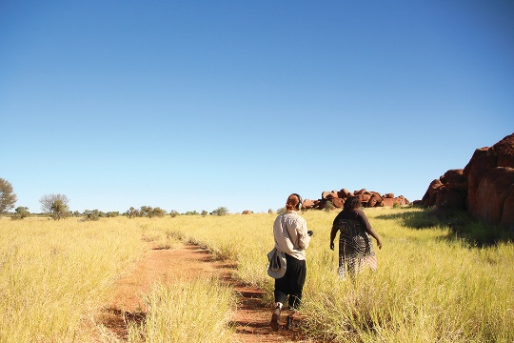
The first community driven project under this initiative is the Preserve, Strengthen, Renew in Community Project, a two-year pilot in collaboration with the Kiwirrkurra and Karajarri people and Wangka Maya Pilbara Aboriginal Language Centre. A series of case studies are being used to identify regional priorities and processes to renew and strengthen Indigenous knowledges. They involve recording and managing Indigenous knowledge, accessing and returning material already in the AIATSIS collections, establishing culturally informed protocols for listening to and viewing material, and reviewing how these processes build and strengthen cultural knowledge. The project integrates access to the AIATSIS collections, on country recording and the development of community protocols for the management of cultural information. The outcomes are intended to inform a methodology and build a case to support national projects in 2018–20.
More details of the project in Appendix A (page 125), and feature story about the Karajarri experience below.

Karajarri experience of Preserve, Strengthen, Renew in Community Project
The Preserve, Strengthen, Renew in Community Project culminated in the return of material from the AIATSIS archive to the community, recording of new stories and development of strong rules about keeping community stories safe.
While in Canberra to attend the AIATSIS National Indigenous Research Conference 2017, Senior Karajarri traditional owners accessed material from the AIATSIS collection. Approximately 300 hours of audio recordings as well as dozens of photographs were requested and returned to Karajarri. Of particular interest were recordings taken by Father McKelson of restricted men’s songs which have since been used by senior Karajarri traditional owner Mervyn Mulardy for important Karajarri ceremonies.
Keen to record cultural knowledge for the future, Karajarri cultural advisors and rangers hosted AIATSIS researchers at Bidyadanga and the project group recorded stories at and knowledge of Karajarri cultural sites. The group also began to develop a protocol for access to Karajarri materials into the future.
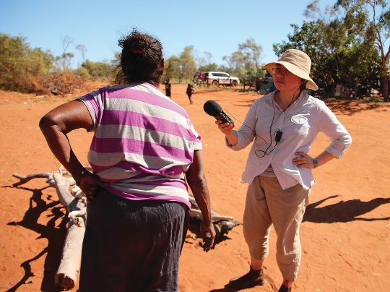
The importance of the collaboration was identified by Karajarri cultural advisor Anna Dwyer who said that:
“It’s very important for Karajarri to be working together with AIATSIS and we need to work together more and develop decision making and protocols, how we can record more information and where we can store it.”
The project aims to counter a long history of information being collected about Indigenous people rather than for them, while enabling traditional owners to assert control over their information and cultural material into the future.

- Explore options for making the third National Indigenous Languages Survey (NILS3), to be conducted in 2017-18 and 2018-19, findings public.
Development of the AIATSIS Languages Strategy commenced in 2016 and is due to be finalised in 2017. Planning of the methodology for the third National Indigenous Languages Survey, to be conducted in 2018-19, is under way and will include the development of options to make the findings accessible.
The previous National Indigenous Languages Surveys were conducted in 2004–05 and 2012-14 to better understand the situation for Indigenous languages in Australia, people’s attitudes and aspirations for their languages, resources and actions needed to support language, and the effectiveness of existing language activity. Both reports are available for free download on the AIATSIS website.
NILS3 will build on these past surveys and include a desktop study to analyse and document existing archival material on Indigenous languages. AIATSIS continues to provide advice to government agencies and Indigenous organisations on language maintenance and revitalisation.
- Further develop the Indigenous family history research service, including training to the sector
The Family History Unit (FHU) continued to provide support and advice on Indigenous family research to Link-Up organisations and Aboriginal and Torres Strait Islander people. The pilot of the Certificate IV Stolen Generations Family Research and Case Management has been successfully completed and evaluated. The course was found to be meeting the original intention of the qualification — to equip graduates to competently achieve the emotional and social wellbeing, family history research and case management outcomes required of their work. The course will be running again from the first quarter of 2017–2018, providing vital and specific training to new workers in the sector who support and reconnect Stolen Generations to family and culture.
AIATSIS has continued to contribute to the national conversation regarding Stolen Generations by contributing to the Healing Foundations Bringing Them Home — 20 Years On report, the unit manager, Narelle Rivers being a panel guest at the Setting the Record Straight for the Rights of the Child symposium and the staff delivering a paper at the 2017 National Native Title Conference.
Two-day unaccredited training in Indigenous family research has also been piloted by the FHU. The training was conducted with 18 professionals from child protection agencies from the ACT and NSW, and organisations that work with young people leaving out-of-home care, with the aim of teaching them to undertake family research for their Indigenous clients who have been disconnected from their culture. The training was well received and evaluated as excellent. Subsequent to the training, correctional institutions, community service organisations and an interstate child protection agency have expressed interest.

National Native Title Conference
The National Native Title Conference was held at the Townsville Entertainment and Convention Centre from Monday 5 - Wednesday 7 June 2017 and attended by 884 delegates from across Australia. The conference was co-convened by AIATSIS, North Queensland Land Council, and held on the country of the Gurambilbarra Wulgurukaba people. This year’s conference celebrated the 25th anniversary since the High Court of Australia’s Mabo decision and the theme was: Looking back, Looking around us and Looking forward.
The program featured over 75 presentations and 150 speakers, with over half of those speakers being Aboriginal and/or Torres Strait Islander people.
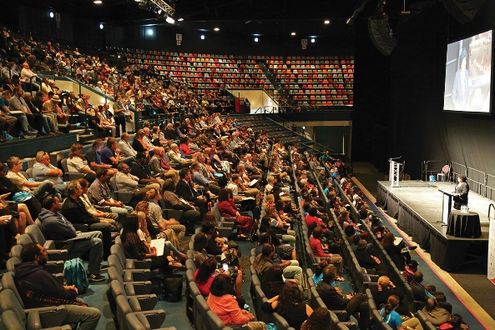
Our focus on youth was significantly developed this year. The 2017 Youth Forum brought together young Aboriginal and Torres Strait Islander people from around Australia with an interest in native title. Participants shared their stories, drew strength from common experiences and explored the challenges and opportunities for young Aboriginal and Torres Strait Islander people in native title processes in both their communities and nationally.
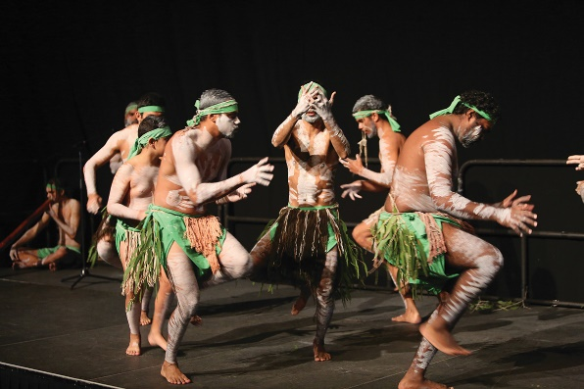
The public program (Days 2 and 3) included a strong focus on improving the rights and interests, resources and opportunities for Prescribed Bodies Corporate (PBCs), such as regional economic coordination and capacity and capability building projects. In the public session, there was a focus on PBC governance and developing economic and commercial opportunities, new advances in cultural heritage and ethical research partnerships. Many sessions explored issues and potential reforms in native title law to strengthen the rights and interests of native title holders through legal mechanisms for land reform, authorisation and decision-making options, agreement-making and compensation.
There was a focus on native title rights for fresh water and sea country, with presentations working with the frustration many Aboriginal and Torres Strait Islander peoples expressed to address new ways forwards for legal rights to and management to water.

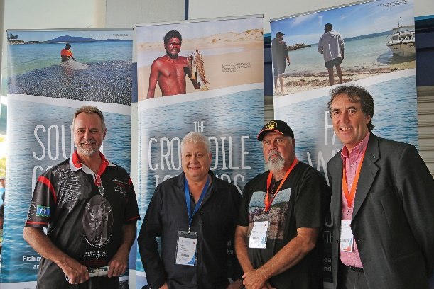
The Living Off Our Waters online exhibition was launched at the conference (see page 69) and attendees were able to access the online exhibition on tablets at the exhibition stall. The Indigenous Affairs Minister visited the stall, met with project lead Dr Rod Kennett and offered to support a fact-finding trip to Erub in the Torres Strait for the project partner organisations.

Our results
Measure and target | 2015–16 Results | 2016-17 Results | Target achieved?
Levels of research quality, innovation, engagement and impact
28 staff publications, 10% increase | 13 publications | 46 publications | Exceeded
100% of contracts completed | — | 100% | Achieved
24 staff presentations | 15 presentations | 57 presentations | Exceeded
$2,063,654 revenue from research activities — income to investment ratio of 4.13 | $2,800,000 | $1,873,040 | Not achieved
Externally funded research projects — 10% increase | 9 projects | 11 projects | Exceeded
Number and value of research partnerships and applied research projects — 2% increase. | 17 projects | 9 new projects (26 total) | Exceeded
Number and value of research impact assessments/  evaluations | New measure | 2 assessments | —

The FHU is funded through the PM&Cs Indigenous Advancement Strategy and has met its contracted targets, providing research support for complex family tracing for Link-Up services and assisting over 400 individuals who contacted the unit directly. This is the first full year of service since the FHU was reopened to qualifying members of the public, so comparative data is not yet available, but the FHU reviews its practice regularly to ensure excellence in customer service. The average time for a customer request, from receipt to closure, was sixteen days.
The National Native Title Conference continues to grow, with 884 delegates for 2017, up from 800 delegates in 2016.
Five contracted research projects were due to be completed during 2016–17, and were done so on time. The delivery date for some projects was renegotiated during the year as circumstances changed.

Analysis
AIATSIS continued to emphasise engagement and impact as the key measures of the success of our research effort. Our partnerships were diverse and intensive, with Indigenous peoples and policy makers engaged in setting research priorities, designing projects, reviewing progress, authoring outputs and communicating results. AIATSIS continues to lead by example in the design and implementation of standards for excellence in Aboriginal and Torres Strait Islander research.
Our project teams and partners maintained an active publication and presentation record, which reinforces the quality and accessibility of the research. AIATSIS contributed to finding solutions to community priorities and had a direct influence and impact on policy and program design across Indigenous affairs and cultural portfolios and provided avenues for Indigenous organisations to also input to policy and practice.
Tools have now been developed to assess the quality, innovation, engagement and impact of research activity, and testing and evaluation is now under way. Significant steps were also taken towards fulfilling AIATSIS’ new role of advising on state of Indigenous culture and heritage.
Almost all contracted research was delivered on time, and the ratio of income to investment was maintained. Revenue continued to be strong, although delays in securing the contract to extend the Core cultural learning activities impacted on us reaching our target. In June, AIATSIS and PM&C signed a contract for a further $1.1 million to support the Commonwealth public service engagement with Core and roll out the course to State and Territory governments. This new funding will be reflected in 2017-18 reporting.

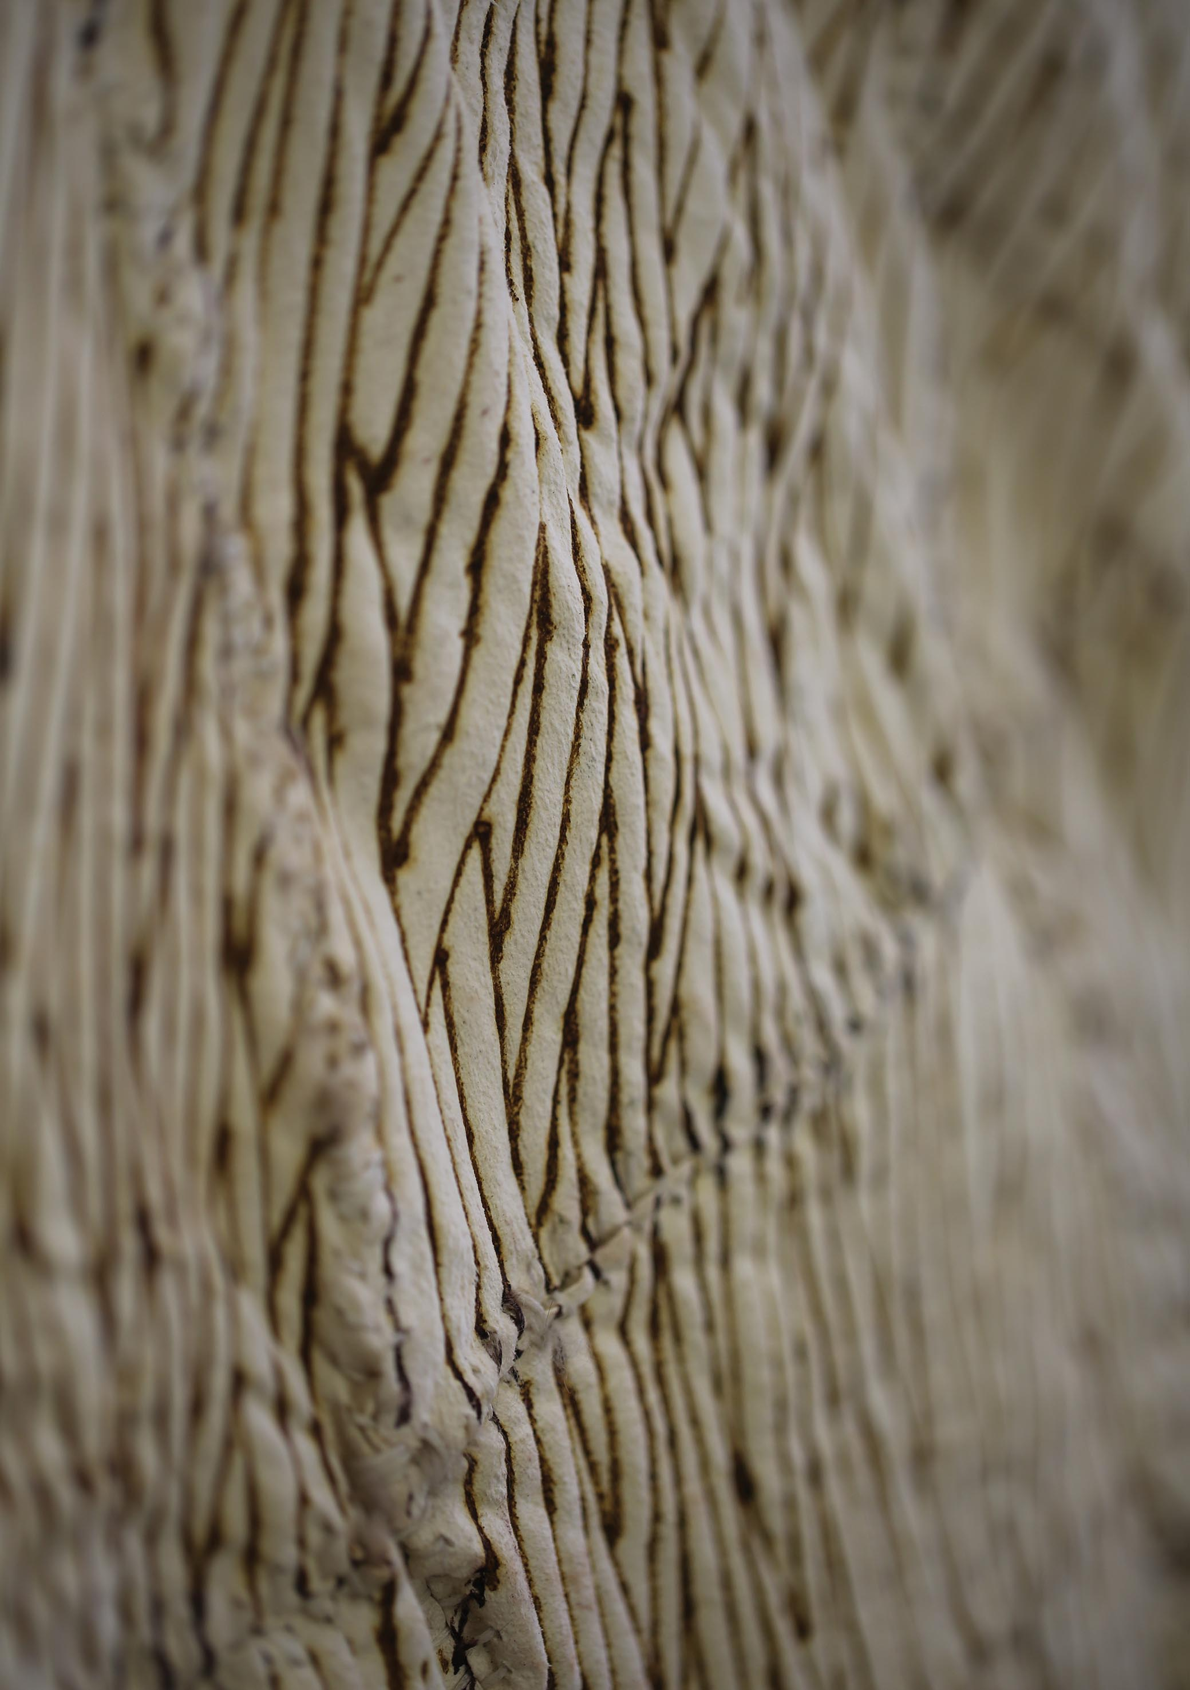

Strategic Priority 4 – Promoting and sharing Aboriginal and Torres Strait Islander cultures and heritage.
AIATSIS will celebrate, promote and share Aboriginal and Torres Strait Islander cultures and heritage within Indigenous communities, the wider Australian community and internationally. We will work to increase Australians experience with, and knowledge of, Aboriginal and Torres Strait Islander cultures, traditions, languages and stories, past and present.
Planned performance and measures
AIATSIS will support Aboriginal and Torres Strait Islander peoples to tell their stories through various means, including publications, the AIATSIS website, and engagement with the national and international communities.
Key outcomes over four years are:
- Improving knowledge and understanding of Aboriginal and Torres Strait Islander people, cultures and heritage.
- Providing a more nuanced and sophisticated public engagement with the diverse communities.
- Developing greater awareness of our work with and for Aboriginal and Torres Strait Islander peoples and communities.
- Publishing timely, relevant, high-quality works, informed by research, and which contribute to the wellbeing of Aboriginal and Torres Strait Islander communities.
Performance criteria, measures and targets for 2016–17 were:
Performance criteria | Measures | Targets 2016-17
All Australians learn about and experience knowledge of Aboriginal and Torres Strait Islander cultures, traditions, languages and stories, past and present. | Number and value of publications. | 10% increase in number of publications
 | Reach and impact of communication and community engagement via media coverage, website and social media reach and activity. | 10% increase in website traffic  10% increase in social media community train and develop 10 web publishers and editors
 | Reach and impact of community engagement through membership and partnerships. | 8% increase in Indigenous members  5% increase in members  10% increase in partnerships  5% increase in value of partnerships  5% increase in value of a public program

Our strategies
AIATSIS will engage with Aboriginal and Torres Strait Islander communities to build knowledge, to share Indigenous culture and heritage, and will provide experiences to all Australians through a public program, digital engagement and access and publishing.
- Optimise digital platforms for improved online discoverability, access and use of the collection
Rollout of a new collections access platform began in 2016-17. Perfect Pictures, the legacy database for access to photographs in the AIATSIS collection, reached the end of its life and was rebuilt into a more accessible online platform. This new system allows greater discoverability and more data management options, and supports practice improvements in line with digital services standards. The new platform will next be extended to provide access to language materials and art and artefacts.
The online Native Title Precedents Database has also been updated with a more user-friendly website and back-end improvements to share select content with other AIATSIS systems (see Appendix A for more details of this project).
- Produce relevant and engaging online content and collateral, communicating and promoting Aboriginal and Torres Strait Islander culture and heritage

Website and online exhibitions
AIATSIS focused on expanding multimedia content to enhance its online presence this year. As well as enhancing the AIATSIS website, 93 videos were added to the official AIATSIS Vimeo channel, generating 13,963 views.
The AIATSIS blog was also launched in late July 2016, enabling AIATSIS staff to promote their expertise, their intimate knowledge of collections, with a personal flavour. Topics for the 23 posts this year included favourite collections items, events, explanation of research resources, team introductions and a guest post from an author. Conversation with stakeholders is enabled through public comments.

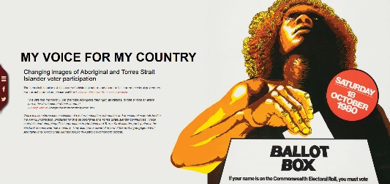
Four online exhibitions were added to the AIATSIS website this year:
My Voice for My Country features electoral education, information and promotional materials held in the AIATSIS Collection, produced for diverse Aboriginal and Torres Strait Islander communities, charting the development official approaches to Aboriginal and Torres Strait Islander participation in the electoral process over half a century.
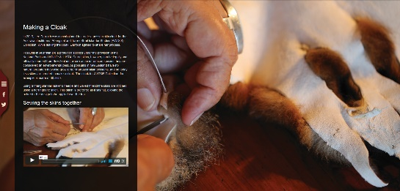
A Possum Skin Cloak shares the process of Yorta Yorta artist Lee Darroch in creating a possum skin cloak for the AIATSIS Collection, commissioned in 2016.
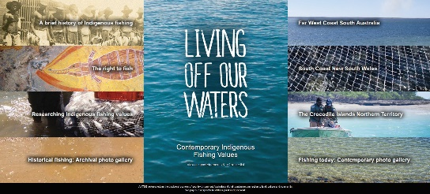
Living Off Our Waters explores contemporary Indigenous fishing values, through stories and images from an AIATSIS Research project completed in collaboration with three Aboriginal communities from around Australia. Participating communities also contributed to the exhibition content through an online photograph competition. A standalone version of the exhibition for tablet computers was produced, which can travel to communities without need of internet access.
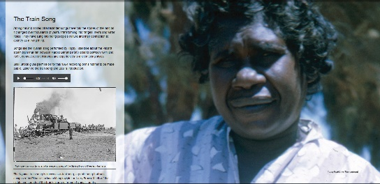
Singing the Train is an extension of the physical exhibition created and displayed in the AIATSIS foyer. It is a multimedia collaboration with the Wangka Maya Pilbara Aboriginal Language Centre that tracks the story of a Nyamal language song about the Spinifex Express in the Pilbara, from its recording in 1964 and repatriation in 2014, to the effects it is having in the community today and across the country.

AIATSIS also partnered with the ABC and National and State Libraries Association to develop the Right Wrongs digital exhibition. This interactive website commemorates the 50th anniversary of the 1967 Referendum and the 25th Anniversary of the High Court of Australia’s Mabo decision. It documents the environment and steps leading up to the 1967 Referendum, the events surrounding the referendum, and perspectives on what has happened in the fifty years since. It was launched by the Minister for Indigenous Affairs, Senator the Hon. Nigel Scullion, at Parliament House during Reconciliation Week 2017. Community-generated content, exploring the impact of the referendum, contributes Indigenous perspectives on this history and culture. Community members who shared their stories attended the launch.
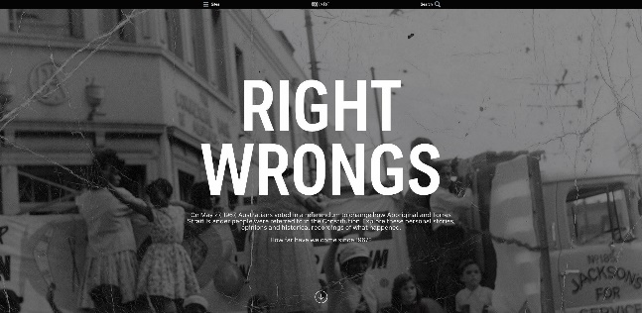

Social media
The AIATSIS social media strategy, policy and moderation guidelines were revised and a selection of scheduling and publishing tools to generate and post content were introduced. Our social media content highlighted our online content, significant key dates, the public program, collection items, publications or projects by AIATSIS staff and volunteers and our work with community. Up 11 per cent from 2015-16, we had 37,202 followers across all of our social media accounts at the end of 2016-17.

e-Newsletter
10 issues of the AIATSIS e-newsletter were produced, with 3,523 subscribers at the end of the year. The newsletter is a summary of Institute activity previously published through our online channels, including the website, news, blogs, online exhibitions, publications and social media accounts.

Media
AIATSIS featured in over ninety news items through the year across television, print, radio and online platforms, promoting our work with and for communities throughout Australia, and highlighting the expertise of our staff and the results and impact of our research and other projects. Media coverage of Aboriginal Studies Press books and authors was substantial and included print reviews and radio and television interviews.
A highlight was local and national television and online coverage by ABC and NITV of the visit by a group of young people from Uniting Jaanimili Aboriginal Aftercare looking to trace family history, including production of a long form piece on The Point with Stan Grant.

- Maintain an innovative public program, and services to strengthen community participation, and attract partners and sponsors
Alongside visitors to our exhibitions and public events, AIATSIS’ popularity as a destination for VIPs, government, academic and cultural institutions’ staff continued strongly, with thirty-three significant stakeholder visits.
We secured sponsorship for both major conferences in 2016–17 (the National Native Title Conference and the Australian National Research Conference), which supported participation through lower registration fees, and the sponsored attendance of selected Indigenous speakers and delegates.
We maintained a number of strategic partnerships (see Appendix C on page 140), alongside partnerships and collaboration on many specific projects and activities (see Appendix A on page 124).

Exhibitions
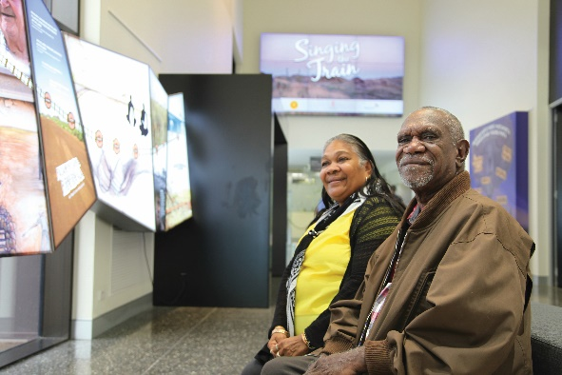
The Singing the Train exhibition at AIATSIS was the culmination of a major collaboration across all areas of AIATSIS and with the Nyamal community. AIATSIS supported two young Pilbara artists, Talor Derschow and Clint Taylor, who worked with the design team in Canberra, and assisted in their professional development. The exhibition includes illustrations of the artists’ interpretation of the train song journey. Later in 2016, Clint Taylor visited with seven community collaborators, including elders came from the Nyamal community, and participated in the Exhibition Launch Opening at AIATSIS. See pages 69 for more details about the research project on which this exhibition is based.
The exhibition, Yes: The Ongoing Story of the 1967 Referendum, at the Museum of Australian Democracy resulted from a partnership between the museum, AIATSIS and Reconciliation Australia. It explores the history of the 1967 Referendum campaign when over 90 per cent of Australians voted in favour of allowing the Commonwealth to make laws in relation to Aboriginal and Torres Strait Islander people and allowing them to be included in the census. The exhibition highlights the efforts of Aboriginal and Torres Strait Islander activists during the campaign and features rare archival material from the AIATSIS manuscript and photographic collection.
The development of processes to facilitate the loan of items from the AIATSIS collection for display in other exhibitions resulted in the inclusion of items in:

- Defying Empire: 3rd National Indigenous Art Triennial, at the National Gallery of Australia 26 May–10 September 2017; and
- A Change is Gonna Come, at the National Museum of Australia, 24 May 2017–
3 January 2018.
AIATSIS also collaborated on the following exhibitions:
- Yes: The Ongoing Story of the 1967 Referendum, at the Museum of Australian Democracy, 25 May 2017–11 May 2018; and
- Memory of the World in Canberra, at the Canberra Museum and Gallery,
12 November 2016–19 March 2017.

Major events
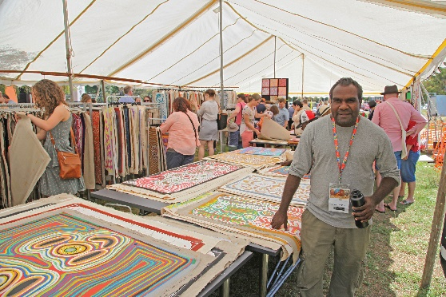
Thousands of people from Canberra and the region attended the AIATSIS Art Market in December with four art centres from the remote Northern Territory participating; Djilpin Arts – artists of Beswick (Wugularr), Ikuntji Art Centre - Ikuntji Artists, Warnayaka Art Centre – Warlpiri artists, Warlukurlangu Artists Aboriginal Corporation – artists of Yuendumu.
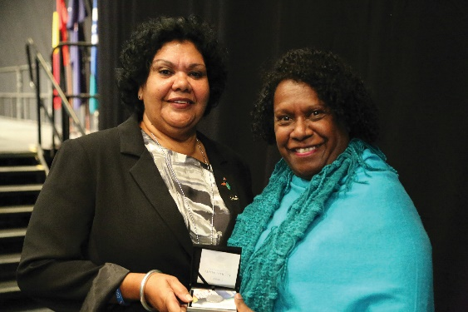
National Reconciliation Week (NRW) for 2017 was especially significant this year, with two major anniversaries in the nation’s history; the 50th Anniversary of the 1967 Referendum and the 25th Anniversary of the High Court of Australia’s Mabo decision.
To create opportunities for people to engage deeply with these events, AIATSIS worked with 13 national cultural institutions in Canberra, as well as the Department of Prime Minister and Cabinet, and Reconciliation Australia in the development of the National Reconciliation Week Trail. The Trail included occasional lectures, the launch of the Right Wrongs Digital Exhibition, orations, exhibitions, interactive and educative activities, panel discussions, a series of onsite and digital events with special guests, special film screenings, a range of family activities and the launch of a commemorative coin produced by the Royal Australian Mint recognising the two anniversaries.

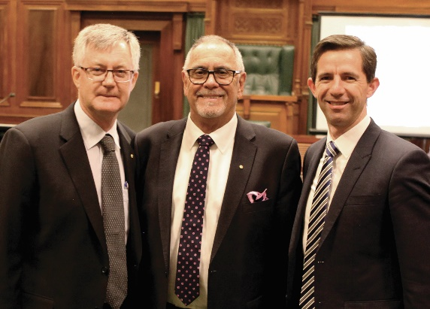
Inaugural Russell Taylor Oration
Eminent Public sector and Indigenous leaders attended the inaugural Russell Taylor Oration on 30 May 2017. The Oration celebrates the achievements and contributions of senior Aboriginal and Torres Strait Islander leaders in the Australian Public Service (APS). It is named in honour of the former CEO of AIATSIS, and the first oration was delivered by Mr Taylor himself. Special guests included the Minister for Education, Senator the Hon. Birmingham, the University of Canberra Chancellor Mr Tom Calma and Senator Malarndirri McCarthy.
Mr Taylor has been a tireless campaigner for AIATSIS, with a public sector career in Indigenous Affairs spanning more than 20 years. He is recognised for his service to the community as a cultural leader and appointed as a Member of the Order of Australia.

AIATSIS volunteer program
Commencing in late December 2016, the AIATSIS Volunteer program has welcomed ten volunteers who have contributed a total of 833 hours of their work during this first year of the program. Our volunteers include interns from the ANU, experienced workers (either retired or currently working), those volunteering as a course requirement, and a recent graduate. Of these volunteers, two are Indigenous.
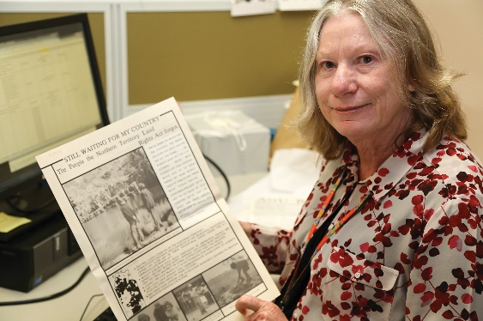
Volunteer roles are developed in collaboration with staff, with individual skills, experience and interests of volunteers kept in mind to produce a mutually beneficial outcome for staff and volunteers.
Rowena Ball commenced volunteering in January 2017. A Professor of Mathematics at the Australian National University, she wanted to volunteer in an entirely different field. She is rehousing the Tom Austen Brown newspaper clippings to free space in the closed stack, preserving the deteriorating clippings and creating a reference list of dates, names, places, and events noted in the clippings. Rowena is finding her volunteer role challenging and rewarding, and increasingly interesting as it progresses.
Another volunteer, John Page, has said: ‘I am finding volunteering at AIATSIS to be very rewarding, enabling me to improve my knowledge and understanding of Aboriginal and Torres Strait Islander issues while (hopefully) also contributing to the work of AIATSIS.

- Share and promote the results and impact of AIATSIS Research
The results of AIATSIS research were shared with partner communities as well as broader audiences through publications (ranging from peer reviewed reports to community reports and newsletter features) workshops and engagement activities (see Appendix D for a full list of research outputs) and more indirectly via facilitating community participation in research design and delivery (see pg. 59–65 for more details). Our research was communicated to general audiences through news features, such as the ABC reports on the Ngunnawal language project and the Preserve, Strengthen and Renew project; to community members via audio visual reporting and community reports; to policy audience though project presentations and briefs and to specialist audiences via academic publications.
AIATSIS produces and maintains a suite of resources to support native title stakeholders, including PBCs—also referred to as registered native title bodies corporate—and convenes the National PBC email network. www.nativetitle.org.au is the home of native title information. In 2016–17 AIATSIS produced 3 issues of Native Title Newsletter, 12 issues of What’s New in Native Title and began work on a new online format for the Native Title Information Handbook. 7 National and State PBC Funding and Training Guides were also produced, in addition to book reviews, research reports, journal articles and submissions (see Appendix D).
Physical exhibitions and online exhibitions also highlight the results of research projects – see 71–72 for more information.
AIATSIS also holds occasional seminars and convenes the National Native Title Conference (see page 62–63) and the AIATSIS National Indigenous Research Conference (see page 49). Both of these events feature and promote AIATSIS research to a broader audience of Indigenous communities, policy makers, practitioners and researchers who are key stakeholders in our research.

- Implement a new publishing model for the AAS journal and develop strategies to increase the profile and reach of our research publishing activities

Australian Aboriginal Studies journal
Australian Aboriginal Studies is a multidisciplinary journal presenting scholarly articles, research reports and book reviews which contribute to discourse about Indigeneity, Aboriginal and Torres Strait Islander knowledge and wellbeing. The journal is available in print, but is principally distributed in digital form. 29,375 full-text articles were downloaded during the year. Journal use was primarily academic (97 per cent of use), including all 39 Australian universities in Australia, plus 27 overseas universities from Canada, Japan, New Zealand, South Africa, United Kingdom, United States of America. AIATSIS has been considering the recommendations of a 2015-16 external review of its publishing activities, including investigation of alternative models for publishing the journal.

AIATSIS Research Publications
AIATSIS Research Publications, an imprint of Aboriginal Studies Press, are available as free ebooks. Authors outside of AIATSIS were invited to submit and were published for the first time in 2016-17. The imprint’s website presentation was streamlined, to be more user friendly for author submissions and customers, and metadata standards were applied to improve discoverability. The e-books have been made available via Trove, and other distribution expanded. A print on-demand option has also been implemented via Lightning Source.

Stanner Award
The biennial Stanner Award is an important and unique channel to encourage, identify and publish excellent scholarship and research. Named in honour of Emeritus Professor WEH Stanner, it is awarded to the best unpublished academic manuscript by an Aboriginal and/or Torres Strait Islander author or authors. The winner receives a $5000 cash prize, an inscribed glass eel trap sculpture by Jenni Kemarre Martiniello, mentoring support to turn their manuscript into a publication, and publication by Aboriginal Studies Press. Submissions for the 2017 award closed on 31 January 2017 with a record number of entries.
The award was presented to Alice Springs-based researcher and policy officer Dr Josie Douglas for her manuscript entitled, ‘Kin and Knowledge: the meaning and acquisition of Indigenous Ecological Knowledge in the lives of young Aboriginal people in Central Australia’, in a ceremony at AIATSIS on 10 August 2017.

BOOKS PUBLISHED IN 2016–17

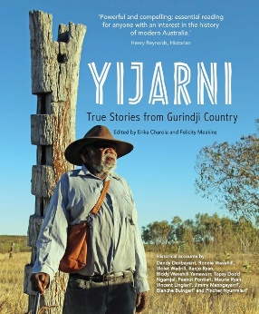
Yijarni: true stories from Gurindji Country edited by Felicity Meakins and Erika Charola (August 2016)
On 23 August 1966, approximately two hundred Gurindji stockmen and their families walked off Wave Hill Station in the Northern Territory protesting against poor working conditions and the taking of their land by pastoralists. While it is well known that the Walk Off was driven by the poor treatment of Aboriginal workers, what is less well known is the previous decades of massacres and killings, stolen children and other abuses by early colonists. Told in both English and Gurindji, these compelling and detailed oral accounts of the events that Gurindji elders either witnessed or heard from their parents and grandparents, will ignite the interest of audiences nationally and internationally and challenge those who question the extent of frontier battles and the legitimacy of the Stolen Generations.
Yijarni was launched by Senator Patrick Dodson with then CEO Russell Taylor on Friday 19 August 2016 at the Freedom Day Festival in Kalkarinji, Northern Territory.

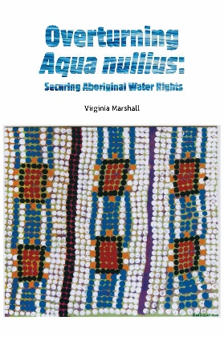
Overturning Aqua Nullius: securing Aboriginal water rights by Virginia Marshall (February 2017)
Winner of the 2015 Stanner Award, Overturning Aqua Nullius aims to cultivate a new understanding of Aboriginal water rights and interests in the context of Aboriginal water concepts and water policy development in Australia. Aboriginal peoples in Australia have the oldest living cultures in the world. From 1788 the British colonisation of Australia marginalised Aboriginal communities from land and water resources and their traditional rights and interests. More recently, the national water reforms further disenfranchised Aboriginal communities from their property rights in water, continuing to embed severe disadvantage. Overturning Aqua Nullius aims to cultivate a new understanding of Aboriginal water rights and interests in the context of Aboriginal water concepts and water policy development in Australia.

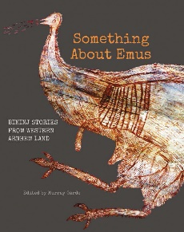
Something about emus: Bininj stories from Western Arnhem Land edited by Murray Garde (April 2017)
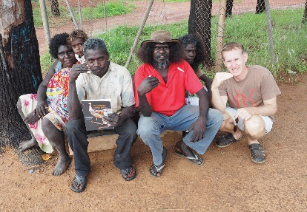
In this bilingual, highly illustrated, full-colour publication, Something about emus reveals valuable ecological knowledge in a collection of essays by senior members of the Bininj Kunwok language group from Kakadu National Park and Western Arnhem Land. Something about emus goes beyond biology and ecology to encompass other culturally important domains such as the visual and verbal arts, music, ritual and the relationships between humans and animals.
The book was launched in partnership with the ARC Centre of Excellence for the Dynamics of Language at the University of Melbourne by Bininj ecologist and land management Elder Dean Yibarbuk.

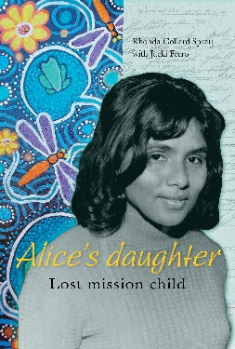
Alice’s daughter: lost mission child by Rhonda Collard-Spratt with Jacki Ferro (May 2017)
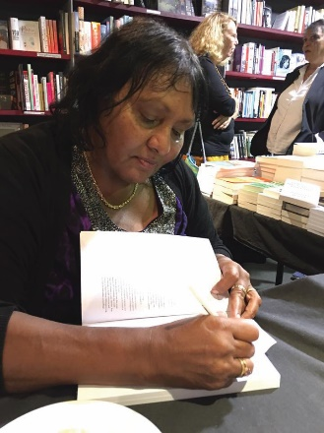
In 1954, aged three, Rhonda Collard-Spratt was taken from her Aboriginal family and placed on Carnarvon Native Mission, Western Australia. Growing up in the white world of chores and aprons, religious teachings and cruel beatings, Rhonda drew strength and healing from her mission brothers and sisters, her art, music and poetry. Alice’s daughter is the story of Rhonda’s search for culture and family as she faces violence, racism, foster families, and her father’s death in custody; one of the first deaths investigated as part of the Royal Commission into Aboriginal Deaths in Custody. Written in Rhonda’s distinctive voice and accompanied by her vibrant and powerful paintings and poetry, Alice’s daughter is fearless, compelling and intimate reading.
Alice’s Daughter was launched by poet, rapper, actor and writer Stephen Oliver to a packed crowd at Brisbane’s Avid Reader Bookstore on National Sorry Day in May 2017.

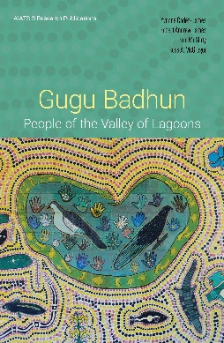
Gugu Badhun: People of the Valley of Lagoons by Yvonne Cadet-James, Robert Andrew James, Sue McGinty and Russell McGregor (June 2017)
Bridging historical scholarship and Aboriginal oral tradition, this innovative book tells the story of the Gugu Badhun people of the Valley of Lagoons in North Queensland. It provides new insights into Aboriginal–European interactions, and new understandings of how Aboriginal people sustained their identities and exercised agency. Much of the story is told in the words of the Gugu Badhun people themselves. Interviews are interspersed with commentary and analysis by the four authors, one of whom, Yvonne Cadet-James, is herself a Gugu Badhun elder. Gugu Badhun: People of the Valley of Lagoons was launched at the AIATSIS National Native Title Conference in June 2017.

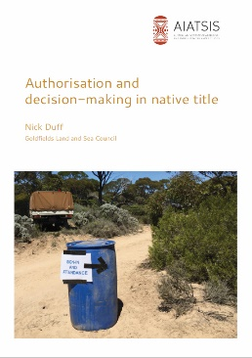
Authorisation and decision-making in native title by Nick Duff (February 2017)
Authorisation and decision-making in native title interrogates the interface between the Australian legal system and the Indigenous legal, cultural and political systems. The assertion and management of native title rights involves collective action by sometimes large and disparate groups of Indigenous people. Contentious politics makes such collective action difficult and the courts will often be asked to decide whether group decisions have been validly made. In the last two decades, a vast and complex body of law and practice has developed to address this challenge. This book sets out the legal rules and their application in various situations and addresses key practical, ethical and political dimensions of native title decision-making.

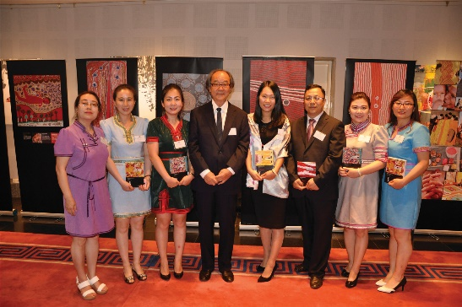
Chinese editions
Five Aboriginal Studies Press titles were translated and published as Chinese editions for distribution, initially into Australian studies centres in China: Fight for liberty and freedom, Convincing ground, Mutton fish, Doreen Kartinyeri and Paint me black. Brokered through Professor David Walker, Chair of Australian Studies, Peking University, the translations were managed by Mr Li Yao from the Inner Mongolia Normal University, who, along with the Foundation for Australian Studies, provided funding for the translations. The titles were published in China by Beijing Time Chinese Publishing House. The series went on to win the Australia–China Council 2016 Special Award for Translation

- Initiate partnerships with other publishers to produce materials for the educational sector
AIATSIS entered into an agreement with Cengage Learning Australia to produce an educational series for primary schools. It will align with the cross-curriculum priority of Indigenous cultures and histories and draw extensively on the AIATSIS collections. Books, themed student cards, teacher resource books and an online gallery will address three themes — country/place, people and culture. The lower primary series will be published in July 2018, middle primary in October 2018 and upper primary in January 2019. A revised edition of Aboriginal Study Press’ popular title The Little Red Yellow Black Book (3rd edition) will be included in each pack. This action was planned for 2017–18, but AIATSIS took an earlier opportunity to proceed.
- Explore options for an AIATSIS public space.
As part of the development of AIATSIS’ Public Program Strategy, two options for a public exhibition space were developed. One involves extension of the AIATSIS building, and the other an internal refit. The extension option would form part of a broader plan to consolidate all AIATSIS staff in one location; improve vault capacity and conditions, and generate opportunities for community and the public to access the collections. Consultants have been engaged to generate construction design proposals, which are expected to be completed towards the of 2017. These will be used to select and make the case to fund one of these options.

Our results
Measure and target | 2015–16 Results | 2016-17 Results | Target achieved?
Number and value of publications
6 books published, $243,000 revenue | 7 books published.  $349,878, including $62,944 from the online shop | 6 books published. $337,594 revenue, including online sales $69,818 | Achieved
2 journal editions, $20,000 revenue | New measure | 2 editions published, $13,281 revenue. | Revenue target not achieved
5 other publications | New measure | 3 research reports and 4 submissions | Exceeded
Reach and impact of communication and community engagement via media coverage, website and social media reach and activity
35 media releases, alerts and web news stories | 64 media items featuring AIATSIS  (includes interviews, as per measure below) | 91 media items featuring AIATSIS  (53 interviews plus 38 other items) | Exceeded
35 interviews by media outlets with AIATSIS staff or affiliates | New measure (included in media items above) | 53 interviews with AIATSIS staff or affiliates | Exceeded
26 requests for content/information by media completed | New measure | 29 requests | Exceeded
10 AIATSIS e-newsletters | New measure | 10 e-newsletters | Achieved
10 Members e-newsletters | New measure | 5 e-newsletters | Not achieved.
10% increase in website traffic | 1,418,078 page views | 1,910,640 page views (35% increase) | 34.73% increase – exceeded
Increase in Indigenous author contributions +5% | 4 out of 7 books (57%) | 5 out of 6 books | Exceeded
Train and develop 10 web publishers and editors | New measure. | 12 | Exceeded
Reach and impact of community engagement through membership and partnerships
Increase in Indigenous members +8% | 23% | 25% (an increase of 8%) | Achieved
5% increase in members | 650 members | 671 members (3% increase) | Not achieved
10% increase in partnerships | 8 strategic partnerships;  13 partnership projects | 3 new strategic partnerships (37% increase);  4 new partnership projects (31% increase) | Exceeded
5% increase in value of partnerships | New measure | Measure still in development | —
5% increase in value of public program | New measure | Measure still in development | —

Overall our engagement with audiences and communities online shows a vast improvement. Users of the AIATSIS website are up 50 per cent from the previous year to 609,218 users. Our page views are up 35 per cent from the previous year to 1,910,640 views this year. Organic searches continue to draws the most traffic to our website, approximately 72 per cent of all traffic.
The target for the Members e-newsletter was not achieved because AIATSIS suspended production of the e-newsletter due to content duplication with our general e-newsletter. It will be reviewed, along with the e-newsletter, in the next financial year, alongside consideration of options to increase the strategic engagement of members (see Strategic Priority 5 on page 85–95).

Analysis
Aboriginal Studies Press met its target to publish six books and exceeded its revenue target. All but one book had an Indigenous author or co-author. We hope to see the work this year extend the reach of our research publications reflected in next year’s data.
Most targets for reach and coverage of communications, media, online engagement and public program activity were also exceeded.
Website analysis shows a strong increase in usage and followers across our social media accounts has steadily grown. Top pages accessed during the year (including the ever-popular AIATSIS Map of Indigenous Australia, exhibitions relating to the Freedom Ride, Mabo case, Eddie Koiki Mabo, the 26 January 1938 Day of Mourning, and pages relating to family history and Aboriginality) indicate that AIATSIS is reaching people in the general population who are searching for information on significant people and events in Indigenous affairs, and Aboriginal and Torres Strait Islander people interested in family history research.
The public program continued to generate strong interest and all our public program activities were well-attended. Activities like the National Reconciliation Week Trail and the Right Wrongs online exhibition are the product of new levels of leadership and collaboration by AIATSIS.
Media interest remains steady. There was an increase in interest for content around significant anniversaries, 25th anniversary of the Mabo decision and the 50th anniversary of the 1967 Referendum. Prior preparation of materials by Collections enabled AIATSIS to service these requests where previously access conditions limited our serviceability. We aim to continue this practice into the future.
Significant new partnerships were established, both strategic and project-specific, which will advance our goals in providing leadership in research, in managing collections in partnership with communities, and in promoting Aboriginal and Torres Strait Islander culture and history in educational and other settings.

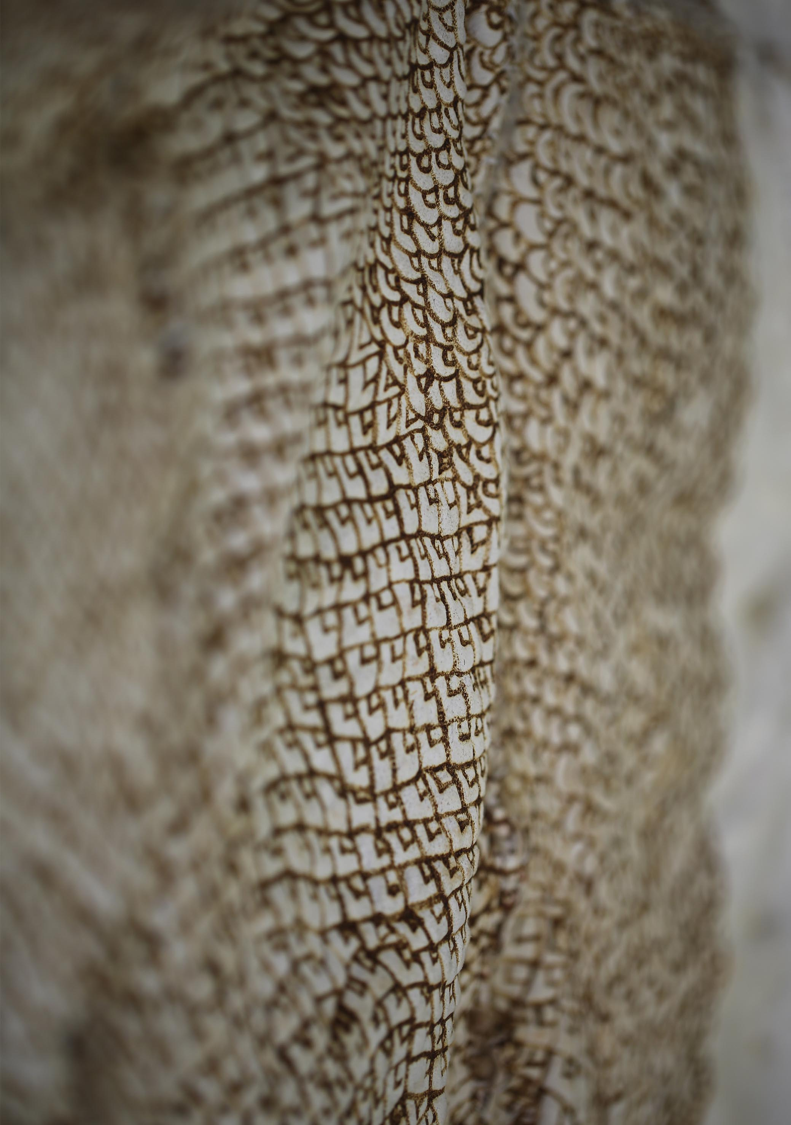

Strategic Priority 5 – Building strong governance and organisational resilience.
AIATSIS’ priority is to shift its focus to long-term capability-building to place itself on a secure and sustainable footing for the future. This includes inculcating forward-thinking behaviours, increasing Indigenous employment, enhancing professional competence and diversifying our resource base, enabled by changes to the AIATSIS Act, along with modernised governance and additional ongoing funding to support delivery and growth of the program of work.

Planned performance and measures
Key outcomes planned over four years are:
- Ensuring governance in AIATSIS reflects best practice, and is achievement-oriented, transparent, and in accord with the expectations of our stakeholders.
- Working to ensure AIATSIS has a strong profile with government.
- Ensuring AIATSIS has the resources to ensure long term viability and sustainability.
- Ensuring AIATSIS is a place where people want to work — a high performing culture that balances work, life and wellbeing.
- Supporting AIATSIS’ staff to be culturally competent.
- Growing AIATSIS’ staff levels to more than 35 per cent made up of Aboriginal and/or Torres Strait Islander people.
- Developing a knowledge management strategy that supports the opening of digital materials to the public in ways that are meaningful and sustainable.
- Ensuring Corporate services in AIATSIS meet the needs of AIATSIS and its staff.
One target related to this Strategic Priority was published in the Corporate Plan 2017–2020: to achieve Indigenous employment of 35 per cent over the four years of the plan.
AIATSIS monitors performance under this Strategic Priority using the following criteria and measures:
Criteria | Measures
Indicators of Employee satisfaction (consistent with APSC) | Rates of voluntary departure
 | Rates of unscheduled absence
 | Employee engagement—APS Employee Census approval rating
Indigenous employment | Aggregated proportion of Indigenous employees

Our strategies
- Develop a capital plan to identify the assets and infrastructure that AIATSIS needs to undertake the activities in this corporate plan, and ensure that it is funded within the budget process
AIATSIS prepared plans for future growth and costings to replace the climate-controlled collection storage vaults, as these are considered the highest priority capital investment for AIATSIS due to risks to the collection. Plans, business case and costings were also developed for expansion of the building to provide for public engagement and increase access to the collection.
The next steps, in 2017–18, will be the development of a sustainability plan to underpin future capital investment and possible funding options.
- In conjunction with the AIATSIS Foundation, develop and implement a funding strategy by seeking input from corporate, private and philanthropic sources which allows AIATSIS to undertake work that is in accord with its strategic direction
The AIATSIS Foundation was created to support the work of AIATSIS by raising funds to secure the future of the world’s largest and most significant collection of Indigenous Australian culture, history and heritage. The Chair of the Foundation is Ms Rachel Perkins.
- The Foundation developed a business plan, and the first projects it will pursue are:
- Dictionaries Project - recording Indigenous languages across Australia and Torres Strait Islands by 2020.
- Songlines Project - record Songlines across Australia and the Torres Strait Islands by 2023.
Building an encyclopaedia of Indigenous language and culture which builds on existing interactive maps by 2026.
The Dictionaries and Songlines projects were launched in late 2016 at events in Melbourne and Sydney attended by corporate, philanthropic and benevolent organisations and other stakeholders. Work commenced on the Dictionaries project – see 126 for more details.

To raise awareness of the Foundation and its priority projects, AIATSIS held a showcase at Tjapukai Aboriginal Cultural Park Cairns on Friday 30 June 2017. Presented in partnership with the Healing Foundation, Indigenous Business Australia, Indigenous Land Council and NITV, the showcase brought together 250 stakeholders and potential donors.
During 2016-17, $64,765 in donations was received and a further $25,000 was pledged.
- Redevelop our human resource strategy focused on career advancement for succession planning; high levels of cultural competency; and effective Human Resources support and services for AIATSIS staff and management
AIATSIS has rebuilt elements of its human resource toolkit during 2016-17, including recruitment, retention and cultural competency frameworks and tools.
- A Job design tool was developed and rolled out for use in recruitment, employee development and performance management. This tool incorporates a cultural competency framework based on the Australian Public Service Commission’s (APSC’s) Aboriginal and Torres Strait Islander Capability Framework, stepping through the holistic consideration of the cultural competency needs of that specific role.
- The AIATSIS online Human Resources (HR) hub was redeveloped with more online support and tools to assist with processes, employee & supervisor roles, recruitment and performance management.
AIATSIS staff are encouraged and supported to participate in Aboriginal and Torres Strait Islander activities as part of continuous learning, by interactions with community members or through attending or participating in community events. This approach increases cultural appreciation and practical application of learning directly to the work at AIATSIS and continually builds competency across the workforce.
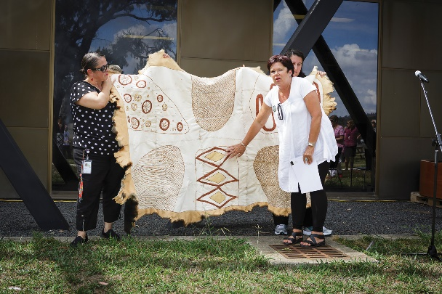
Activities this year included events during NAIDOC Week and National Reconciliation week. Staff present outcomes of their projects, research, and field work at fortnightly staff meetings, including some of the challenges and achievements faced by Aboriginal and Torres Strait Islander communities who were involved. There were cultural development opportunities as volunteers for the AIATSIS National Native Title conference, Ngunnawal language classes and the ceremonial handover of the AIATSIS possum skin cloak.

- Increase recruitment and retention of Indigenous staff through an effective strategy to attract, train and retain Indigenous staff using tailored recruitment practices and traineeships to develop the skills AIATSIS needs in its new staff
AIATSIS is working towards increasing its own Indigenous employment, but recognises that this needs to be part of APS-wide increases in order to offer choice, diversity in roles and long-term career paths. AIATSIS focused this year on whole-of-government collaboration and leadership on Indigenous employment, as well as recruitment, retention and development.
AIATSIS participated in initiatives relating to cultural competency internally and across the APS, which is beneficial to Indigenous employees as well as the Indigenous clients and stakeholders of government policies and services. As part of its commitment to the Commonwealth Aboriginal and Torres Strait Islander Employment Strategy, AIATSIS together with the Australian Public Service Commission, the Department of Human Services (DHS) and other agencies co-designed the APS Indigenous Capability Forum (the Forum). The Forum is a quarterly platform for HR managers responsible for Indigenous employment in their agency. The CORE Cultural Capability Program developed in partnership with PM&C formed the basis for the forum and was the focus of the inaugural Indigenous Capability Forum
AIATSIS also contributed to and, in partnership with other APS agencies, co-designed a career development program for APS indigenous employees at the APS5 and 6 level.
AIATSIS continues to include and celebrate culture in every aspect of work including acknowledgement or welcome to country at meetings and other activities, in recruitment processes, and job design. It continues the use of affirmative measures in recruitment processes to ensure it meets its commitment to increased Indigenous employment.
AIATSIS advised and continues to advise other APS agencies on the use of affirmative measures across the APS.

APS Indigenous Graduate Program
In 2016-17, AIATSIS participated in the APS Indigenous Graduate Program. Jacob O’Keefe, a young Aboriginal man with a commitment to contribute in a positive way to Aboriginal and Torres Strait Islander people and the wider community, commenced work at AIATSIS in January 2017. Jacob is supported by mentors, the AIATSIS graduate coordinator and his Senior Executive sponsor, AIATSIS Deputy CEO Letitia Hope.
As part of his graduate year and in collaboration with indigenous graduates at the National Library of Australia (NLA), Jacob is undertaking a project that reviews the discoverability of indigenous collections on Trove.
During 2016-17, Jacob rotated through several program areas of AIATSIS including the Rights team, HR and the Family History Unit. At the end of his Graduate year Jacob, will become a permanent member of the Collection Services team.
- Maintain strategic engagement with government
During the year AIATSIS maintained its relationship with relevant areas of government through direct conversation with Secretaries, CEOs and other leaders in organisations including the Departments of Prime Minister and Cabinet, Education and Training, Defence, Finance, Veterans’ Affairs, Human Services, Environment and Energy and Foreign Affairs and Trade. We also maintained close relationships with other national cultural institutions through a range of formal and informal forums and channels, some for focused collaboration and others for general oversight and advocacy of the sector.
AIATSIS’ participation in strategic networks within the public service included the Indigenous Champions Network, Indigenous Senior Executive Network and the APSC Indigenous Talent Council Working Group. AIATSIS also engaged Ministers and other government representatives and leaders in significant events through the year, including the National Native Title Conference, the AIATSIS Foundation Showcase in Cairns and the inaugural Russell Taylor Oration – each of these events is discussed elsewhere in this report.

- Engage membership in strategic thinking and innovation
AIATSIS was founded as a member-based organisation. While it has grown and changed into a national institution, the membership creates a rich network of Indigenous and non-Indigenous people involved in many aspects of Indigenous knowledge and culture, with interests/skills in research, archiving, education and Aboriginal and Torres Strait culture and heritage. AIATSIS’s current membership is over 670, which represents a large, and largely underutilised, pool of skilled and interested people.
AIATSIS Members play an important role in shaping the AIATSIS Council, with four of the nine elected by, and from among, the AIATSIS members. Following the Council election in April 2017, AIATSIS developed options to increase engagement and create more opportunities for Members to contribute. The Membership criteria were also reviewed to maintain the balance between increasing Membership numbers while properly qualifying applications. With appointments finalised following the elections, Council will consider options at its meeting in September.

Our results
Measure and target* | 2015–16 results | 2016-17 results
Rates of voluntary departure | 12% | 4.22%
Rates of unscheduled absence | 8.82 days per full-time equivalent employee | 12.08 days per full-time equivalent employee
Employee engagement—APS Employee Census approval rating | Job: 75%  Team: 91%  Supervisor: 77%  Agency: 60% | Job: 77%  Team: 75%  Supervisor: 80%  Agency: 60%
Aggregated proportion of Indigenous employees. | 23% | 25%

Analysis
AIATSIS’ indicators of employee satisfaction show improvements in some areas, such as satisfaction with supervisor and job and a reduction in the rate of voluntary departure, but an increase in unscheduled absences and decreased levels of team satisfaction. While this is not unexpected in what has been a year of rapid change, it will be monitored closely.
The proportion of Indigenous employees increased, although not at the rate that would be required to achieve 35 per cent by 2020. The groundwork undertaken in 2016–17 will improve the cultural competency of staff and the broader APS, which will provide the foundation for more focused action and visible increases in future years.
The AIATSIS Foundation launched its first projects and has begun to raise its profile and secure donations. Work began on the Foundations Dictionaries project.
The AIATSIS Council elections and the process of appointment of office-holders has delayed the strategic engagement of members. With Council membership now stable until Ministerial appointments are next due in 2019, this will provide an opportunity to develop, apply and consolidate engagement with members and other stakeholders.

Our organisation

Minister
Portfolio responsibility for AIATSIS during 2016–17 was held by the Minister for Education and Training, Senator the Hon. Simon Birmingham.

AIATSIS Council
The AIATSIS Council is the accountable authority under the Public Governance, Performance and Accountability Act 2013. It consists of nine members.
- Four members are elected from and by AIATSIS Members. Since the AIATSIS Act was amended in March 2016, at least two of the elected members must be Aboriginal and/or Torres Strait Islander people, and two must be women.
- Five members are appointed by the Minister. The Minister’s appointments must ensure a majority of Indigenous representation and take into account gender balance, skills and experience.
Council members are appointed or elected for four-year terms and may not serve more than two consecutive terms.
An election was held for AIATSIS members to elect four new Council members in April 2017. There were four vacancies, and eight candidates nominated, five female and three male. The majority of the candidates were Indigenous. The following members were elected: Mr Stephen Kinnane, Professor Michael McDaniel, Ms Rachel Perkins and Dr Myfany Turpin.
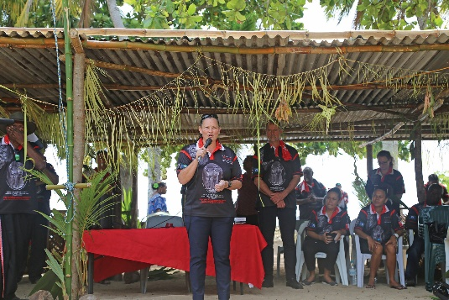
Ms Perkins had previously held a Ministerial appointment to the Council, and her election created a vacancy. As at 30 June 2017, a candidate was still to be appointed to this vacancy, and to the positions of Chair and Deputy Chair.
Council members are remunerated in accordance with the Remuneration Tribunal determination for part-time statutory office holders. All members of the AIATSIS Council are non-executive members.
The following table provides information on each of the Council members during 2016–17, including their period of appointment and number of meetings attended. Their experience and qualifications are outlined in ‘AIATSIS Council members’ on page 10–18.

AIATSIS Council members
Name | Gender | Position | State | Start date | End date | Meetings eligible | Meetings attended
Elected councillors
Professor Michael Dodson AM | M | Chairperson | ACT | 17/05/14 | 16/05/17 | 3 | 3
Professor Emeritus Robert Tonkinson | M | Deputy Chairperson | WA | 17/05/14 | 16/05/17 | 3 | 3
Professor John Maynard | M | Member | NSW | 17/05/14 | 16/05/17 | 3 | 3
Professor Sandy Toussaint | F | Member | WA | 11/08/16 | 16/05/17 | 3 | 3
Mr Stephen Kinnane | M | Member | NSW | 17/05/17 | 16/05/21 | 1 | 1
Professor Michael McDaniel | M | Member | NSW | 17/05/17 | 16/05/21 | 1 | 1
Ms Rachel Perkins | F | Member | NT | 17/05/17 | 16/05/21 | 1 | 1
Dr Myfany Turpin | F | Member | NT | 17/05/17 | 16/05/21 | 1 | 1
Appointed councillors
Ms Jodie Sizer | F | Member | VIC | 10/02/15 | 09/02/19 | 4 | 4
Professor Cindy Shannon | F | Member | QLD | 10/02/15 | 09/02/19 | 4 | 3
Mr Geoffrey Winters | M | Member | NSW | 29/09/16 | 09/02/19 | 3 | 3
Ms Rachel Perkins | F | Member | NT | 10/02/15 | 09/02/19 | 3 | 3
Ms Donisha Duff | F | Member | QLD | 10/02/15 | 09/02/19 | 4 | 3

Organisation structure
AIATSIS is a national institution based in Canberra. Its main offices are at 1 Lawson Crescent, Acton. AIATSIS also had offices in Childers Street, Canberra City, during 2016–17.
As at 30 June 2017, AIATSIS had 144 employees in total (headcount), with a full-time equivalent workforce of 134.25. Of the total, 53.47 per cent were female and 25 per cent identified as Indigenous.
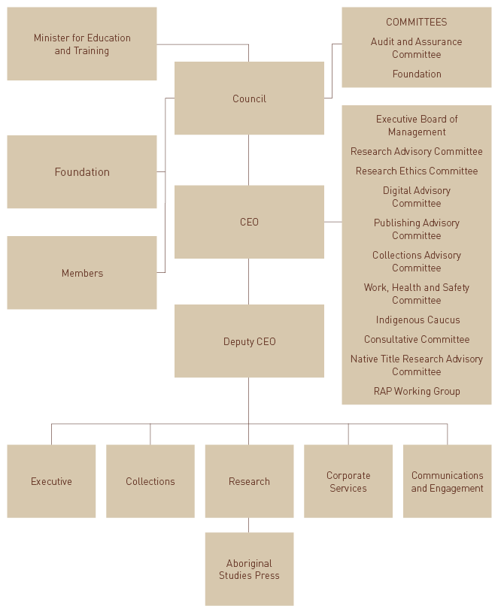

Governance
The AIATSIS Council meets four times a year to consider strategic directions and matters of operational significance. It operates under a charter. Following an internal review of governance in 2016-17, supported by the Australian Institute of Company Directors, governance training will be delivered to new members of Council to build capability and ensure a consistent and best-practice approach.
A number of committees have been established to provide the AIATSIS Council and the CEO with advice about particular issues and areas of business. These committees are listed, along with their membership during 2016-17 in Appendix B.
The Executive Board of Management is AIATSIS’s main internal governance forum. It comprises senior managers from across AIATSIS, with other members and attendees by invitation of the CEO. The board meets monthly to advise the CEO on strategy and operational matters.
In 2016-17, AIATSIS did not make any related entity transactions.
In 2016–17, AIATSIS did not issue any indemnities to the AIATSIS Council, to its members or to any officers of AIATSIS.

Financial results and compliance
AIATSIS’s total financial result is an operational surplus of $880,000. This is primarily due to the valuation of donated artworks to the collection including the Jimmy Pike collection. The financial results otherwise show that AIATSIS has effectively allocated resources to achieve a balanced position in 2016-17.
The Minister received no reports relating to non-compliance with the finance law involving AIATSIS in 2016–17.

Policy and operational environment
There were no government policy orders in effect that applied to AIATSIS during 2016–17.
Beyond matters discussed elsewhere in this report, such as the amendments to the AIATSIS Act, no significant activities or changes affected the operations or structure of AIATSIS during 2016–17, including significant judicial decisions or decisions of administrative tribunals, or reports by the Auditor-General, any parliamentary committee, the Commonwealth Ombudsman or the Office of the Australian Information Commissioner.

Work health and safety
AIATSIS ensures the work health and safety (WHS) of employees through annual health and wellbeing surveys, an active and proactive WHS Committee, regular face –to-face and online WHS training, walkarounds and dedicated WHS resources on the online ‘HR Hub’. During 2016 17 there were no notifiable incidents or investigations under the Work Health and Safety Act 2011.

Advertising and market research
AIATSIS made no payments to advertising agencies, market research organisations, media advertising organisations polling organisations or direct mail organisations that are reportable under section 311A of the Commonwealth Electoral Act 1918.

Ecologically sustainable development and environmental performance
Through its research program and collection, AIATSIS contributes to ecological sustainability. Our research activity (see Strategic Priority 3) includes land and water, culture and heritage and native title research projects that contribute to the understanding of heritage values of places and activities, including from social, economic and cultural perspectives. The AIATSIS Collection includes documentation of those values for peoples and communities.
We also monitor and work to continuously improve the environmental performance of our day-to-day operations. For the last five years the ACT Government has recognised AIATSIS’s contribution to the environment by reducing waste. In the last year alone we avoided CO2 emissions equivalent to more than 25 tonnes. AIATSIS has also diverted over 35 kilograms of waste toner from land fill. In line with efforts to reduce costs and waste, recycled and secondhand furniture and materials were used for a number of small fit out and accommodation projects.



FINANCIAL STATEMENTS



APPENDICES
Appendix A — Research project summaries
Appendix B — Governance committees
Appendix C — Strategic partnerships
Appendix D — Research outputs — publications and presentations
Appendix E — Researcher memberships and offices
Appendix F — Abbreviations and acronyms
Appendix G — Index of compliance

Appendix A — Research project summaries

New projects 2016–17
Restoring Dignity: Networked Knowledge for Repatriation Communities (Return Reconcile Renew stage II)
Started: April 2017 | Completion due: December 2019
Project summary: AIATSIS is a partner in Restoring Dignity: Networked Knowledge for Repatriation Communities. The project aims to build a digital facility that supports the repatriation of Indigenous human remains. Repatriation contributes to reconciliation and Indigenous healing and wellbeing, and has been the most important agent of change in the relationship between Indigenous peoples, cultural institutions and the academy over the past forty years. Successful repatriation requires and produces research materials diverse in type, geography and accessibility. This project will gather, preserve and make accessible a critical and extensive record of repatriation information worldwide. The project is expected to support repatriation practice and scholarship and improve the opportunities of repatriation for social good.
Partners: Australian National University (lead), University of Queensland, University of Melbourne, University of Tasmania, University of Otago, Flinders University, National Museum of Australia, Association on American Indian Affairs, University of Amsterdam, Humboldt State University, Kimberley Aboriginal Law and Culture Centre, Ngarrindjeri Regional Authority, Gur A Baradharaw Kod Sea and Land Council.

Sharing Success, Measuring Impact Literature Review and Case Studies
Started: February 2017 | Completion due: December 2018
Assessing research impact is a critical element of AIATSIS’ aspirations to collaborate with Indigenous partners and create meaningful change within communities. However, how impact is defined and assessed is not clear, nor is there an established methodology for assessing the unique research that is carried out at AIATSIS — in accordance with the principles of the Guidelines for Ethical Research in Australian Indigenous Studies (GERAIS) and in collaboration with communities. This project involves the development of a literature review and discussion paper on research impact. This methodology will be tested via the case studies working with AIATSIS as a part of the Preserve, Strengthen and Renew initiative, and in pre-existing projects throughout 2017–2018, starting with the Singing the Train exhibition (see page 71 for more details).
Partners: Karajarri Traditional Lands Association, Central Desert Native Title Services, Wangka Maya Pilbara Aboriginal Language Centre, Kimberley Land Council, Tjamu Tjamu Aboriginal Corporation.

Understanding Native Title Economies (NTRU)
Started: October 2016 | Completion due: June 2017
This project is an economic and socio-cultural analysis of the costs, benefits and values of enacting native title work in the pre- and post-determination periods — from native title claim groups to Prescribed Bodies Corporates (PBCs). In partnership with two PBCs, researchers tracked the type and amount of work (paid and voluntary) carried out by members of native title claim groups and PBCs. The final co-authored report can be found at: http://aiatsis.gov.au/sites/default/files/docs/projects/general/emac-ntsv_report_final.pdf
Partners: Eastern Maar Aboriginal Corporation, Department of the Prime Minister and Cabinet (funder).

Regional governance and economic coordination for Prescribed Bodies Corporates (NTRU)
Started: October 2016 | Completion due: June 2018
This project examined the foundations behind different models of regional governance and economic coordination between native title organisations, particularly between Native Title Representative Bodies and PBCs. In particular it explored the ways PBCs build capacity by engaging with local stakeholders and taking up other opportunities associated with their native title lands. The project was the focus of two sessions at the 2017 National Native Title Conference.
Partners: Department of the Prime Minister and Cabinet (funder).

Preserve, Strengthen, Renew in Community Project
Started: July 2016 | Completion due: July 2018
This two-year pilot project involves a series of case studies in collaboration with the Kiwwirrkurra and Karajarri people and Wangka Maya Pilbara Aboriginal Language Centre to identify regional priorities and processes to renew and strengthen Indigenous knowledges. The project integrates access to the AIATSIS collections, on country recording and the development of community protocols for the management of cultural information. The outcomes from these case studies are intended to inform a methodology and build a case for further funding to support national projects in 2018–2020. This is an AIATSIS funded project.
The three project partners are at three different stages of production and management of materials: Kiwirrkurra is primarily interested in recording more of their knowledge; Karajarri are in the process of recording their knowledge and have created a database in which to store their materials; Wangka Maya has a large collection of language material, archived both at Wangka Maya and AIATSIS, and is interested in developing culturally safe ways to make their materials available for families to listen to and copy.
Partners: Karajarri Traditional Lands Association, Central Desert Native Title Services, Wangka Maya Pilbara Aboriginal Language Centre, Kimberley Land Council, Tjamu Tjamu Aboriginal Corporation

Foundation Dictionaries Project
Started: July 2016 | Completion due: June 2019
In response to the alarming rates of language loss in Australia, the AIATSIS Foundation has launched a project to support the publication of Indigenous language dictionaries. There are many cases where a good dictionary database has been created but a lack of funding has impeded publication. In numerous other cases publication has taken place, but in low-quality physical formats which have now deteriorated, leaving the community without a dictionary. The project aims to identify potential dictionaries and develop a process for publication. Contact will be made with various linguists, language centres, networks and any other channels to determine any dictionaries which may be in the pipeline. The project will first identify a pipeline of dictionary projects which are ready or are anticipated to reach readiness for publication over the next two years. Once the pipeline is established, the present project will support a program of funding dedicated to supporting the publication of dictionaries.
This is an AIATSIS Foundation flagship project.

National Prescribed Bodies Corporate Website Redevelopment Project (NTRU)
Started: July 2016 | Completion due: June 2018
A new Prescribed Body Corporate website will serve as a platform for a wider range of content and increased networking for native title organisations. Alongside improved usability and structure, the content of the website will be expanded to include a wider range of information for native title organisations and stakeholders, such as guides and resources and community news and events. The project is currently in the web-development and content production stage.
Partners: Department of the Prime Minister and Cabinet (funder).

Prescribed Body Corporate Capability Project (NTRU)
Started: July 2016 | Completion due: June 2018
Mixed method research and organisational data are being used to understand the current administrative, governance and economic capabilities of PBCs nationally. This project builds on a 2011 analysis of Prescribed Body Corporate (PBC) data by the Department of the Prime Minister and Cabinet and the AIATSIS 2013 PBC Capacity Survey.
Desktop research has been completed and two publications were in preparation at the end of the year. A survey has been distributed and interviews begin in later 2017.
Partners: Department of the Prime Minister and Cabinet (funder).

Breath of Life program
Started: June 2017 | Completion due: December 2018
Breath of Life is a program that supports Indigenous peoples to strengthen or revitalise their languages. The program enables collecting institutions and linguists to support Indigenous people to navigate archival collections and use linguistic resources found to develop language resources. The program was established by the Smithsonian Institutes and has been operating biennially in the United States with great success since the 1990s and now encompasses seventeen language groups and four archives. This project will involve a pilot to support the development of an ongoing Breath of Life Institute-based program at AIATSIS. The program will host a gathering of Indigenous community representatives to be trained in archival linguistic research.
Partners: TBA.

Continuing projects
Core: Defence resource library
Started: January 2016 | Completion due: August 2017
Following its development of the Defence Cultural Awareness (Indigenous) Learning Framework, the Department of Defence commissioned AIATSIS to develop an electronic resource library containing accessible and accurate materials, mapped to illuminate each area of the framework. In 2015–16 the project team finalised the solutions architecture and the first forty-five pieces of foundational content to populate the system.
Partners: Department of Defence.

Mapping Livelihood Values of Indigenous Customary Fishing
Started: July 2015 | Completion due: November 2017
Using a case study approach, this project is working to understand and articulate Indigenous cultural and social values associated with customary fishing and to develop tools and strategies to recognise and use these values in the development of contemporary fisheries management strategies. The project team has worked closely with three Aboriginal project partners from New South Wales, Northern Territory and South Australia to examine the values of Indigenous fishing around Australia.
A major new development has been the design, production and publishing of the online exhibition for the project, the Living Off Our Waters exhibition was launched at the conference and is available here: http://aiatsis.gov.au/exhibitions/living-off-our-waters
Partners: Fisheries Research and Development Corporation, Rural Solutions South Australia, Far West Coast Aboriginal Corporation Registered Native Title Bodies Corporate, NSW Aboriginal Fishing Rights Group, Crocodile Islands Rangers, Milingimbi and Outstations Progress and Resource Association Inc.

Maximising Equity in Native Title Land (NTRU)
Started: July 2015 | Completion due: June 2018
This project is examining and developing different models of communal title that could enable individuals and communities to access the value of native title land and develop economically and socially sustainable communities. Following the presentation of a proposed leasing model ‘Native title leasing under the non-extinguishment principle’ to several forums in 2015–16, work to explore it continued in 2016–17 and a paper is currently being drafted.
Partners: Department of the Prime Minister and Cabinet (funder).

Native Title Representative Bodies Knowledge Management Project
Started: July 2015 | Completion due: June 2018
This project is a technical redevelopment and expansion of the NTRB Legal Precedents Database, a critical resource for legal practitioners operating in the complex, evolving and high-pressure area of law surrounding Native Title Representative Bodies and service providers (NTRBs). It will improve support for native title organisations and the legal practitioners working in them by improving the structure and usability of the database and making it more comprehensive and up to date.
During 2016–17, the project team collaborated with native title stakeholders to review the membership costs and structure of the database. The improved database is now in operation.
Also, as part of this project, AIATSIS hosted the Legal Workshop, 7–8 February 2017 in the Mabo Room, AIATSIS. Native title lawyers from eight NTRBs across Australia gathered at AIATSIS for two days of intensive discussions about native title law.
Partners: Department of the Prime Minister and Cabinet (funder).

History of NSW Aborigines Protection/Welfare Board 1883–1969 (ARC Discovery Project)
Started: July 2015 | Completion due: June 2018
A team of Indigenous and non-Indigenous researchers from AIATSIS and the Universities of Newcastle, Sydney and New England are using archival and oral history research to produce a landmark social history of the Aboriginal experience of the New South Wales Aborigines Protection/Welfare Board. We play an important role in facilitating access to AIATSIS records relating to the board. An important product of this project, to be delivered in the second half of 2016, will be an interactive map of the various missions, reserves and stations in New South Wales to support easy searching for family and other forms of history.
Partners: University of Newcastle

Hearing Histories of the Western Pilbara (ARC Discovery Project)
Started: July 2015 | Completion due: June 2018
This project is the first collaborative, interdisciplinary investigation of the Thaabi Pilbara public song genres, part of the rich musical heritage of the Pilbara region. A map-based online platform will deliver records of these songs and histories to communities and the wider public.
Partners: University of Melbourne

Centre of Excellence for the Dynamics of Language Corpora Project
Started: 2015 | Completion due: 2021
Through the Corpora Project, AIATSIS is providing language and linguistics expertise to the Centre of Excellence for the Dynamics of Language over the next six years. During this time, we will develop protocols and structures to help the centre’s partners access AIATSIS’ archived materials, accession materials, and support the development of linguistic corpora for up to ten Australian languages, drawing on AIATSIS-held materials. The project team will also develop and disseminate principles and protocols for archiving complex electronic objects comprising language data in the AIATSIS archives.
Partners: Centre of Excellence for the Dynamics of Language

Managing Information in Native Title (NTRU)
Started: January 2015 | Completion due: June 2018
This project arose from a series of workshops and requests from organisations that identified a need for solutions to manage, store and use the large volumes of information and materials gathered and created through the process of claiming and managing native title. It will produce information management resources and guidelines for organisations, and provide the foundation for the return and management of native title information assets in communities. It is now part of the Preserve, Strengthen and Renew in Community Project During 2016–17, AIATSIS identified and began building relationships with community project partners.

Serving our Country (ARC Linkage Project)
Started: January 2014 | Completion due: October 2017
This four-year research project explores the history of Aboriginal and Torres Strait Islander service in the Australian defence and auxiliary services from the 1890s to 2000. It is expanding and enhancing archival collections and both scholarly and popular writing and other resources. It will facilitate health and wellbeing outcomes for ageing participants, strengthen networks and relationships of Indigenous people and researchers and strengthen the national understanding of our history. A richly illustrated book presenting an individual and collective biographical, family and community history approach to understanding Aboriginal and Torres Strait Islander defence service will be produced in the second half of 2017.
Partners: Australian National University (lead), University of Newcastle, Australian Catholic University, Department of Defence, Australian War Memorial, National Archives of Australia, Department of Veterans’ Affairs, Australian Research Council (funding partner).

Longitudinal Study of Aboriginal and Torres Strait Islander Peoples’ Wellbeing (Mayi Kuwayu)
Started: 2014 | Completion due: Ongoing
This project is an investigation into how Aboriginal and Torres Strait Islander culture affects health and wellbeing. It is the first time a study like this has been undertaken.
The project team is following people over a long period and monitoring changes in their wellbeing. The focus of Mayi Kuwayu is to examine how improvements in Aboriginal and Torres Strait Islander wellbeing are linked to things like connection to country, cultural practices, ritual, spirituality and Aboriginal and Torres Strait Islander language use.
In 2015–16 the survey questionnaire was piloted at a number of case study sites, including with communities in the Murray–Darling region.
Partners: Australian National University, National Aboriginal Community Controlled Health Organisations, Apunipima, University of Adelaide, University of Toronto, Winnunga Aboriginal Medical Service, Aboriginal Health Council of Western Australia, Aboriginal Health Council of South Australia, Victorian Aboriginal Controlled Health Organisations, Aboriginal Medical Services Alliance Northern Territory, Baker Heart and Diabetes Institute.

Ngunnawal Language Project
Started: 2013 | Completion due: Ongoing
Ngunnawal community members and AIATSIS linguists first met in early 2014 to discuss the possibility of working together on language revival. AIATSIS and the Ngaiyuriidja Ngunnawal Language Group announced the signing of a cooperative research agreement to revitalise the Ngunnawal language of the Australian Capital Territory and south-east New South Wales in July 2014.
In 2016–17 the project continued its work of revitalising the Ngunnawal language.
The second phase of the project involves establishing classes in Ngunnawal language and the production of a leaner’s guide as a resource for this project. These classes will initially involve ten Ngunnawal community members, with the intention that these community members would be able to teach the language in further language classes. The Ngunnawal community are drivers of this project with no organisation specifically engaged to run the workshops
Partners: Ngaiyuriidja Ngunnawal Language Group, Centre of Excellence for the Dynamics of Language.

Return, Reconcile, Renew: Understanding the history, effects and opportunities of repatriation and building an evidence base for the future (ARC Linkage Project)
Started: January 2014 | Completion due: December 2017
Return, Reconcile, Renew illuminates over forty years of the repatriation of Indigenous ancestral remains. This international project brings together community organisations, government, cultural institutions and universities to significantly advance repatriation research. It will provide in-depth analysis of historical context, reveal rich Indigenous histories, explore the effects of repatriation, and present new understanding about its current and future role in community development. It will deliver publications in scholarly and popular domains and its data archive will forge new ground in the Indigenous development of protocols for the digital archiving of, and online access to, information of high cultural sensitivity.
Partners: Australian National University (lead), University of Queensland, University of Melbourne, Flinders University, Kimberley Aboriginal Law and Culture Centre, Ngarrindjeri Regional Authority, Gur A Baradharaw Kod Sea and Land Council.

Projects completed in 2016–17
Aboriginal and Torres Strait Islander Health Research in Practice — History of the Lowitja institute
Started: July 2014 | Completed: August 2016
This project uses a historical approach to understand the evolution of Indigenous health research in Australia, specifically through the Lowitja Institute and its predecessor cooperative research centres. It will look at the role of influential individuals, major contributions of AIATSIS to health research, and important partnerships and their success factors. The final product, a publication and e-book, will be completed in August 2016.
Partners: Lowitja Institute.

Singing the Train Project
Started: January 2014 | Completed: July 2016
This is a collaborative history research, recording and exhibition production project. It is a collaboration between AIATSIS, the Wangka Maya Pilbara Aboriginal Language Centre, and Revolutions Transport Museum, Western Australia. The project has recorded, repatriated and translated historical sound recordings and created an exhibition, Singing the Train. It is based on an Indigenous language song sung by Topsy Fazeldean Brown in the Nyamal language of Western Australia’s Pilbara region, recorded by Carl von Brandenstein in 1964. The initial research and exhibition at Revolutions Transport Museum in 2014–15 was extended to the production of an exhibition at AIATSIS in Canberra and an online exhibition that was launched in July 2017.
Partners: Wangka Maya Pilbara Aboriginal Language Centre.

Core: Australian Public Service cultural capability e-learning program
Started: January 2014 | Completed: October 2016
In June 2015 AIATSIS partnered with the Department of the Prime Minister and Cabinet and the Department of Social Services to develop an Aboriginal and Torres Strait Islander cultural capability e-learning program for use across the Australian Public Service (APS) titled Core Cultural Learning: Aboriginal and Torres Strait Islander Australia (Core) Foundation Course. The course was made available to APS agencies in October 2016 and work on further rollout and support has continued. As of June 2017, forty-four Commonwealth departments and agencies have accessed Core.
Partners: Department of the Prime Minister and Cabinet, Department of Social Services

Reducing incarceration using Justice Reinvestment: an exploratory case study
Started: April 2013 | Completed: March 2016
Utilising Justice Reinvestment methodology, this research explored the conditions, governance and cultural appropriateness of re-investing resources otherwise spent on incarceration, into services to enhance juvenile offenders’ ability to remain in their community to reduce further criminal behaviours and health costs associated with incarceration.
Partners: Australian National University, University of New South Wales, Cowra Shire Council, Cowra Aboriginal Land Council, New South Wales Children’s Court, Australian Research Council (funding partner)

Murray Darling Basin Wellbeing Survey
Started: September 2014 | Completed: January 2017
The project is about finding out how caring for country activities are related to Aboriginal wellbeing for local communities around the Murray Local Land Services region. In doing this, it was essential to collaborate with Aboriginal groups within the Murray LLS region to identify how they define their own wellbeing, and to reflect and incorporate culturally appropriate measures of wellbeing in a survey instrument that would meet best practices standards for wellbeing measurement more broadly.
Partners: University of Canberra (funding partner), University of Sydney, Murray Local Land Services

Integrating measures of Indigenous land management effectiveness (ARC Linkage Project)
Started: November 2012 | Completed: November 2016
There are strong synergies between the holistic connectedness of Indigenous people to the land and relatively recent concerns for biodiversity, greenhouse gas emissions and other environmental services.
While Indigenous land managers work to enhance wellbeing, both they and investors in land management, also expect to be able to measure environmental and social improvements. The project team aim to collaborate with Indigenous people to develop measures of land management effectiveness that can determine whether these objectives have been met. The methodology developed will also contribute to international efforts to measure performance under the UN Declaration on the Rights of Indigenous Peoples and Convention on Biological Diversity.
Partners: Charles Darwin University (lead), University of Queensland, Commonwealth Scientific and Industrial Research Organisation (CSIRO), four other organisations

Appendix B — Governance committees

Committees advising the AIATSIS Council

Audit and Assurance Committee
The Audit and Assurance Committee provides independent assurance and assistance in developing and overseeing the control, risk and compliance framework and external accountability responsibilities.
The committee comprises of at least three independent members, two of the members are AIATSIS Council members. Members in 2016–17 were:
- Ms Karen Hogan FCPA, GAICD (Chair, independent member)
- Mr Andrew Cox (independent member)
- Professor Cindy Shannon (AIATSIS Council member)
- Mr Geoffrey Winters (AIATSIS Council member from 22 November 2016)
- Ms Rachel Perkins (AIATSIS Council member until 30 August 2016)
- Ms Donisha Duff (AIATSIS Council member from 30 August 2016)

Finance Committee
The Finance Committee provides a forum for evaluating AIATSIS’s financial activities. During 2016–17 membership comprised:
- Mr Russell Taylor AM (Chair, AIATSIS CEO until 30 December 2016)
- Mr Craig Ritchie (Deputy CEO until 30 December 2016; Chair, AIATSIS CEO from 31 December 2016)
- Ms Jodie Sizer (AIATSIS Council representative)
- Ms Donisha Duff (AIATSIS Council representative)
- Mr Michael Burton (Chief Finance Officer until 30 November 2016)
- Ms Natalie Watson (Chief Finance Officer from 3 January 2017)

AIATSIS Foundation
The AIATSIS Foundation works to raise funds to secure the future of the world’s largest and most significant collection of Indigenous Australian culture, history and heritage. The Chair of the AIATSIS Foundation reports to the AIATSIS Council.
The Chair of the AIATSIS Foundation in 2016–17 was Ms Rachel Perkins.

Committees advising the CEO

Executive Board of Management
The Executive Board of Management (EBM) supports the CEO in the leadership and strategic management of the Institute’s operations. It comprises the directors of AIATSIS program areas and other members as nominated by the CEO.

Research Advisory Committee
The Research Advisory Committee advises the Council in relation to strategic research matters and applications for admission to the AIATSIS Fellows category of membership. It also advises the CEO on research strategies, priorities and major projects and programs. Members are appointed by the AIATSIS Council, and include two Council representatives and the AIATSIS CEO and Executive Director — Research.
Members in 2016–17 were:
- Professor Sandy Toussaint (AIATSIS Council member)
- Professor Cindy Shannon (AIATSIS Council member)
- Professor Bronwyn Fredericks
- Professor Shane Houston
- Mr Steve Kinnane
- Professor Michael McDaniel
- Professor Maggie Walter
- Dr Lyndon Ormond-Parker
- Mr Craig Ritchie (AIATSIS CEO)
- Dr Lisa Strelein (AIATSIS Executive Director of Research)

Research Ethics Committee
The AIATSIS Research Ethics Committee is concerned with reviewing the ethical aspects of research projects, including ethical suitability and oversight as appropriate during the course of a project. The quality of research projects in other respects is the responsibility of the AIATSIS Research Advisory Committee and Council.
Members of the committee are in line with categories established by the National Health and Medical Research Council. Membership must include at least five Indigenous members and, as far as practicable, should reflect a gender and age balance. Members normally serve for three year terms. Members may be reappointed by Council.
The current members are:
- Ms Christine Grant (Chair until 31 August 2016)
- Ms Kerry Sculthorpe (Chair, Laywoman from October 2016)
- Ms Caroline Marsh (Deputy Chair, Lawyer from October 2016)
- Ms Melanie Gentgall (Researcher from May 2017)
- Reverend Karen Kime (Minister of Religion from October 2016)
- Mr Rob Clifton-Steele (Layman from October 2016)
- Dr Andrew Crowden (Practitioner from October 2016)
- Dr Jillian Marsh (Researcher from October 2016)
- Dr Lorraine Muller (Researcher from October 2016)
- Dr Margaret Raven (Researcher from October 2016)
- Mr Dave Johnston (Researcher until 31 August 2016)
- Ms Lauren Butterly (Lawyer until 31 August 2016)
- Ms Joyce Graham (Layperson until August 2016)
- Dr Sarah Holcombe (Researcher until August 2016)

Digital Advisory Committee
A subsidiary advisory committee of the EBM. It provides advice and recommendations to the EBM on digital and IT initiatives and investments.

Publishing Advisory Committee
The Publishing Advisory Committee makes recommendations for publication to the AIATSIS CEO after considering peer-assessed manuscripts submitted by Aboriginal Studies Press.
Committee members provide a range of skills: academic credentials; Indigenous community and language knowledge; and writing and publishing expertise. The committee comprises two AIATSIS Council members, the AIATSIS CEO, the Executive Director of Research, the Director of Aboriginal Studies Press, and four external members with diverse expertise. Meetings are held two to three times a year as required.
Committee members during 2016–17 were:
- Mr Russell Taylor AM (AIATSIS CEO until 30 December 2016)
- Mr Craig Ritchie (AIATSIS CEO from 31 December 2016)
- Professor Michael Dodson (AIATSIS Council member)
- Dr Lisa Strelein (Executive Director, Research)
- Ms Rachel Ippoliti (Director, Aboriginal Studies Press)
- Professor John Maynard (AIATSIS Council member)
- Professor Tess Lea (Social policy researcher)
- Professor Shino Konishi (Historian, Yawuru woman from WA)
- Dr Sandy O’Sullivan (Indigenous art and knowledges researcher, Wiradjuri woman).
At the end of 2016–17 two positions became vacant due to the departure of AIATSIS Council members Professor Michael Dodson and Professor John Maynard.

Collections Advisory Committee
The Collections Advisory Committee was established by the AIATSIS Council to provide advice to the AIATSIS CEO and the Executive Director of Collections about matters in relation to collection development, management and access. This includes providing advice on proposals for major donations or deposits, policy development, risks to the collections, major projects and strategic issues.
The committee comprises two AIATSIS Council representatives, four external independent members, the CEO of AIATSIS and the Executive Director of Collections.
Members during 2016–17 were:
- Ms Nadine McDonald-Dowd
- Dr Veronica Lunn
- Mr Daniel Featherstone
- Professor Peter Radoll
- Ms Lelani Bin Juda
- Professor Cindy Shannon (AIATSIS Council member)
- Mr Geoffrey Winters (AIATSIS Council member)
- Mr Russell Taylor AM (AIATSIS CEO until 30 December 2016)
- Mr Craig Ritchie (AIATSIS CEO from 31 December 2016)
- Ms Lyndall Osborne (AIATSIS Executive Director Collections).

Indigenous Caucus
The Indigenous Caucus consists of a voluntary membership of Aboriginal and Torres Strait Islander staff members. It is an energetic, supportive, and cohesive network supporting AIATSIS. Caucus’ key roles are to:
- promote and monitor progress towards cultural competency within AIATSIS,
- promote and monitor recruitment at all levels,
- provide advice to management on tender and consultancy appointments,
- participate in AIATSIS planning workshops,
- lead relevant AIATSIS policy and procedure development,
- promote AIATSIS in relevant forums,
- where required broker cultural knowledge on issues such as artefacts and their storage, and
- coordinate a range of public forums.

Consultative Committee
The AIATSIS Consultative Committee (the committee) is a joint employee, management and union committee established under the AIATSIS Enterprise Agreement (EA). The purpose of the committee is to discuss matters affecting employment. They work within the framework of the EA to progress employment matters for AIATSIS employees, exercise functions under the EA, and address such matters as are agreed to at the request of the CEO.
The committee is comprised of representatives of employees, management, and union. There are up to four employee representatives elected by AIATSIS employees, including one representative from the AIATSIS Indigenous Caucus.

Native Title Research Advisory Committee
The Native Title Research Advisory Committee was established by the AIATSIS Council to provide advice to the CEO on the research program of the Native Title Research Unit. The committee usually meets twice each year. It comprises two AIATSIS Council members, the Principal and Deputy Principal, four experts in the field of native title and a representative from the Department of the Prime Minister and Cabinet.
Committee members during 2016–17 were:
- Mr Russell Taylor AM (AIATSIS CEO until 30 December 2016)
- Mr Craig Ritchie (AIATSIS CEO from 31 December 2016)
- Professor Michael Dodson AM (AIATSIS Council member until 12 May 2017)
- Mr Kado Muir (AIATSIS Council member until 15 May 2016)
- Ms Natalie Rotumah (CEO, Native Title Services Corporation)
- Mr Wayne Beswick (Department of the Prime Minister and Cabinet)
- Mr Glen Kelly (CEO, National Native Title Council)
- Dr Valerie Cooms (National Native Title Tribunal Board)
- Ms Melissa George (CEO, North Australian Indigenous Land and Sea Management Alliance).

Reconciliation Action Plan Working Group
The Reconciliation Action Plan (RAP) Working Group is an internal committee chaired by the AIATSIS CEO that is reviewing and developing the successor to the AIATSIS Elevate RAP for 2014–16.

Appendix C — Strategic partnerships
Network/purpose | Partners | AIATSIS role
NEW PARTNERSHIPS 2016–17
Aboriginal and Torres Strait Islander peoples, histories and cultures — develop a series of educational resources for primary schools | Cengage Learning Australia | Collaborating organisation — knowledge, expertise, collection materials
Memorandum of Understanding to support the preservation of remote Aboriginal and Torres Strait Islander audio-visual collections and promote the significance of the collections | Indigenous Remote Communities Association (IRCA) | Collaborating organisation — knowledge, expertise, collection materials
Memorandum of Understanding to guide mutual cooperation on Australian Indigenous Languages | First Languages Australia | Collaborating partner
CONTINUING PARTNERSHIPS
National Indigenous Research and Knowledges Network (NIRAKN) ARC Strategic Research Initiative | Queensland University of Technology (lead), Central Queensland University, Charles Darwin University, Australian National University, University of Newcastle, University of Melbourne, University of Tasmania, University of Technology Sydney, University of Western Australia, University of Wollongong, United Nations University, Aboriginal and Torres Strait Islander Healing Foundation, National Congress of First Peoples, NintiOne, South Coast Women’s Health and Welfare Aboriginal Corporation | Collaborating organisation  Yuraki — History, Politics & Culture NIRAKN node leader
ARC Centre of Excellence for the Dynamics of Language | Australian National University (lead), University of Melbourne, University of Queensland, University of Western Sydney, ten international institutions | Partner organisation  1 chief investigator on AIATSIS staff
Lowitja Institute Cooperative Research Centre for Aboriginal and Torres Strait Islander Health (CRCATSIH) (2014–19) | Lowitja Institute, Edith Cowan University, James Cook University, Menzies School of Health Research, University of New South Wales, Charles Darwin University, La Trobe University, University of Melbourne, Griffith University, Queensland Institute of Medical Research Berghofer Medical Research Institute, Department of Health, Central Australian Aboriginal Congress, Aboriginal Medical Services Alliance Northern Australia, The George Institute for Global Health | Essential participant  CRC-funded projects  Collaborative research projects and contract research  1 board member on AIATSIS staff  Various projects throughout the life of the agreement
Cooperative Research Network for Indigenous Research Capacity | Batchelor Institute of Indigenous Tertiary Education (lead), Monash University, Charles Darwin University, ANU | Project partner
Memorandum of Understanding — collaborative agreement to establish a National Centre for Cultural Competence | University of Sydney, Georgetown University (USA) | Partner  Steering committee coordinator  1 joint appointment located at AIATSIS
Memorandum of Understanding to support knowledge exchange audio-visual preservation standards and best practise, training and capacity building for Indigenous communities and support for Indigenous staff | National Film and Sound Archive.  This MOU includes agreement to partner with IRCA to deliver the Indigenous Remote Archival Fellowship. | Collaborating organisation
National Partnership Agreement with Link-Up agencies to provide Indigenous family history research services to the Stolen Generations | Link-Up QLD, Link-Up NSW, Nunkuwarrin, Yunti (SA), Link-Up VIC, NT Stolen Generations Aboriginal Corporation, Yorgum Aboriginal Corporation (WA), Kimberley Stolen Generation (WA) | Collaborating organisation, service provider
Agreements with national institutions to collaborate and share information to support Stolen Generations to trace family | AIATSIS has separate agreements with:  - National Archives of Australia  - National Library of Australia  - Australian War Memorial  - Noel Butlin Archives  - ACT Territory Records  - Australian Heritage Library | Collaborating organisation, service provider

Appendix D — Research outputs — publications and presentations

Books:
Jebb, MA & Allbrook, M 2017, Carlotta’s Perth: Memories of a Colonial Childhood, City of Perth, Perth.
Jebb, MA, Allbrook, M, Blundell, V, Borman, J, Doohan, K & Vachon, D 2017, Barddabardda Wodjenangorddee: We’re Telling All of You, Dambimangari Aboriginal Corporation, Derby, WA.
Jebb, MA, Singley, B & Bamblett L 2017, A Short History of the Lowitja Institute, Lowitja Institute, Carlton, Vic.

Book chapters:
Jebb, MA 2017, ‘Fear, Affection and Wurnan: Reframing Station Histories in the Kimberley through Jack Wherra’s Art’, in Macintyre, S, Layman, L & Gregory, J (eds) A Historian For All Seasons: Essays for Geoffrey Bolton, Monash University Publishing, Clayton Vic, pp. 236–69.
Tran, T & Kennett, R 2016, ‘Reclaiming Indigenous knowledge in land and sea management’, in Stoianoff, NP (ed), Indigenous Knowledge Forum — Comparative Systems for Recognising and Protecting Indigenous Knowledge and Culture, Lexis Nexis, Sydney, pp. 97–114.

Journal Articles (peer reviewed)
Brammer, J, Brunet, N, Burton, AC, Cuerrier, A, Danielsen, F, Dewan, K, Herrmann, TM, Jackson, M, Kennett, R, Larocque, G, Mulrennan, M, Pratihast, AK, Saint-Arnaud, M, Scott, C & Humphries, M 2016, ‘The role of digital data entry in participatory environmental monitoring’, Conservation Biology, vol. 30, no. 6, pp. 1277–87.
Jackson, M, Blackwood, J, Maurer, G, Weller, D, Barkley, S, Booth, L, Dejersey, J, Ling, E, Mamoose, G, Kennett, R & Stone, L 2016, ‘Establishing the Importance of the Greater Mapoon Area for Waterbirds through Collaboration with Indigenous Land and Sea Rangers’, Stilt, no. 69–70, pp. 66–73.
Lee, E & Tran, T 2016, ‘From boardroom to kitchen table: shifting the power seat of Indigenous governance in protected area management’, Australian Aboriginal Studies, vol. 2, pp. 81–93.
Singley, B 2017, ‘Parrot pie and possum curry — how colonial Australians embraced native food’, The Conversation, published online 26 January 2017, available at <http://theconversation.com/parrot-pie-and-possum-curry-how-colonial-australians-embraced-native-food-59977>.
Singley, B, Downing K & Jones, R 2016, ‘Handout or Hand-up: Ongoing Tensions in the Long History of Government Response to Drought in Australia’, Australian Journal of Politics & History, vol. 62, no. 2 pp. 186–202.
Tran, T, Smyth, L, Kennett, R, Egan, H, Stewart, Y, Stewart, W, Brierley, J, Nye A & Butler T 2016, ‘What’s the catch? Aboriginal cultural fishing on the NSW South Coast’, Australian Environment Review, vol. 31, no. 5, pp. 182–4.
Walsh, M 2017, ‘Ten postulates concerning narrative in Aboriginal Australia’, Narrative Inquiry, vol. 26, no. 2, pp. 193–216.

Articles and reports (non-peer reviewed):
Andriolo, A 2016, ‘Guidelines for managing information in native title’, AIATSIS Native Title e-Newsletter, Issue 3, AIATSIS.
Blechynden, A 2017, ‘Native Title Snapshot’, AIATSIS Native Title e-Newsletter, Issue 1, AIATSIS .
Blechynden, A, Burbidge, B, O’Kane, M & Roberts, P 2016, ‘Victoria leads the way in Australian Aboriginal intangible heritage protection’, AIATSIS Native Title e-Newsletter, Issue 3, AIATSIS .
Burbidge, B 2016, Land rights and township leasing’, AIATSIS Native Title e-Newsletter, Issue 2, AIATSIS.
Burbidge, B 2017, ‘An introduction to Edward Koiki Mabo’, AIATSIS Native Title e-Newsletter, Issue 1, AIATSIS.
Burbidge, B & Clark, J 2017, ‘Tracking native title work: Community report to Eastern Maar Aboriginal Corporation and Native Title Services Victoria’, AIATSIS, Canberra.
Burbidge, B & Kelly, G 2016, ‘The National Native Title Council opens up membership to PBCs’, AIATSIS Native Title e-Newsletter, Issue 3, AIATSIS.
Burbidge, B & Williams A 2016, ‘National Native Title Conference 2016’, AIATSIS Native Title e-Newsletter, Issue 2, AIATSIS.
Little, S 2016, ‘Native title compensation awarded to Timber Creek claimants in first judgment of its kind’, AIATSIS Native Title e-Newsletter, Issue 3, AIATSIS.
Little, S 2017, ‘Native title lawyers from across the country meet in Canberra: NTRB Legal Workshop 2017’, AIATSIS Native Title e-Newsletter, Issue 1, AIATSIS .
McClelland, S & Little, S 2017, ‘1992–1993 Cabinet papers reveal internal government response to Mabo’, AIATSIS Native Title e-Newsletter, Issue 1, AIATSIS .
Pearson, T 2016, ‘Youth forum a success: report on the Indigenous youth talking circles at the National Native Title Conference 2016’, AIATSIS Native Title e-Newsletter, Issue 2, AIATSIS.
Reidy, N & Tran, T 2017, ‘Karajarri Community Report March 2017’, AIATSIS, Canberra.
Reidy, N & Tran, T 2017, ‘Kiwirrkurra Community Report April 2017’, AIATSIS, Canberra.
Reidy, N & Tran, T 2017, ‘Karajarri Wankayi Muwarr Community Report May/June 2017’, AIATSIS, Canberra.
Smyth, L 2016, ‘AIATSIS at the East Arnhem Ranger Forum’, AIATSIS Native Title e-Newsletter, Issue 2, AIATSIS.
Smyth, L 2016, ‘Adani’s Carmichael Mine: International law and the definition of consent’, AIATSIS Native Title e-Newsletter, Issue 3, AIATSIS.
Smyth, L, Stewart, W, Stewart, Y & Butler, T 2016, ‘Aboriginal fishing values on the New South Wales South Coast’, AIATSIS Native Title e-Newsletter, Issue 2, AIATSIS.
Williamson, B 2017, ‘Growing Up Native Title’, AIATSIS Native Title e-Newsletter, Issue 1, AIATSIS.

Submissions:
AIATSIS 2016, Submission to the Productivity Commission’s Inquiry into Australia’s Intellectual Property Arrangements, AIATSIS, Canberra.
AIATSIS 2016, Submission to the Productivity Commission’s Inquiry into Marine Fisheries and Aquaculture, AIATSIS, Canberra.
Strelein, L, Burbidge, B & Little, S 2017, Submission to the Senate Legal and Constitutional Affairs Committee’s Native Title Amendment (Indigenous Land Use Agreements) Bill 2017 [Provisions], AIATSIS, Canberra.
Strelein, L, Kennett, R, Burbidge, B & Blechynden, A 2016, Submission to the Assistant Secretary, Land Branch, Department of the Prime Minister and Cabinet, Prescribed Body Corporate (PBC) Support Strategy, AIATSIS, Canberra.

Book reviews:
Burbidge, B 2017, ‘Traditional healers of Central Australia: Ngangkari’, Australian Aboriginal Studies Journal, vol. 1, pp. 117–9.
Craw, C 2016, ‘Performing indigeneity: global histories and contemporary experiences’, Australian Aboriginal Studies, vol. 1, pp. 93–5.
Koch, G 2017, ‘Collaborative Ethnomusicology: new approaches to music research between Indigenous and non-Indigenous Australians’, Australian Aboriginal Studies, vol. 1, pp. 113–14.
Little, S 2017, ‘Pictures from my memory: my story as a Ngaatjatjarra woman’, Australian Aboriginal Studies Journal, vol. 1, pp. 115–16.
Singley, B 2016, ‘Warrior: A legendary leader’s dramatic life and violent death on the colonial frontier’, Australian Aboriginal Studies, vol. 1, pp. 116–17.
Singley, B 2017, ‘Just relations: the story of Mary Bennett’s crusade for Aboriginal rights’, Australian Aboriginal Studies, no.1, p. 95.
Tran, T & Barcham, C 2017, ‘Engaging Indigenous economy: debating diverse approaches’, Australian Aboriginal Studies, vol. 1, pp. 119–20.

Multimedia publications and exhibitions:
AIATSIS 2016, Core Cultural Learning: Aboriginal and Torres Strait Islanders Australia (Core) Foundation Course, (eLearning platform, 10 hours).
Jebb, MA & Reidy, N 2017, Singing the Train, AIATSIS online exhibition and installation, Canberra, available at <https://aiatsis.gov.au/singing-train>.
Smyth, L, Koschel, E, Kennett, R, James, B & Calogeras, C 2017, Living Off Our Waters: contemporary Indigenous fishing values, AIATSIS online exhibition, AIATSIS, available at <http://aiatsis.gov.au/exhibitions/living-off-our-waters>.
Strelein, L, Alfred, T & Corntassel, J 2016, ‘Every Day Acts of Resurgence: a talk by Taiaiake Alfred, Jeff Corntassel and Lisa Strelein’, Intercontinental Cry, 2 October 2016, available at <https://intercontinentalcry.org/everyday-acts-of-resurgence-talk/>

Conference and Seminar Presentations:
Bauman, T 2016, ‘Indigenous and State engagement and dialogue: context and competence’, presented at the International Austronesian Conference, Taipei, Taiwan, 23–27 November.
Bauman, T & Richardson, G 2017, ‘Working in and with Government’, HDR Research Lab, presented at the Concepts Methodology Theory and Practice Indigenous Studies Research, National Centre for Indigenous Studies, Australian National University, Canberra, 6 April 2017.
Blechynden, A 2017, ‘Digital Development: Information Resources and PBCs’, paper presented at the National Native Title Conference, Townsville, 5–7 June 2017.
Craw, C 2016, ‘As new as to-morrow, as old as mankind! The “Arunta” Fabrics as Early Aboriginalia’, part of an AIATSIS Panel: Shared Histories from the AIATSIS Collection, paper presented at the Australian Historical Association Conference, Ballarat, 4–8 July.
Craw, C 2016, ‘As new as to-morrow, as old as mankind! The “Arunta” Fabrics as Early Aboriginalia’, part of an AIATSIS Panel: Shared Histories from the AIATSIS Collection, AIATSIS Seminar, Canberra, 9 August.
Craw, C 2016, Presentation on My Voice for My Country exhibition as part of roundtable at Picturing Politics Symposium, ANU School of Art, Canberra, 17 August.
Craw, C 2016, ‘Designing for Democracy: Visualising parliamentary processes in Aboriginal and Torres Strait Islander electoral education, 1962–1996’, presented at the Crossroads in Cultural Studies, University of Sydney, Sydney, 14–17 December.
Craw, C 2016, ‘Australia’s First Foods’ & participant in panel discussion on traditional cuisines and policy, at the First Global Encounter on Traditional Cuisines, Secretariat of Foreign Affairs, Mexico City, 23–25 September.
Denigan, K 2016, ‘Out of the box: using photographs from the AIATSIS collection to further Aboriginal traditional knowledge’, part of an AIATSIS Panel: Shared Histories from the AIATSIS Collection, paper presented at the Australian Historical Association Conference, Federation University, Ballarat, 4–8 July.
Dodson, M 2017, ‘Reflections on native title: the 25th anniversary of the Mabo decision’, Keynote address, paper presented at the National Native Title Conference, Townsville, 7 June.
Garwood-Houng, A 2017, ‘Reframing the collection’, paper presented at the International Indigenous Librarians Forum, Sydney, 21–23 February.
Garwood-Houng, A & Craw, C 2017, ‘Floor talk: Significance’, presented in conjunction with the Memory of the World, Canberra Museum and Gallery, Canberra, 9 March.
Kennett, R 2016, ‘Old and new: Indigenous caring for country in contemporary landscapes’, Conference of the Association of Australian Studies, Cologne, Germany.
Kennett, R, Smyth, L, Kinnane, S, Miller, P, Collins, D, Morgan, G, Chewying, R & Stewart, W 2017, ‘Living off our waters: Indigenous fishing values’, presentation at the National Native Title Conference, Townsville.
Koch, G, 2017, ‘Australian Aboriginal Languages: An Adventure in Pronunciation’, Seminar presented to the Voluntary Guides, National Gallery of Australia, Canberra.
Lattimore, S, Morinaga, Y 2016, ‘ANU AIATSIS Interns’ presentations on their projects to the Australian National Internship Program, Australian National University, Canberra.
Little, S 2017, ‘The Native Title System’, presentation at the National Native Title Conference 2017, Townsville, 5–7 June 2017.
Marmion, D 2017, ‘Australian Words, Australian Languages: a guide to pronouncing names of Australian languages’, a presentation to the National Health and Medical Research Council, Canberra.
Marmion, D 2017, ‘Language Revival in Australia: Bringing back Ngunnawal’, paper presented at the AIATSIS National Indigenous Research Conference, Canberra, 21–23 March.
Marsh, D 2017, ‘Core Foundation Course’, presentation at the APS eLearning Forum, Canberra.
Marsh, D, Mason, C, Glavimans, F & Radoll, D 2017, ‘Core Foundation Course’, presentation at the APSC Indigenous Liaison Network meeting, Canberra.
Pearson, T 2017, delegate at the National Indigenous Youth Parliament, hosted by Australian Electoral Commission in collaboration with YMCA and the Museum of Australian Democracy, Canberra, 23–29 May.
Ritchie, C 2017, ‘Bringing Culture Back? Cultural Resilience, Activism, and the “Courage to be”’, 10th International Indigenous Librarians’ Forum, State Library of NSW, Sydney, February.
Ritchie, C 2017, ‘Reflections on Mabo’, paper delivered at the Sydney Mechanic’s School of the Arts, Sydney, 26 June.
Rivers, N, Denigan, K, Vink, E & Williams, PJ 2017, ‘Exploring the future of Indigenous family history research’, paper presented at the National Native Title Conference, Townsville, 5–7 June.
Singley, B 2016, ‘Singing the Gurindji Blues’, paper presented at the Australian Historical Association Conference, Federation University, Ballarat, 4–8 July 2016
Singley, B 2016, ‘Picturing Democracy: Telling the Story of Aboriginal and Torres Strait Islander Education’, seminar, School of History, Australian National University, 24 August.
Singley, B 2016, ‘Aboriginal activism and rights in the 1960s–70s’, guest lecture for HIST2239 — Rock, Sex and War: Australia’s 1960s–1970s, Australian National University, 11 October.
Singley, B 2016, ‘“Their god is certainly their belly”: Explorers’ accounts of Aboriginal foodways in nineteenth century Australia’, International Australian Studies Association Conference, Curtin University, Freemantle, 7–9 December.
Singley, B 2017, ‘The 1967 Referendum Exhibition’, presentation to the National Indigenous Youth Parliament, Museum of Australian Democracy, Canberra, 25 May.
Singley, B & Craw, C 2017, ‘Searching for new pathways: the Identity magazine project’, Museum and Galleries Australia National Conference, Brisbane, 14–17 May.
Smyth, L, Kennett, R, Stewart, W & Chewying, R 2017, ‘Research practice and impact in Indigenous values research: Lessons learned from an Aboriginal fishing values case study on the South Coast of NSW’, presentation at the AIATSIS National Indigenous Research Conference, Canberra, 21–23 March.
Strelein, L 2017, ‘Core Cultural Learning: Key takeaways from the forum’, Indigenous capability forum, Australian Public Service Commission, Canberra, 29 November.
Strelein, L 2017, ‘Using Indigenous land as collateral for lending’, Indigenous Banking Forum, Department of the Prime Minister and Cabinet, Redfern, NSW, 6 December.
Strelein, L, Ritchie, C, Bauman, T & Richardson, G 2017, ‘Building Cultural Capability and Competency’, presentation at the AIATSIS National Indigenous Research Conference, Canberra, 21 March.
Tran, T 2016, ‘Building Indigenous Capacity in Data Governance: the Kiwirrkurra case study’, paper presented to the Governance Systems for Data Management and Benefit Sharing Roundtable, University of Technology, Sydney.
Tran, T 2016, ‘Indigenous Knowledge Project’, workshop convened at the Indigenous Desert Alliance Meeting, Trinity College, Perth.
Tran, T & Little, S , 2016 ‘Precedents Database Update’, presentation to the Goldfields Land and Sea Council, Perth.
Walsh, M 2017, ‘“Language is like food”: Health and wellbeing implications of regaining or retaining Australian Languages’, 5th International Conference on Language Documentation and Conservation (ICLDC), Hawai’i, United States of America.
Williamson, B 2017, ‘The ACT Aboriginal Cultural Fire Management Initiative’, presentation at the National Native Title Conference, Townsville, 5–7 June 2017.
Williamson, B 2017, ‘Canada, Australia and the Imposition of Empire’, AIATSIS internal presentation, Canberra.
Williamson, B 2017, ‘Caring for Country and the Resurgence of Traditional Governance in Australia’, presentation at the Native American and Indigenous Studies Association (NAISA) Conference, Vancouver, Canada.
Wiltshire, KD 2016, ‘Disassembling archaeological practice: auto-ethnographic experiences of archaeological with and for the Ngarrindjeri Nation’, paper presented at World Archaeological Congress Conference, Doshisha University, Kyoto, 28 August–2 September.
Wiltshire, KD 2016, ‘From archaeologist to archivist: exploring the archaeological research potential of moving image collection items at AIATSIS’, paper presented at World Archaeological Congress Conference, Doshisha University, Kyoto, 28 August–2 September.
Wiltshire, KD (co-organiser and co-chair) 2016, ‘Bridging the divide: the use of multi-media in connecting Indigenous and Western knowledges’, Australian Archaeological Association Conference, Darkinjung Local Aboriginal Land Council, 6–8 December.
Wiltshire, KD 2016, ‘Digging in the archives: using moving image collection items to study the agency of Indigenous knowledges in past archaeological practice’, paper presented at Australian Archaeological Association Conference, Darkinjung Local Aboriginal Land Council, 6–8 December.
Wiltshire, KD 2017, ‘Week 10: Indigenous Heritage’, guest lecture for the subject ARCH8101 — An Introduction to Cultural and Environmental Heritage, Australian National University, Canberra, 11 May.
Wiltshire, KD 2017, ‘Disassembling and reassembling archaeological practice for the future of Ngarrindjeri Ruwe/Ruwar’, paper presented at ‘(ir)replaceable: a discussion about heritage, conservation and future-making’, University of Canberra, Canberra, 21 June.
Wiltshire, KD, Johnson, I & Koch, G 2016, various presentations at the ‘Archaeology at AIATSIS’ seminar, AIATSIS, Canberra, 24 November.
Wraith, J 2016, ‘2016 Alice Moyle Lecture’, presented at the Annual Australasian Sound Recording Association Conference, National Film and Sound Archive, Canberra, 2 September.

Workshops and conferences convened:
Cameron, F, Harvey, L, Dowd, A, Buttner, H & Strelein, L (convenors) 2016, Planning your way to Research Impact, workshop, INORMS Conference, 11–15 September, Melbourne, Vic.
Jebb, MA, Allen, T, Obata, K & Barcham, C (facilitators) 2017, Managing and accessing Wangka Maya Pilbara Aboriginal Language Centre (WMPALC) collections, 14–15 June, Port Hedland, WA.
Jebb, MA, Burns, C & Turner, A (convenors) 2016, Technical and ethical aspects of recording, workshop delivered as part of the Preserve, Strengthen, Renew in Community Project, AIATSIS, Canberra, 15 February.
Jebb, MA, Tran, T & Allen, T (facilitators) 2017, Audit and Rights Workshop, Preserve, Strengthen, Renew in Communities Project, AIATSIS, Canberra, 10 February.
Marmion, D (facilitator) 2017, Australian Languages Workshops, APSC NAIDOC Week, Canberra, 4–6 July.
Strelein, L (facilitator) 2016, Native Title Policy and Research Forum, AIATSIS & Department of the Prime Minister and Cabinet, Canberra, 7–8 November.
Strelein, L, Kennett, R & Burbidge, B (convenors) 2017, National Native Title Conference 2016: Our land is our birth right: MABO25 & Beyond, Townsville, 5–7 June.
Strelein, L (facilitator) & Little, S (convenor) 2017, NTRB Legal Workshop, AIATSIS, Canberra, 7–8 February.
Strelein, L, Tran, T, Marmion, D, Blackburn, F, McCallum, C & Corbin, F (convenors) 2017, AIATSIS National Indigenous Research Conference 2017: Impact, Engagement, Transformation, AIATSIS, Canberra, 21–24 March.

Appendix E — Researcher memberships and offices

Toni Bauman
- Member, AIATSIS
- Fellow, Australian Anthropological Society
- Board member, Centre for Native Title Anthropology, Australian National University
- Member, Editorial Board, Australian Indigenous Law Review

Dr Belinda Burbidge
- Fellow member, Australian Anthropological Society
- Member, National Native Title Conference Committee, AIATSIS
- Member of the Consultative Committee, AIATSIS
- Member of the Research Publications Operations Committee, AIATSIS

Cedric Hassing
- Solicitor member of the Law Society of NSW
- Member of Australian Lawyers for Human Rights — committee member and submission writer for Indigenous rights subcommittee and disability rights subcommittee
- Member of Touching Base
- CIRCA Researcher

Dr Mary Anne Jebb
- Visitor, ANU School of History
- Member, Oral History Association of Australia
- Member, Australian History Association
- Panel member, Indigenous Community Stories
- Member, AIATSIS
- External Member of the Digital Humanities Research Group Western Sydney University

Dr Rod Kennett
- Member, Arafura Timor Sea Experts Forum
- Ambassador, Australian–American Fulbright Commission
- Adjunct Professor, University of Canberra
- Member, Uunguu Monitoring and Evaluation Committee for the Wunambal Gaambera Aboriginal Corporation
- Member, AIATSIS
- Member, International Union for the Conservation of Nature (IUCN) Species Specialist Group
- Member, Theme on Governance of Natural Resources, Equity and Rights, IUCN Commission on Environmental, Economic and Social Policy
- Member, IUCN Sustainable Use and Livelihoods Specialist Group

Dr Doug Marmion
- Adjunct Research Professor, Batchelor Institute of Indigenous Tertiary Education
- Member, Australian Linguistic Society
- Member, AIATSIS
- Member, ARC Centre of Excellence for the Dynamics of Language
- Member, Foundation for Endangered Languages
- Board member, ACT Branch of the International Mother Language Movement
- Visiting Fellow, School of Language Studies, Australian National University
- Member, AIATSIS Digital Collection Object Storage System Committee
- Member, AIATSIS Digital Mapping Committee

Dr Blake Singley
- Visiting Fellow, School of History, Australian National University
- Member, Australian Historical Association
- Member, International Australian Studies Association

Dr Lisa Strelein
- Editor, Australian Aboriginal Studies journal
- Adjunct Professor, National Centre for Indigenous Studies and College of Law, Australian National University
- Adjunct Professor, Indigenous Governance Program, University of Victoria, British Columbia

Dr Tran Tran
- Member, AIATSIS Enterprise Agreement Employee Bargaining Team
- Member, AIATSIS National Indigenous Research Conference

Dr Michael Walsh
- Honorary Associate, University of Sydney
- Member, Australian Association for Lexicography (Australex)
- Member, AIATSIS
- Honorary life member, Australian Linguistic Society
- Affiliate, ARC Centre of Excellence for the Dynamics of Language
- Member, Foundation for Endangered Languages
- Member, International Association of Forensic Linguists
- Life member, Mind Association
- Member, Technical and Scientific Subcommittee, Geographical Names Board of NSW
- Member, Society for the Study of the Indigenous Languages of the Americas
- Member, Executive Committee, Placenames Australia
- Volunteer, Australian Computational and Linguistics Olympiad
- Member, Editorial Board, La Questione Meridionale / The Southern Question
- Member, Language Curriculum Advisory Group, Australian Curriculum Assessment and Reporting
- Committee member, Australasian Association for Lexicography
- Visiting Research Fellow, Linguistics, ANU

Kelly Wiltshire
- Member, Australian Archaeological Association
- Member, World Archaeological Congress
- Member, Ngarrindjeri Regional Authority (NRA) Research Policy and Planning Unit

Appendix F — Abbreviations and acronyms
ABC Australian Broadcasting Corporation
ACT Australian Capital Territory
AIAS Australian Institute of Aboriginal Studies (now AIATSIS)
AIATSIS Act Australian Institute of Aboriginal and Torres Strait Islander Studies Act 1989 (Cth)
AIATSIS Australian Institute of Aboriginal and Torres Strait Islander Studies
AM Member of the Order of Australia
ANIRC Australian National Indigenous Research Conference
ANU Australian National University
APS Australian Public Service
APSC Australian Public Service Commission
ARC Australian Research Council
Australex Australasian Association for Lexicography
CEO Chief Executive Officer
CSIRO Commonwealth Scientific and Industrial Research Organisation
DAMS Digital Asset Management System
EBM Executive Board of Management (AIATSIS)
EDRMS Electronic Document and Records Management System
FHU Family History Unit (AIATSIS)
GERAIS Guidelines for Ethical Research in Australian Indigenous Studies
IPA Indigenous Protected Area
IRCA Indigenous Remote Communications Association
MOU Memorandum Of Understanding
NAIDOC National Aboriginal and Islander Day Observance Committee
NILS3 National Indigenous Languages Survey (the third)
NIRAKN National Indigenous Research and Knowledges Network
NITV National Indigenous Television
NLA National Library of Australia
NMA National Museum of Australia NRW National Reconciliation Week
NSLA National and State Libraries Australasia
NTRB Native Title Representative Body
NTRU Native Title Research Unit (AIATSIS)
NTSCORP Native Title Service Provider for Aboriginal Traditional Owners in New South Wales and the Australian Capital Territory
PBC Prescribed Body Corporate
PBS Portfolio Budget Statements
PGPA Act Public Governance, Performance and Accountability Act 2013 (Cth)
PM&C Department of the Prime Minister and Cabinet
RAP Reconciliation Action Plan
ROMTIC Return of Materials to Indigenous Communities program (AIATSIS)
WHS work health and safety

Appendix G — Index of compliance with PGPA Rule 2014 and other legislation
Index of compliance with PGPA Rule 2014, section 17BE — contents of annual reports by corporate Commonwealth entities.
S17BE  Paragraph | Requirement | Page
a | Establishing legislation | 9
b | Objects and functions set out in the legislation, and the purposes included in the corporate plan for the period | 9–22
c | Responsible Ministers during the period | 91
d | Ministerial directions | 95
e | Government policy orders under section 22 of the Act | 95
f | Particulars of any non-compliance with a Ministerial direction or Government policy order referred to in (d) or (e) — particulars of the non compliance | N/A
g | Annual performance statements in accordance with paragraph 39(1)(b) of the Act | 21–90
h | Any significant issue reported to the responsible Minister under paragraph 19(1)(e) of the Act relating to non compliance with the finance law | 94
i | An outline of action taken to remedy any non compliance listed under (h) | N/A
j | Information on the AIATSIS Council (the accountable authority) | 10–18, 91
k | Organisational structure | 93
l | Location of major activities or facilities | 93
m | Corporate governance practices | 94
n | Decision making processes regarding related entity transactions | N/A
o | Details of any related entity transactions | 94
p | Any significant activities and changes that affected the operations or structure of AIATSIS during the period | 95
q | Relevant judicial decisions or decisions of administrative tribunals made during the period | 95
r | Any reports on AIATSIS during the period by the Auditor General, a Committee of either House, or of both Houses, of the Parliament; the Commonwealth Ombudsman; or the Office of the Australian Information Commissioner | 95
s | Relevant information not obtained from a subsidiary | N/A
t | Indemnities that applied during the period to the accountable authority, any member of the accountable authority or officer of the entity | 94

Other working requirements:
Requirement | Page
Work health and safety (Schedule 2, Part 4 of the Work Health and Safety Act 2011) | 95
Advertising and market research (section 311A of the Commonwealth Electoral Act 1918) | 95
Ecologically sustainable development and environmental performance (section 516A of the Environment Protection and Biodiversity Conservation Act 1999) | 95

Index

Page numbers that appear in italics denote captions.

A
ABC, 70, 74
Aboriginal Studies Press, 30, 46, 75, 79, 82
abbreviations, 154
Access and Use Policy, 50
acquisitions and donations, 26-7, 29, 87, 90
AIATSIS Art Market, 72
AIATSIS Collection, 25-39
access to, 37-8
bibliographies, 42
deposits, 27, 31, 39
MURA online catalogue, 38
performance against preservation targets, 25, 36-7
physical and digital preservation, 36-7, 39
repatriations to communities, 53, 58, 124, 131
significant additions, 28-31
skilled recruitment, 87-8
specialist research services, 74
see also acquisitions and donations
AIATSIS Council
appointments, 92
Chairperson, 4-5, 10
governance and advisory committees, 134-9
meetings, 92
membership, 4, 10-18, 91
remuneration, 91
AIATSIS Foundation, 86-7
Annual Performance Statement, 21-3
APS Employee Census, 85, 90
art and artefacts, 32, 68
digitisation targets, 36
asset management see digital assets management system (DAMS); electronic document management system (EDRMS)
ATSIC collection, 27-8
audio collection, 30, 35, 60
digitisation targets, 36, 39
audio-visual material, 27-8, 30, 74
digitisation targets, 36-7
Audit and Assurance Committee (AIATSIS), 134
audition sheets, 37
Auditor-General reports, 95
Australian Aboriginal Studies journal, 75
Australian Institute of Aboriginal and Torres Strait Islander Studies Act 1989, 9
amendments, 4
Australian National Indigenous Research Conference, 49
awards and recognition, 75, 79

B
Birmingham, Senator the Hon. Simon, 73, 91
books, new, 76-9, 82
sales revenue, 80
Bryson, Ian
collection, 30

C
Calma, Chancellor Tom, 73
Chairperson see McDaniel, Professor Michael
charter, 94
Chief Executive Officer see Ritchie, Mr Craig
Collections Advisory Committee (AIATSIS), 137
Commonwealth Ombudsman, 95
community outreach and visits, 26-7, 34, 39, 59-60, 67, 71
compliance index, 156-7
conferences, forums and seminars, 26, 42-3, 49, 51, 61-4, 74, 145-9
see also Australian National Indigenous Research Conference; National Native Title Conference
Consultative Committee (AIATSIS), 138
Core e-learning program, 45, 65
corporate governance, 94
Corporate Plan 2016–17 to 2019–20, 22
Council, AIATSIS see AIATSIS Council
cultural competency, 7, 51, 87
cultural materials handling, 25-6, 32
curriculum development, 48, 80

D
Darroch, Lee, 7, 29
Department of Defence, 56, 127, 130
Department of Education and Training, 43, 91
Department of Parliamentary Services, 31
Department of Social Services, 58, 132
Department of the Prime Minister and Cabinet, 28, 125-6, 128, 132, 139
Department of Veteran’s Affairs, 57, 130
deposits to AIATSIS Collection see acquisitions and donations
Digital Advisory Committee (AIATSIS), 136
digital assets management system (DAMS), 32-3, 38
digital preservation and storage, 25, 32, 36
digitisation equipment, 32-3
performance against targets, 36-8
discoverability aids, 37
Djilpin Arts, 72
document management systems see digital assets management system (DAMS); electronic document management system (EDRMS)
Dodson, Professor Michael (former AIATSIS Chair and Council member), 4, 6, 11
Dodson, Senator Patrick, 31, 76
Douglas, Dr Josie, 75

E
e-books, 75
e-learning programs, 45, 58, 132
education and training programs
Core e-learning, 7, 45, 58, 132
cultural competency, 41, 51
family history research, 61, 141
electronic document management system (EDRMS), 32-3
employees, 85-8, 90
engagement survey, 90
gender, 93
health and wellbeing, 95
Indigenous, 88-90, 93
new, 88
number, 93
recruitment, 87-8
training and development, 88
turnover, 90
unscheduled absence, 90
enterprise agreement, 138
ethical publishing guidelines, 43, 46, 50
ethical research, 41-4
events, 71-3, 86, 89
Executive Board of Management (AIATSIS), 94, 135
exhibitions and displays, 71-2, 82
online, 29, 68-70, 127

F
family history research, 61, 82, 141
Family History Unit (AIATSIS), 61
Finance Committee (AIATSIS), 134
financial results and compliance, 94
financial statements, 97-120
finding aids, 28, 37
fishing, customary, 56, 127
forums see conferences, forums and seminars
foyer design, 7, 69
functions, 4, 23
funding allocations, 38, 86

G
goals, 23, 25, 41, 53, 67, 85
governance see corporate governance
governance committees, 134-9
government policy orders, 95
Guidelines for Ethical Research in Australian Indigenous Studies (GERAIS), 41, 43

H
health initiatives, employee, 95

I
Indigenous caucus (AIATSIS), 138
Indigenous employees see employees
Indigenous languages, 31, 33, 57, 61, 77, 86, 126-7, 129, 132
Ngunnawal, 74, 87, 131
international engagement, 46

J
judicial and tribunal decisions, 95

K
Kinnane, Mr Steve (AIATSIS Deputy Chairperson), 12

L
lectures, 145-8
legislative framework, 9
Link-Up services, 61, 64, 141
Little red yellow black book, The, 80

M
Mabo decision anniversary, 62, 70, 72, 82
Mabo, Eddie Koiki
Videotapes, 31
management and accountability, 93-4
manuscripts, 36-7
Map of Indigenous Australia, 82
McCarthy, Senator Malarndirri, 73
McDaniel, Professor Michael (AIATSIS Chair and Council member),
biography, 10
statement 2016–17, 4-5
media engagement, 67-70, 80-2
members, 67
moving image collection, 28
digitisation targets, 36-9

N
NAIDOC Week, 87
National Native Title Conference, 62-4
National Research and Science Agenda, 43
native title and traditional ownership
knowledge management, 57, 128,
Native Title Precedents Database, 68, 128
Prescribed Body Corporate, 74, 125
projects, 55-7, 125-6, 128-9
research, 55, 142
resources, 74
stakeholders, 43, 55
Native Title Research Advisory Committee (AIATSIS), 139
Native Title Research Unit (AIATSIS),
publications, 142-9
National Indigenous Television (NITV), 70, 87
notifiable incidents, 95

O
online shop, 80
organisational changes, 4
organisational structure, 93

P
parliamentary committee, 95
partnerships and collaboration, 53, 55, 140-1
performance statements, 21-2
photographic images, 28, 30, 60, 68
digitisation targets, 35-6
Pike, Jimmy
collection, 29, 33
Portfolio Budget Statements 2016–17, 23
possum-skin cloak, 29, 69, 87
prescribed bodies corporate, 56, 63, 125-6
presentations, 64-5, 145-8
preservation see AIATSIS Collection; digital
preservation and storage, 25, 34, 86
Preserve, Strengthen and Renew initiative see research
print materials, 28, 36
professional indemnity, 94
Public Governance, Performance and Accountability Act 2013, 21
publications,
Chinese language translations, 79
new, 47, 80, 82
promotion and distribution of, 74-5
revenue, 80
statistics, 53, 64-65, 67, 82
Publishing Advisory Committee (AIATSIS), 136
publishing guidelines see ethical publishing guidelines

R
radio broadcasts, 70
RAP Working Group (AIATSIS), 139
recruitment, 87-8
reporting lines to Minister, 93
Research Advisory Committee (AIATSIS), 135
Research Ethics Committee (AIATSIS), 43, 135
research partnership agreements, 140-1
research projects,
community reports on, 74, 124-5, 143
cultural competency, 45, 51, 127
culture and heritage, 55, 65, 126-132
health and wellbeing, 130, 132-3
land and water management, 133
native title and traditional ownership, 125-6, 128-9
Preserve, Strengthen and Renew initiative, 26, 56, 59-60
statistics, 53
see also Right Wrongs online exhibition; Singing the Train exhibition
research standards and guidelines, 41,43-4, 46
researcher memberships and offices, 150-3
Right Wrongs online exhibition, 70, 72
risk management, 134
Ritchie, Mr Craig (CEO), 6-7
role and functions, 4, 90
Russell Taylor Oration, 73

S
Scullion, Senator the Hon. Nigel, 63, 70
Shorten, Mr Bill (Opposition Leader), 48
Singing the Train exhibition, 69, 71, 132
social media, 67,70, 80, 82
stakeholder engagement see partnerships and collaboration
Stanner Award, 75
strategic planning, 94

T
Taylor, Mr Russell (former AIATSIS CEO), 4, 6, 73
Tonkinson, Professor Bob (former Deputy Chairperson), 4, 13
tours of AIATSIS see visitors to AIATSIS
training and development see employees
Turnbull, Prime Minister Malcolm, 48

U
Uluru Statement from the Heart, 5, 48

V
vision, 9
visitors to AIATSIS, 71
international, 46
statistics, 37
volunteer program (AIATSIS), 73

W
Warlpiri drawings, 35
Wentworth, William ‘Bill’
collection, 30
Work health and safety, 95

